Caroline Nelson (cn8764)

RFM Assignment

1. Using a pivot table, I obtained the average buy rate: 0.0238

Top quintile score on Recency: 0.0379

Bottom quintile: 0.0178

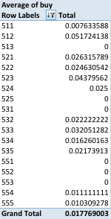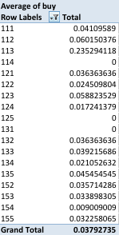

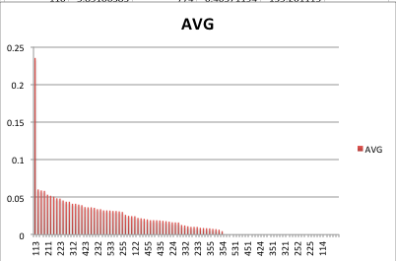

2. We expect 86,947*0.0238=2069.34 customers to buy a catalog.

3. Costs: $0.80/catalog, average purchase=$104, 50% profit margin

Breakeven return rate: -0.8*86947+52*86947x=0

X=0.0154

|  |  |  |  |  |  |
| --- | --- | --- | --- | --- | --- |
| RFM | NumCust | AVG | ExpNumCust | CumCust | CumExpcust |

…

|  |  |  |  |  |  |
| --- | --- | --- | --- | --- | --- |
| 353 | 985 | 0.018348624 | 18.0733945 | 49358 | 1792.152395 |
| 254 | 1556 | 0.017857143 | 27.78571429 | 50914 | 1819.93811 |
| 124 | 528 | 0.017241379 | 9.103448276 | 51442 | 1829.041558 |
| 224 | 571 | 0.016393443 | 9.360655738 | 52013 | 1838.402214 |
| 534 | 1034 | 0.016260163 | 16.81300813 | 53047 | 1855.215222 |
| 324 | 511 | 0.016129032 | 8.241935484 | 53558 | 1863.457157 |
| 432 | 709 | 0.012820513 | 9.08974359 | 54267 | 1872.546901 |
| 332 | 710 | 0.012195122 | 8.658536585 | 54977 | 1881.205437 |
| 554 | 2269 | 0.011111111 | 25.21111111 | 57246 | 1906.416549 |
| 454 | 2527 | 0.010309278 | 26.05154639 | 59773 | 1932.468095 |
| 555 | 3118 | 0.010309278 | 32.1443299 | 62891 | 1964.612425 |
| 233 | 1061 | 0.010204082 | 10.82653061 | 63952 | 1975.438956 |
| 154 | 1233 | 0.009009009 | 11.10810811 | 65185 | 1986.547064 |
| 434 | 1137 | 0.00877193 | 9.973684211 | 66322 | 1996.520748 |
| 333 | 1161 | 0.008547009 | 9.923076923 | 67483 | 2006.443825 |
| 355 | 3367 | 0.008333333 | 28.05833333 | 70850 | 2034.502158 |
| 511 | 1263 | 0.007633588 | 9.641221374 | 72113 | 2044.143379 |
| 453 | 1211 | 0.00729927 | 8.839416058 | 73324 | 2052.982796 |
| 422 | 1442 | 0.006535948 | 9.424836601 | 74766 | 2062.407632 |
| 354 | 2172 | 0.004587156 | 9.963302752 | 76938 | 2072.370935 |
| 114 | 27 | 0 | 0 | 76965 | 2072.370935 |
| 125 | 90 | 0 | 0 | 77055 | 2072.370935 |
| 131 | 107 | 0 | 0 | 77162 | 2072.370935 |

From this information, we would choose to target 53,558.

4. Assuming at least 1863.457 will respond in the targeted set, and 2072.37 will respond if we sent catalogs to everyone, expected profits are as follows:

-0.8(53558)+(52*1863.457)=$54,053.36

-0.8(86947)+(52*2072.37)=$38,205.64

The targeted approach gave substantially better results (roughly $16,000) due to the marginal decrease in gain of potential customers as another group is added. Though some groups with low response rates may be large, they bring little to no profits. There are also many groups with a response rate of zero that would not be worth targeting. The targeted approach sends catalogs to those most likely to buy, yielding higher profits.