Caroline Nelson

Cn8764

Marketing Assignment #3

1. The graph below assumes a forecast period of 20 years, coefficient of innovation=0.03, coefficient of imitation=0.4, and a market size of 25 million.

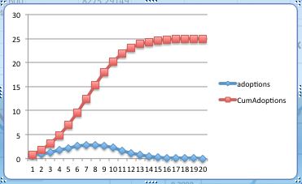

2. The graph below assumes a forecast period of 20 years, coefficient of innovation=0.4, coefficient of imitation=0.03, and a market size of 25 million.

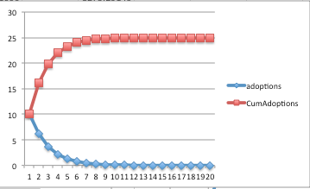

3. The first model, p=0.03 and q=0.4 implies that it would take longer to acquire customers; the year with the most acquired customers is not until year 8. The second model, where p=0.4 and q=0.03, suggests that people adopt the new product quickly to a certain point, and then fewer and fewer people adopt it years later, so the curve flattens.

4. Market Penetration

The same concepts from question 3 are evident in our market penetration results; when p=0.03, the market penetration is slow at first, and then levels off, while when p=0.4, the new product penetrates the market immediately and quickly levels off.

P=0.03, Q=0.4

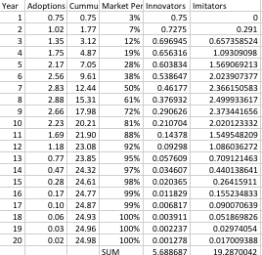



P=0.4, Q=0.03

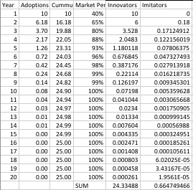



This chart illustrates that when people are more likely to be innovators, 97% of the market penetration comes from innovators, and 3% from imitators. When people are more likely to by imitators, 77% of the share of sales comes from imitators, while 23% come from innovators. This is what we would expect.