Caltech Fish Counting with the CFC-DAOD Dataset Proposal

The Caltech Fish Counting Dataset (CFC-DAOD) provides a valuable benchmark for domain adaptive object detection. It focused on fish detection in sonar images. This project wants to develop a robust object detection model to detect and localize fish in the target domain (Kenai Channel) by using source domain data (Kernai Left Bank) to train the model. It could solve the domain adaptation challenges and improve detection accuracy under different environment conditions.
The dataset includes labeled bounding boxes for fish in the source domain and unlabeled or labeled images in the target domain. Each image is processed into a three-channel format (Baseline++) which combines the original image, background subtraction, and frame difference, enhancing fish visibility. The response variable is the bounding box coordinates (x, y, width, height), with fish detection performance using mean Average Precision (mAP) at IoU=0.5. From Figure 1, we could find the fish count distribution. Most images contain 2-4 fish, while some contain up to 14 fish. From Figure 2, we could find the bounding box size distribution which indicates the widths peak at around 80 pixels and the heights peak at around 20 pixels.
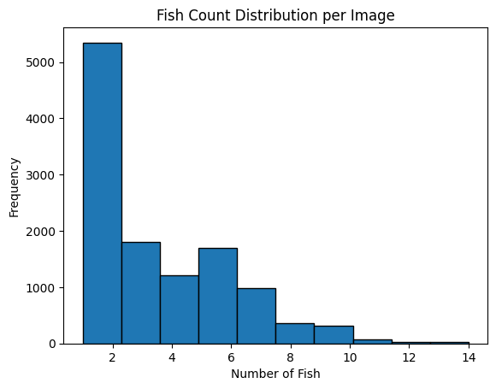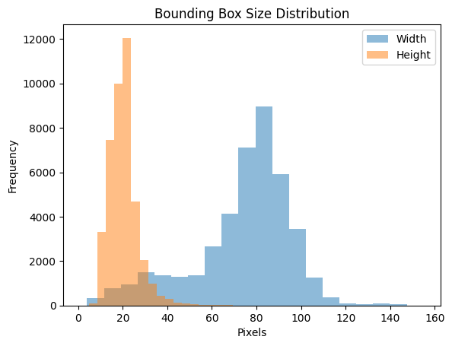
Figure 1: Fish Count Distribution. Figure 2: Bounding Box Size Distribution

I plan to employ YOLO because of its efficiency in detecting small objects and integrate pseudo-labeling to adapt the model to the target domain. The dataset needs careful preprocessing in order to make sure the compatibility with YOLO. The reasons of choosing YOLO are its speed, accuracy, and real-time detection capabilities. Its anchor-based detection mechanism is particularly effective for handling the different sizes of fish bounding boxes observed in the dataset. Training begins with labeled source domain data, leveraging YOLO’s transfer learning capabilities to fine-tune the pre-trained weights for detecting fish in the sonar imagery. A major challenge in this project is the domain shift between the source and target datasets. To address this, I want to try pseudo-labeling. Pseudo-labeling is effective for domain adaptation as it leverages the target domain data structure to improve generalization. The model is evaluated on the labeled target domain test data using mean Average Precision (mAP) at IoU=0.5. This metric ensures a comprehensive assessment of the model’s detection accuracy. Evaluation results are compared with baseline models to measure improvements achieved through domain adaptation.
These methods were chosen for their suitability in addressing the specific challenges of the dataset, including sparse annotations, domain shift, and the need for efficient detection in noisy sonar images. YOLO’s ability, combined with pseudo-labeling’s capacity to utilize unlabeled data, ensures a robust and adaptable solution.
Here is a timeline for this project:
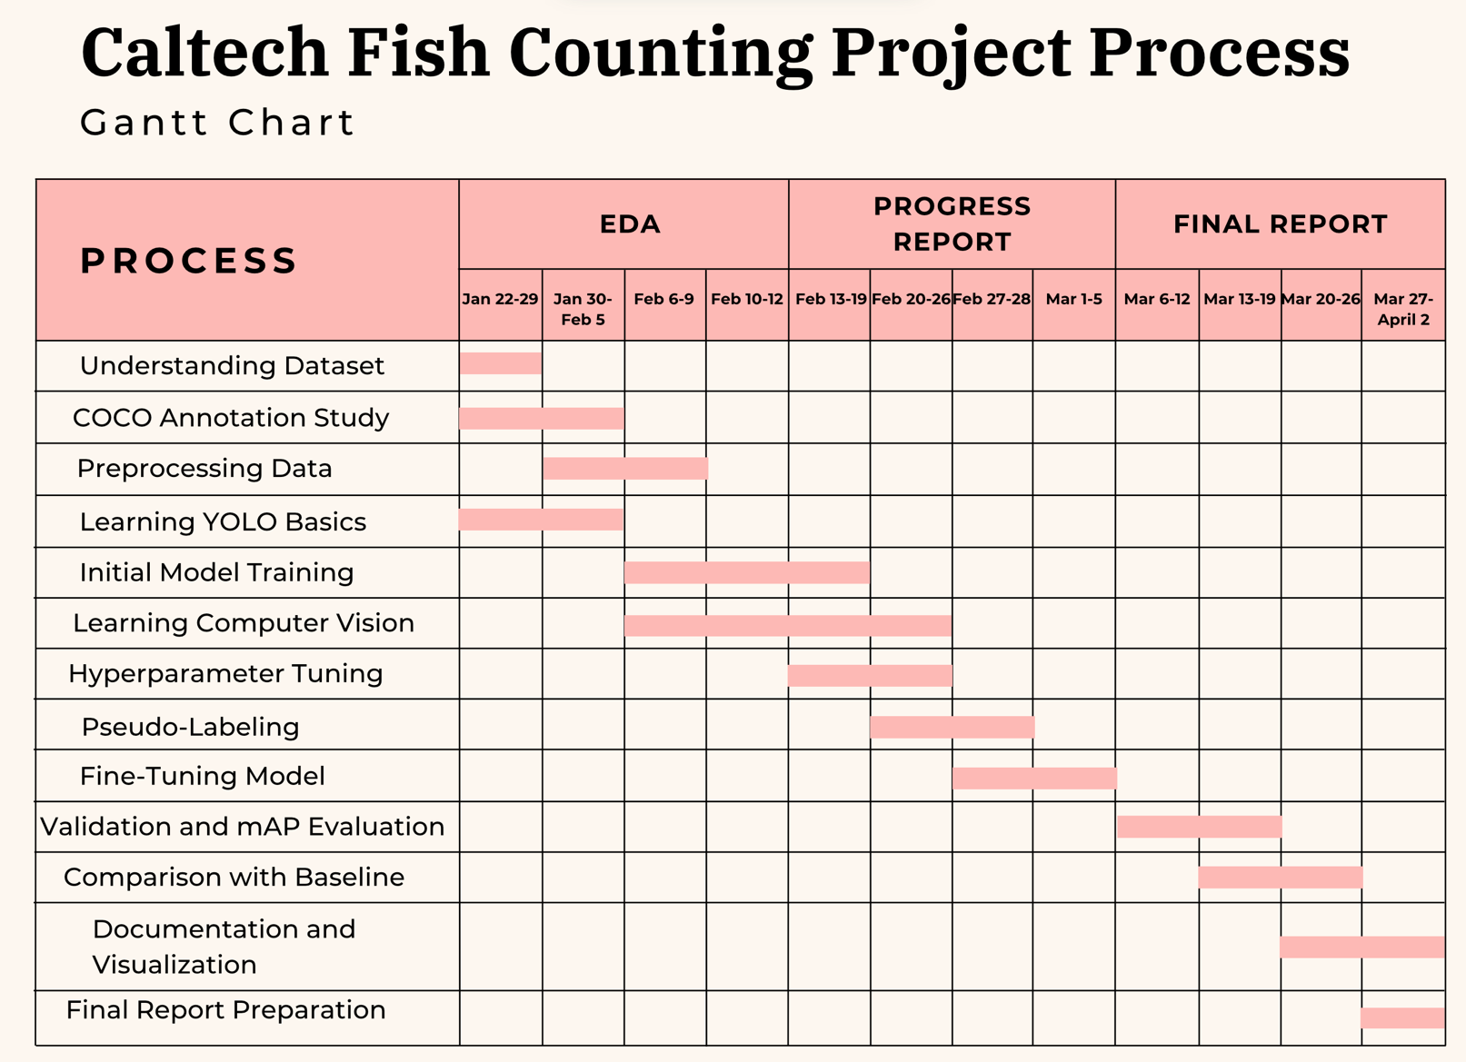
In conclusion, this project will develop a robust fish detection model utilizing YOLO and domain adaptation techniques. By addressing domain shift challenges with pseudo-labeling, it aims to advance the field of sonar-based object detection within real-world environments.

