How to set it up

Give the user group permissions to the target table, show target table

Configure the followup.html file

followup.html

Copy the followup.html file and place it under the actionpad folder. 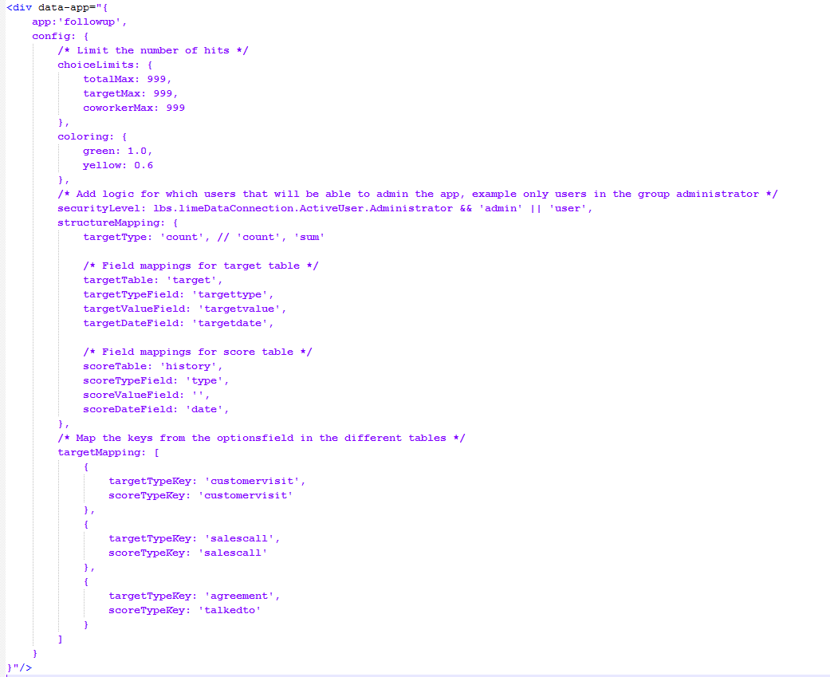

See followup.html for example.

In the Install folder you can find 4 files

1. Code_ for_ThisApplication
2. Followup.bas
3. FollowupChildData.cls
4. FollowupParentData.cls

1. Code_ for_ThisApplication

Take the code from the file and paste it in the Setup sub in ThisApplication.

2. Followup.bas

Insert the Followup.bas file in the VBA. Run the sub Install() to create the necessary localization posts for the app.

3. FollowupChildData.cls

Insert the FollowupChildData.cls file in the VBA.

4. FollowupParentData.cls

Insert the FollowupParentData.cls file in the VBA.