Axial -> 2 Coordinate System

Cubial -> 3 Coordinate System



initialize method

size = 7

x

z

y

-1

-1

0

x-axis

y-axis

z-axis

1

1

1

3

0

-1

-1

0

1

-2

0

-1

-2

-2

3

-1

-3

1

1

-1

-4

1

1

radius = 4

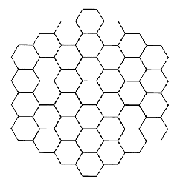

0

-1

1

-1

2

-1

-3

3

0

-2

2

0

3

-3

0

0

2

-2

x+y+z = 0

