

Computer Games Development CW208
Technical Design Document
Year IV

Caroline Percy
C00248791
24th of April 2023

Contents

Architecture 2
Class Diagram 2
Design Decisions 3
UI 3
Button 3
Findable Item 3
Editor Item 4
Level Editor Screen 4
Level End Screen 4
List 4
Text Box 5
Timer 6
Screens 6
Screen Template 6
Main Game 6
Main Menu 7
Theme Input Screen 7
Scene Manager 7
Saves 8
Save Writer 8
Save Reader 8
Image Retriever 9
Background 11
Globals 11
References 12

Technical Details

Architecture

Class Diagram
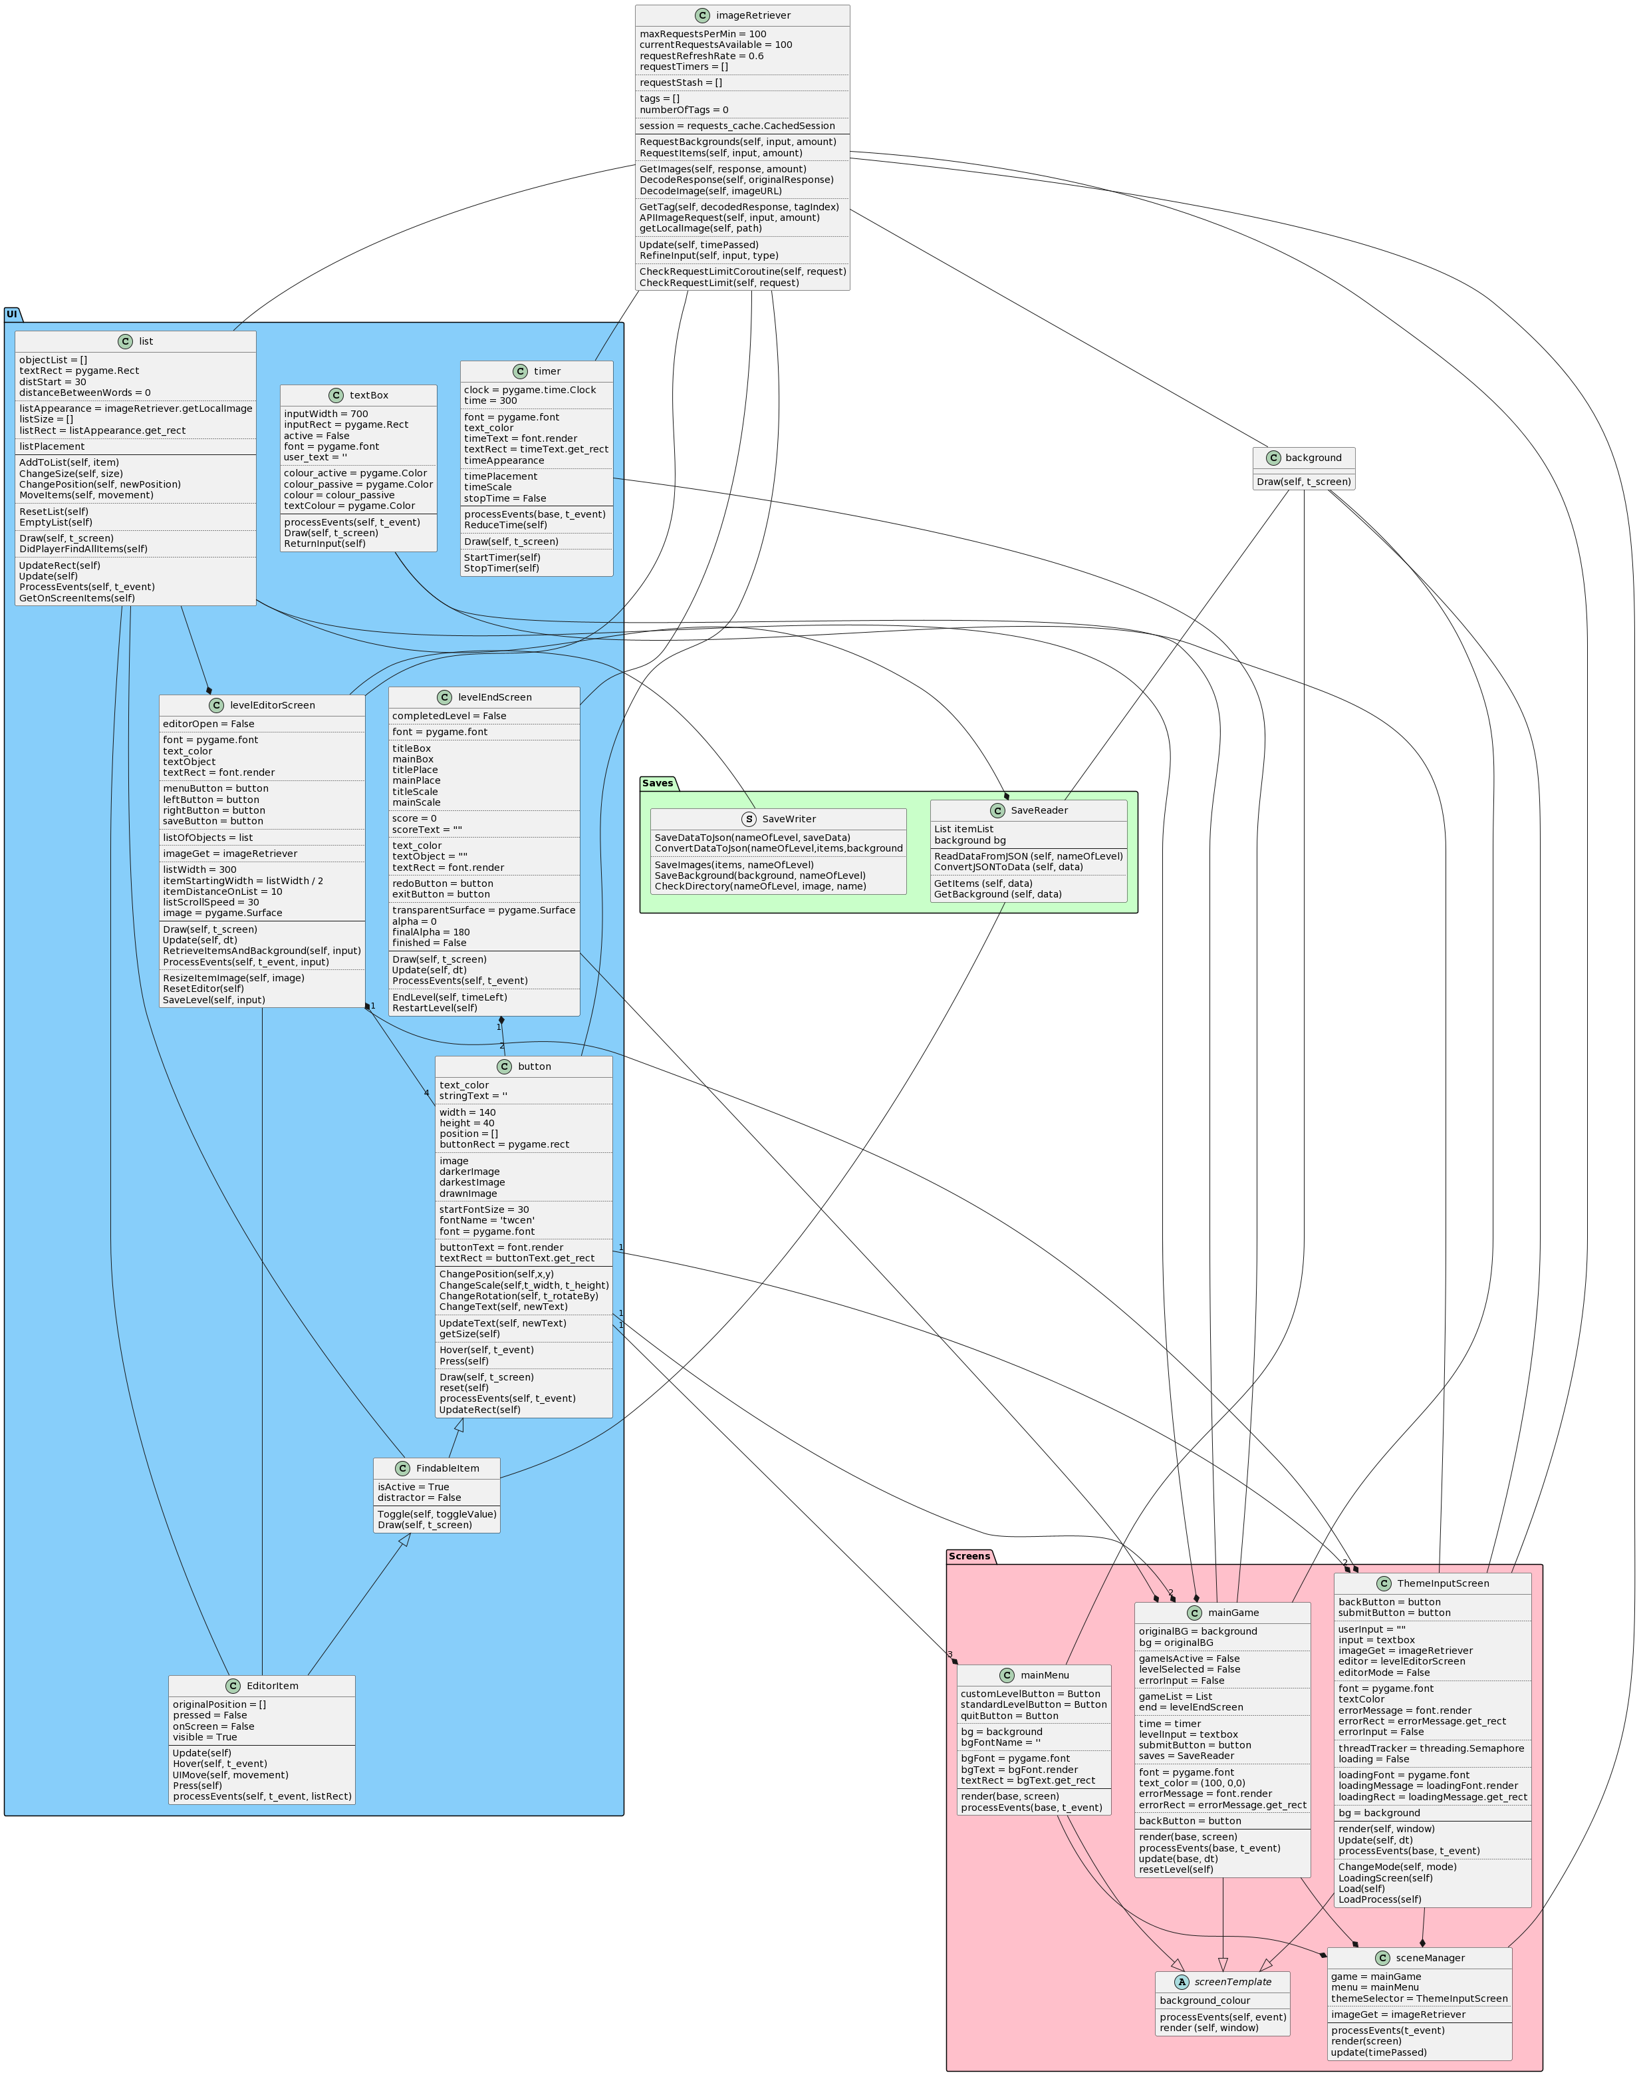
Figure 1: Class Diagram of Hidden Art.

Design Decisions

UI
I am using Pygame for my programme. Pygame is a Python library designed for creating video games. (Shinners, 2016) While Pygame is very versatile and easy to use, it does not have any inbuilt UI, resulting in myself making each object seen on the screens.

Button
A simple object that has some kind of appearance, often a sprite or a coloured rectangle. If the user hovers the mouse over the button, it will turn a darker shade. It will go a darker shade again if the user left mouse clicks while the mouse is over the button.
def processEvents(self, t_event):

check = False

if t_event.type == pygame.MOUSEBUTTONDOWN and t_event.button == 1: # 1 = left click in pygame

check = self.Press()

elif t_event.type == pygame.MOUSEMOTION or (t_event.type == pygame.MOUSEBUTTONUP and t_event.button == 1):

self.Hover(t_event)

return check
Figure 2: The event handler for the Button class.
The button will trigger some event once the user clicks the sprite, depending on what context the button is in. I was able to create this object using a Pygame Surface and a Pygame Rect.
Button objects are found all throughout my project – they are used to navigate between screens, save levels, load levels and exit the programme.

Findable Item
Findable Item is a child object of Button. It is Button changed to not change colour when hovered over, and designed that once it is clicked, it will be “toggled” and no longer be visible or interactable.
They are used in the Level Loader screen – they represent the items that needed to be found in a standard hidden object level. They are stored in my custom list class, which I will address later in the paper.

Editor Item
Editor Item is a child object of Findable Item. It is like the Findable Item in appearance, but when you click on the object, instead of it toggling off, the object follows the mouse as you click and hold it.
They are used on the Level Editor screen. Once the user lets go of the mouse button, the object will sit where the mouse let it go. Once the user hits the “Save Level” button, all Editor Items in the editor will have their positions and sprites saved locally, so they can be reused in the Level Loader.
They are also stored in the same list class aforementioned in the Findable Item paragraph.

Level Editor Screen
Level Editor Screen is a collection of other classes such as list, buttons and a background. This class controls everything to do with the Editor part of this project.
While Theme Input Level is what loads the editor up – more on this later in the document – Level Editor Screen allows the user to interact with the objects given back by the REST API, moving them around and placing them where they want, as well as hitting save and recording where all the objects are to a json file, and save each object image as a PNG.

Level End Screen
Level End Screen controls all aspects related to when the user finishes a level. It is what shows the player’s final time at the end, buttons to retry the level or to go back to the main menu, and it is in charge of the fading darkness over the background once the level is complete. It is used in the Main Game class,

List
List is a handler of objects. The list class is used on both the Level Editor Screen and the Main Game screen.
It has a physical appearance as a sprite, and the objects it has stored are in front of it. It will behave differently depending on what kind of item you give it.
For example, if you store a Findable Item in the list, it will not move the item itself onto it’s sprite, but instead make a silhouette copy, and have the silhouette appear on the list instead. This silhouette is to clue the user into what kind of shapes of objects they are to search for in the scene.
Alternatively, if you give it an Editor Item, it will directly move the item onto the list appearance. This is so that when the user opens the menu to view the list, they are all organised together, rather than all over the screen.
def AddToList(self, item):
self.objectList.append([item, False])

if not isinstance(item, EditorItem.EditorItem) and isinstance(item, FindableItem.FindableItem):

try:
silhouette = item.image.copy()

w, h = silhouette.get_size()
for x in range(w):
for y in range(h):
a = silhouette.get_at((x, y))[3]
silhouette.set_at((x, y), pygame.Color(0, 0, 0, a))

if (silhouette.get_height() > 100):
newSize = ((100 / silhouette.get_height()) * silhouette.get_width(), 100)
silhouette = pygame.transform.scale(silhouette, newSize)
self.objectList.append([silhouette, False])

except Exception as e:
print(e)
Figure 3: An example of adding an object to the List.

Text Box
The text box class is a rectangle surface, that when clicked on, will become active and a darker shade of gray. Once the text box is active, any keys the user presses will be stored and displayed inside the rectangle surface, mimicking the appearance of a text box.
If the user hits enter while the text box is active, it will notify the screen the text box is attached to, and it will react the same way as submitting the answer. The text box is used on the main game screen and the theme input screen.
def processEvents(self, t_event):

entered = False

if t_event.type == pygame.MOUSEBUTTONDOWN:

if self.inputRect.collidepoint(t_event.pos):
self.active = True
self.colour = self.colour_active

else:
self.active = False
self.colour = self.colour_passive

if t_event.type == pygame.KEYDOWN and self.active:

if t_event.key == pygame.K_BACKSPACE:

self.user_text = self.user_text[:-1]

elif t_event.key == pygame.K_RETURN:
entered = True

else:
self.user_text += t_event.unicode

return entered
Figure 4: The code that controls what happens when the user types into the text box.

Timer
The Timer class is a representation of a digital clock counting down on the top of the screen. It is used in the Main Game screen, after a level is loaded.
The timer always starts at 5 minutes. Once it hits 0, the level automatically ends and returns the player to the main menu.
Every time a second passes, this class’s time variable goes down by one. This variable is then converted into minutes and seconds, and displayed to the user.
The timer can be started and stopped, such as when the player starts and finishes the level.
def ReduceTime(self):
if (self.stopTime == False):

self.time -= 1
convertTime = time.strftime("%M:%S", time.gmtime(self.time))

self.timeText = self.font.render(convertTime, True, self.text_color)
Figure 5: The function that is called after each second to reduce the time appearance.

Screens

Screen Template
Screen template is an abstract parent class for Main Game, Main Menu and Theme Input Screen. By itself, it does no processing and it only renders a screen filled with one colour.

Main Game
Main Game is where the levels are played. You can access the screen by going through the Main Menu.
When you enter the screen, you can use the text box to search for a level by name. If you don’t give it a name that it recognises, it will throw up an error to the user.
Once you do put in a valid name, the Save Reader will load all the images and locations, which will be given to the list in Main game. The background will update to match the loaded one, and the timer will start.
if (not base.errorInput):
base.gameList = base.saves.itemList
base.bg = base.saves.background
base.levelSelected = True
base.gameIsActive = True
base.time.StartTimer()
Figure 6: What is triggered when the user puts in a valid level name.
Once the level is loaded, the appearance completely changes – the text box and submit button stop being interactable and rendered, and the background, the objects, the list and the timer get shown instead.
The game changes again when the user finds all the objects. The End Level Screen appears and is interactable, the timer is stopped, and the final time is shown on screen.

Main Menu
Main menu is the screen the programme starts on. It allows traversal between the Theme Input screen and Main Game screen, as well as giving the user the ability to quit.

Theme Input Screen
The theme input screen is in charge of everything related to the level editor, before the images are loaded in.
First, it will use the text box to let the user input a word. Once the user submits the word, the screen will make two threads – one to act as the game’s loading screen, and the other to get the response from Pixabay. I chose threads for this because the program does stall waiting for the response, causing the program to appear as if it was crashing. Having a loading screen lets the users know that this pause in intentional.
def Load(self):

t1 = threading.Thread(target=self.LoadProcess)
t2 = threading.Thread(target=self.LoadingScreen)

t1.start()
t2.start()
Figure 7: The threading that occurs for the loading screen.
If the response from Pixabay tells the programme that there are no matching images for either the background or the items, it will give the user an error, and ask them to put in a more appropriate word.
If the images returned are valid however, they are given to the Level Editor Screen and the move is changed. The textbox and submit button are no longer interactable and rendered, but the Level Editor Screen is now visible and usable.

Scene Manager
Scene manager is used to swap between the screens. It uses a global enumerator to decide what is to be interactable, updated and rendered in that moment.
def render(screen):
global currentScreen

if (currentScreen == screenTemplate.Screens.MAIN_MENU):
menu.render(screen)

elif (currentScreen == screenTemplate.Screens.MAIN_GAME):
game.render(screen)

elif (currentScreen == screenTemplate.Screens.MAIN_THEME_SELECTOR):
themeSelector.render(screen)
Figure 8: An example of how the programme decides what will be rendered this frame.

Saves

Save Writer
Save Writer is what is called after the user hits the “Save Level” button on the Level Editor Screen.
It takes in all the objects that are on the background of the Editor, and the background of the editor itself. It will then check if the keyword given by the user has a directory available to store the images. If It goes, save those images to that local path. If not, it makes a new directory with the name of said directory being named after the keyword.
def CheckDirectory(nameOfLevel, image, name):

path = os.path.join(Path(os.getcwd()).parents[1], 'Assets\\AutoSavedAssets\\', nameOfLevel, name)
saveData = "../Assets/AutoSavedAssets/" + nameOfLevel + "/" + name

try:
pygame.image.save(image, path)

except:
os.mkdir(Path(path).parents[0])
pygame.image.save(image, path)

return saveData
Figure 9: Our check to see if the directory is already made.
It also creates a JSON file, where the paths to those images are stored, as well as the locations of each object as they were on the Editor screen.

Save Reader
The Save Reader is used to load the levels after they have been written by the save writer. It does this by getting the keyword for the level, and loading up both the JSON file and the images related to that keyword.
If the keyword has two or more words in it – for example, “living room” – It will turn it into one word using underscores. It will then save both the loaded background and loaded Findable Items into its variables, which lets the Main Game to extract them afterwards.
def GetItems(self, data):

self.itemList.EmptyList()

for item in data['items']:
location = (float(item['position']['x']), float(item['position']['y']))

newItem = FindableItem.FindableItem(item['image'])
newItem.ChangePosition(location[0], location[1])
self.itemList.AddToList(newItem)
Figure 10: The code used to load the Findable Items out of the json object.

Image Retriever
The image retriever class is one of the biggest features of the project. It is what controls the requests to Pixabay, and decodes the JSON given to it by Pixabay into Pygame Surfaces.
First, the keyword is passed in. This is filtered so that it is a valid link to call a response to. The link will change depending on whether the requested image was a background or an item.
def RefineInput(self, input, type):

if " " in input:

words = input.split()
newInput = ""

for w in words:
newInput += "+" + w

newInput = newInput[1:]
input = newInput

result = "https://pixabay.com/api/?q=" + input

if (type == globals.ImageType.BACKGROUND):
#result += "+interior"
result += "&category=background"
result += "&min_width=" + str(globals.SCREEN_WIDTH)
result += "&min_height=" + str(globals.SCREEN_HEIGHT)

elif (type == globals.ImageType.ITEM):
result += "&colors=transparent"

result += "&image_type=photo"
result += "&key=" + self.key
result += "&safesearch=true"

return result

Figure 11: The filters the input goes through in order to get the right images.

Once it gets back the link it will use, it sends it off to Pixabay – If the response has no errors, it will begin extracting photos from the result. If not, it will return an empty Pygame Surface as an error.
The extraction of the images is a bit complicated. First, it will loop through all the images the first request got. For an example, let’s say it got 5. For each image, it finds the tags attached to that image, and stores them. After each image, the program will check if the amount of images extracted is enough for the amount requested – for our example, we will say the program requested 10 images.
Since the first request only returned 5 but we want 10 images, the program will use the tags that were attached to the first set of images to retrieve more items. It will then store the tags of those images as well, making it so it could keep searching, no matter how big the requested amount of images were.
x = 0

for image in imList:
finalList.append(self.DecodeImage(image["webformatURL"]))
x += 1

if (x >= amount):
break

while (x < amount):
tag = self.GetTag(imList, currentExtraTag)
nextList = self.DecodeResponse(self.session.get(self.RefineInput(tag, globals.ImageType.ITEM)))

for image in nextList:
finalList.append(self.DecodeImage(image["webformatURL"]))
imList.append(image)
x += 1

if (x >= amount):
break

currentExtraTag = (currentExtraTag[0], currentExtraTag[1] + 1)

if (currentExtraTag[1] >= len(self.tags)):
currentExtraTag = [currentExtraTag[0] + 1, 0]
Figure 12: The Code in control of getting all the required images from Pixabay.
If however, the first response gets no images back, another error is shown, and the user is asked to put in a more appropriate word.

Background
The Background class is given a path to an image in its constructor, and draws that image to the size of the screen.

Globals
There are four global entities in this project – the width and height of the screen, the FPS (frames per second) the project should do, and an enumerator called Image Type.
The screen width and height are used all around the project, as it is used to keep the appearance of the window proportional, in case the size changes.
The FPS is used in the main game loop, only allowing the number to go ahead after 1/60th of a frame has passed.
The Image Type enumerator has three values; Default, Background and Item. Default is for debugging – it should never be used. If it is, somewhere in my code has gone wrong. Background and Item are for what kind of image the image retriever should get – either a background for a level, or a transparent image of an item you could hide in a scene.

References
Shinners, P. (2016, 12). About. Retrieved from Pygame: https://www.pygame.org/wiki/about

