* The unit must be on top of an enemy (ie rabbit on plumber, and vice versa) in order to attack using melee power.\*

\*Abilities can bypass this rule.

* Attacks, abilities, and movement can only be used once per turn.
* The plumber’s ability is to attack anywhere that is two spaces or less away from them, though the damage is halved. If they do this on their turn, they will be unable to standard attack. Likewise, if they standard attack beforehand, this option becomes unavailable.  
  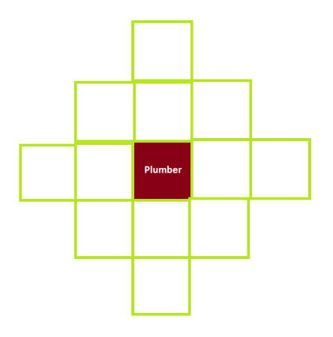

Example of Plumber’s ability range.

* The rabbits ability is to ‘jump’ three spaces in any direction. However, they are unable to turn mid-air. They are not restricted on when they can do this.