**UX00. Home Page (Portal Opening View)**

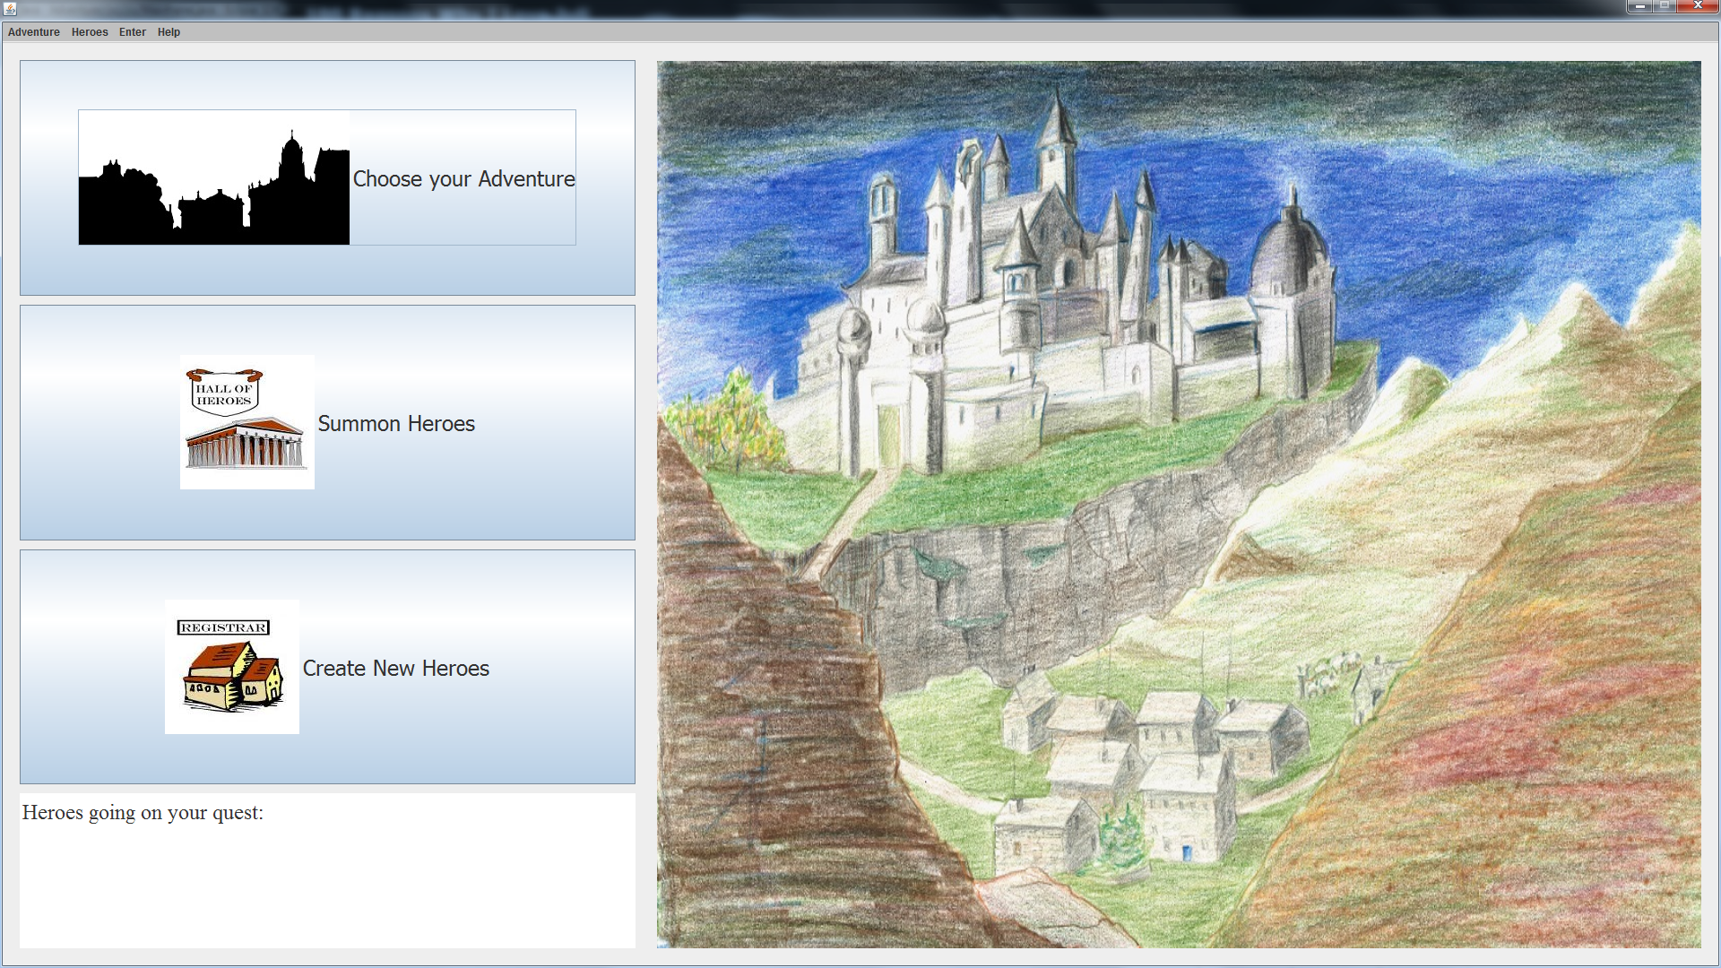

**Corrections to this picture: There needs to be an Exit and Help option on the top left corner (not necessarily in the menu bar.)**

See the UI_Rules document for a description of the behavior of this screen, and that immediately following this screen after mouse clicks.