**UX01. Create New Hero Input Panel**

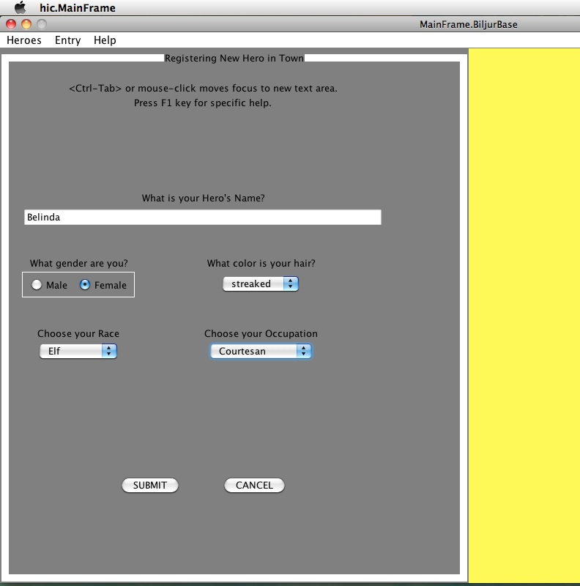

NOTES (features from top to bottom)

1. The left hand side of the computer screen (text panel) is a panel to collect input data for the Hero being created, and is displayed whenever a player requests to create a new Hero. The panel contains the name of the activity in play: “Registering New Hero in Town”
2. A graphic of the Registrar is shown in the right-hand side (shown in yellow above).
3. The Help Key, F1, brings up specific help page for the panel. Hovering over a widget brings up a help tip for that widget.
4. Inputs widgets are as follows. See use case A01. Create New Hero for more detail.

* Hero’s name: Default focus, any name up to the string length limit. This is the name by which the Hero is saved and retrieved.
* Gender: male or female
* Hair color: Cosmetic description from a list of colors, including “bald”.
* Race: one of eight Races, currently. Human is the norm and default.
* Occupation: One of dozens of Occupations, and each comes with a Skill, except the Occupation default of “None”.

1. Cancel button closes the panel. Submit button extracts all information, validates it, and creates the Hero, then displays the Hero output panel, UX02. Hero Output Panel.