**UX02. Hero Display (Output Panel)**

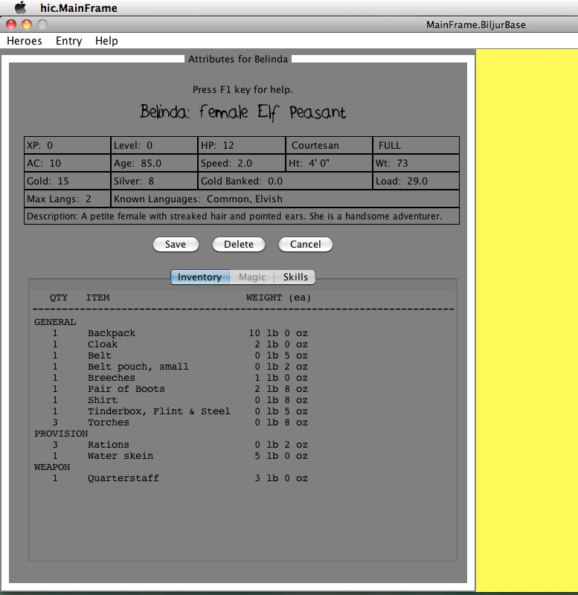

**UX02a. Inventory Tab**

NOTES (features from top to bottom)

1. **General.** This panel is displayed when a new Hero is created or the player wants to see the attributes, inventory, or skills of the Hero. The wireframe above shows the attributes with the Inventory tab view open.

* Message about using the Help Key, F1, which brings up specific help page for the panel. Hovering over a widget brings up a help tip for that widget.
* Hero’s name, in a stylized font. Belinda’s name plate (name, gender, race, Klass) is shown in AskesHandwriting.ttf font.

1. **Attributes.** The grid at top shows the various experiential attributes for the Hero, but in general, does not show internal attributes needed for game internals. The player is expected to infer that during gaining experience adventuring. The most important, or most frequently used items, are at the top, and decrease downward.
   * Row 1: XP (Experience Points), Level (0), HP (Hit Points), Occupation (Courtesan), Hunger (FULL). All new Heroes start at 0 XP and 0 Level.
   * Row 2: AC (Armor Class), Age, Speed, Ht (height in feet and inches, using the ‘ and “ symbols), Wt (weight in lbs). New Heroes start at AC 10 and are adjusted according to other traits. Speed is on a scale of 1-5, but is used relatively, so the actual number isn’t important.
   * Row 3: Gold, silver, gold banked, load. New Heroes start with very little wealth. 1 gold piece (gp) is equal to 10 silver pieces (sp). Gold banked is measured only in gp wealth, which is why it is shown as a decimal. This Hero has a wealth of 15.8 gp. Load is the weight the Hero carries, measured in lbs. It changes with inventory.
   * Row 4: Max Langs and Known Languages. Max Langs is the most languages the Hero can learn, not counting Common and a possible racial language (and Thieves’ Cant for Rogues). Belinda will be able to learn two more languages.
   * Row 5: Description of the Hero inferred from race, weight, height, gender, and Charisma (an undisplayed attribute).
2. **Buttons**

* Save: (Disabled if Hero has not changed since last save; always shows for new Heroes.) Save the Hero in it current state, closes the window and returns to Town Map (initial menu).
* Delete: After a confirmation prompt, removes the Hero from the game and storage. See use case A03. Delete Hero.
* Cancel: Closes this window, returning the player to the Town Map. Usually, for existing characters, Cancel and the close window button (top left) are the same.

1. **Inventory tab**. The Hero’s possessions that are not reserved for magical purposes are shown here. A new Hero has no magic, so the Magic tab is disabled.

* Quantity, Item, and Weight (lb, oz) column headings identify the values in the scrolling inventory list. (The wireframe is incorrect as it shows lb/oz for every item, instead of as a column heading.)
* Category: Each item is grouped by category and displayed. General, Provision, and Weapon are the three categories shown in UX02a.
* Load: The total weight of al Inventory items to the nearest pound is 29 lbs, as shown.
* Certain Occupations have Kits that are included as part of beginning inventory, and these are added to the Hero’s load. A Weaponsmith, for example, carries around a 10 lb. Metalworking Kit to assist the Hero in his or her skill. A Gambler carries only two sets of dice-- honest dice and crooked dice—2 oz. each.

1. **Skills tab.** All Skills, whether Occupational, Racial, or for Klass, are shown, with a quick description of what that skill can do. Some skills are described in relative terms of plus or minus percent chances of success at a goal, such as a “15% hide in shadows”. Greater experience and promotion at one of the guilds will increase those chances. See UX02b for the wireframe that shows the Skill *Luck* for the Occupation *Gambling* for a Human peasant—no racial skills. (The +2 should be +10% on all...).
2. **Magic tab** is disabled until the Hero owns magical devices.

**UX02b. Skills Tab**

