**UX03. Open Adventure Town View**

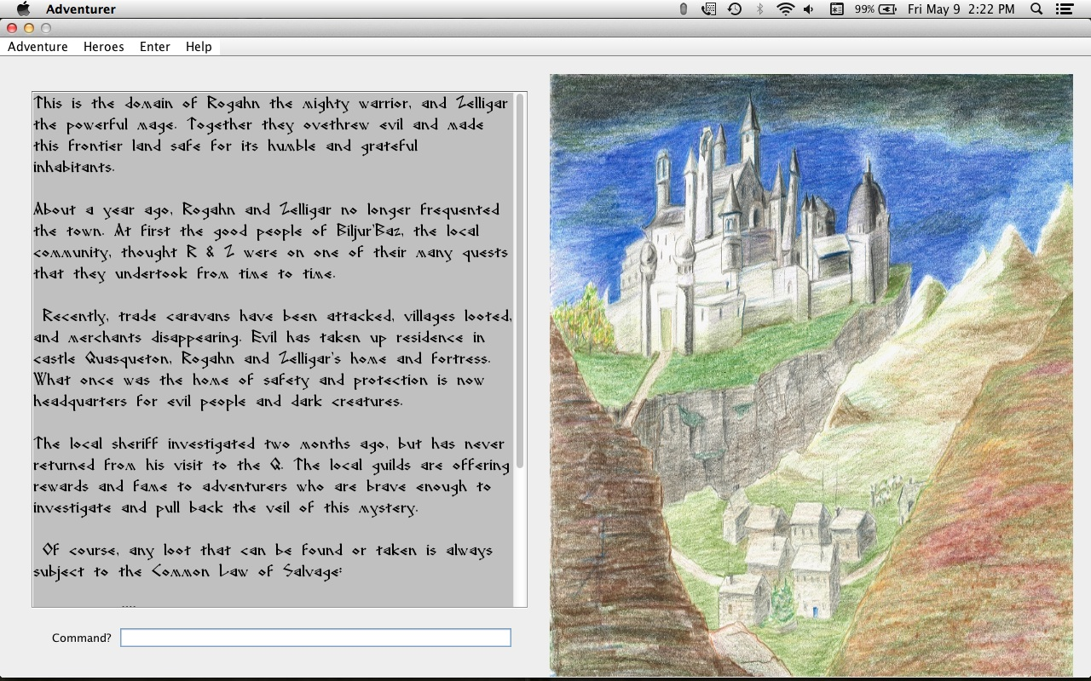

This image is displayed when an Adventure is opened.

Town image: contains building hot zones that, when clicked, take the player to the exterior of the Building specified. The Arena is also clickable. The names of the building are extracted from the Adventure object.

Output panel contains a description of the town from the Adventure selected.

Command line: allows a building’s interior to be entered dwithout clicking, by ENTER <Building Name>.

See the UI Rules document for a description of the behavior of this screen, and that immediately following this screen after mouse clicks.