HONG KONG INSTITUTE OF VOCATIONAL EDUCATION

**Laboratory 1 P1: Version Controlling by Github (Single Player version)**

**Module Intended Learning Outcome:**

On completion of the module, students are expected to be able to:

* apply the practical techniques to big data project;
* manage data using contemporary data science tools;

**Lesson Intended Learning Outcome:**

On completion of this lab, students are expected to be able to:

* + Github desktop
    - Basic setting and configurations
    - Environment setting
  + Development Cycle
    - Staging, pushing, fetch, pulling.
    - Update file to the server
    - Synchronize the file from the server

**TASK:**

**Considering the following situation:**

A Client employed you to further develop a client-size website project. You may receive a development folder **Lab01MaterialP1**. The folder contains HTML files, CSS files, and custom font files. You are required to enhance the content of the website to become more attractive. Furthermore, the client wants to keep track of the development of the website and provide instant comments on the project. So, you have to use the GitHub system to update your progress to your client. The following is the sample image of the website.

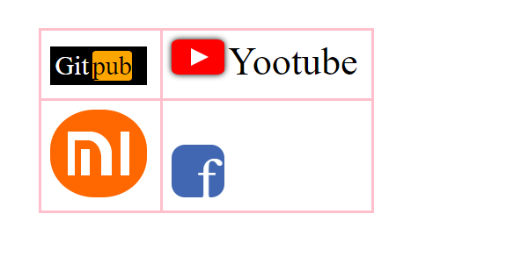

1. **Visit GitHub official website to create an account.**

[**https://github.com/**](https://github.com/)



1. **Download GitHub Desktop from the official website**

[**https://desktop.github.com/**](https://desktop.github.com/)

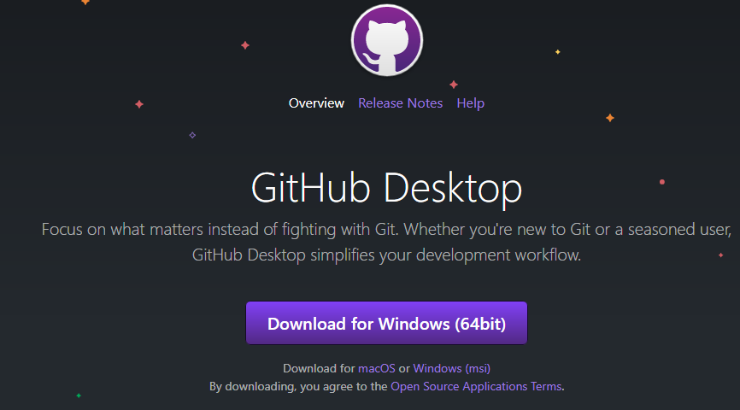

1. **Install the GitHub Desktop and execute it.**

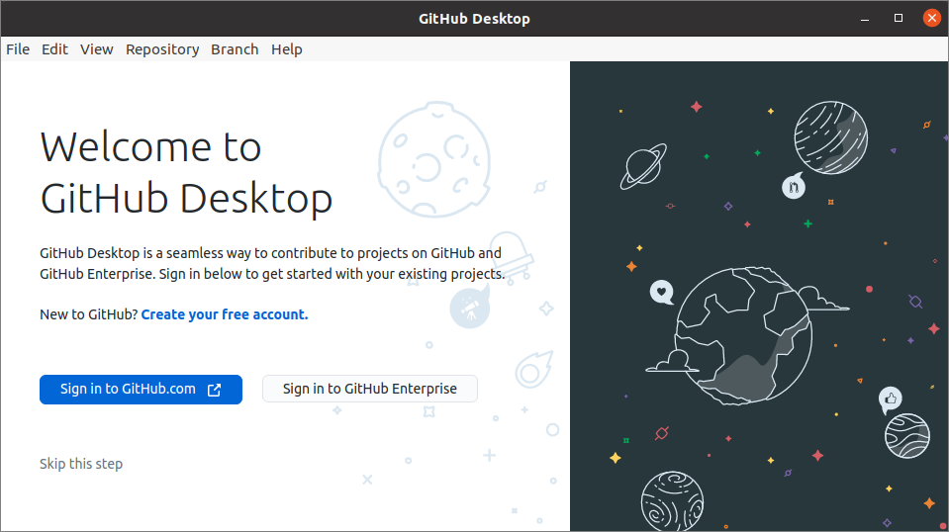

1. **Go to Github (**[**https://github.com/**](https://github.com/)**) and create a new project**一張含有 文字 的圖片

   自動產生的描述
2. **Name your Repository name (or project name) as Lab01 and set it as Private, then create the repository.**

1. **Done! Then you can log in to the GitHub desktop and clone your project.**一張含有 文字 的圖片

   自動產生的描述
2. **Choose the Lab01 Repository (which is you created in the last step) and clone it!** **The** **local path will become the file path of this repository.** 一張含有 文字, 螢幕擷取畫面, 監視器, 黑色 的圖片

   自動產生的描述
3. **Okay! The project is now set up in your local PC!** 一張含有 文字, 螢幕擷取畫面, 監視器, 螢幕 的圖片

   自動產生的描述
4. **Your Github project now is empty. You have to upload your existing document to the github server. Therefore, Remember the procedures to upload your proceed document.**
5. **Coding is already! Skip it!**
6. **Stage! Copy the existing folder to Repository Folder.**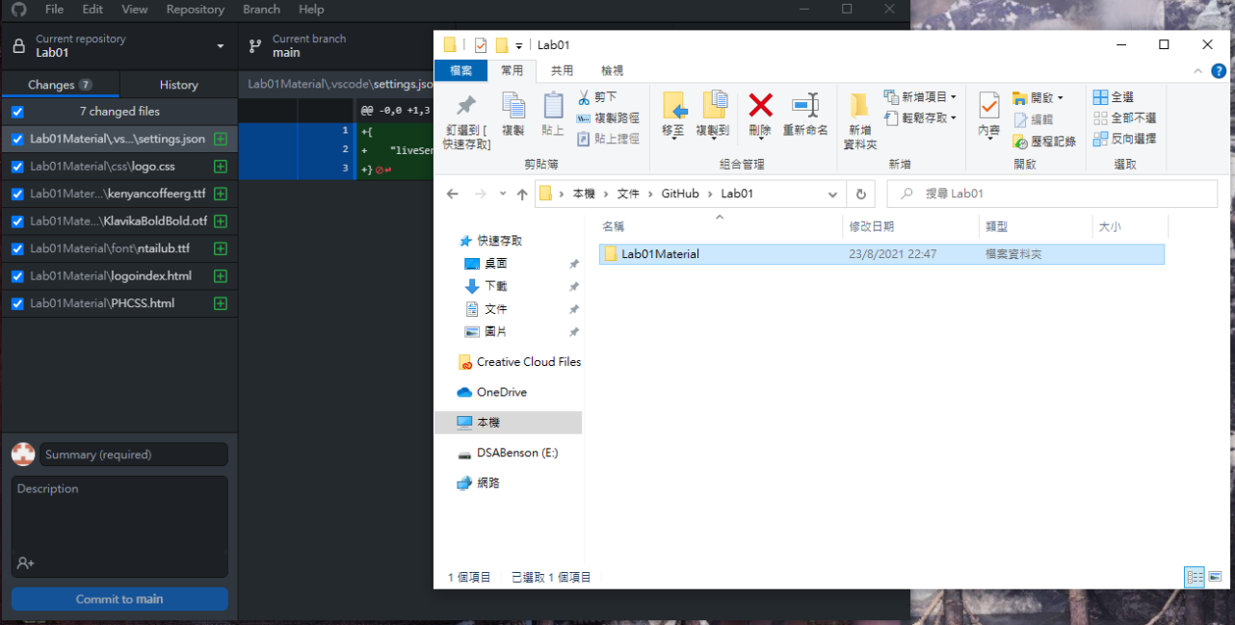
7. **Please check that all existing files are added to the project and Github will display something that is changed**

1. **Commit! You have to comment on what you have done and press the “Commit to main” button.** PS: you may check the History to find out what you updated.

1. **Push!! Click Push or Publish branch to upload your work to the server!** 一張含有 文字 的圖片

   自動產生的描述
2. **Done! You can see your work on Github!**

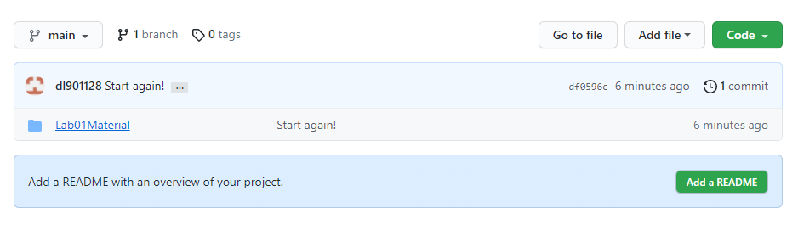

1. **Okay! Your turn! Your client requires that change the Gitpub logo colour from black to aqua.**

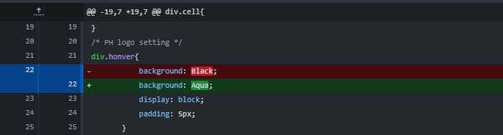

1. **When you finished the client’s requirement, please upload your work to the git server by repeating steps 12 to 14, and the commit topic is “Update Login GitPub in CSS” and the comment is “Update the logo Color from black to aqua.”**

1. **Remember to Push your work to the server, you will see the following when you succeed.** 一張含有 文字 的圖片

   自動產生的描述
2. **Continue! Next page!**

**How to get back your work when you using other PC? (or, you may restart the campus PC, if you want to try this section.)**

**Remember the following procedures!**

1. **Just the same, your new PC should installed Github Desktop**
2. **Login in the Github Desktop by account.**
3. **Clone your project.**
4. **Fetch!! Press Feteh to update the progress record**
5. **Press Repostory => Pull to get back your work!** **一張含有 文字 的圖片

   自動產生的描述**
6. **Done!**

**Some futuristic tech in Github! You can revert back to original version!**

**You can revert back to original version!**

1. **Right click the version/Commit that you want to revert, then click “Revert change in commit”**.

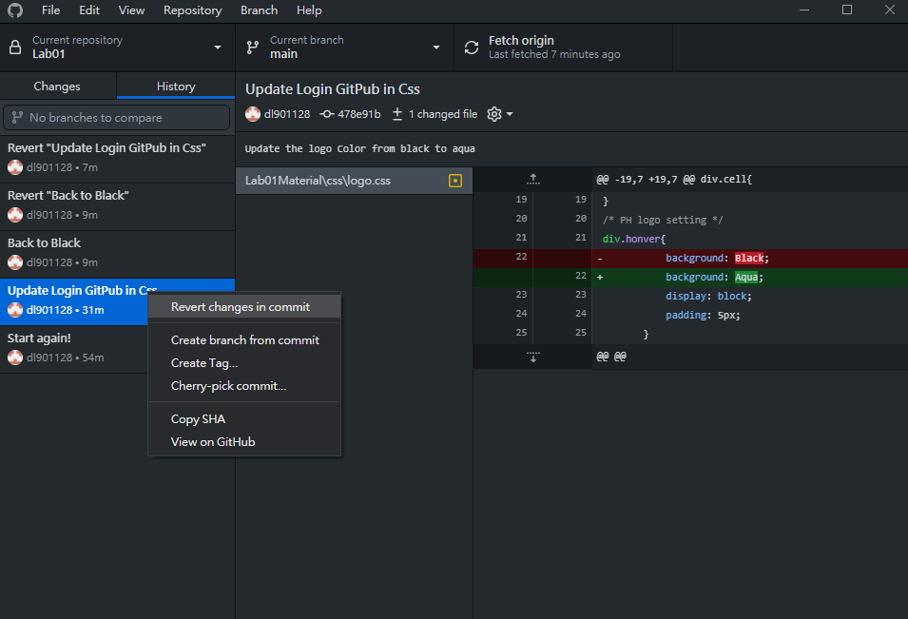

1. **Press Push!**
2. **Done!**

**Remember !! although you are revert to the older version, you still commit a new version and the content is the older one!! Remember!!**

**Some Notes for you**

1. **If you see the following step when you executing Github desktop, please choose “Use my GitHub account name and email address, and the Emai should match with your Github login account. Then, Press Finish.**