**Supervised learning techniques for classification of liver disease patients**

**1.Introduction**

**1.1 Classification of liver disease**

The incidence of liver disease is increasing throughout the world. In addition to the effects of alcohol consumption, harmful gases and drugs on the liver, the obesity and diabetes epidemic are likely to bring about an epidemic in liver disease as a result of their contribution to non-alcoholic fatty liver disease (NAFLD), which is increasingly recognized as the most common chronic liver disease in the western world [ref].

Liver disease covers a diverse group of pathologies, that notoriously present late, due to the vague symptom profile in early disease and the ability of the liver to continue to function normally even when partially damaged.

An early diagnosis of liver problems will increase patient’s survival rate and reduce burden on healthcare services. Analysis of liver function blood tests are used to aid liver disease diagnosis. However, the tests can be difficult to interpret, as they can be affected by other conditions and generally don’t correlate well to disease severity. Therefore, automated tools to aid classification of liver disease from blood test results could be useful as a screening tool.

**1.2 The dataset**

|  |  |  |  |
| --- | --- | --- | --- |
| **Feature** | **Distribution** | **Description** | **Correlation with Class** |
| Age | Normal | Average age: 45. Age range: 4-90. |  |
| Gender | Categorical | 75% male and 25% female patients. |  |
| Total Bilirubin | Right Skewed | A product of red blood cell breakdown, processed by the liver, increases with liver damage. |  |
| Direct Bilirubin | Right Skewed | Just the processed form of bilirubin, increases with liver damage. |  |
| AlkPhos | Right Skewed | Alkanine Phosphatase: An enzyme found in bone and liver. Increases with liver damage and bone disease. |  |
| Sgpt/ALT | Right Skewed | Alanine aminotransferase: Parenchymal liver enzyme, increases with liver damage. |  |
| Sgot/AST | Right Skewed | Aspartate aminotransferase: Parenchymal liver enzyme, increases with liver damage. |  |
| Total_Protein | Normal | Measure of proteins produced by liver and elsewhere, can increase or decrease in liver disease. |  |
| Albumin | Normal | A protein produced by the liver, usually decreases late in liver disease. |  |
| A/G ratio | Normal | Albumin/Globulin – ratio of albumin to globulin proteins produced in liver, can decrease or increase with liver disease. |  |
| Class Label | Categorical | 1 = Liver Disease, 2 = No Liver Disease |  |

The Indian Liver Patient Dataset (ILPD) is an open source dataset available on the UCI machine learning repository[refa] and has been used to develop classification algorithms for liver disease[ref][ref][ref]. The data was collected from the north east of Andhra Pradesh, India. It is composed of 583 instances and 11 attributes, one of which is a selector class used to divide the instances into binary sets - liver disease (416 patients) or no liver disease (142 patients) – as labelled by experts. The remaining 10 attributes are listed and described in table 1 along with the distribution of the feature, as visualised by histograms and boxplots in section 1.4 of the attached notebook.

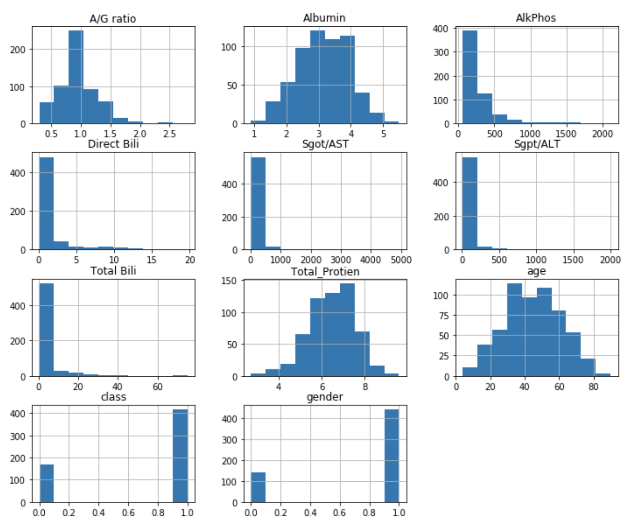 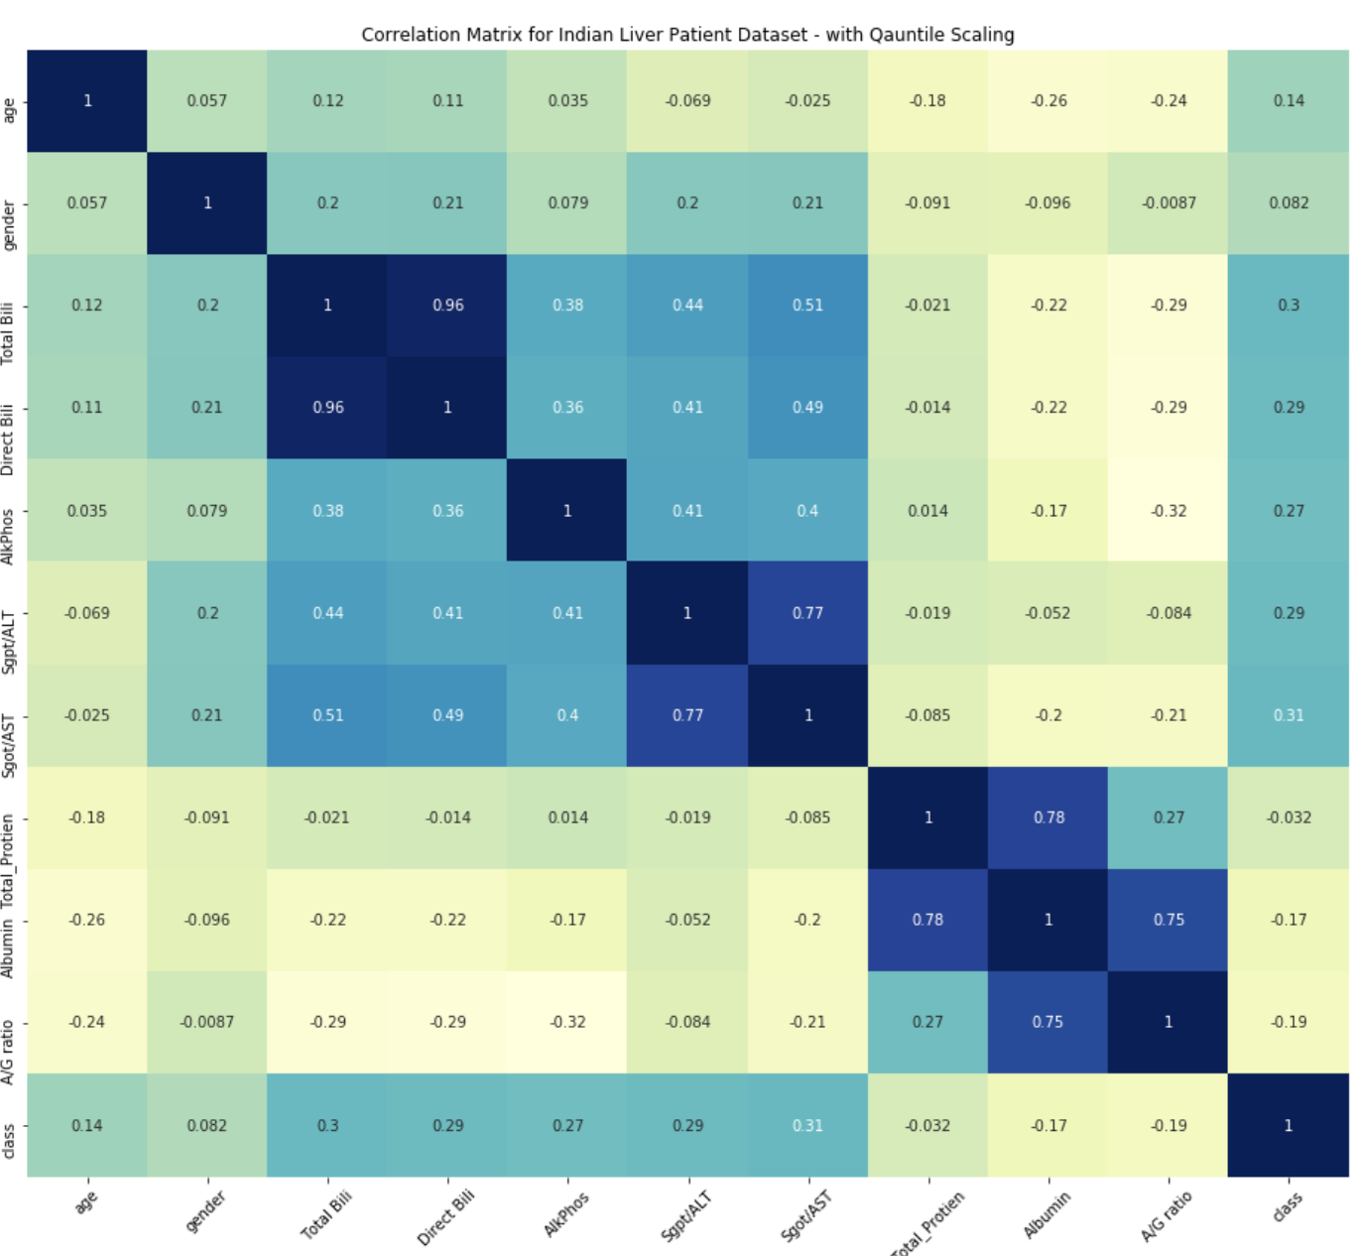

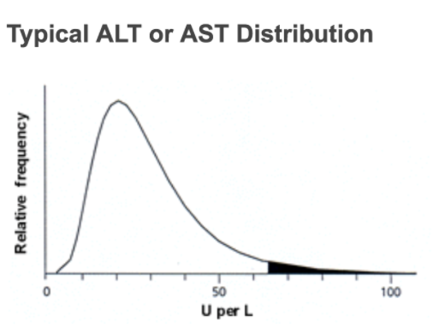**1.3 The effect of right skewed distributions**

Total Bili, Direct Bili, Sgot/AST, Agpt/ALT and AlkPhos (which are all products or enzymes that rise as a result of liver damage) have a **right skewed distribution** with a long tail at higher values. This is a known feature of the distribution of these products [refb] as can be seen in the figure to the right. These liver products can increase to very large values in certain stages of liver disease - e.g. in acute hepatic injury, values can be > 10 time the upper reference range [refc]. Therefore, the outlier values for these features are most likely to represent real values, rather than input or measurement error and were all included in the models.

The effect of this distribution, however, is that the large outlier values dominate the feature space and make it hard to visualise (see figure 1.4). Quantile scaling is a form of scaling that spreads out the most frequent values and reduces the impact of the outliers [refd]., better revealing the feature space in 3D. Section 2.1 of the notebook further explores these plots.

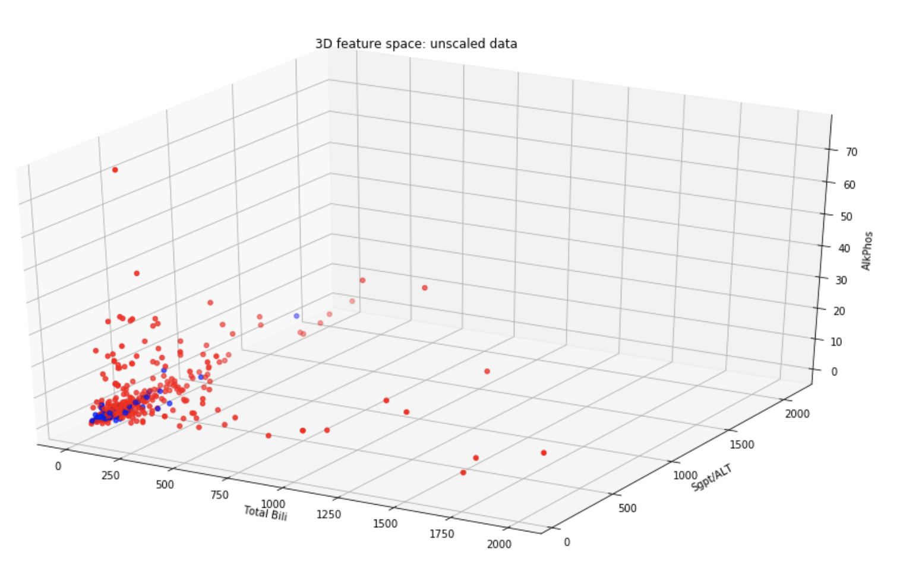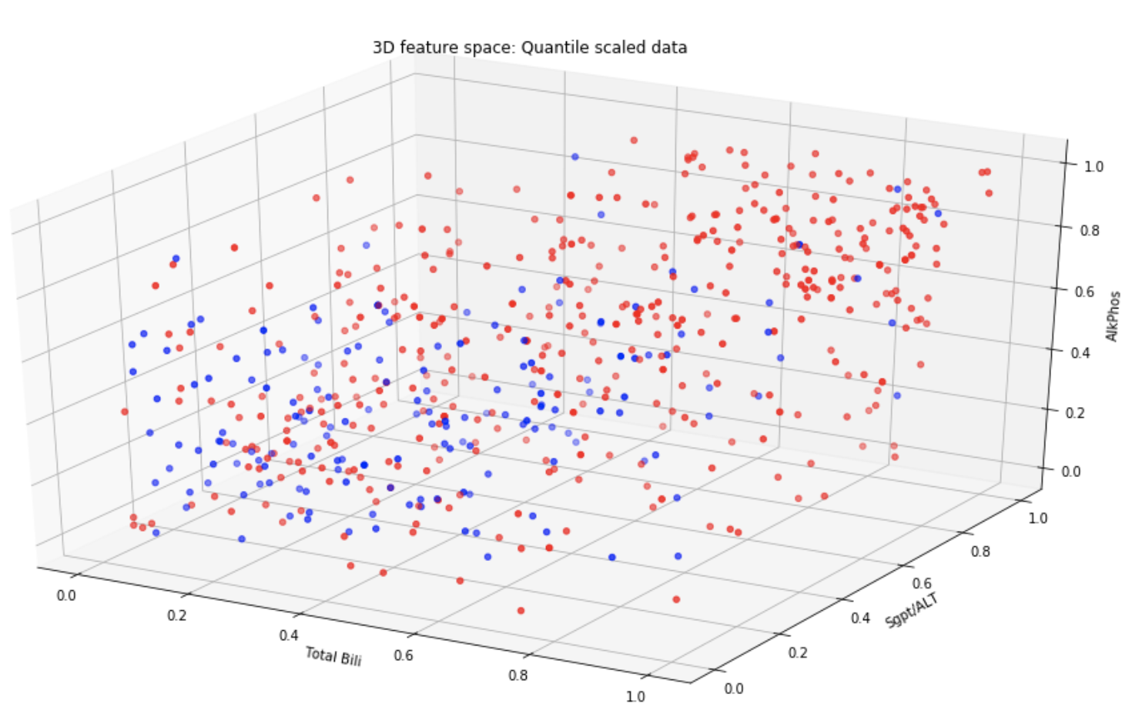

**2. Method**

**2.1 Data Cleansing**

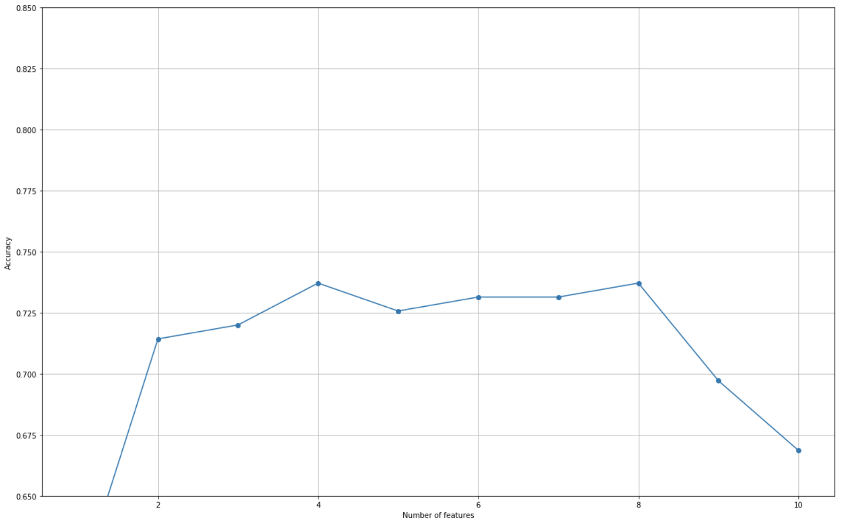Non-liver patient class value was changed from 2 to 0, to resemble common classification values. Gender was converted to numerical categorical values: female=0, male=1. **Imputation** with mean values was used on the 4 instances with missing values in the albumin/globulin ratio column. Both **min-max scaling** and **quantile scaling** were applied to the data and used to optimise pipelines. To avoid overfitting of the algorithms and reduce bias, the dataset was **split 70%/30%** into training/testing samples. **Random over sampling** of the non-liver group was used to balance the dataset - as machine learning models often misclassify data when faced with imbalanced datasets due to minority classes being treated as noise[refE]. Under sampling was not used as the dataset is already small.

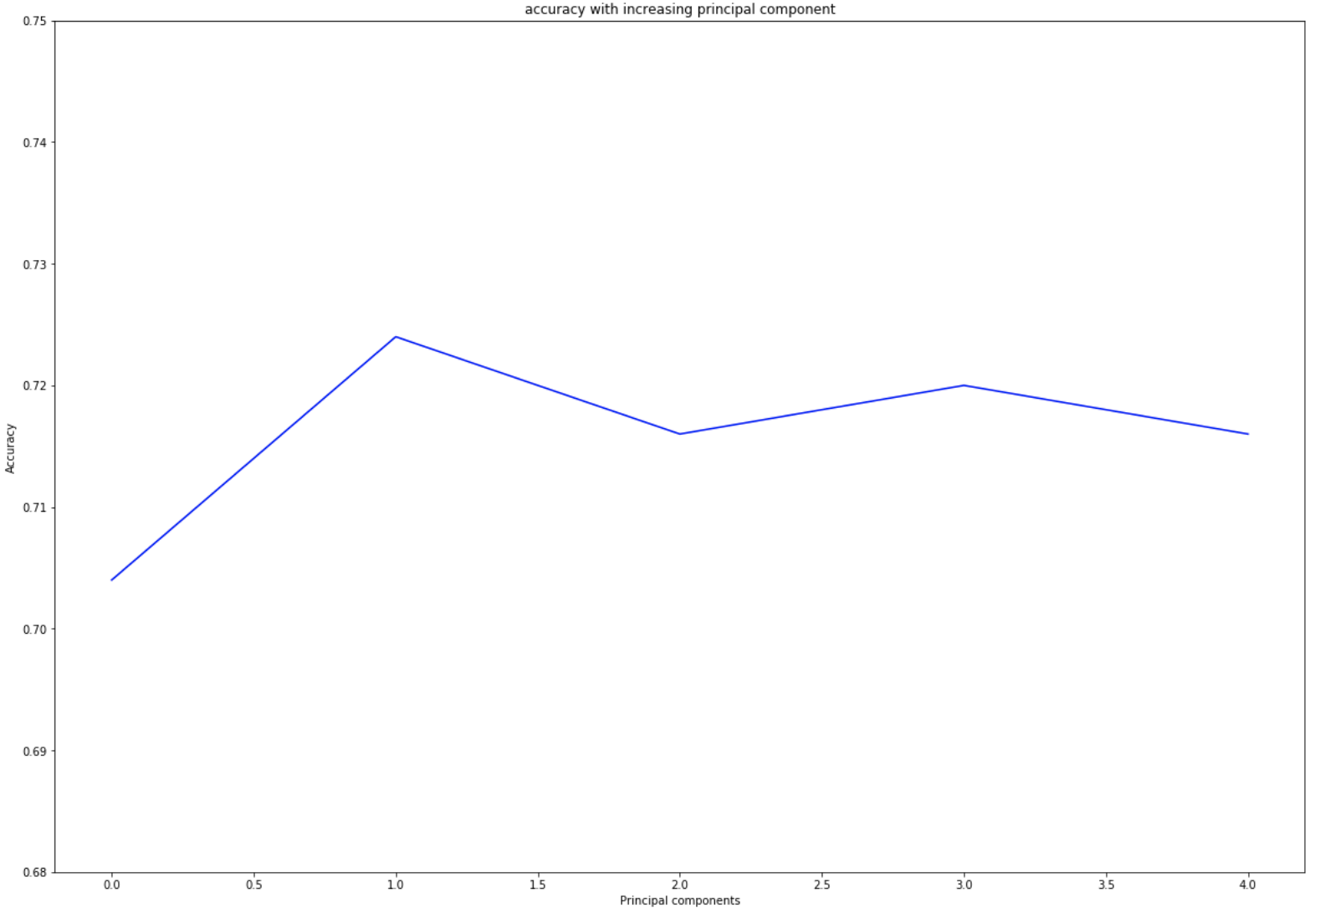**2.2 Feature Selection**

A combination of 'filter' (algorithm independent) and 'wrapper' (sequential backward selection – SBS) techniques were used to select a subset of features to reduce redundancy/noise and improve model accuracy. Combining the results of SBS and Weka attribute ranking carried out on the ILPD by Ramana et al.[ref], four features were chosen for exclusion from the dataset (gender, direct bili, total_protein, A/G ratio). This is discussed in more detail in section 3 of the notebook.

**2.3 Feature Extraction; Dimensionality Reduction**

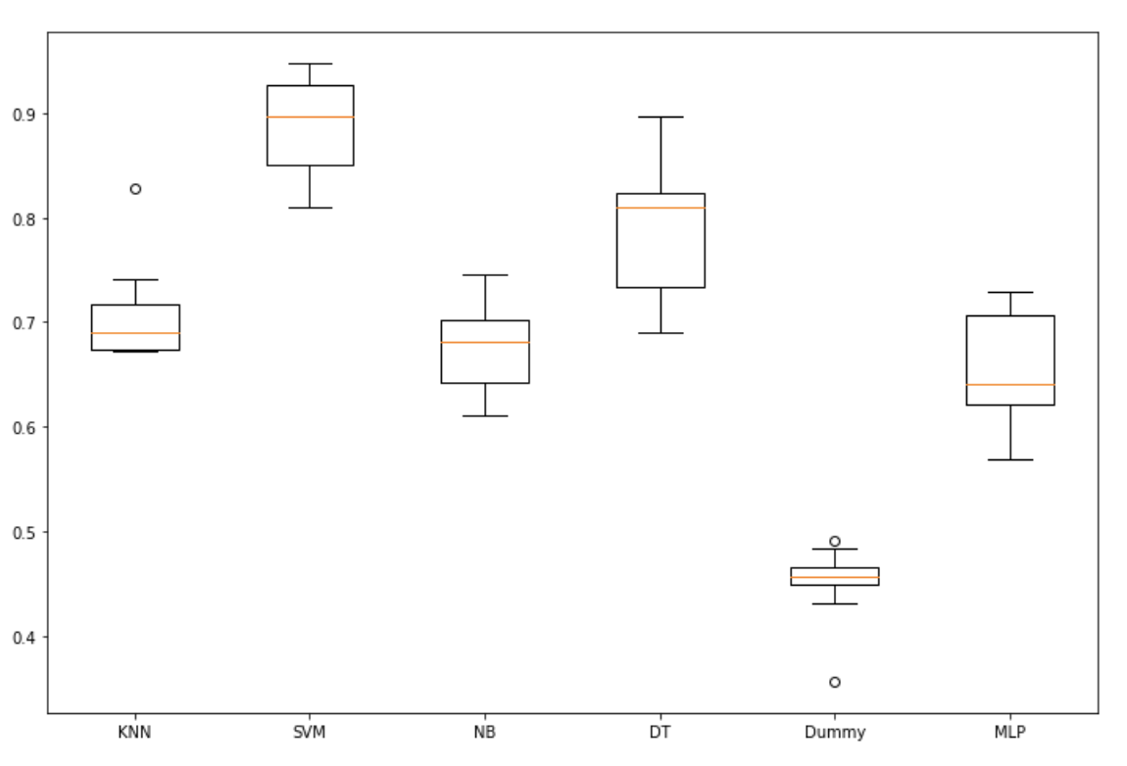A basic un-tuned naïve-bayes algorithm was used to evaluate accuracy with increasing principal components (see figure X). Reducing to 2 principal components appears to provide best accuracy – most likely by reducing noise in the model.

**2.4 Algorithm Selection**

An array of un-tuned pipelines was used to compare the accuracy of different classification algorithms and provide as a basis for selecting two to focus on (see figure X). Support vector machine and decision tree performed well and were thought to fit the needs of the dataset as will now be discussed.

**2.5 Support Vector Machine (SVM)**

SVM is a supervised machine learning algorithm that discriminates between two classes by generating a separating hyperplane. A hyperplane is an object that has one less dimension than the dataset. In non-linearly separable datasets, hyperplanes are determined by applying non-linear kernel functions.

The advantage of using SVM is that it is ‘model free’[ref1] – in contrast to logistic regression which relies on a pre-determined model. This makes SVMs powerful for classification with small sample sizes (such as the ILPD) and large number of variables. As a result, they have frequently been used in attempts to automate multi-factorial disease classification in the clinical setting[ref2].

**2.6 Decision Trees (DT)**

A decision tree is a predictive modelling algorithm that aims to map a set of instances to a target function that will accurately classify the instances, by searching a set of function hypotheses. For classification trees target variables have discrete values. In decision trees, leaves represent class labels and branches represent conjunctions of features that lead to those class labels. The algorithm uses a top down approach, looking at predictors at each node to find a cost value that best splits the data into two groups. The cost value either tries to minimize the impurity of nodes (entropy) or maximize the information gained (gini index).

|  |  |
| --- | --- |
| **Support Vector Machine (SVM)** | **Classification Decision Tree** |
| 1. Identify the classification category. 2. Determine closest points from one group of data points to the another**: ‘support vectors’.** 3. Look for separating boundary (hyperplane) that maximizes distance between hyperplane and support vectors**: ‘maximal separating hyperplane’.** 4. If data is not linearly separable - apply non-linear kernel functions to transform data – **linear, polynomial, radial basis function or sigmoid** 5. Allow for some data points to be on the wrong side of the hyperplane by specifying a **parameter ‘C’**: Higher ‘C’ creates a harder margin that will be sensitive to noise). [ref3] 6. Specify a **parameter ‘gamma’** value that defines how far the influence of a single training example reaches - low values meaning ‘far’, high values meaning ‘close’. 7. Classify new data points by determining which side of the hyperplane they fall into. | 1. Choose criteria to split each node of decision tree – **entropy** (minimise impurity) or **gini** (maximise information gain). 2. Specify some splitting and stopping criteria – e.g. **maximum depth** of the tree (the maximum number of terminal nodes or leaves in a tree), **minimum samples** for node split. 3. Create a root node by searching for decision attribute (A) among all input variables that produces best split for criteria. Assign A to root node. 4. For each value of A at root node – create a descendent node. 5. Search and assign again at each descendent node for best decision attribute from remaining variables as in step 2. 6. Repeat splitting, searching and assigning as in steps 2-4 until the instances are perfectly classified or the stopping criteria is met. |

**2.7 Hyper-parameter Tuning**

As discussed in the pseudocode table, the algorithms can be tuned with by altering parameter values. The optimal parameters for SVM and DT were determined by using sci-kit learn grid search. This was only done on training data so as not to introduce bias to the model by exposure to the test data. A comparison of the hyper-parameter results will be discussed in results.

**2.8 Cross Validation, Supervised Learning and Model Evaluation**

To further reduce potential for bias and overfitting, 10-fold cross validation was incorporated into the training algorithms (10 folds of the data were used to train on each fold and test on a different held out subset, then test accuracy on the whole training set).

The final SVM and DT models, with optimised hyper-parameters were fitted to the clean, feature selected, dimension-reduced data in a two-phase process: the training phase (with cross-validation) builds the classifier on the training set of tuples and the second phase classifies by testing on the unseen test data. Several performance estimates were used to evaluate the models: area under the curve (AUC), accuracy, sensitivity, specificity, positive predictive value (PPV) and negative predictive value (NPV). These will be discussed in section 3.

**2.9 An Ensemble Approach to Decision Trees: Gradient Tree Boosting**

An automated machine learning tool called TPOT was applied to the ILPD. It can explore thousands of machine learning pipelines using genetic programming[ref4]. The outcome showed a gradient boosting classifier was optimal.

Gradient tree boosting (GTB) is a generalisation of boosting ensemble learning. GTB achieves improved performance by combining decision trees and gradually minimising the loss function at each sequential combination using gradient descent method (an [algorithm](https://en.wikipedia.org/wiki/Algorithm) for finding the minimum of a function). GTB handles heterogeneous data well and is robust to outliers, which may to explain its strong predictive power for the ILPD. However, due to the sequential nature of boosting, it is not suitable to scaling/parallelisation.

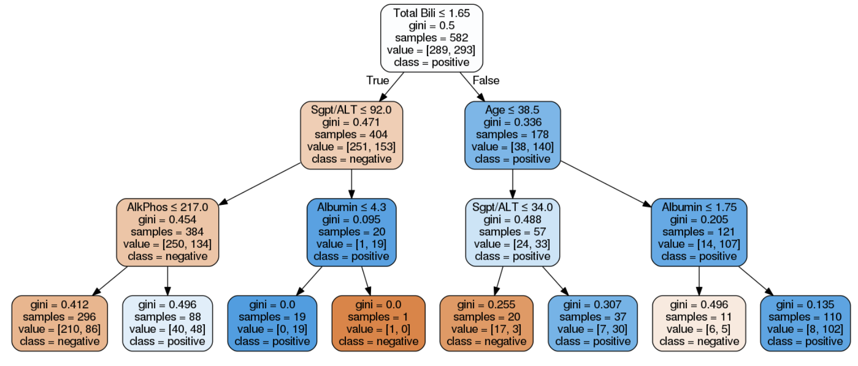

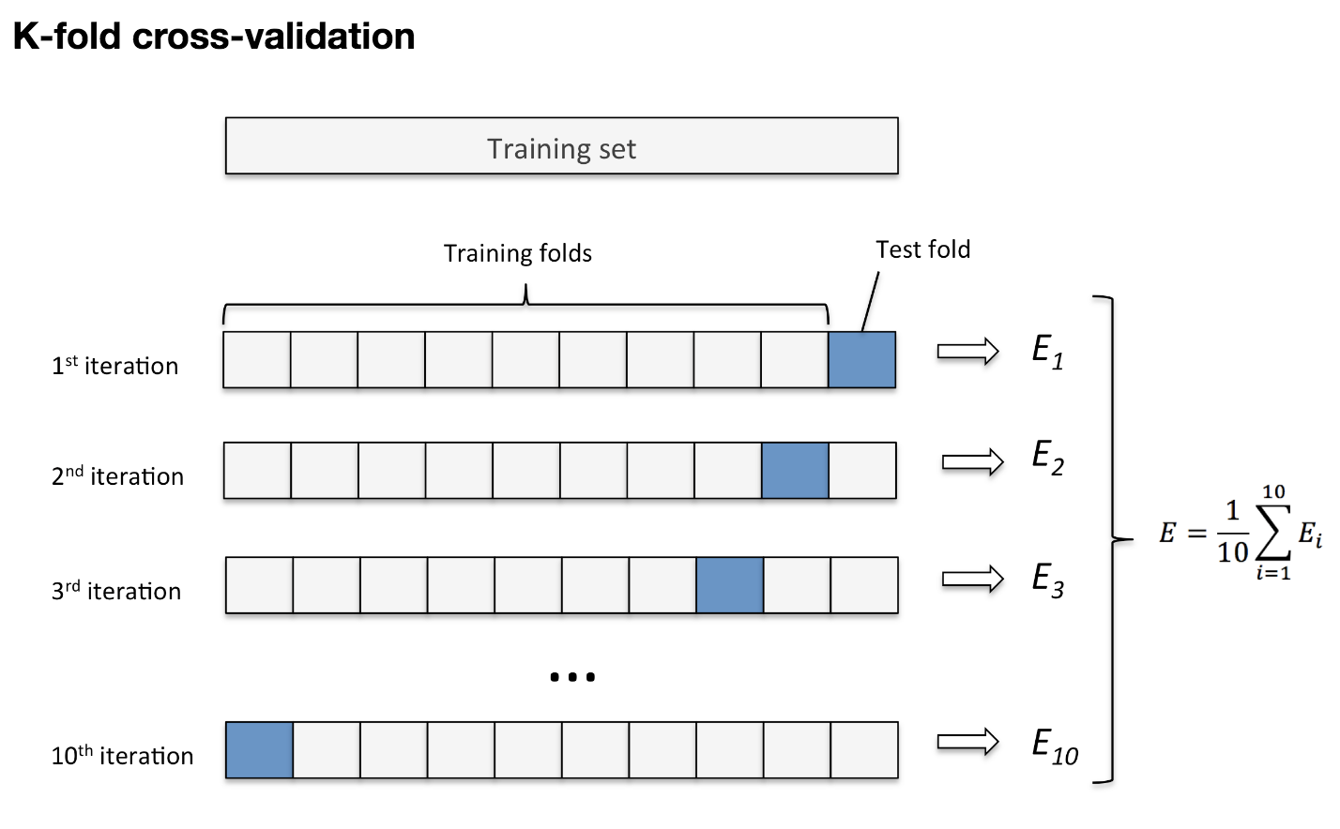

**3. Results**

**3.1 Optimal Hyper-Parameters**

Grid search was performed on pipelines for both SVM and DT, yielding the optimal hyper-parameters as seen in table X. The grid search was performed to optimise both accuracy and area under the curve (AUC) – metrics that will be discussed later.

For SVM, the optimal C-parameter was always small (1.0 or 10.0), creating a softer margin that is less sensitive to noise. The optimal kernel was ‘rbf’ which stands for radial basis function, a non-linear transformation function, indicating the non-linear nature of the dataset.

|  |  |
| --- | --- |
| **Model** | **Optimal Hyper-Parameters** |
| SVM, 10-fold CV, 2 principal components, standard scaler | C: 1.0, gamma: 1000.0, kernel: 'rbf' - based on accuracy |
| SVM, 10-fold CV, 2 principal components, standard scaler | C: 10.0, gamma: 1000.0, kernel: 'rbf' - based on AUC |
| DT, 10-fold CV, 2 principal components, standard scaler | criterion: ‘gini’, max_depth: 9, min_samples_split: 4 - based on accuracy |
| DT, 10-fold CV, 2 principal components, standard scaler | criterion: ‘gini’, max_depth: 9, min_samples_split: 4 - based on AUC |

For DT, the optimal criterion was gini, meaning the nodes will be split to minimise the gini impurity index, and the tree should be grown to a max-depth of 9 with 4 samples needed at each node for a split.

**3.2 Learning Curves; Bias and Variance**

Learning curves are graphs that plot model performance on training and testing data against varying numbers of training instances. It allows training and testing performance to be viewed separate from each other to get an idea for how well the model can generalise to new data.

Learning curves allow us to diagnose bias and variance issues. High bias is when training and testing errors are high and converge, resulting in poor generalisation. High variance is when there is a large gap between the errors. It could indicate there is not enough data or the model is too complex with too many features[refF].

As can be seen in figure X, for SVM – with 2 principal components the training line (blue) is at its maximum regardless of training examples showing severe overfitting. Testing score (green) increases over time and there is a large gap between the scores indicating high variance. Reducing the complexity of the model (to 1 principal component) can be seen to reduce the variance with a trade-off that bias is increased (accuracy reduces). Variance can also be seen to reduce for DT learning curve when going from 10 principal components and 10 features to 2 components and 6 features. Collection of more data will likely improve the variance of the models.

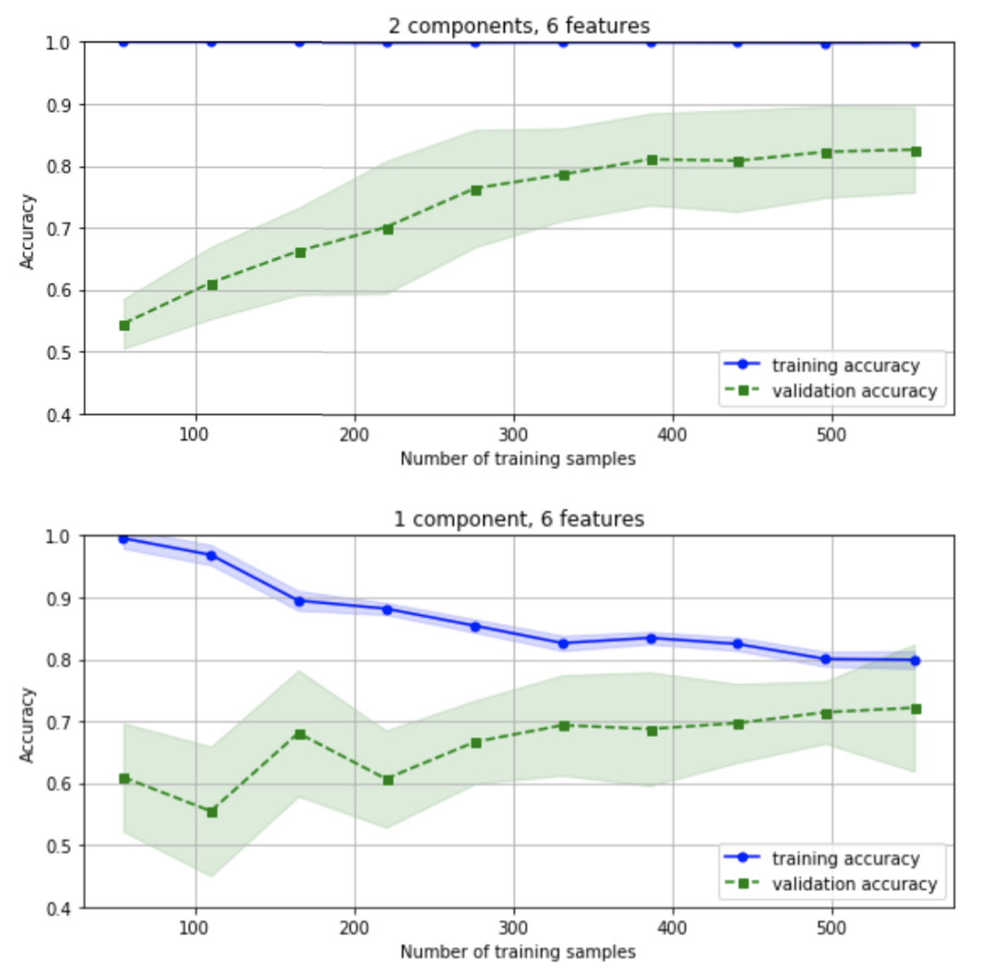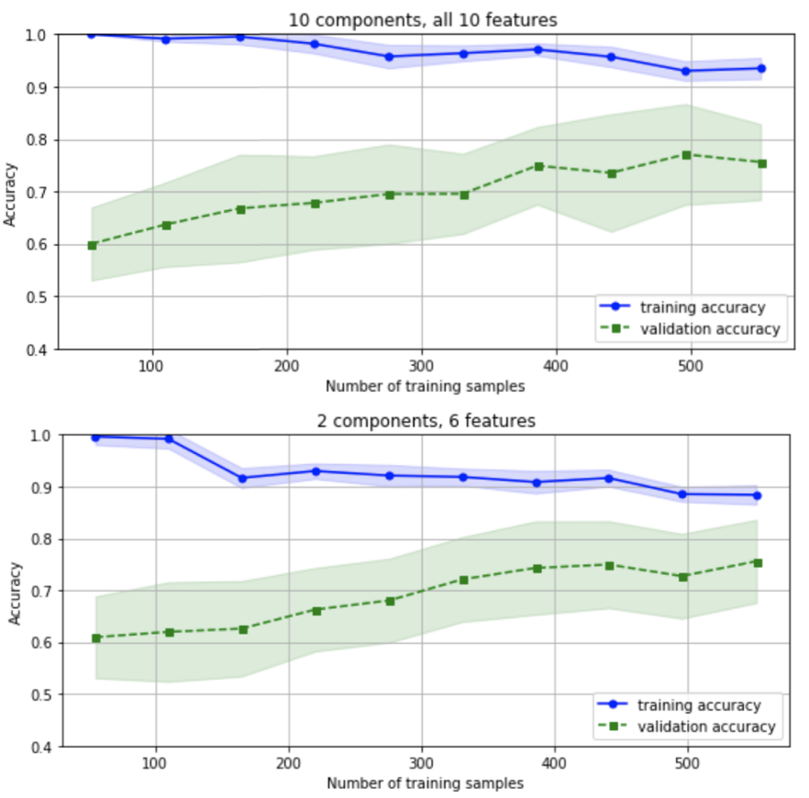

**3.3 Model Performance**

As a simple measure of performance, classification accuracy was used throughout to allow quick comparison between pipelines. This is a ratio of the number of correct predictions out of all predictions that were made. However, accuracy can be misleading, particularly on imbalanced data and it is important to look at a range of performance metrics.

A confusion matrix provides a summary of all of the predictions made compared to the expected actual values. A perfect set of predictions is shown as a diagonal line from the top left to the bottom right of the matrix. Confusion matrices for all 3 classifiers are showin in figure X.

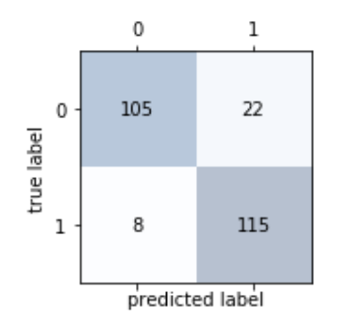 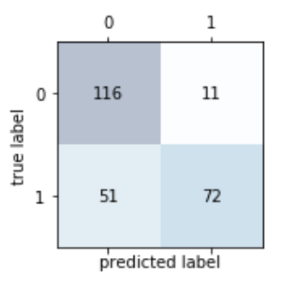 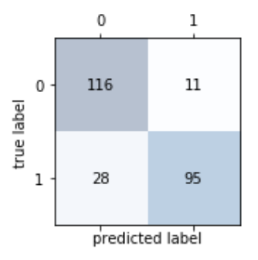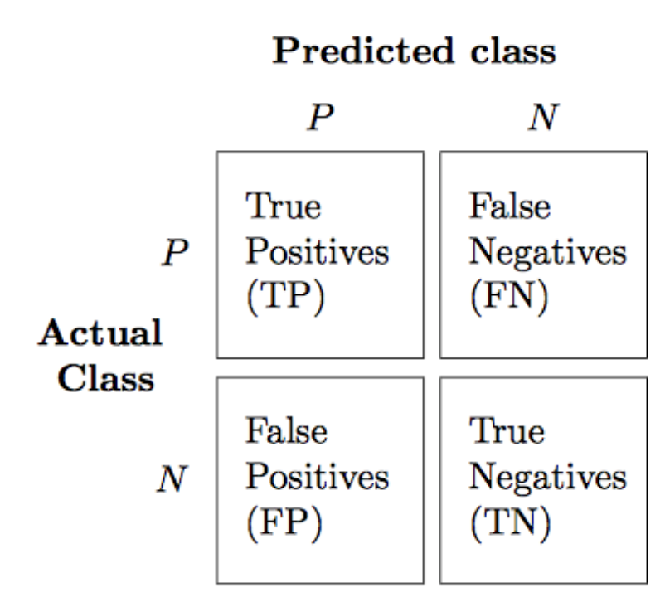

As we can see, SVM produces the ‘best’ confusion matrix with the most number of TP and TN results identified. DT has a high FP rate, and consequently a lower TN rate. These figures were used to calculate a range of performance metrics shown below.

Overall, SVM performs the best for all metrics except PPV and NPV, for which GTB performs slightly better. SVM has a high sensitivity (ability correctly classify as ′disease′) and high specificity (ability to correctly classify as ‘disease- free’).

DT performs the worst for all metrics except NPV. It has a particularly low specificity – as expected from the high number of false positives.

*Accuracy = (TP +TN) / (TP + FP + FN +TN)*

*Specificity (true negative rate) = TN / TN + FP*

*Sensitivity / recall (true positive rate) = TP / (TP + FN)*

*Positive Predictive Value (Precision) = TP / (TP+FP)*

*Negative Predictive Value (NPV) = TN / TN + FN*

*F1 = 2*(precision *recall) / (precision + recall)*

|  |  |  |  |  |  |  |
| --- | --- | --- | --- | --- | --- | --- |
| **Model** | **Accuracy** | **Specificity** | **Sensitivity (recall)** | **PPV (precision)** | **NPV** | **F1** |
| SVC | 0.88 | 0.93 | 0.88 | 0.89 | 0.83 | 0.88 |
| DT | 0.75 | 0.58 | 0.75 | 0.78 | 0.86 | 0.74 |
| GTB | 0.84 | 0.77 | 0.84 | 0.85 | 0.89 | 0.84 |

|  |  |  |  |  |
| --- | --- | --- | --- | --- |
| Model | Area Under Curve (AUC) | | | |
| Support Vector Machine | RBF | Linear | Sigmoid | Polynomial |
| 0.83 | 0.76 | 0.64 | 0.77 |
| Decision Tree | Gini, depth=9 | Entropy, depth=9 | Gini, depth=6 | Entropy, depth=6 |
| 0.85 | 0.85 | 0.78 | 0.77 |
| Gradient Tree  Boosting | n_estimators=100, learning_rate=0.5, max_depth=6 | | | |
| 0.95 | | | |

**3.4 Receiving Operation Characteristic (ROC) and Area Under Curve (AUC)**

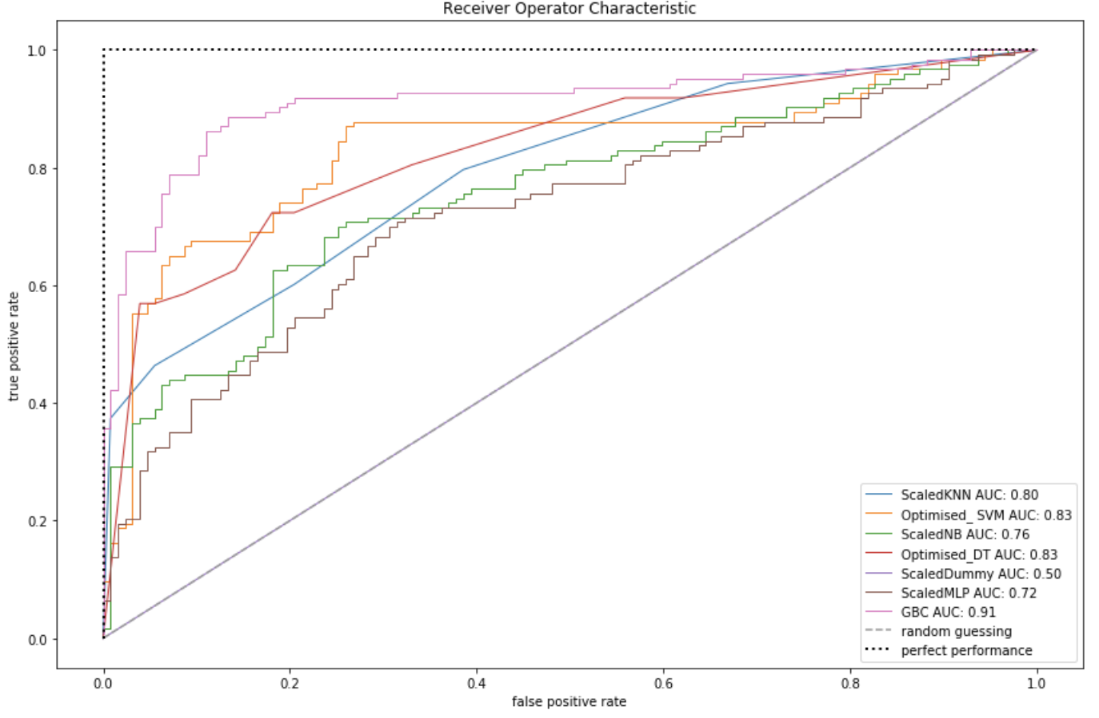AUC was calculated for each classifier and used to plot the ROC curve seen in Figure X. AUC is used to compare the discriminatory powers of the models based on predicted outcome vs true outcome. In Figure X, a perfect classifier, dummy classifier and some un-tuned classifiers are plotted alongside SVM, DT and GTB.

A table comparing AUC for SVM, DT and GTB with different hyper-parameters is shown below. All 3 classifiers have a high AUC, indicating good predictive power of the models. The best AUC for each model is seen with the optimised hyper-parameters discussed in section 3.1. GTB with n-estimators=100 produces the best AUC - 0.95.

It is noted that AUC for DT is high despite its poor specificity and lower accuracy score. Accuracy and other metrics above are computed at single threshold values (default=0.5). While AUC is computed by averaging expected values across all threshold values [refH], which could explain this discrepancy. It also highlights the importance of using a range of model evaluation techniques.

**4. Discussion and Conclusion**

**4.1 Comparison of results with other studies on ILPD**

The results of this study have found GTB to be the best performing classifier when looking at AUC. SVM showed the highest specificity and sensitivity. While DT performed better than naïve algorithms, it’s specificity was low. The algorithms generalised best with a reduced model complexity and feature selection applied.

Bendi Venkata Ramana et al[refG] analysed several classifiers on the ILPD and found SVM to have the best precision, in keeping with my results. In contrast, however, they found the accuracy improved with the addition of new attributes – but they did not comment on other evaluation metrics.

Anju Gulia et al.[refI] found SVM algorithm to be the most accurate before applying feature selection (accuracy: 71.3551%). But, Random Forest algorithm was optimal with the help of feature selection (accuracy: 71.8696%). My accuracies for SVM are higher which could be explained by hyper-parameter tuning, which they do not discuss.

Jankisharan Pahariya et al.[refJ] also found Random Forest with over sampling 200% outperformed all the other techniques.

The success random forests (an ensemble tree classifier) in 2 other papers, is in keeping with my finding that GTB performs the best on this dataset. Ensemble (boosting) tree techniques are widely found to be powerful off the shelf classifiers[refK]

**4.2 Proposals for improving methodology**

This was a simple, focused study into tuning of two machine learning algorithms for liver disease classification. With more time, I would expand the study and improve the methodology with the following considerations:

• **Under Sampling:** Oversampling was used due to the low sample size. However, under sampling of the liver disease group or a mixture of over and under sampling could be assessed.

• **Optimisation of naïve models:** During model evaluation, on scaled data, simple algorithms (K-nearest neighbours and naïve bayes) showed accuracy ranges similar to that of SVM. It would be interesting to see the effect of optimising these simple algorithms for comparison.

• **Reduce variance:** Collecting more data or combining with other datasets could help reduce variance and improve robustness of the models.

**• Analyse varying cut-off values for evaluation metrics:** As discussed in the results, the AUC gives a different picture to some of the other evaluation metrics – most likely due to being an average over different threshold (cutoff) values. Looking into varying this threshold to optimise other metrics such as sensitivity and specificity could be assessed and thresholds could be tuned to match objectives of a screening tool for liver disease.

**4.3 Potential usage of ILPD classification algorithms in healthcare**

As discussed in the introduction, the benefit of developing a liver disease classifier lies in being able to detect liver disease onset at an earlier stage. The classifier could be used as a screening tool by primary care doctors to refer for further testing e.g. an automated web-based risk calculator. Clinicians often use simplified visual versions of decision trees to analyse blood test results. The DT classifier could help to tune these visual tools.

However, the ILPD data is very limited in its usefulness to produce clinical classification tools due to the lack of associated metadata about the patients. ‘Liver disease’ encompasses a wide range of conditions of differing aetiologies, requiring different screening methods and management. There is no information about the type of liver disease in the ILPD and the large age range indicates the dataset likely includes many forms of liver disease. This produces a ‘black box’ situation often talked about in machine learning; where our algorithm may be classifying well but we are unable to use the information to make informed decisions on management. Classification studies focused on particular categories of liver disease would be a more useful approach in future.

Refs

Ref1 – diabetes paper

Ref2 – svm ref in diabetes paper

Ref3 - Gamma svms - <https://stackoverflow.com/questions/35848210/support-vector-machine-what-are-c-gamma>

Ref 4- <https://github.com/EpistasisLab/tpot>

Ref5 - <https://www.analyticsvidhya.com/blog/2015/11/quick-introduction-boosting-algorithms-machine-learning/>

Refa – uci machine learning repo

Refb - <https://www.aafp.org/afp/1999/0415/p2223.html>

Ref c - - <https://www.ncbi.nlm.nih.gov/pmc/articles/PMC545762/>

Ref d -  <http://scikit-learn.org/stable/modules/generated/sklearn.preprocessing.QuantileTransformer.html>

RefE - ref - <https://www.analyticsvidhya.com/blog/2017/03/imbalanced-classification-problem/>

Ref F - <http://www.ritchieng.com/machinelearning-learning-curve/>

Ref H - https://stats.stackexchange.com/questions/90659/why-is-auc-higher-for-a-classifier-that-is-less-accurate-than-for-one-that-is-mo