Carolyn Chen

CSC 642

Assignment3

Prototyping tool: Justinmind

Home Page

* 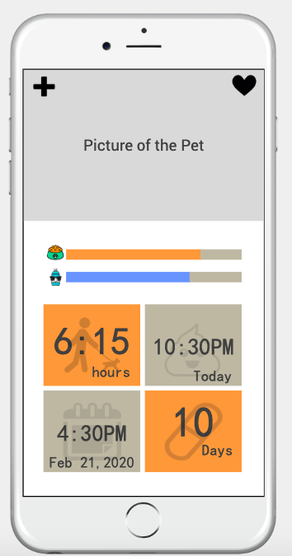This is the page user will see after they open the app.
* User can upload their pet’s picture.
* The + is for adding another pet. User can swap left and right to check on different pets if they have more than 1.
* The Heart is link to Health Page
* The orange bar show food level. User can click to update
* The blue bar show water level. User can click to update
* Top left orange box is showing how long your pet did not go out. User can click to update
* Top right gray box is showing the last time their pet poop. User can click to update
* Bottom left gray box is showing the next appointment. User can click to update
* Bottom right orange box is showing when is the next time your pets need medicines. User can click to update
* User can hold the image area to enter the Profile page.

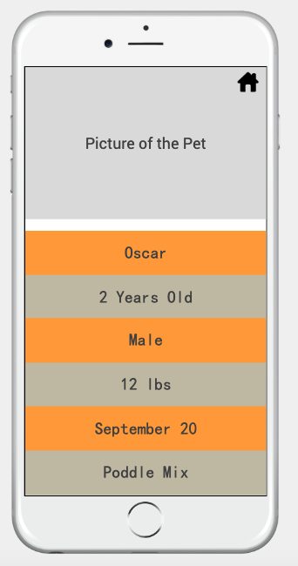Profile Page

* User can upload their pet’s picture.
* Home button for back to home page
* User can input pet’s information: name, age, gender, weight, birthday and breeds.
* Click on the area to change information.
* Those information will also help develop the health page.

Health Page

* 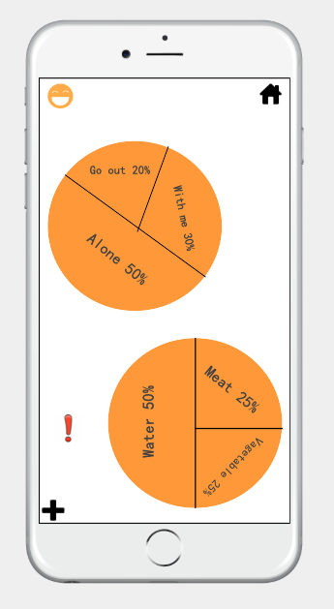A page to show the healthy information of the pet.
* Home button for back to home page
* The smile face is a timer start button. Counting how long the pet is alone at home
* First graph showing the percent of your pet staying alone, go out or with you at home.
* second graph showing the percent of your pets diet.
* Will have a red ! next to the graph if the pet need something like go out or more vegetable.
* User can use + to add a new kind of food you pet ate.

Appointment Page

* 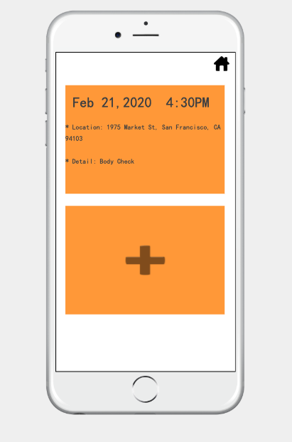This page is showing all appointments.
* User can click on the + to add another appointment
* User can click on the appointment to edit
* Home button for back to home page

Medicines Page

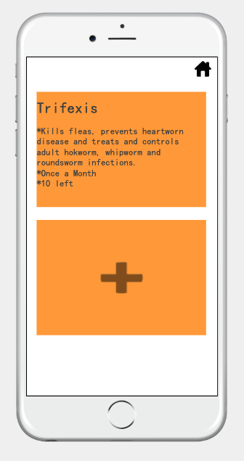

* This page is showing all medicines your pet is using.
* User can click on the + to add another appointment
* User can click on the appointment to edit
* Home button for back to home page