Downtown Walking Map

**To**

**I-35W**

**To121/ DFW**

**Airport**

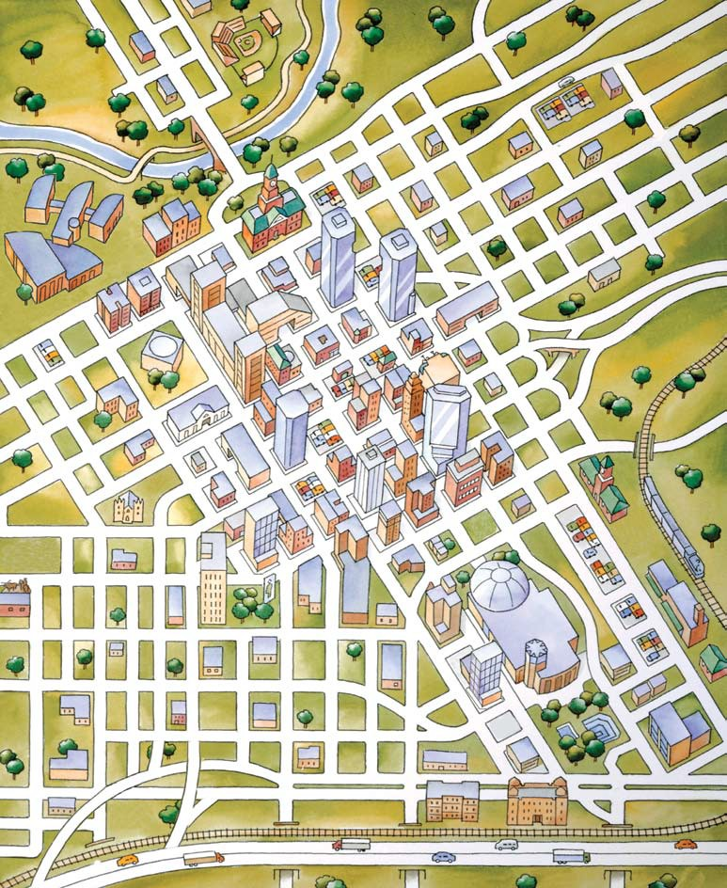

**17**

**1**

**26**

**MC**

**23**

**11**

**21**

**B 22**

**To**

**I-35W**

**To I-30**

**To**

# 287

**9**

**4**

**18**

**280**

**24**

*i*

**13 8**

**3**

**7**

**2**

**B**

**20 15**

**16**

**B B B**

**B 14**

**5th**

# To Cultural District

# 7th

**B B**

**10 B 19**

**MC**

**12**

# 10th B

**6**

**28**

# Texas

**Jennings**

**Taylor**

**Cherry St.**

**Macon**➤

**Florence St.**

**Henderson**

➤

**13th**

**Lamar**

**Burnett**

**30 I-30**

**To**

# To Cultural District

# Lancaster

**5 29**

**25**

Copyright © Fort Worth Convention & Visitors Bureau ★ 02-07

# Lancaster

From I-30, exit Lancaster (westbound) to Commerce to Downtown

**27**

**I-30**

From I-30,

exit Cherry / Lancaster (eastbound) or

Summit (westbound) to Downtown

**To**

**I-35W**

## Airporter Park & Ride

**1**

1000 E. Weatherford ★ 817.334.0092

## The Ashton Hotel

**2**

610 Main St. ★ 817.332.0100

## Chase Bank

**3**

420 Throckmorton ★ 817.884.4105

## Bass Performance Hall

**4**

4th & Calhoun St. ★ 817.212.4280

## Water Gardens

**5**

1502 Commerce St. ★ 817.392.MEET (6338)

## City Hall

**6**

1000 Throckmorton ★ 817.392.2255

## Courtyard by Marriott - Blackstone

**7**

601 Main St. ★ 817.885.8700

## Embassy Suites Hotel

**8**

600 Commerce St. ★ 817.332.6900

## Etta’s Place

200 W. 3rd St. ★ 817.255.5760

**9**

## Federal Building

**10**

10th & Taylor ★ 800.688.9889

## Fire Station No. 1 - 150 Years Exhibit

**11**

2nd & Commerce ★ 817.255.9300

## Fort Worth Convention Center

**12**

1201 Houston St. ★ 817.392.MEET(6338)

## Fort Worth Public Library

**13**

500 W. 3rd St. ★ 817.871.7701

## General Worth Square

**14**

8th & Main St.

## Greyhound Bus Terminal

**15**

9th & Jones ★ 817.429.3089

## Intermodal Transportation Center

**16**

9th & Jones ★ 817.215.8600

**17**

**18**

**19**

**20**

**21**

**22**

**23**

**24**

## LaGrave Field - Fort Worth Cats

301 N.E. 6th St. ★ 817.226.2287

## Maddox-Muse Center

301 E. 5th St. ★ 817.212.4280

## Park Central Hotel

1010 Houston St. ★ 817.336.2011

## Hilton Fort Worth

815 Main St. ★ 817.870.2100

## Renaissance Worthington Hotel

200 Main St. ★ 817.870.1000

## Sid Richardson Museum

309 Main St. ★ 817.332.6554

## StoreOne - RadioShack

400 W. Belknap St. ★ 817.415.0001

## Sundance Square

817.255.5700

**25**

**26**

**27**

**28**

**29**

**30**

## Tarrant County College

1500 Houston St. ★ 817.515.5100

## Tarrant County Courthouse

100 W. Weatherford St. ★ 817.884.1111

## T&P Building

1600 Throckmorton ★ 817.215.8613

## Omni Fort Worth Hotel

1300 Houston St ★ 817.336.8791

Opening January 2009

## Sheraton Fort Worth Hotel and Spa

1701 Commerce St. ★ 817.335.7000

Opening July 2008

**Holiday Inn Select - Downtown Fort Worth**

1111 W. Lancaster ★ 817.338.0215

Opening August 2008



[**WWW.FORTWORTH.COM**](http://WWW.FORTWORTH.COM/)

*i* Downtown / Sundance Square Visitors Information Center 415 Throckmorton 800.433.5747 ✦ 817.336.8791

**B The “T” Bus Stop**

**Motorcoach Parking**

**Attraction**

**Hotel**

**Heritage Trails**

**MC**