Report

**Project name: MyGymClub**

**Team members: 19829047_李莉Lily, 16301144_朱诺仪**

**Technical features:**

**The first page –Old users can login immediately, but if you are a new user, you should sign up fisrt.**



When you click ‘LOGIN’button, jump to ‘login_page’

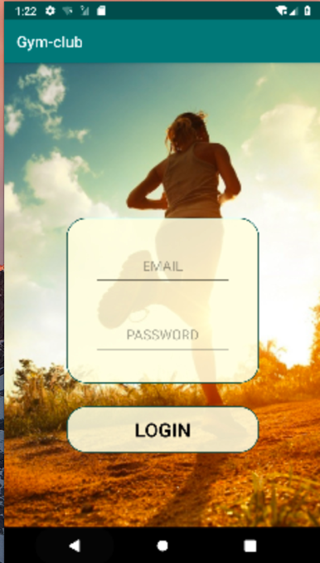

When you click ‘SIGN UP’button, jump to ‘sign_page’

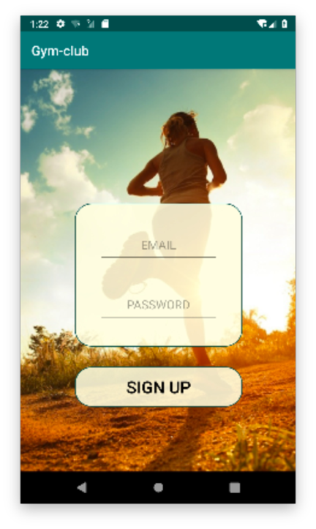

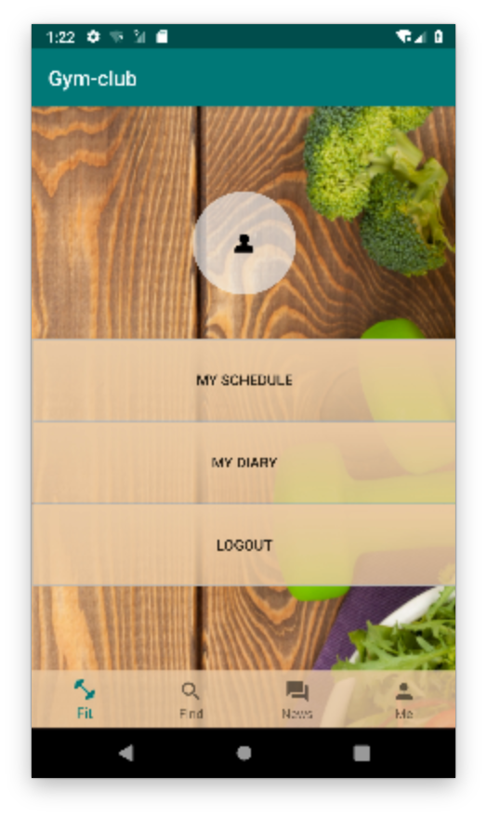

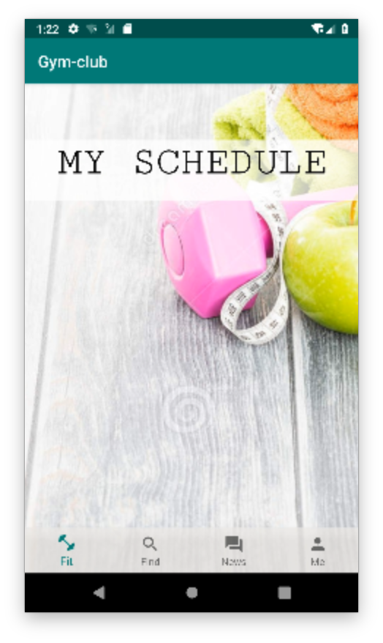

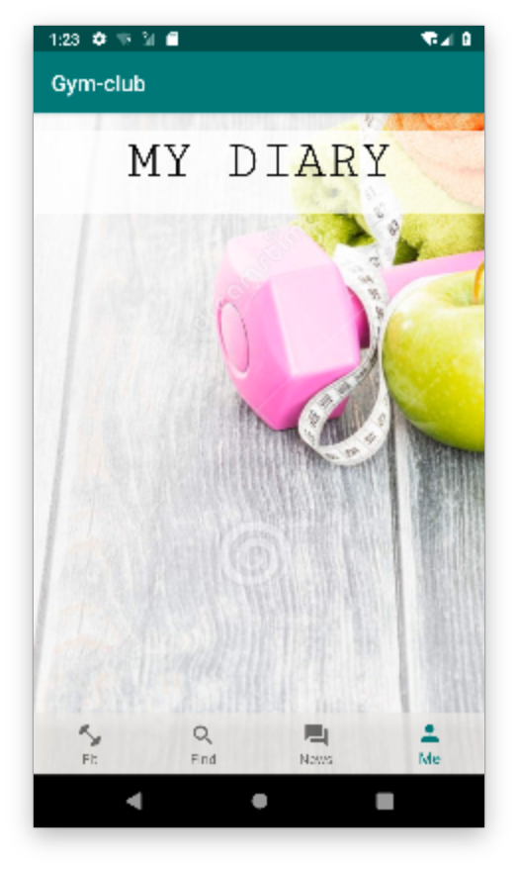

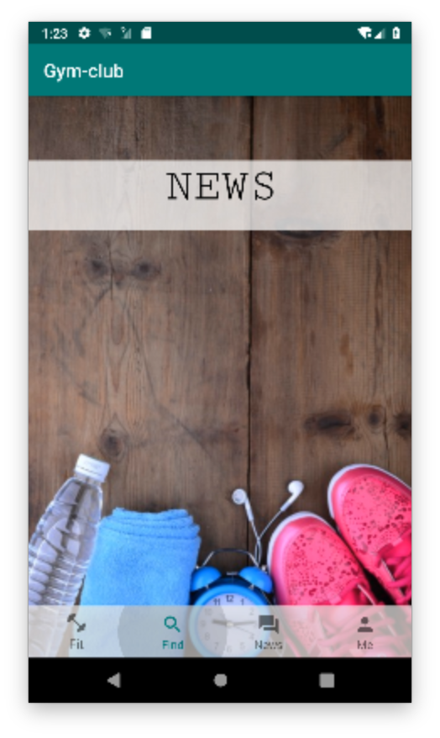

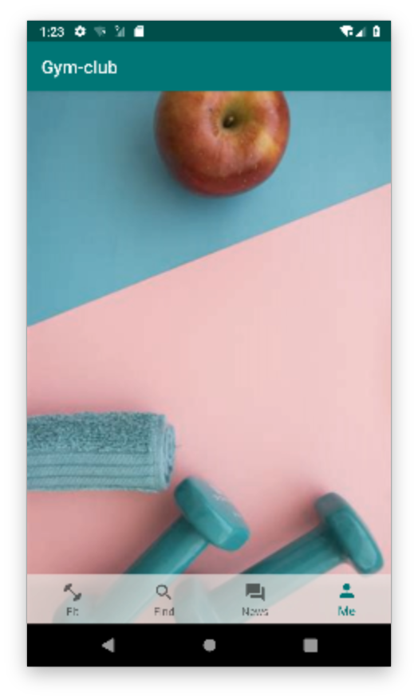

The layout is not fully implemented as the news activity, diary activity and schedule activity requires actual input from the user. That will be implemented in later versions.

When click ‘LOGIN’’SIGN UP’ buttons, them will change colors. When users turn back to the first page, the button will change back into original colors.