1
After troubleshooting a router, the network administrator wants to save the router configuration so that it will be used automatically the next time that the router reboots. What command should be issued?
copy startup-config flash
copy running-config flash
reload
copy startup-config running-config
copy running-config startup-config*
2
Which IPv4 header field is responsible for defining the priority of the packet?​
traffic class
flow label
flags
differentiated services*
3
When connectionless protocols are implemented at the lower layers of the OSI model, what are usually used to acknowledge the data receipt and request the retransmission of missing data?
Transport layer UDP protocols
upper-layer connection-oriented protocols*
connectionless acknowledgements
Network layer IP protocols
4
Why is NAT not needed in IPv6?​
Any host or user can get a public IPv6 network address because the number of available IPv6 addresses is extremely large.​*
The end-to-end connectivity problems that are caused by NAT are solved because the number of routes increases with the number of nodes that are connected to the Internet.
Because IPv6 has integrated security, there is no need to hide the IPv6 addresses of internal networks.​
The problems that are induced by NAT applications are solved because the IPv6 header improves packet handling by intermediate routers.​
5
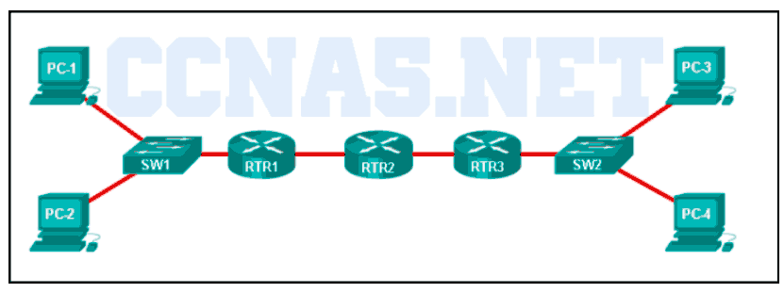
Refer to the exhibit. Fill in the blank.
A packet leaving PC-1 has to traverse “three” hops to reach PC-4.​
6
Which two interfaces will allow access via the VTY lines to configure the router? (Choose two.)
console interfaces
USB interfaces
WAN interfaces*
LAN interfaces*
aux interfaces
7
A technician is manually configuring a computer with the necessary IP parameters to communicate over the corporate network. The computer already has an IP address, a subnet mask, and a DNS server. What else has to be configured for Internet access?
the default gateway address*
the MAC address
the domain name of the organization
the WINS server address
8
Which three commands are used to set up a password for a person who attaches a cable to a new router so that an initial configuration can be performed? (Choose three.)
password cisco *
line vty 0 4
line console 0 *
interface fastethernet 0/0
enable secret cisco
login *
9
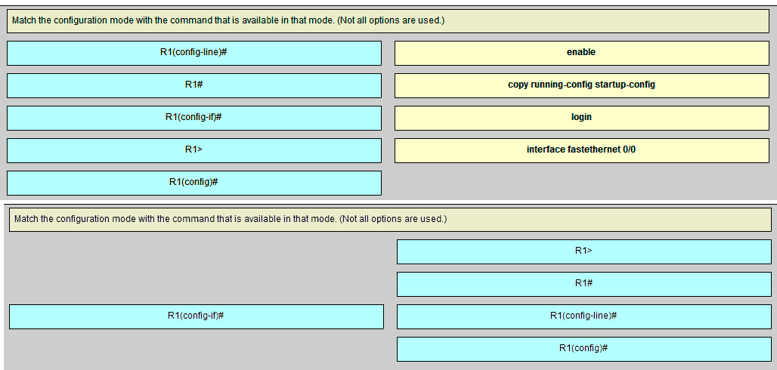
10
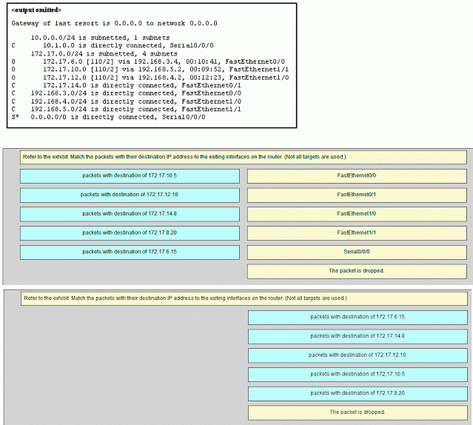
11
Which statement about router interfaces is true?
Commands that apply an IP address and subnet mask to an interface are entered in global configuration mode.
Once the no shutdown command is given, a router interface is active and operational.
Router LAN interfaces are not activated by default, but router WAN interfaces are.
A configured and activated router interface must be connected to another device in order to operate.*
12
A technician is configuring a router that is actively running on the network. Suddenly, power to the router is lost. If the technician has not saved the configuration, which two types of information will be lost? (Choose two.)
routing table*
ARP cache*
Cisco IOS image file
startup configuration
bootstrap file
13
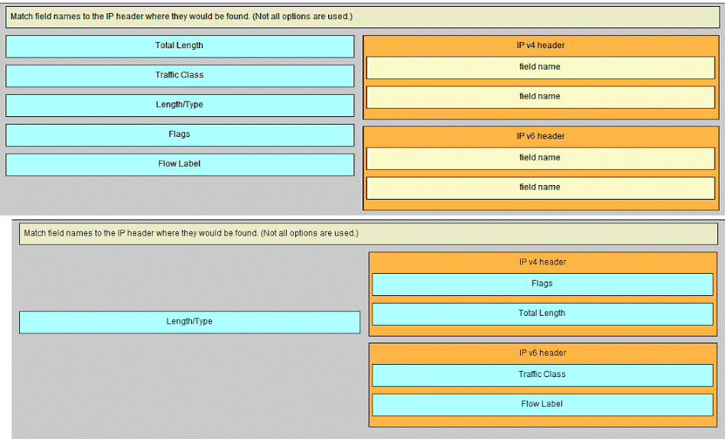
14
How do hosts ensure that their packets are directed to the correct network destination?
They always direct their packets to the default gateway, which will be responsible for the packet delivery.
They send a query packet to the default gateway asking for the best route.
They search in their own local routing table for a route to the network destination address and pass this information to the default gateway.
They have to keep their own local routing table that contains a route to the loopback interface, a local network route, and a remote default route.​*
15
What is a service provided by the Flow Label field of the IPv6 header?
It identifies the total length of the IPv6 packet.
It limits the lifetime of a packet.
It informs network devices to maintain the same path for real-time application packets.*
It classifies packets for traffic congestion control.
16
During the process of forwarding traffic, what will the router do immediately after matching the destination IP address to a network on a directly connected routing table entry?
look up the next-hop address for the packet
discard the traffic after consulting the route table
switch the packet to the directly connected interface*
analyze the destination IP address
17
Fill in the blank.
In a router, “ROM ” is the nonvolatile memory where the diagnostic software, the bootup instructions, and a limited IOS are stored.
18
Which two commands can be used on a Windows host to display the routing table? (Choose two.)
netstat -s
route print*
netstat -r*
tracert
show ip route
19
A computer has to send a packet to a destination host in the same LAN. How will the packet be sent?
The packet will be sent directly to the destination host.*
The packet will be sent only to the default gateway.
The packet will be sent to the default gateway first, and then, depending on the response from the gateway, it may be sent to the destination host.
The packet will first be sent to the default gateway, and then from the default gateway it will be sent directly to the destination host.
20
Which command displays a summary chart of all router interfaces, their IP addresses, and their current operational status?
show interfaces
show version
show ip route
show ip interface brief *
21
Which two files, if found, are copied into RAM as a router with the default configuration register setting boots up? (Choose two.)
POST diagnostics
running configuration
startup configuration*
IOS image file*
22
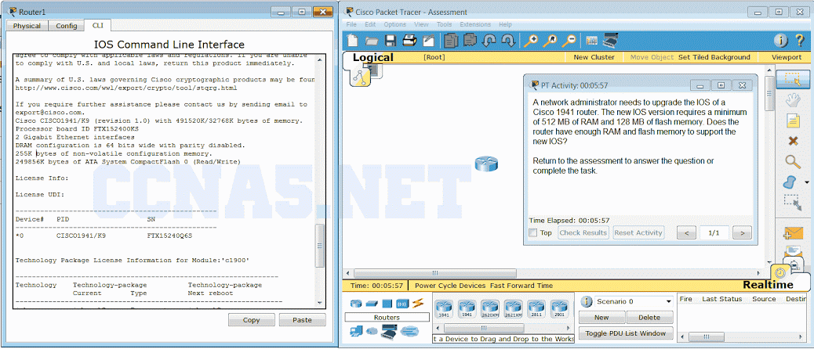
Open the PT Activity. Perform the tasks in the activity instructions and then answer the question or complete the task.
Does the router have enough RAM and flash memory to support the new IOS?
The router needs more RAM and more flash memory for the IOS upgrade.
The router has enough RAM, but needs more flash memory for the IOS upgrade.
The router has enough RAM and flash memory for the IOS upgrade.*
The router has enough flash memory, but needs more RAM for the IOS upgrade.
23
When would the Cisco IOS image held in ROM be used to boot the router?
when the running configuration directs the router to do this
during a normal boot process
when the full IOS cannot be found*
during a file transfer operation
24 Which type of static route that is configured on a router uses only the exit interface?
fully specified static route
default static route
directly connected static route*
recursive static route

