Joseph Carpenter

My pacman version differs a but from the original game. I decided to make a turn based version where the pacman go move one space up down left or right, and the enemy moves similar to the horse in chess. There is one coin on screen at a time and the player must maneuver smartly to get it.

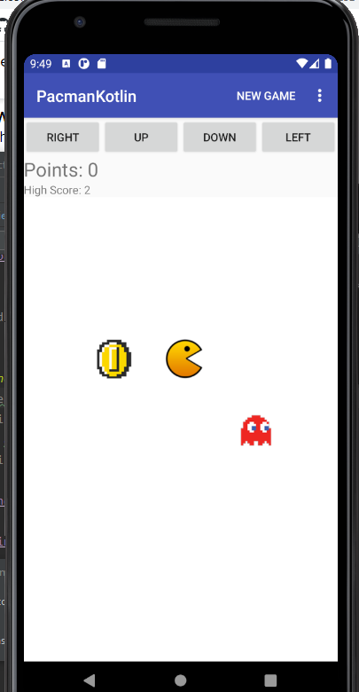

My app has 3 basic types that all inherent from the gameobject interface. The gameobject interface contains x y coordinates aswell as a moveTo function that will move the object to the coordinates specified, there is also canvasposx and y functions that will convert the x, y game coordinates to canvas coordinates.

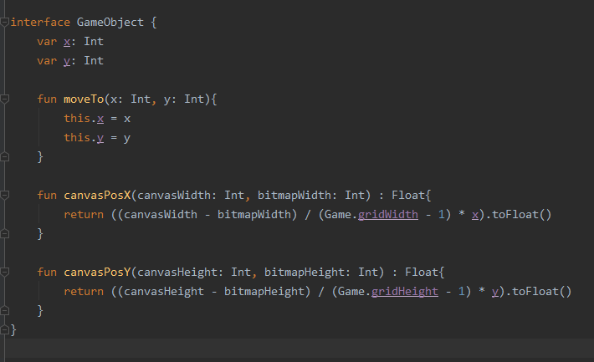

Pacman inherits from this, but also has the move function which takes in the change of x and y, then applies them, while restricting the movement to be within the game board.

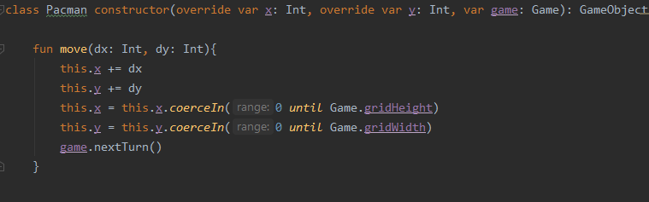

The same with enemy, however this time it includes logic on where to move and then applies it.

I decided to use some randomness to make the game more forgiving, as it is right now, if you move to where the enemy can get you there is a 50% chance they take the right move.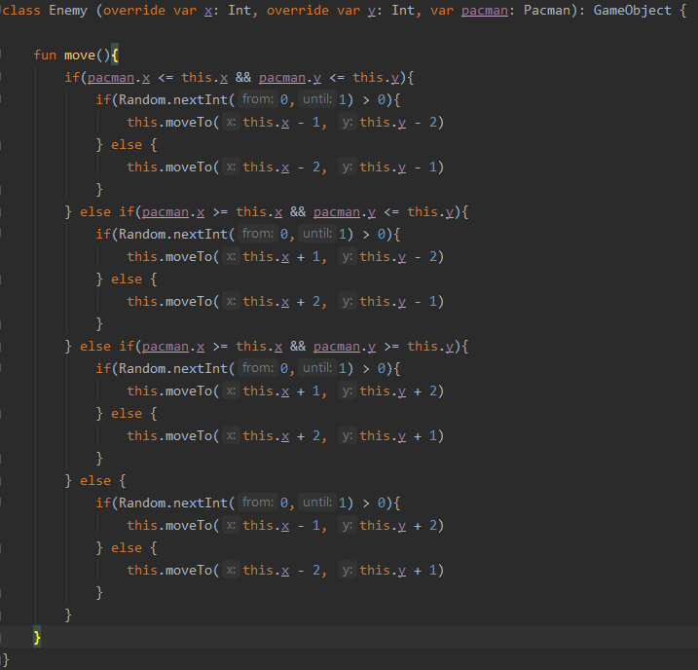

Gold coin is rather simple, it only has the function to move it to a new random position on the board, which is called in the game object.

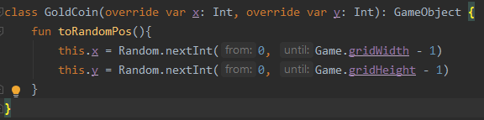

The game object is where most of the logic happens, it contains info about the game board, the enemy, coin and pacman objects, aswell as the functions to check for collision, game over, new game, and next turn. During init the bitmaps for each object are loaded, and all the objects are set to their positions. I also used a companion object to reference the board width and height in other objects.

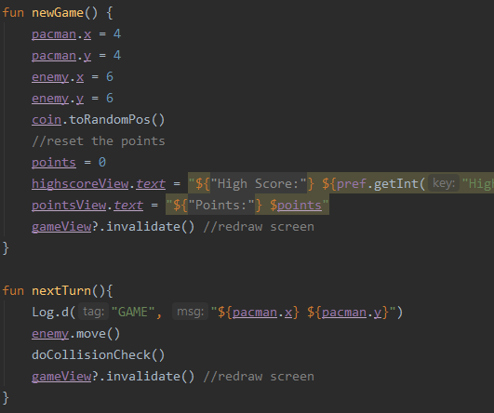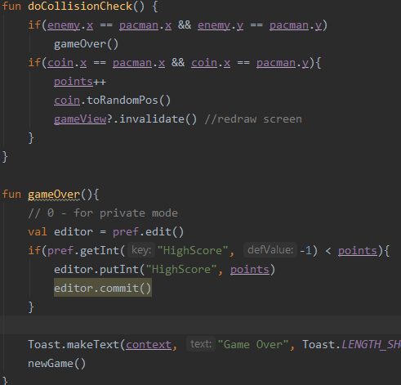

In the game object is also where i use the stored preferences to save the high score. To use shared preferences, you need a sharedpreferences variables, which i define on line 20. I then reference that to see if there is already a high score and what it is, and if the current games score is larger than high score, it it saved to the preference, and the commited.

To test my project, I used the emulator on my computer (which runs very slowly and eats up tons of ram). I built and tested my project for api 26, and I never ran into any problems. Me and my girlfriend tested the app out and we ran into a few problems which I never got around to solving. The enemy is able to go out of bounds due to the logic behind its move, which can cause it to not be seen by the user and unable to tell where to go and not lose. Another problem I ran into was the coin not appearing where it needs to when the player collects it, right now it stays where it was until pacman moves again. The ability to pause was not implemented because it is a turn based game and to pause you just don’t press any buttons.