**ENSF-381**: **Full Stack Web Development Laboratory**

**Lab03**

**Section:**

**Group information:**

Name 1 David Ibrahim (UCID#30207941)

Name 2 Mykola Viktorovskyi (UCID#30233216)

**GitHub Link:** <https://github.com/CarpetToaster/ENSF381lab3.git>

**Exercise 1 Output:**

**Exercise 2 Output:**

Base layout



Flex-direction:column



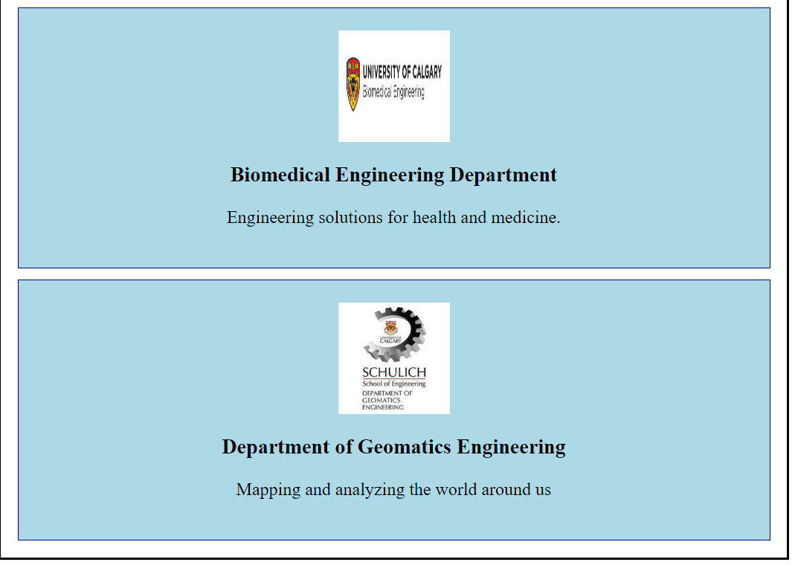

Flex-direction:row-reverse;

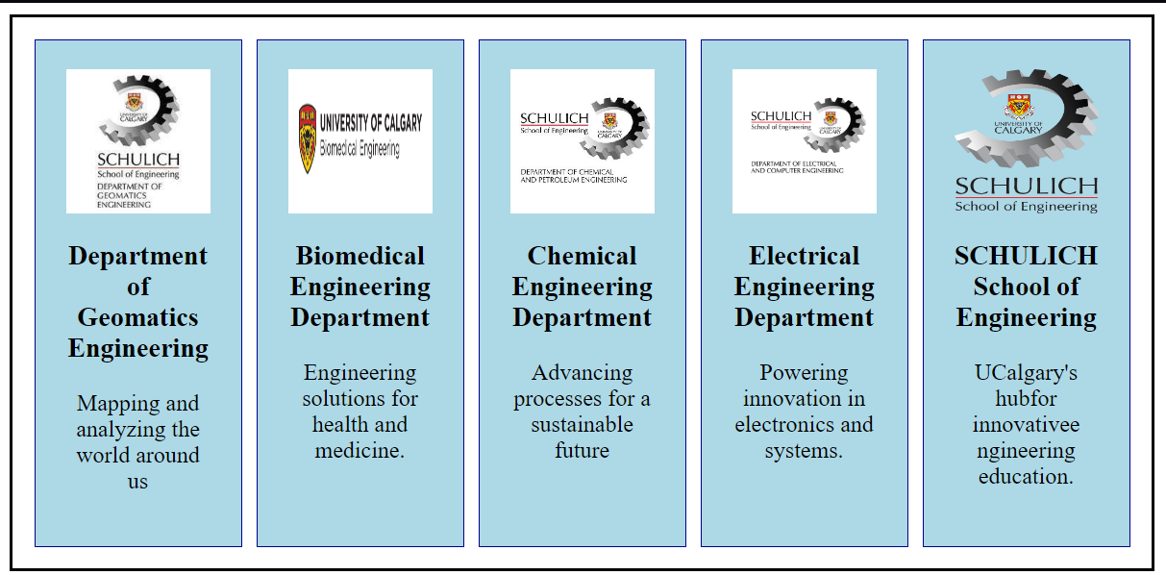

Flex-direction:column-reverse

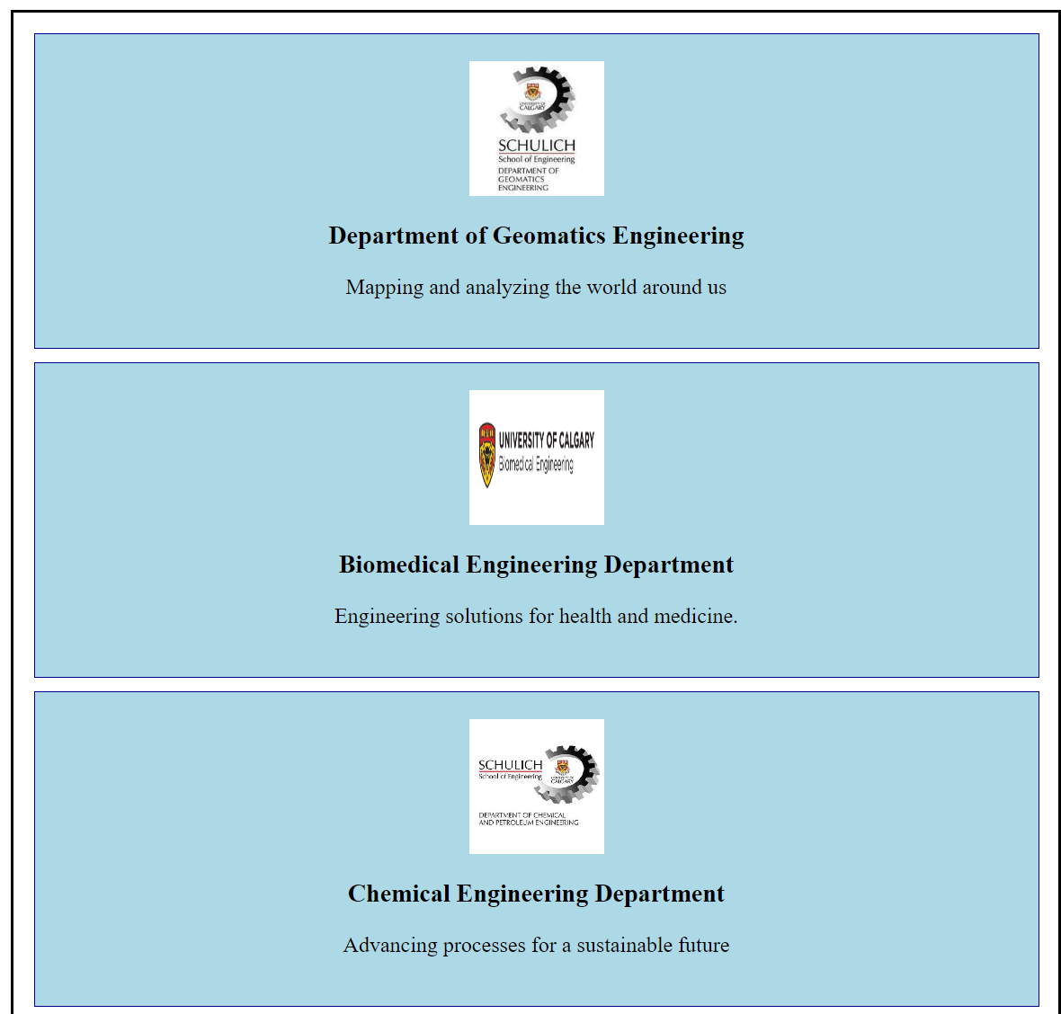



Flex-wrap:wrap;

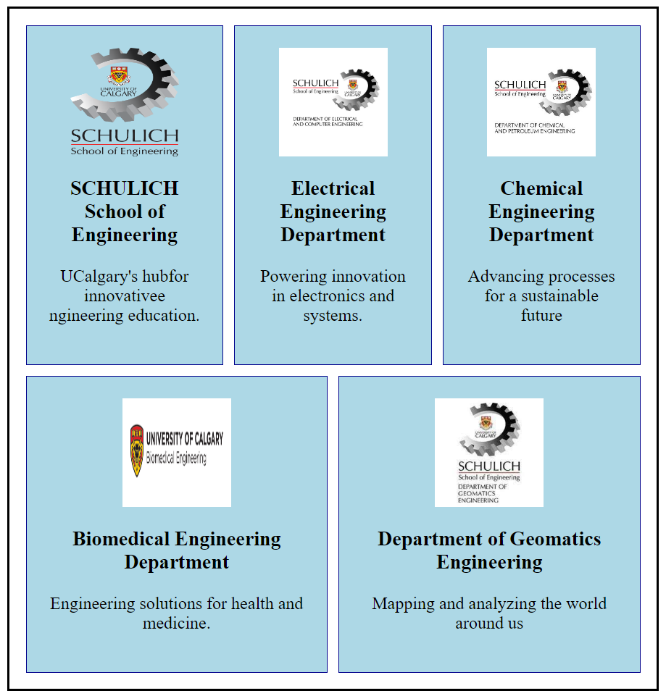

Flex-wrap:wrap-reverse;

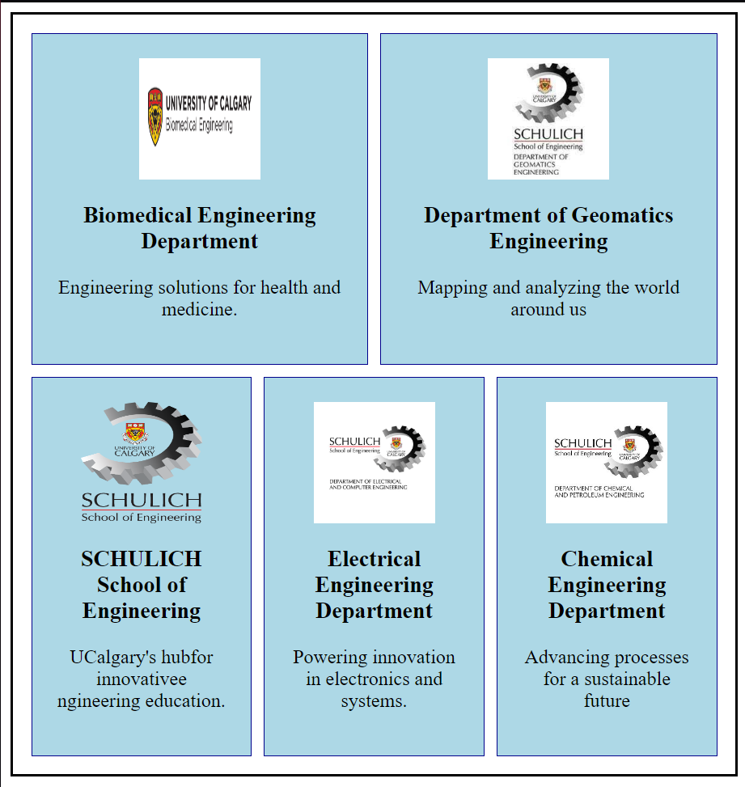

Reordered;



**Exercise 3 Output:**

