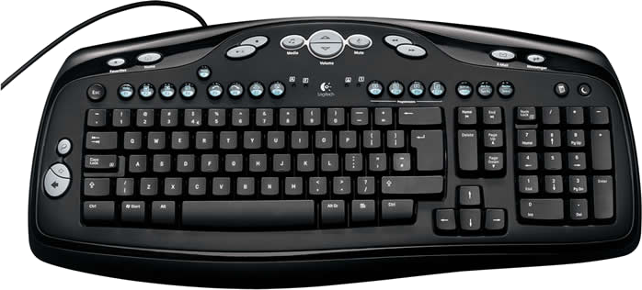
Menu

Bend backward
Turbo
Turn right
Turn left
Bend forward
Accelerate
Brake
Respawn
Left kick/punch
Right kick/punch
Look back

Brake
Accelerate
Left kick/punch
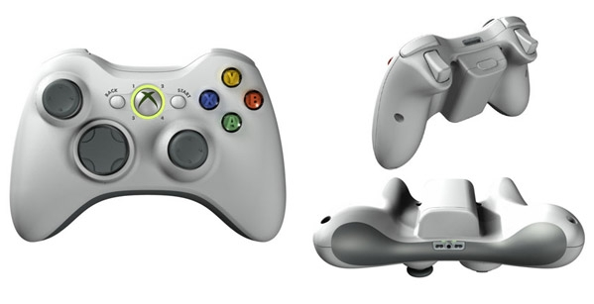
Right kick/punch
Look back
Turbo
Bend forward
Turn right
Turn left
Bend backward
Respawn
Menu

