- General

Put raw ressources (fbx) in assets/3D folder and subfolders including the necessary materials.
In game resources are prefabs that use these raw resources

Be carefull when renaming a resource or changing its folder to do it directly in the unity interface, not in your explorer because you may brake some links if your resource is used in a prefab

The prefabs are stored in the assets/resources folders and corresponding subfolders (frame, wheels, helmets, pilots …).
In the customization menu the prefabs are displayed in alphabetical order so you can change
the name of your prefab in order to change its display order

To create a new prefab
-either clone an existing one (ctrl+D) and modify it (for example if you only want to create a new version of an existing prefab with a different material)
-or open an empty scene and drag your raw resource in the hierarchy panel then drag your node to the corresponding assets/resources subfolder in the project panel

It is easier to modify your prefab in an empty scene but dont forget to click the apply button in the inspector panel to apply the changes you made to the instance in the scene to your prefab

- Bike integration

The bikes are splitted into prefabs for the moment there is :

-one prefab for the front wheel
-one for the rear wheel
-one for the frame

- Bike Frames

You must add the following elements to your frame prefab :

-add a FrameElement component to the prefab root node (menu component/add) and fill the front and rear suspension travel fields (the suspension travel is the maximum movement in meters that the supension can move exemple : 0.2 for front suspension 0.1 for softail 0.0 for hard tail)

- Rename the front fork movable parts as follow (beware it is case sensitive) Front fork

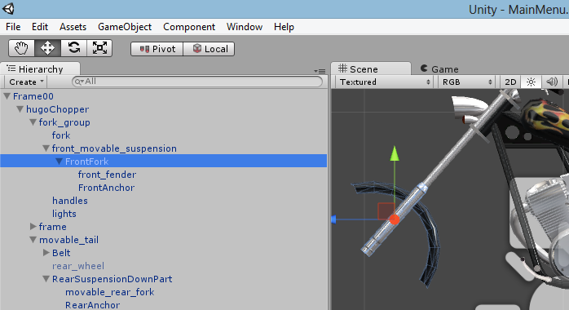

-add a dummy node named FrontAnchor (menu game object/create empty) as a child of the front fork. Move it to the position of the front wheel axle and rotate so that y axis is pointing toward the fork top.
Rename the movable front suspension root FrontFork (case sensitive)

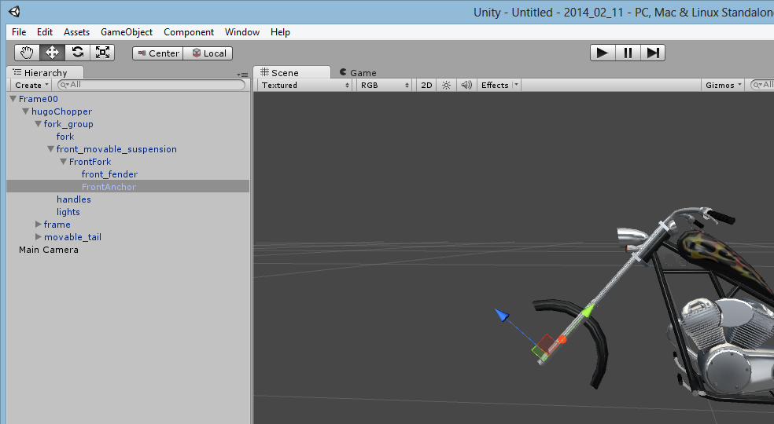

-add a dummy node named RearAnchor (menu game object/create empty) as a child of the rear part. Move it to the position of the rear wheel axle. If the bike has a softail rotate the node so that y axis is perpendicular to the lower movable part of the softail.

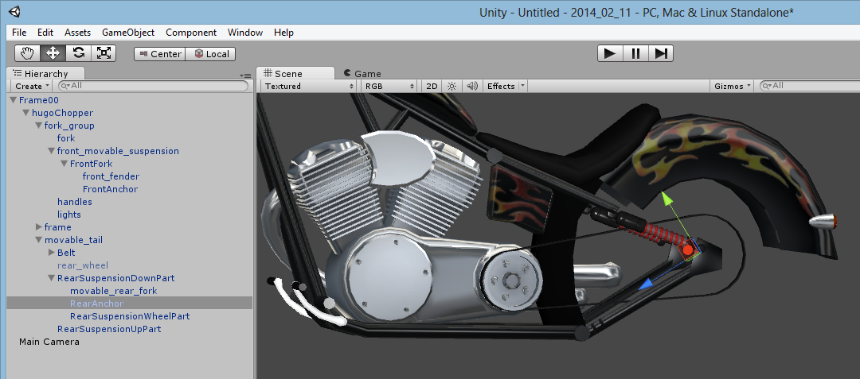

-add dummy nodes named SmokePoint (menu game object/create empty) as a child of the frame on each pipe output. Move it to the output of the pipe. Rotate them so that z axis is ponting out of the pipe (this will determine the smoke fx direction)
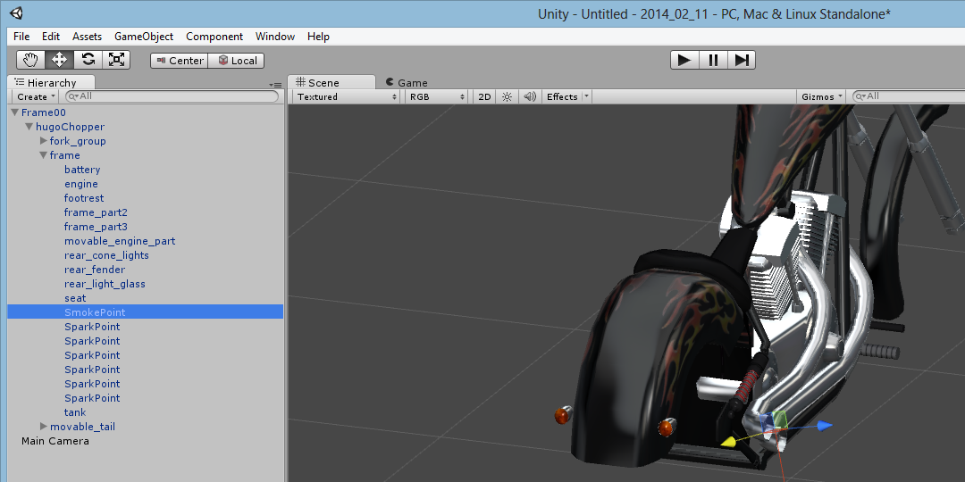

-add dummy nodes named SparkPoint (menu game object/create empty) as a child of the frame on each part of the bike that is likely to be in contact with the road when leaning bike left or right. Move them to the contact point. Rotate them so that z axis is ponting in the sparks direction (this will determine the spark fx direction)

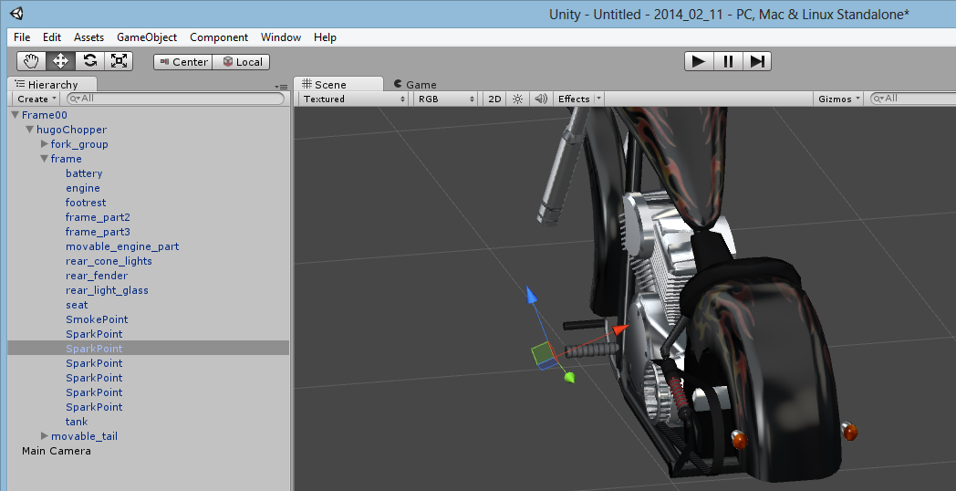

Softail bikes :

For the softail animation rename the following movable parts as follow (beware it is case sensitive):

Belt for the engine belt. Pivot must be on engine anchor point.

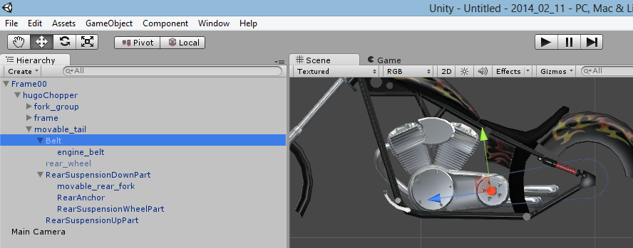

RearSuspensionUpPart for the part the frame up anchor point and the suspension spring. Pivot must be on frame anchor point

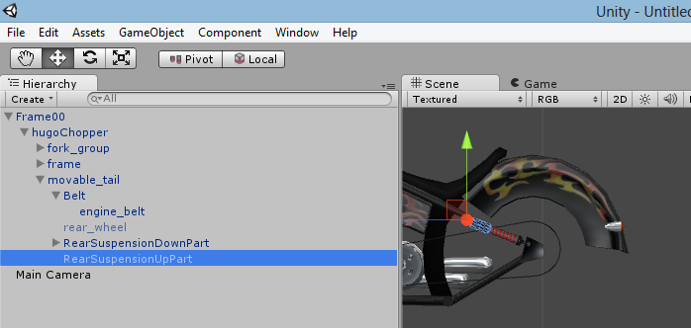

RearSuspensionDownPart for the part between the rear axle and the frame down part. Pivot must be on frame anchor point

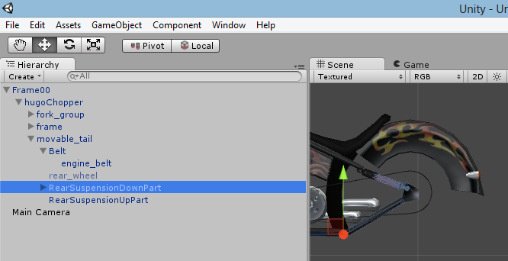

RearSuspensionWheelPart for the spring part between the rear axle and the up part
Also set this part as a child of RearSuspensionDownPart. Pivot must be on wheel anchor point

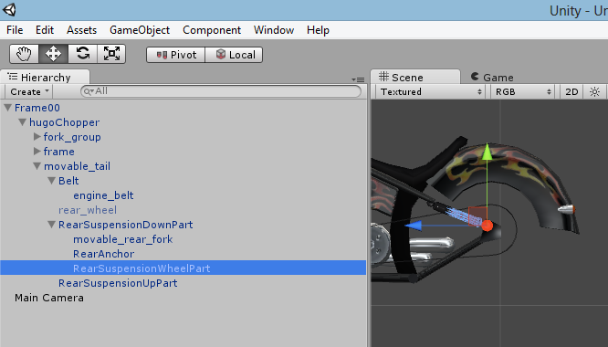

- Front and rear wheels

Create prefabs for front and rear wheels and store then in the assets/resources folders in corresponding subfolders. The wheel pivot must the center of its axle.

-add a WheelElement component to the prefab root node (menu component/add) and fill the original radius (in meters ex : 0.32) and the original tube radius (radius of the tire section in meters, ex 0.1) fields. The scale and therefore the radius of the wheel will be automatically modified to fit each bike.

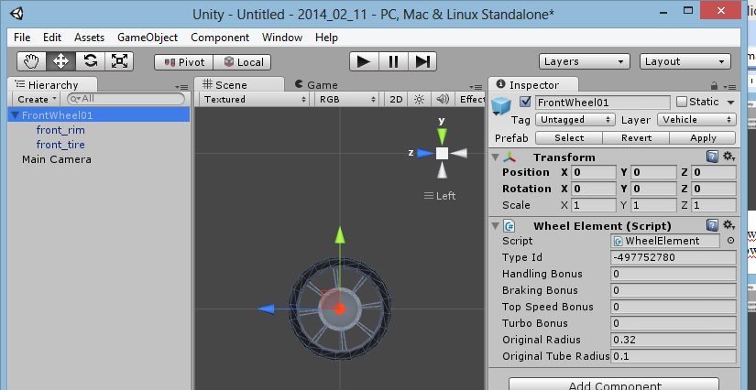

- Headgears

Create prefab for headgear store it in the assets/resources/helmets folder.

-add a VehicleElement component to the prefab root node (menu component/add)

-To adjust the headgear scale rotation and offset open main menu scene, launch the game and go to the customization menu. Select your new headgear, and click pause to adjust scale rotation and offset (the headgear is child of the head_joint_end node of the pilot in the hierarchy, you can also pick it by clicking on it in the scene tab).

As you are in play mode you cannot click the apply button to apply the changes you made to your instance directly to the prefab. So right click on the transform component in the inspector panel and select copy component, then select you prefab in the project tab, right click again on the transform component in the inspector and select paste component values

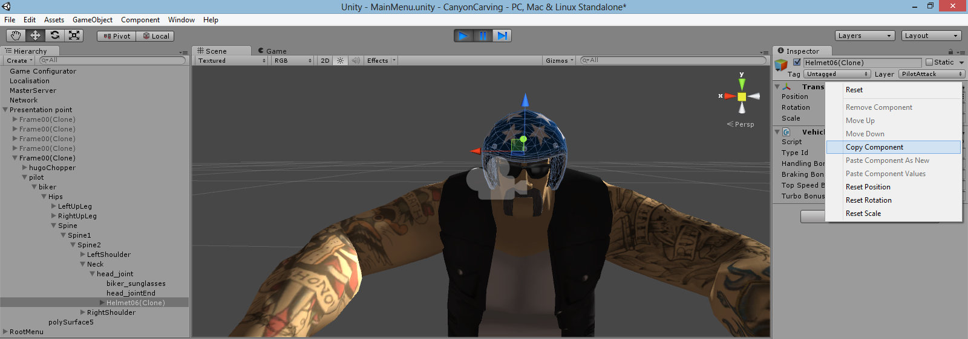

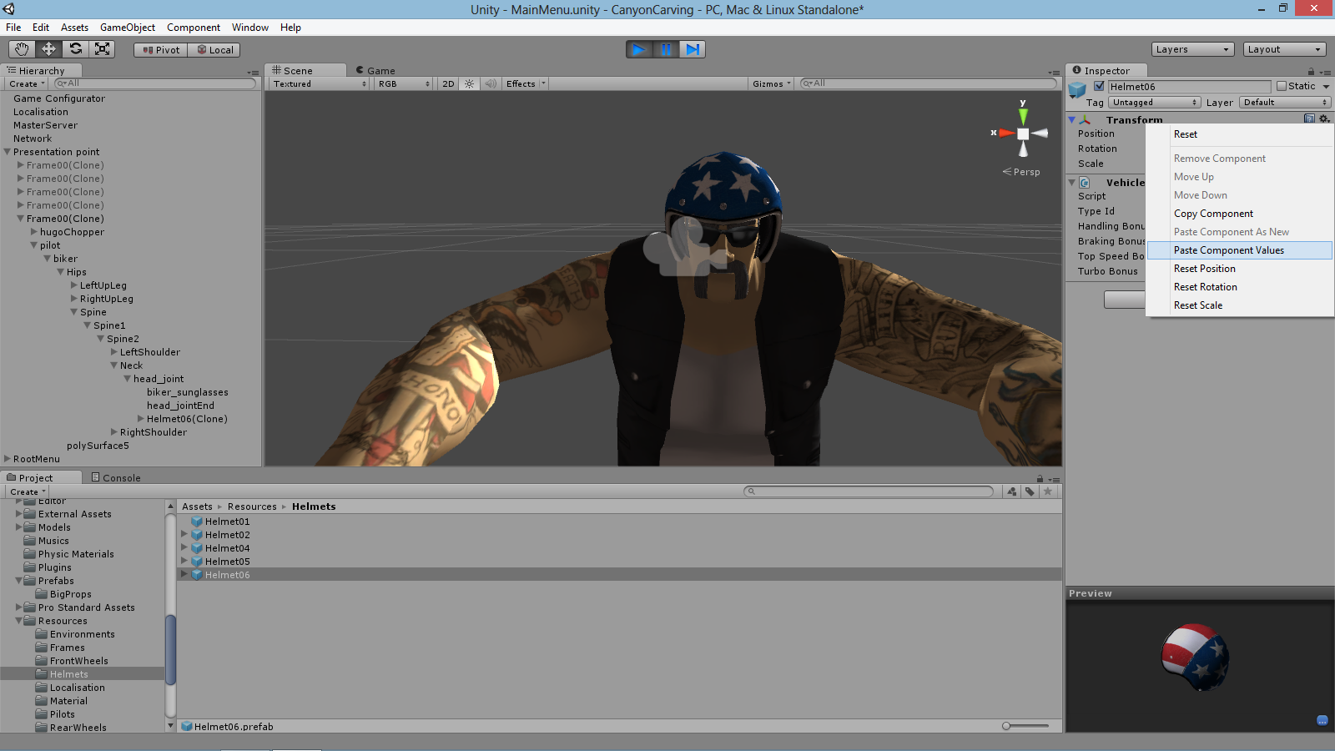

- Environments

Environments are prefabs that determine the content of each generated level including. When generating a new level one environment prefab of the assets/resources/environments folder is selected randomly.
Each environment prefab helps you to determine :

The water material
The skybox material
The road material
The ambient color
The main and second light parameters
The fog parameters
The shadow strenght
The trees prototypes
The grass prototypes
The detail prototypes (rocks etc)
The terrain textures : the spalt map is an image that is computed using the altitude and slope of the terrain tiles. Then the terrain textures are blended according to this map (ex sand on low altitude, grass on mid altitude, snow on high altitude and rocks on vertical slopes)
The big props prototypes (buildings, panels), for each of these props you can determine multiple constraints to determine the implantation of these props.

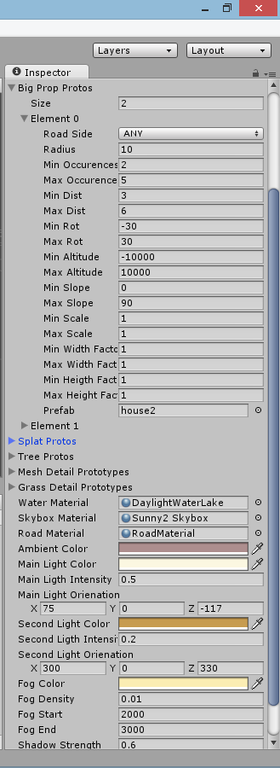

Testing
In order to test an environment, open the Ingame scene and select the « Track » node in the hierarchy panel. In the inspector panel check the force environment checkbox and enter the number of the environment you want to check. Then click the rebuild track button.

Props colliders
Props need a collider in order to collide with bikes you can add a collider using menu component/physics. But be carefull when choosing a collider especially if your prop has a lot of occurrences in the scene (ex trees). You don’t really need to have precise collisions on props on the side of the road. Here is a rough comparison of the cpu cost of each type of collider

Sphere 1
Capsule 3
Box 6
Convex mesh 20
Non convex mesh 100

So you can see that it is better to use a combination of spheres, boxes and capsules than to use a non convex mesh collider.

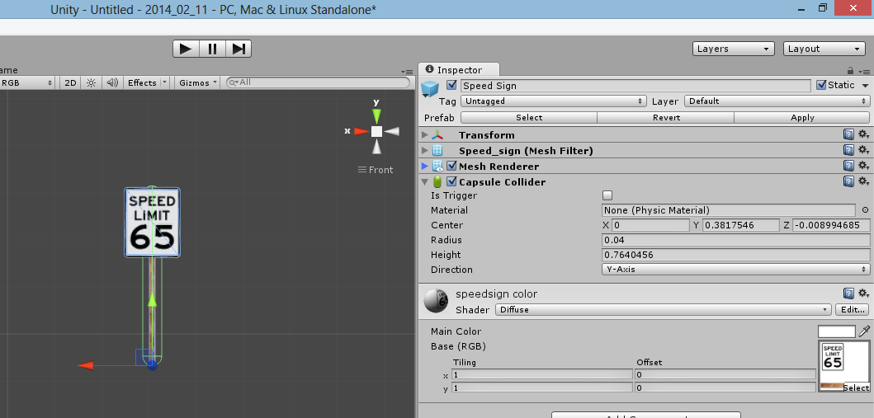

here is how tracks are built
A random environment is chosen
A random terrain is generated using perlin noise and voronoi features and other erosion algorythm.
A 2d track (a linked list of points) is generated using perlin noise algorythm
the track is projected on the terrain to get altitude of each point
the track is smoothed
the terrain around track is smoothed
the start line and checkpoints are set
Artificial Intelligence ideal line is computed using A-Star algorythm
The water level is computed to be below the lowest part of the road
Big props are spawned around the track defining exclusion areas for other props and vegetation
vegetation is spawned around the track
end of race cameras are spawned aound the track
the splatmap (terrain texture distribution map) is computed considering altitude and slope. Terrain is now texturized
Lightmaps are computed using Unity beast plugin
All this shit is binarized zipped and save to a file (5 MO)
The file is uploaded to the game site and a new entry is added in the tracks database
all this process is automated and takes about 10 minutes on a recent computer for 1 track
Any track can be regenerated identically using the same random seed .

