Cloud Computing
WS 2018/19

Adrian Schwab
Maximilian Waiblinger

Chat Server

Task:

The task is to set up a chat server offering the following:
- login, providing a username
- chronological display of messages, containing name and timestamp
- login and logout notifications
- a \list command, listing the names of all active users
- private messages
- sending multi-media files

Component Diagram

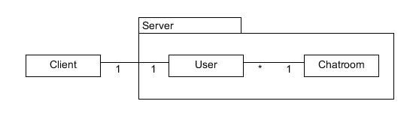
Each client creates a socket on the serverside providing access and identification.
Each user is conected to the chatroom, that is shared by all users.

Mockup

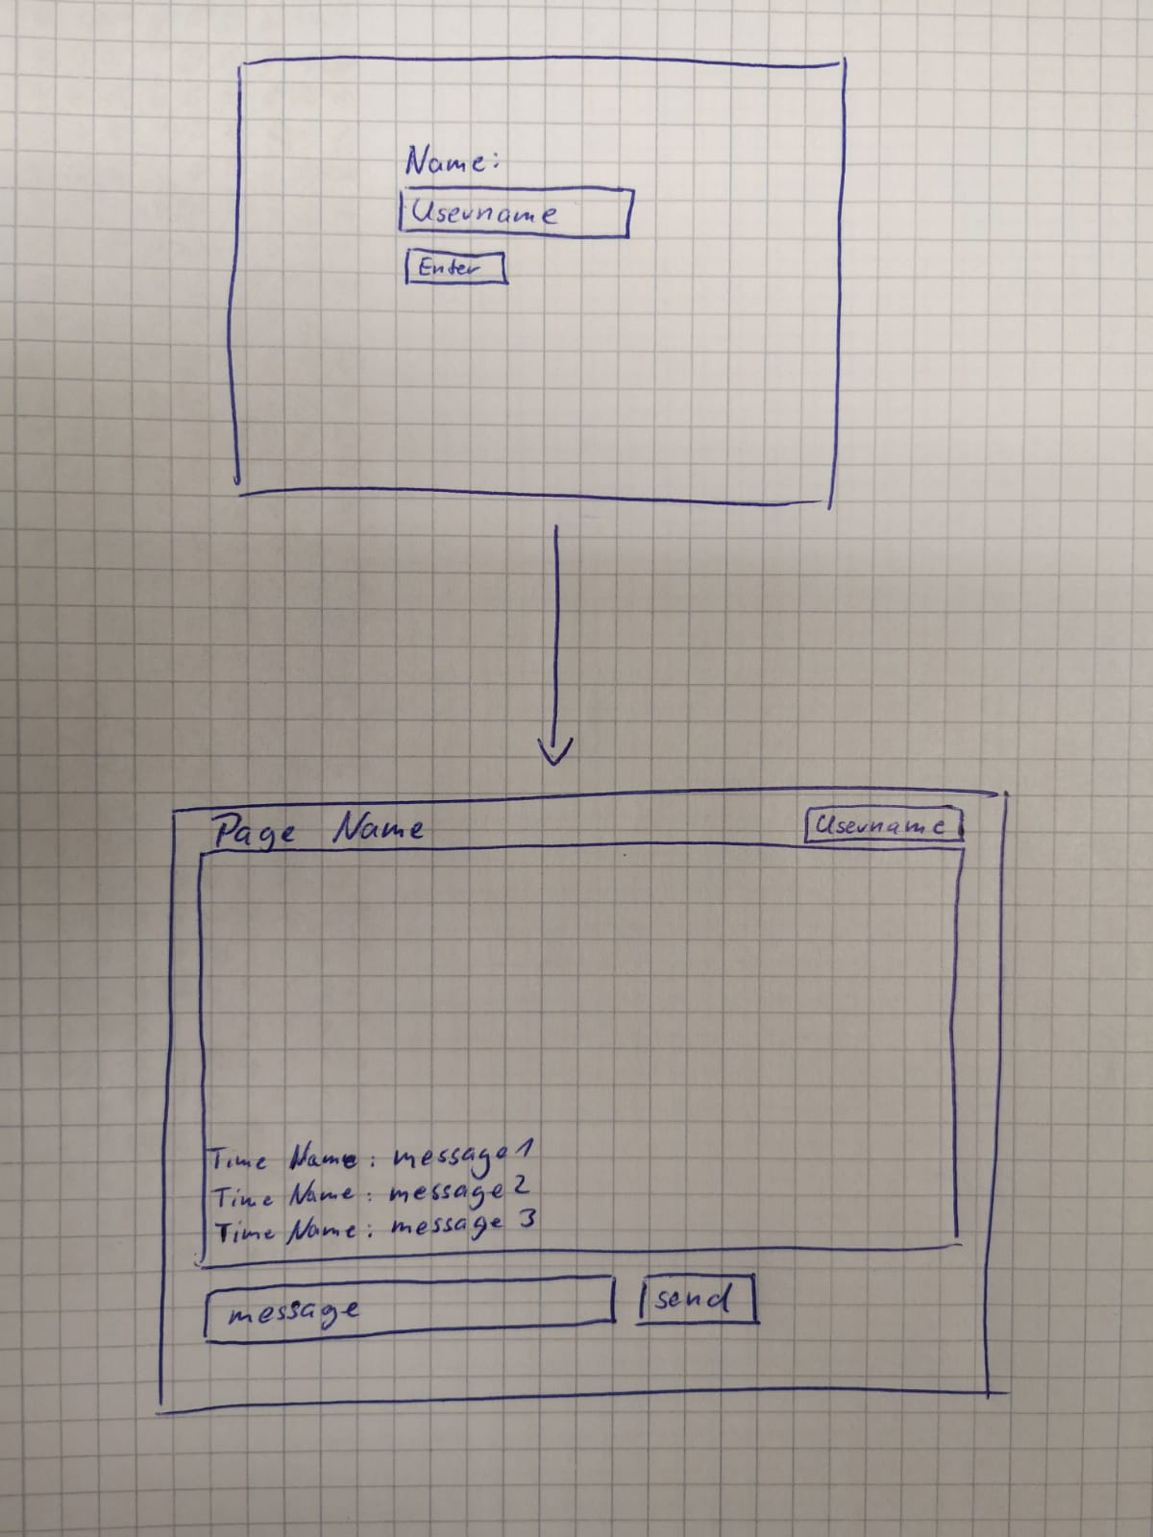
Simple and based on SocketIO example

Mockup - Scrapped Ideas

Multiple Chats Side-by-Side:
Global Chat
Private Chat

Different colors for different chats:

Global Chat
Private Chat
Sequenzdiagram
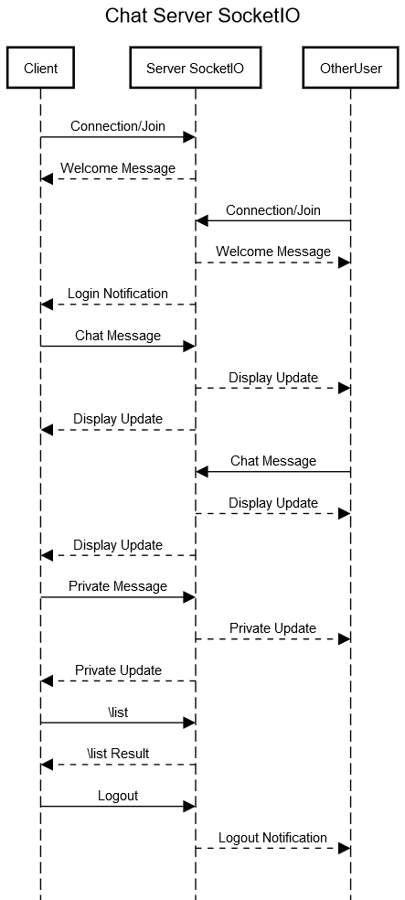

Lesson-Learnt

  - usefull and easy to use modules
  - a lot of function already given

Todo for next exercise:

  - media messages
  - server-side username validation

