**Cloud Computing WS18/19**

**Chat Service**

**Documentation**

Adrian Schwab, Matrikelnr.: 762382

Maximilian Waiblinger, Matrikelnr.: 762390

**Tasks**

Creating a Chat Server

* A new user has to register with the website first by providing a user name
* In the chat room, all messages should be displayed in chronological order with a timestamp and the user name of the user with has posted the message
* A marked message is generated and sent to the chat room each time a new user connects to the chat room or leaves the chat room
* A user can request a list of all online users using the “\list” command; that list ist only sent to the requestor
* A user can send a message to one dedicated recipient (private message) instead of to all online users in the chat room
* A user can send multi-media files to the participants of a chat room or via a private message, e.g., pictures, movies, sound files.

**Technolgy**









Image-Source: https://www.vectorlogo.zone/, https://medium.com/

**Login**

**Tasks**

* Possibility to Enter User Name
* Username Validation
  + Valid Characters: a-z, A-Z, 0-9, optional: ‘-’ or ‘_’
  + No ‘-’ / ‘_’ at first or last index
  + **Server-Side** checking
  + Wrong Input 🡪 Display Feedback
  + No html/javascript execution on submit
* Redirect to Chat only with valid username

**Design**

Form to Submit

* Input Field
  + Placeholder
  + No Autocorrect
* Submit Button
* Feedback Messages or Visualisation

Colors

* No neon colors or similar
* No heavy contrasts

**Mockup**

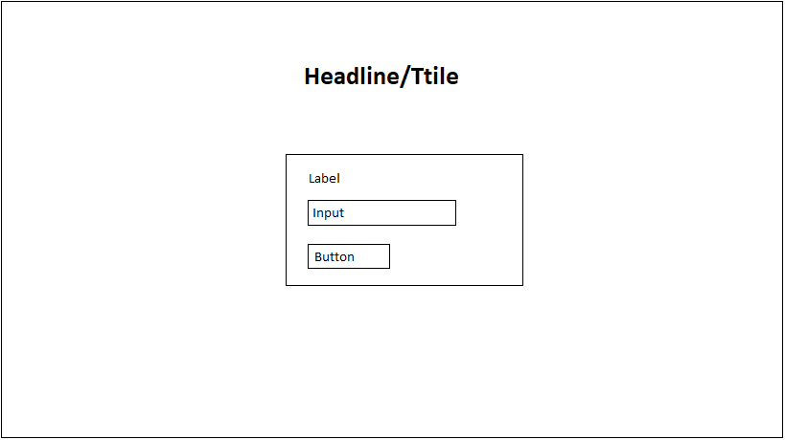

**Validation**

Regular Expression: ^[A-Za-z0-9]+(?:[_-][A-Za-z0-9]+)*$

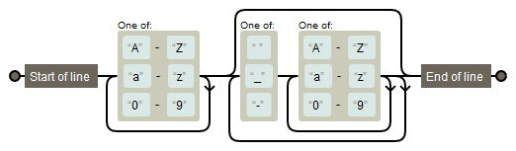

Figure 1 Visualisation with https://regexper.com/

**Chat**

**Tasks**

* Form for message input
  + Message character limit
  + No html/javascript execution on submit
  + File can be added to a message
    - Only media
    - File size limit
  + Command recognision
    - \help
    - \list
    - \whisper
* Message Display
  + Chronological
  + Message Objects content:
    - Timestamp, Username, Message
    - Optional Media
  + Auto update
  + Marked messages
    - Join, Leave
    - Whisper
    - Server message
* Chat Header
  + Information Display
    - Username
    - Chatroom
    - Online user
  + Logout option