Networked Life: Homework Q2, Q3

**Exercise 1:**A simple ad space auction(exercise 2.1 in book)

Three advertisers $(1, 2, 3)$ bid for two ad spaces (A, B). The average revenues per click are $\$6, \$4, \$3$ for the bidders, respectively. For this exercise we define the *clickthrough rate per hour* of an ad space (slot) to be the expected number of clicks to the website of the advertiser if the ad is shown on the internet continuously for 1 hour and the advertiser is of the same basic type in terms of quality score, say QS=1.

In our case we assume that clickthrough rates of the ad spaces are $500, 300$ clicks per hour respectively, and we assume not to depend on which advertiser uses the ad space (i.e., assume all advertisers are of the same basic type with QS=1).

1. Draw the bipartite graph with nodes indicating advertisers/ad spaces and edges indicating values (in $) of advertisers obtained from using the slots per hour. Indicate the maximum matching with bold lines.
2. Assume a GSP auction with truthful bidding, what is the result of the auction in terms of the allocation, the prices charged, and the payoffs received?

**Exercise 2:** eBay auction (exercise 2.2 in book)

On eBay via auction using proxy bidding, Alice lists a lamp for sale with both the start price and reserve price set to $7.00 and a duration of 5 days. The minimal increment is $0.25 and the following events happen during the auction:

* *Day 1* Bidder 1 bids $11.00.
* *Day 2* Bidder 2 bids $9.25.
* *Day 3* Bidder 3 bids $17.25.
* *Day 4* Bidder 2 bids $13.65.
* *Day 5* Bidder 1 bids $27.45.

List the bidding history: winner, winning bid, asked price, at the end of each day of the auction. Who is the winner and what price does she pay?

**Exercise 3:** More items than bidders (exercise 2.3 in book)

Alice and Bob are bidding for three ad slots on a webpage, and a bidder can win at most one slot. Assume that both bidders have the same quality score and they bid once at the beginning of the day to determine their slot allocation during the day. Hence, whoever wins slots 1, 2 or 3 will receive a total rate (to her website) of 500, 300 or 200 clicks per hour, respectively. Assume that Alice profits $*r* per click it receives.

1. Denote by *b*1 and *b*2 the bids by Alice and Bob respectively. In a GSP auction, determine Alice’s payoff (net profit) in terms of *b*1 and *b*2. Find her best response as a function of $b_{2}.$
2. Find a dominant strategy for Alice. Hint: compute the payoff and the best response $b_{1}$ of Alice as a function of $b_{2}$. Check if there is a value for $b_{1}$ that maximizes her payoff (i.e., is a best response) for any value of $b_{2}.$

**Exercise 4:** Spectrum auction and package bidding (exercise 2.5 in book)

Wireless cellular technologies rely on spectrum assets. Around the world, auctions have emerged as the primary means of assigning spectrum licenses to companies wishing to provide wireless communication services. For example, from July 1994 to July 2011, the US Federal Communications Commission (FCC) conducted 92 spectrum auctions, raising over $60 billion for the US Treasury, and assigned thousands of licenses to hundreds of firms to different parts of the spectrum and different geographic regions of the country.

The US FCC uses **simultaneous ascending auction**, in which groups of related licenses are auctioned simultaneously[1] and the winner pays the highest bid. The British OfCom, in contrast, runs **package bidding**, where each potential spectrum bidder can bid on a joint set of frequency bands.

Among the many issues involved in spectrum auctioning is the debate between simultaneous ascending auction and package bidding auction. We will illustrate the inefficiency resulting from disallowing package bidding in a toy example. The root cause for this inefficiency is “bidder- specific complementarity” and the lack of competition. Complementarity refers to case of a player getting more value from combining 2 or more items than the sum if their values if she gets any of them alone. The problem is that this player will never take the risk of bidding high enough expressing the valuation for the set of the items because there is the risk of not getting the whole set, in which case she will incur a loss. We show this through the next example.

Suppose that there are two bidders for two adjacent seats in a movie theater. Bidder 1 is planning to watch the movie together with her spouse as part of a date. She values the two seats *jointly* at $15, and a single seat is worth nothing. Bidder 2 plans to watch the movie by himself, and values each seat at $10, and the two seats together at $12 (since it is a little nicer to have no one sitting next to him on one side of his seat).

1. Assume i) the case of a sequential and then ii) of a simultaneous ascending auction to be used for selling the seats, and bidder 1 correctly guesses that bidder 2 values $10 for one seat and $12 for two seats together. What strategy will bidder 1 take? What is the result of the auction, in terms of the allocation, the price charged, and the payoffs received? We like to show that only possible outcome is for bidder 2 to get both items and Bidder 1 none, although she values them more as a pair. The auction is not efficient and does not achieve the maximum total value generated to the participants (i.e., the SW) of $15. Hint: Is it sensible that bidder 1 bids even 1 cent in this auction? Think first of sensible strategy for the rational bidder 2 (easy to guess). Then show that bidder 1 will always loose playing against that strategy.
2. Repeat part (a) but now assume package bidding[2] is used. In particular, bidder 1 can bid on a package consisting of both seats. Explain the differences with (a).

**Exercise 5:**VCG auction

Find the prices obtained by a VCG mechanism for the bidders (1,2,3,4) and items (A, B) below (the numbers above the edges are the bidders’ valuations for the items).

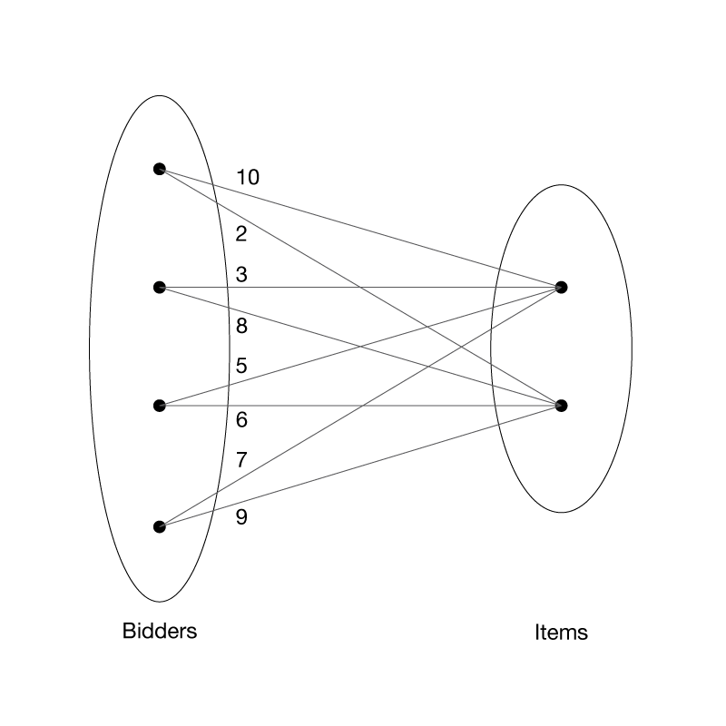

**Exercise 6:** Cyclic ranking (exercise 3.2 in book)

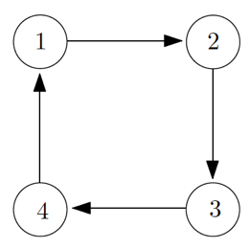

Figure 3.6 A simple network of webpages with a cycle.

Write out the matrix **H** of the graph above. Iterate $π[k]T = π[k - 1]T H$, where $k = 0,1, 2,…$, and let the initialization be

$$π[0] = [1/2, 1/2, 0, 0]T$$

What happens to the vectors $\{π[k]\}$ as $k$ becomes large? Solve for $π^{*}$ such that $π^{*T}=π^{*T}H$ and $\sum_{i}{π_{i}^{*}=1}$.

**Exercise 7:** PageRank with a different $θ$ (exercise 3.3 in book)

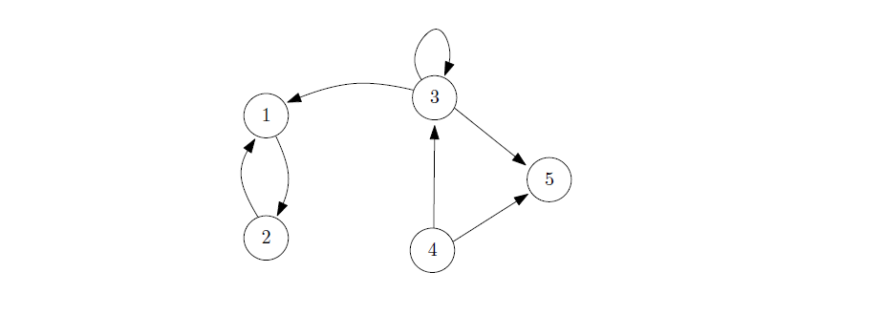

Compute the PageRank vector $π^{*}$ of the graph in the Figure above, for $θ=0.1, 0.3, 0.5,$ and $0.85$. What do you observe?

**Exercise 8:** Block aggregation in PageRank (exercise 3.4 in book)

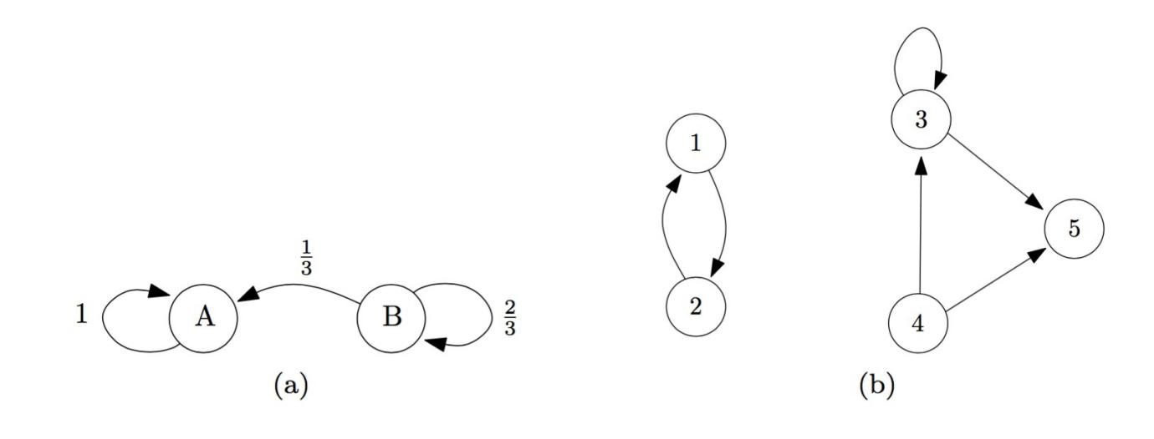Set $θ = 0.85$ and start with any normalized initial vector $π[0$].

1. Compute the PageRank vector ${\left[\begin{matrix}π_{A}^{*} & π_{B}^{*}\end{matrix}\right]}^{T}$ of the graph in figure (a) above with

$$H=\left(\begin{matrix}1 & 0 \\ 1/3 & 2/3\end{matrix}\right)$$

Note the uneven splitting of link weights from node *B*. This will be useful later in the problem.

1. Compute the PageRank vectors ${\left[\begin{matrix}π_{1}^{*} & π_{2}^{*}\end{matrix}\right]}^{T}$ and ${\left[\begin{matrix}π_{3}^{*} & \begin{matrix}π_{4}^{*} & π_{5}^{*}\end{matrix}\end{matrix}\right]}^{T }$ of the two graphs in figure (b) above.
2. If we divide the graph in exercise 7 into two blocks as shown in the figure below, we can approximate $π^{*}$ in the previous question by

$${\tilde{π}}^{*}={\left[\begin{matrix}π_{A}^{*}∙[\begin{matrix}π_{1}^{*} & π_{2}^{*}\end{matrix}] & π_{B}^{*}∙[\begin{matrix}π_{3}^{*} & \begin{matrix}π_{4}^{*} & π_{5}^{*}\end{matrix}\end{matrix}]\end{matrix}\right]}^{T}$$

Compute this vector. Explain the advantage, in terms of computational load, of using this approximation instead of directly computing $π^{*}$.

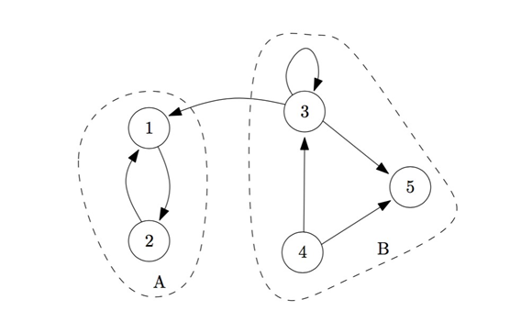

**Exercise 9:** Order of nodes in PageRank

For the following graph we like to order its nodes in descending order according to PageRank as this is computed according to $\hat{H}$  (no need to construct the full G).

Which of the following arrangements is correct? Provide an analytical explanation.

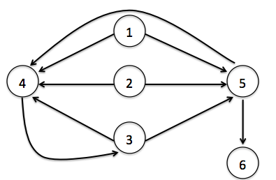

$3>4>5>6$

$4>3>5>6$

$3>4>6>5$

$4>5>3>6$

1. Instead of sequentially (sequentially: one auction starts after the previous ends). In a simultaneous ascending auction for items A, B assume the following process. There are two independent auctions, auction A for item A and auction B for item B. These auctions are “coupled” by synchronizing the price increase: at each clock tick $t=1,2,…,$ the price of the item in each auction increases by the same bid increment. Then, bidders decide for each of the two auctions to stay or leave. Once a bidder leaves an auction, she cannot join any more that auction; she remains active only in the auctions that she keeps participating. Each auction terminates after a price increase when there is no more demand or there is a single remaining bidder. In the former case, the item is assigned with equal probability to the bidders that were active in the last round for a price equal to the price at that round. In the latter case, the single remaining bidder is the winner and pays the last price at which there were >1 bidders active.
2. In our previous example, package bidding is to make at most 3 separate pay-your-bid sealed bids (where you pay what you bid): for item A only, for item B only, and for the combination A+B. The auctioneer chooses the combination of bids from the bidders that corresponds to a feasible allocation (e.g., in our case allocate A+B to one of the bidders, or item A to Bidder 1 and B to Bidder 2, or…) which maximizes the total revenue from the bids. If bidders are truthful, this maximizes the social welfare of the allocation.