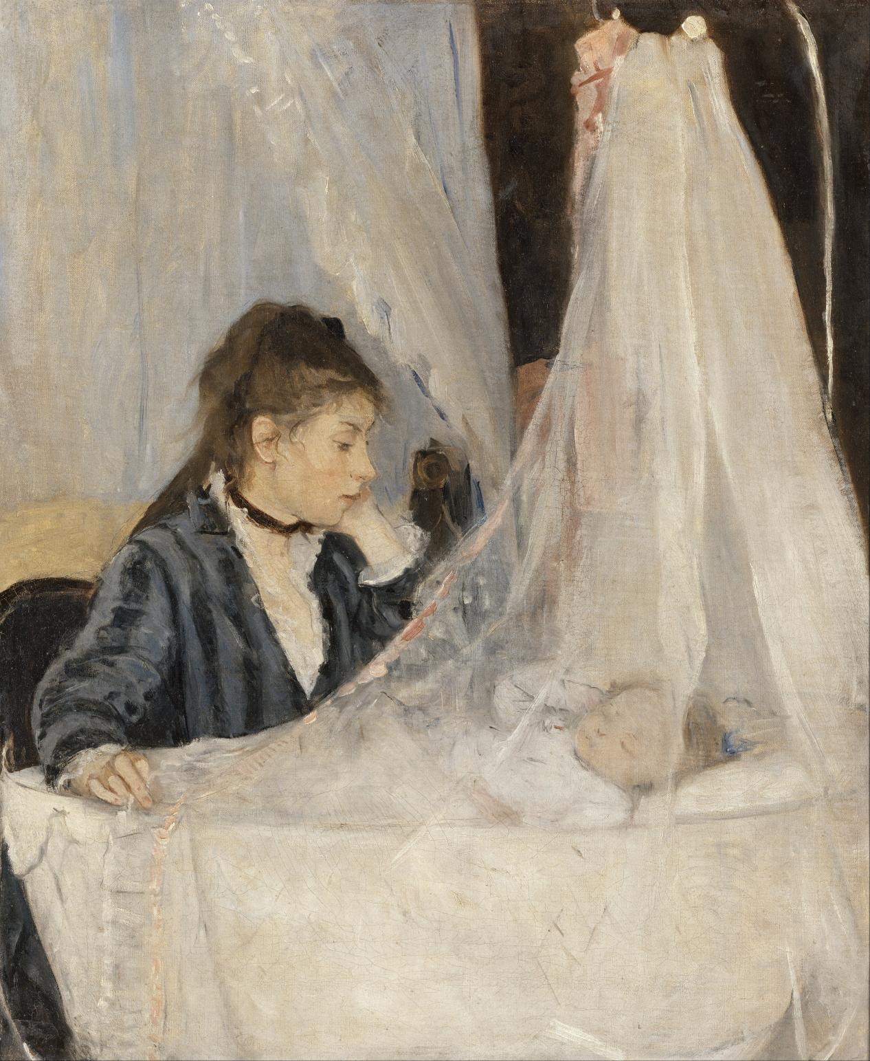
Berthe Morisot
摇篮 The Cradle, 1872
Oil on canvas, 56x46.5cm

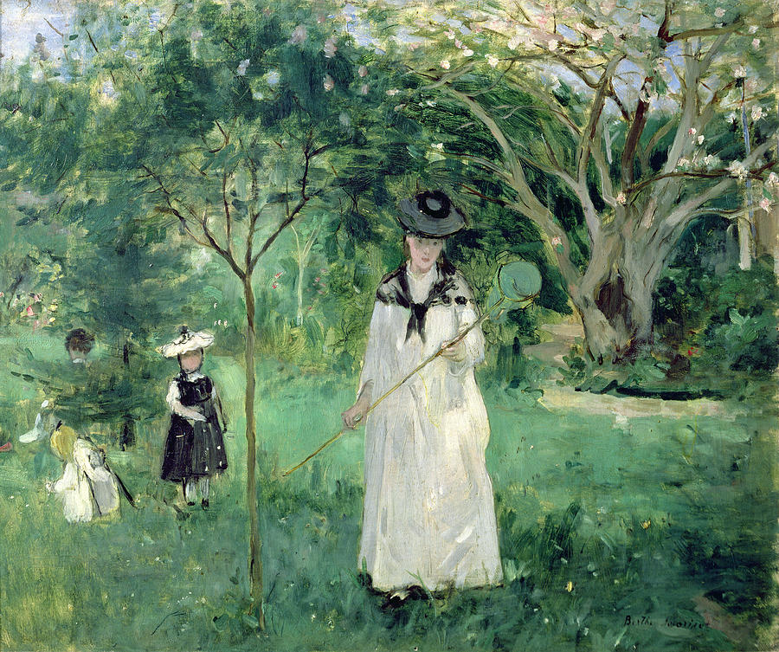
Berthe Morisot
捕蝶 The Butterfly Hunt, 1874
Oil on canvas, 56x46cm

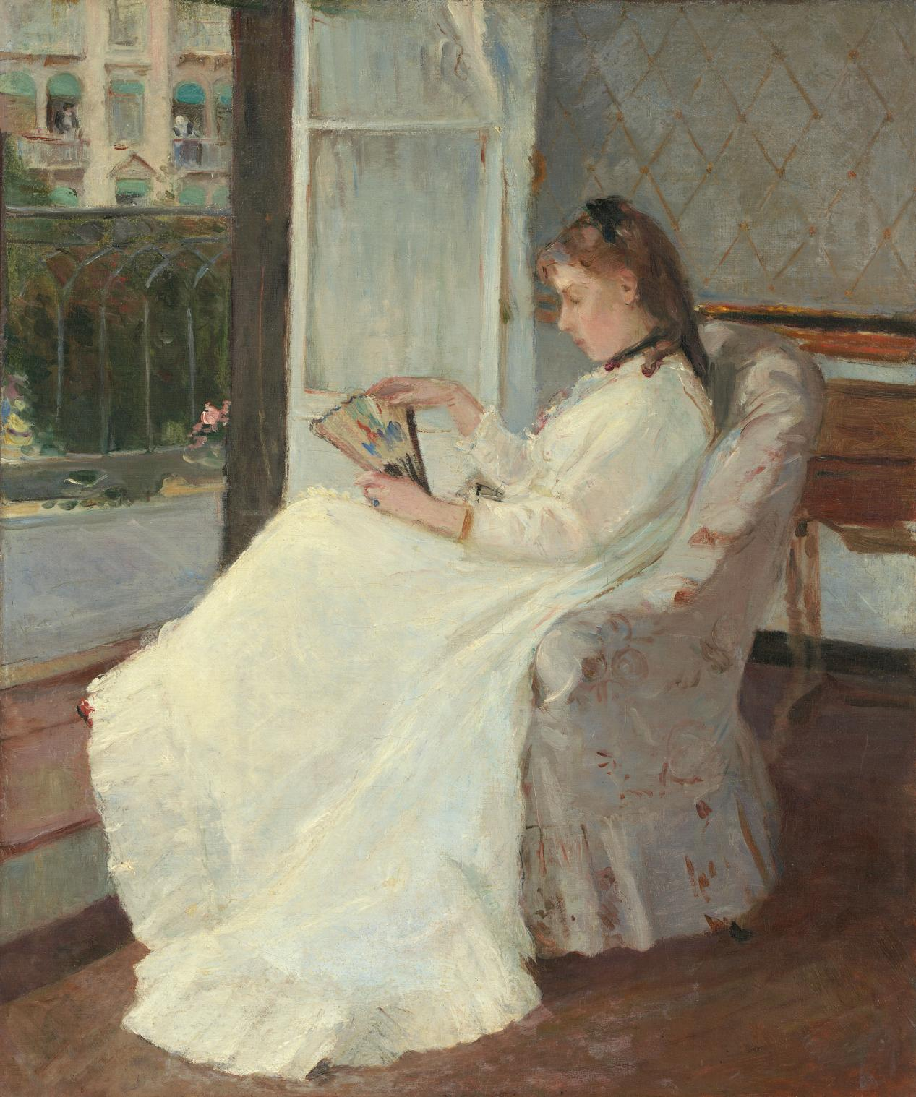
Berthe Morisot
作家的妹妹坐在窗边 The Artist's Sister at a Window, 1869
Oil on canvas, 54.8x46.3cm

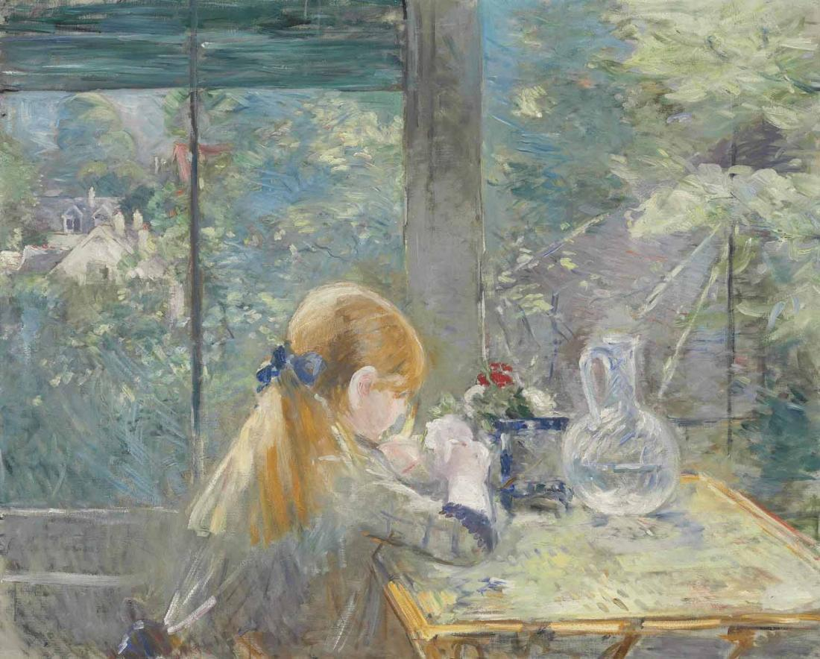
Berthe Morisot
在阳台上 Dans la véranda, 1884
Oil on canvas, 81.2x100.2cm

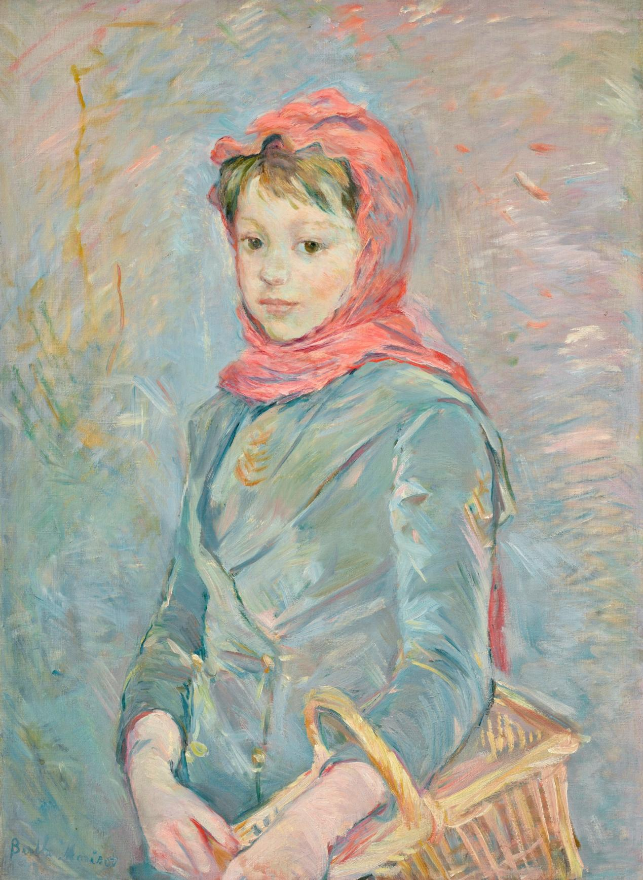
Berthe Morisot
提篮子的女孩 Fillette portant un panier, 1888
Oil on canvas, 70x51cm

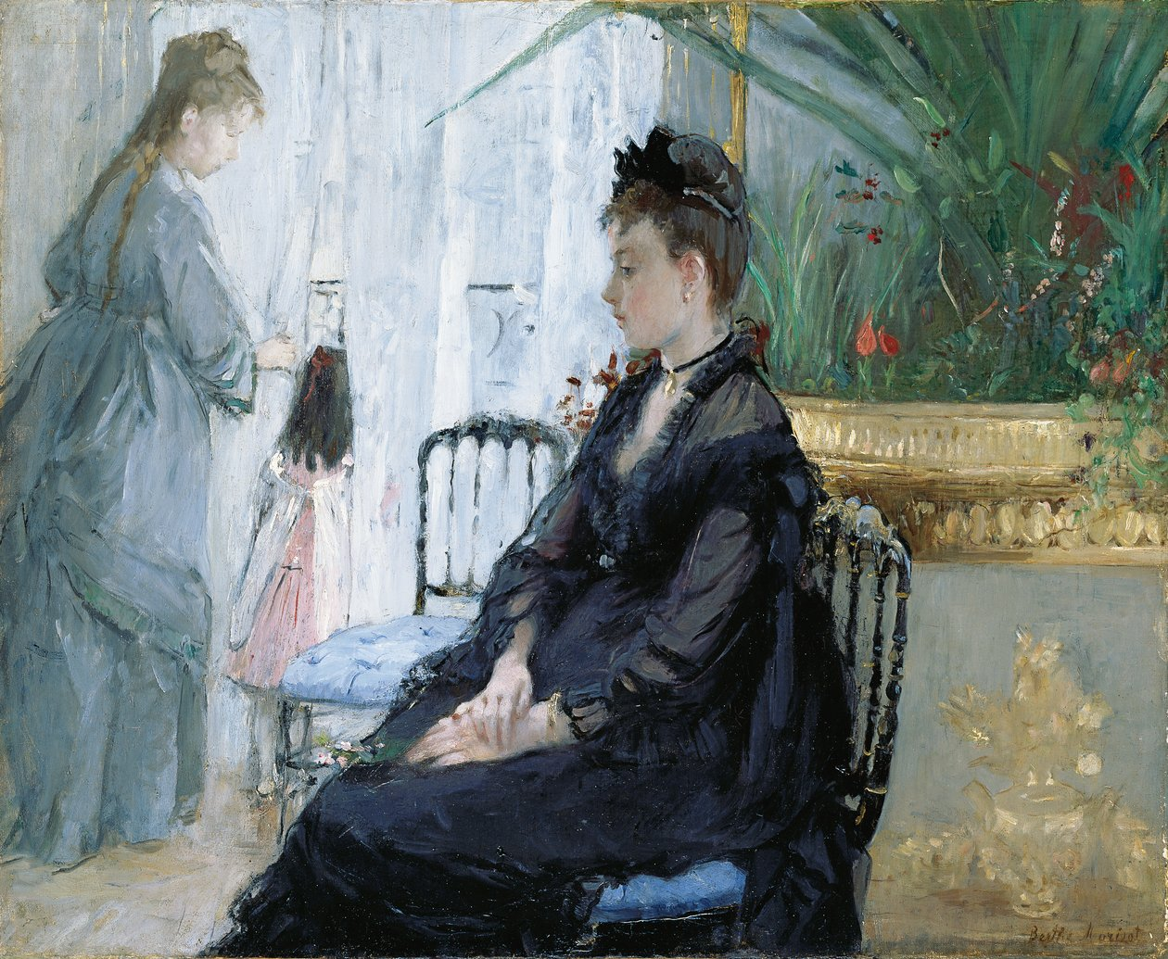
Berthe Morisot
里面 Intérieur, 1872
Oil on canvas, 60x73cm

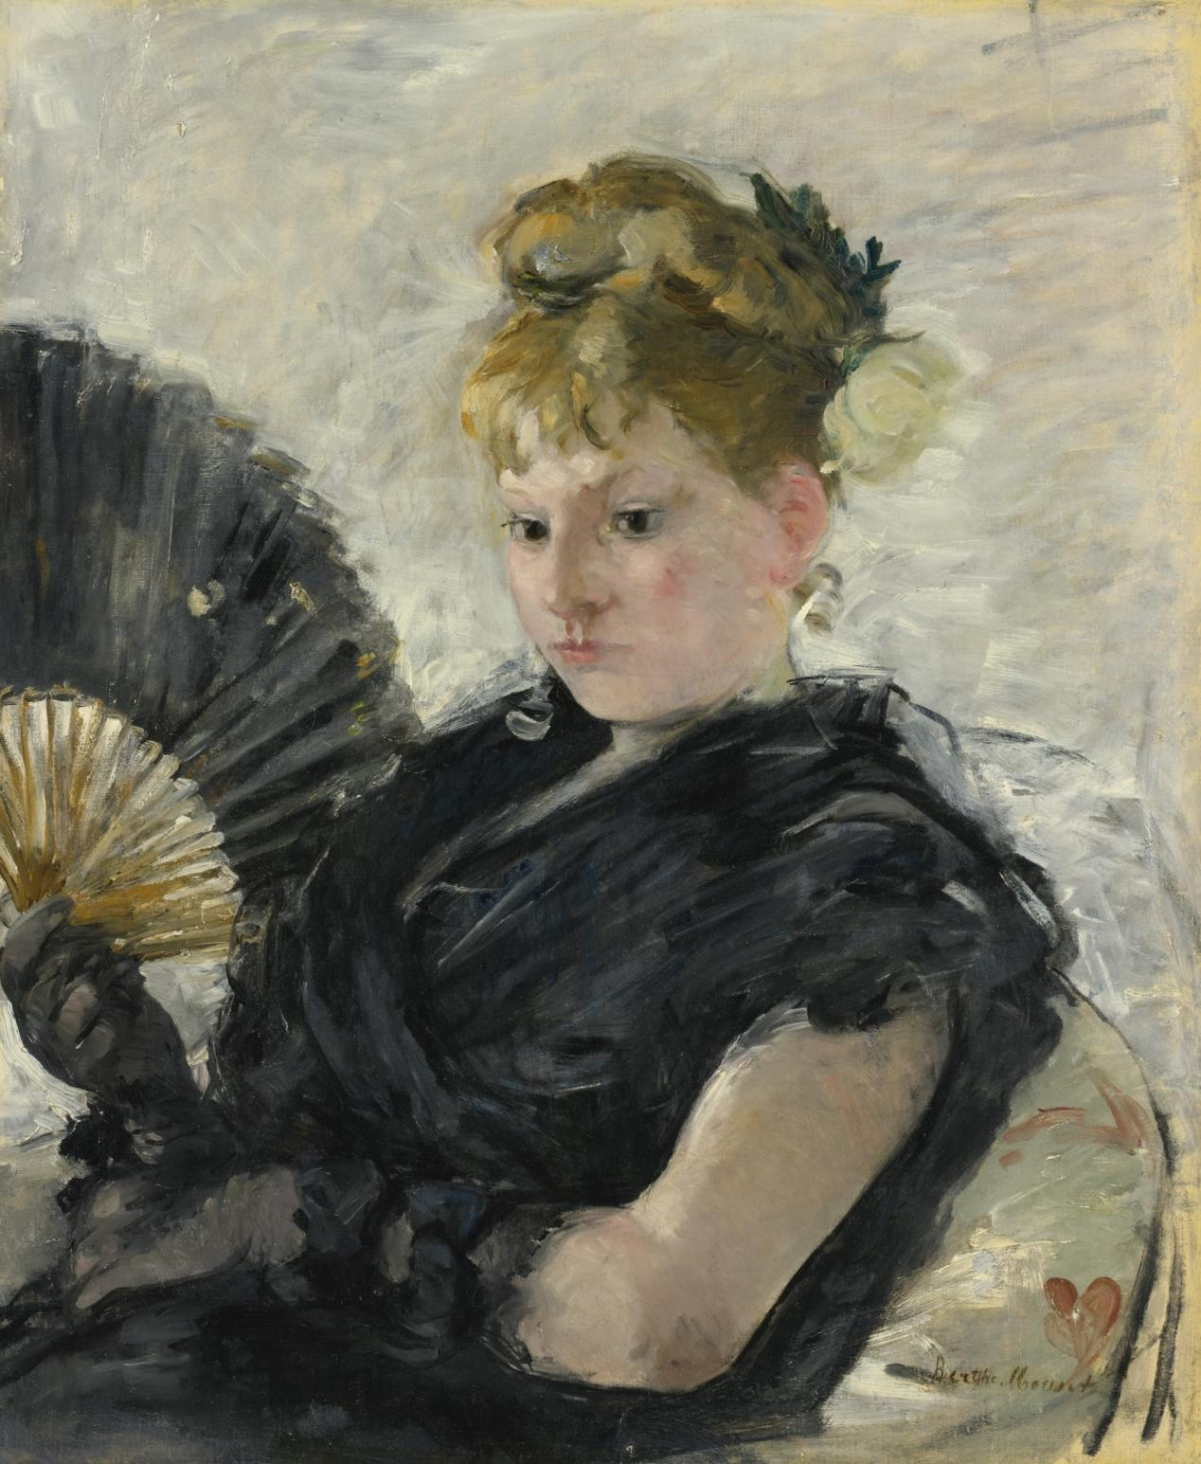
Berthe Morisot
拿着扇子的女人, Femme à l’éventail, 1876
Oil on canvas, 62x52cm

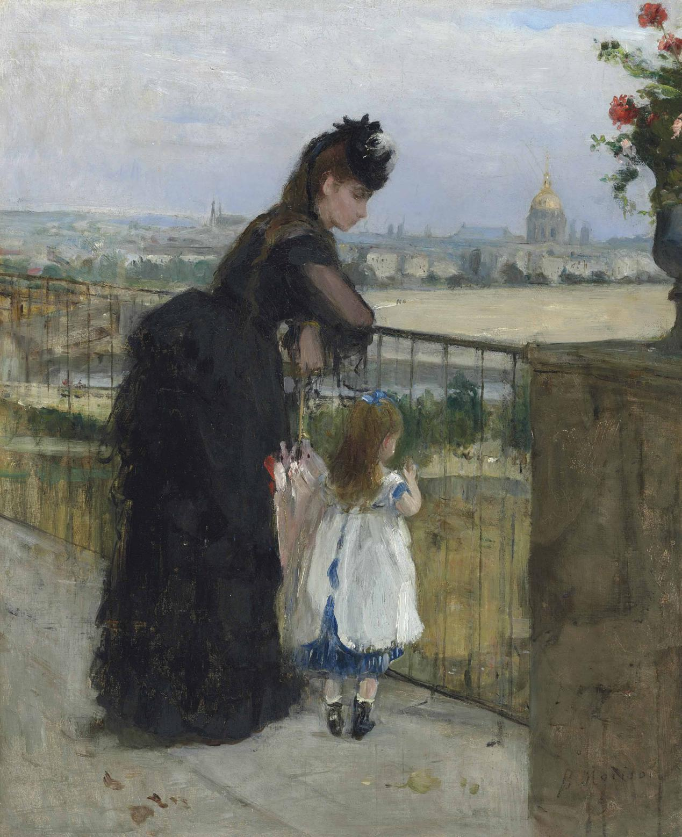
Berthe Morisot
阳台上的女人和孩子 Femme et enfant au balcon, 1872
Oil on canvas, 60x50cm

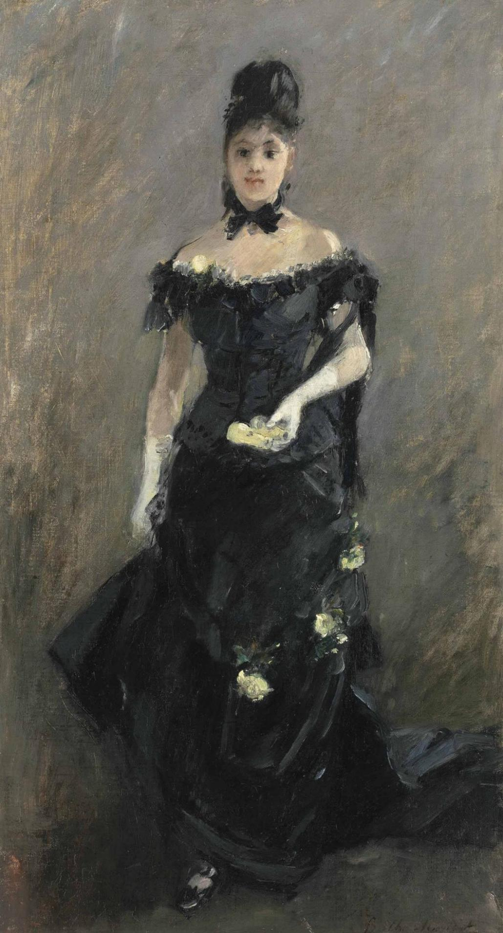
Berthe Morisot
剧院前的黑金色女人 Femme en noir or Avant le théâtre, 1875
Oil on canvas, 57.3x30.7cm
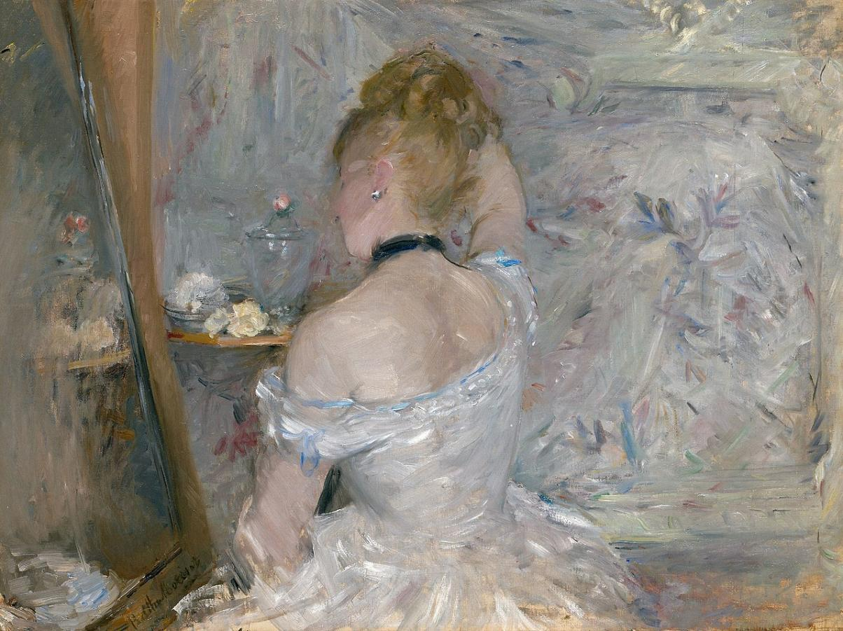
Berthe Morisot
坐在梳妆台前的女人 Woman at Her Toilette, 1875-1880
Oil on canvas, 60.3x80.4cm

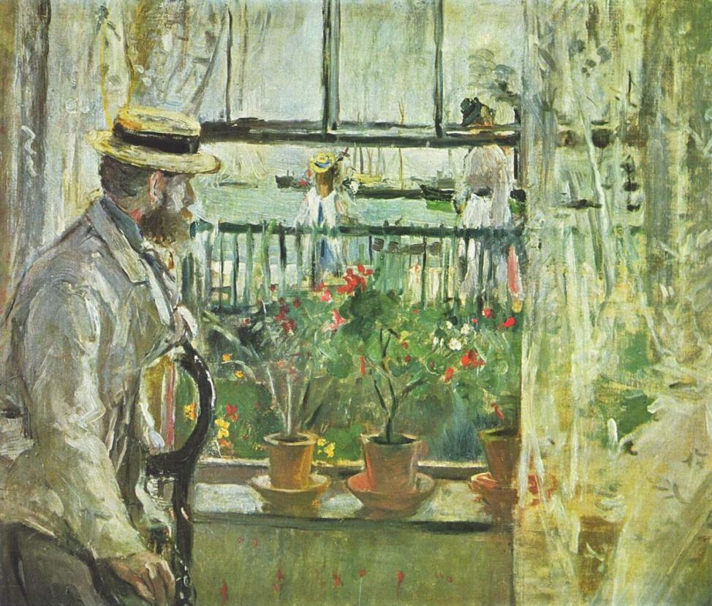
Berthe Morisot
怀特岛上的尤金·马奈 Eugène Manet on the Isle of Wight, 1885
Oil on canvas, 38x46cm
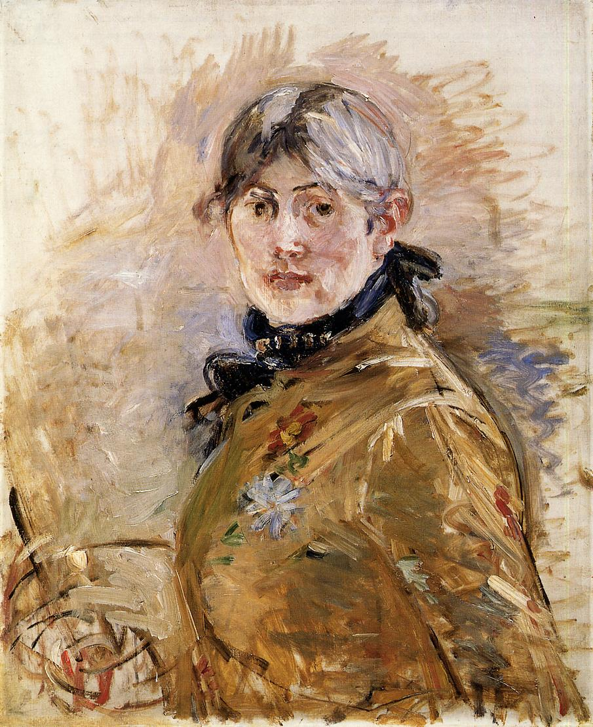
Berthe Morisot
自画像 Self-Portrait, 1885
Oil on canvas, 50x61cm

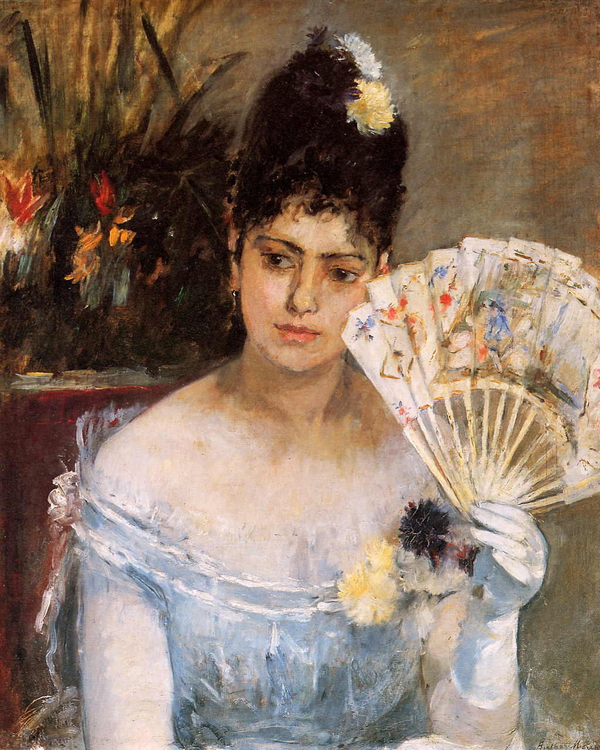
Berthe Morisot
在舞会上 At the Ball, 1875
Oil on canvas, 52x65cm

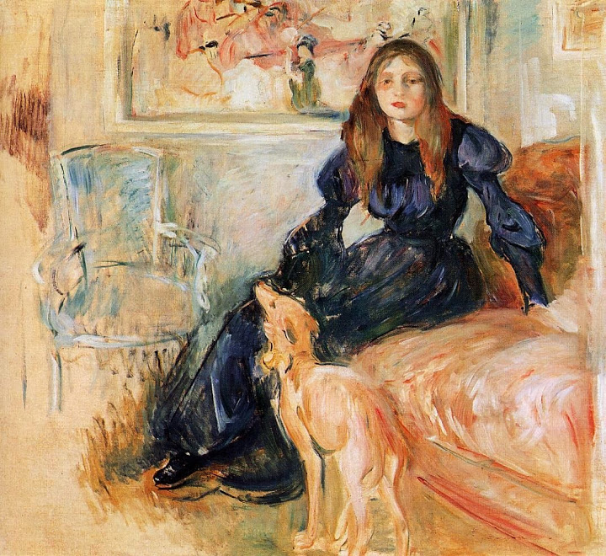
Berthe Morisot
朱莉·马奈和她的格力犬莱尔提斯 Julie Manet with her Greyhound Laerte, 1893
Oil on canvas, 73x80cm

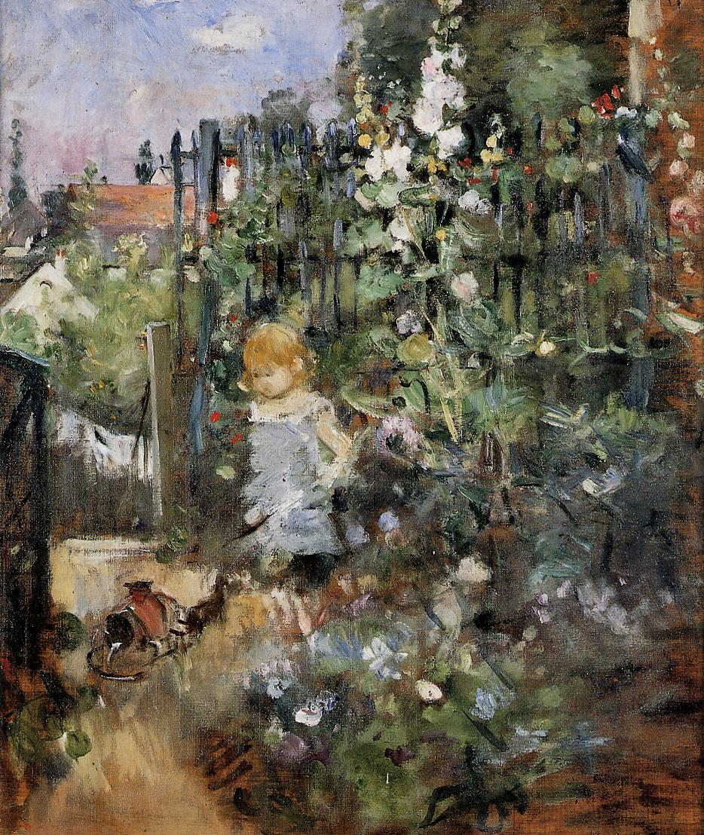
Berthe Morisot
玫瑰园里的孩子 Child in the Rose Garden, 1881
Oil on canvas, 50x42cm

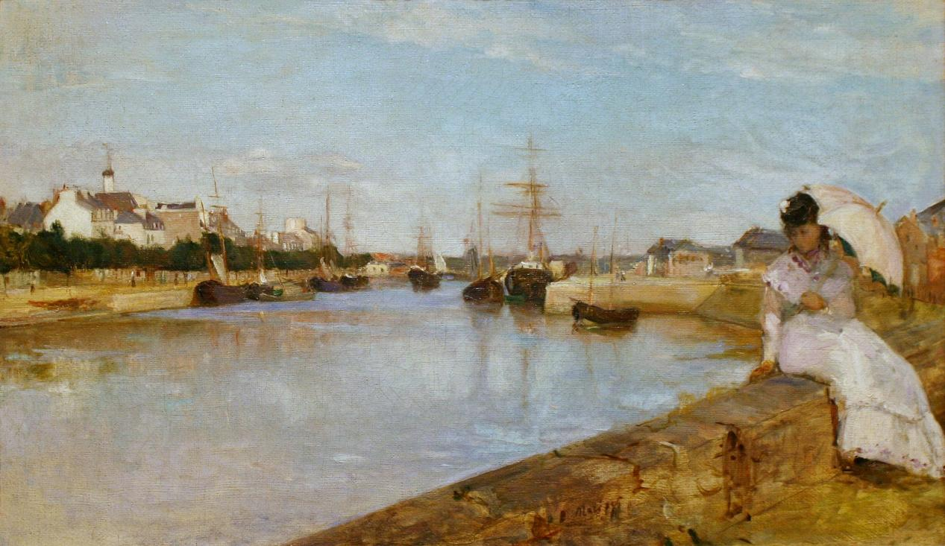
Berthe Morisot
洛里昂海港 The Harbor at Lorient, 1869
Oil on canvas, 43x72cm

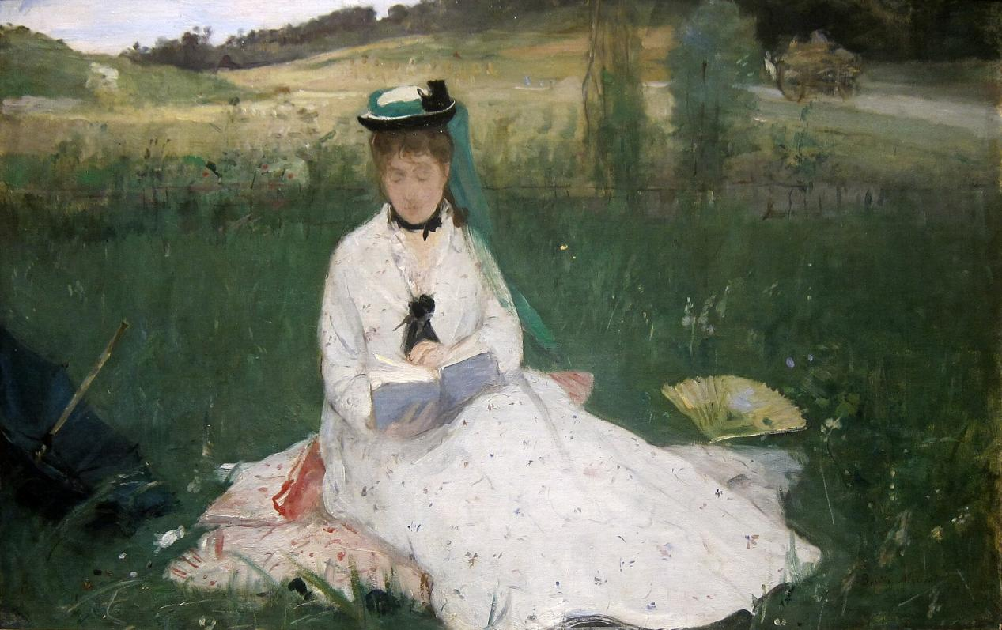
Berthe Morisot
阅读 Reading, 1873
Oil on canvas, 46x71.8cm

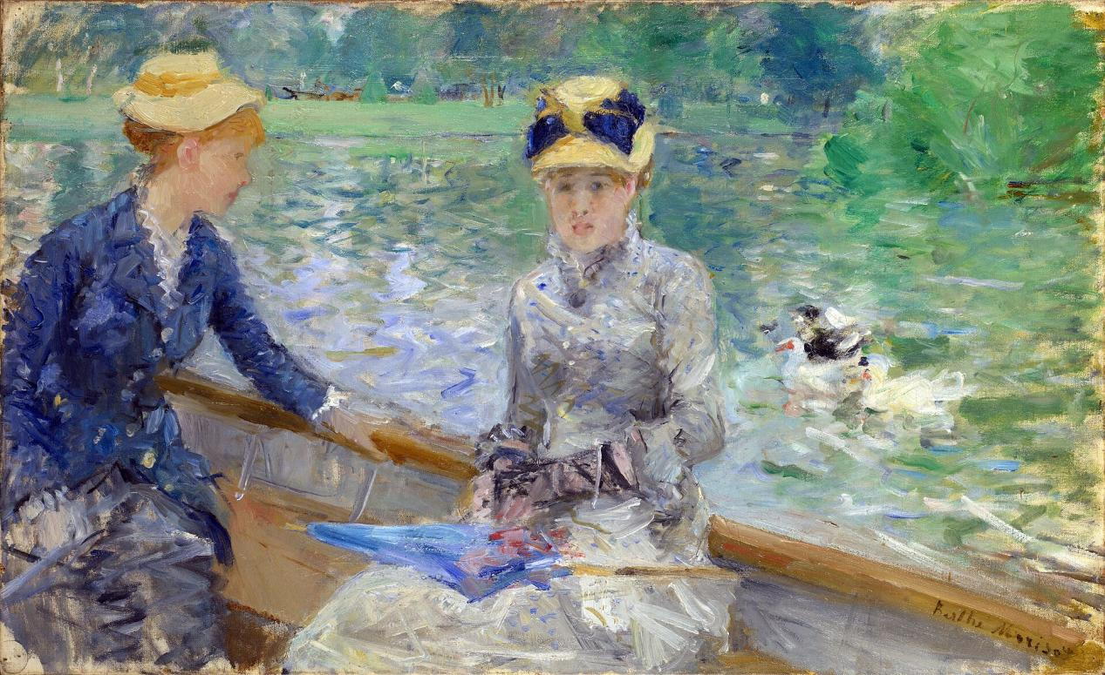
Berthe Morisot
夏日Summer Day, 1879
Oil on canvas, 45.7x75.2cm

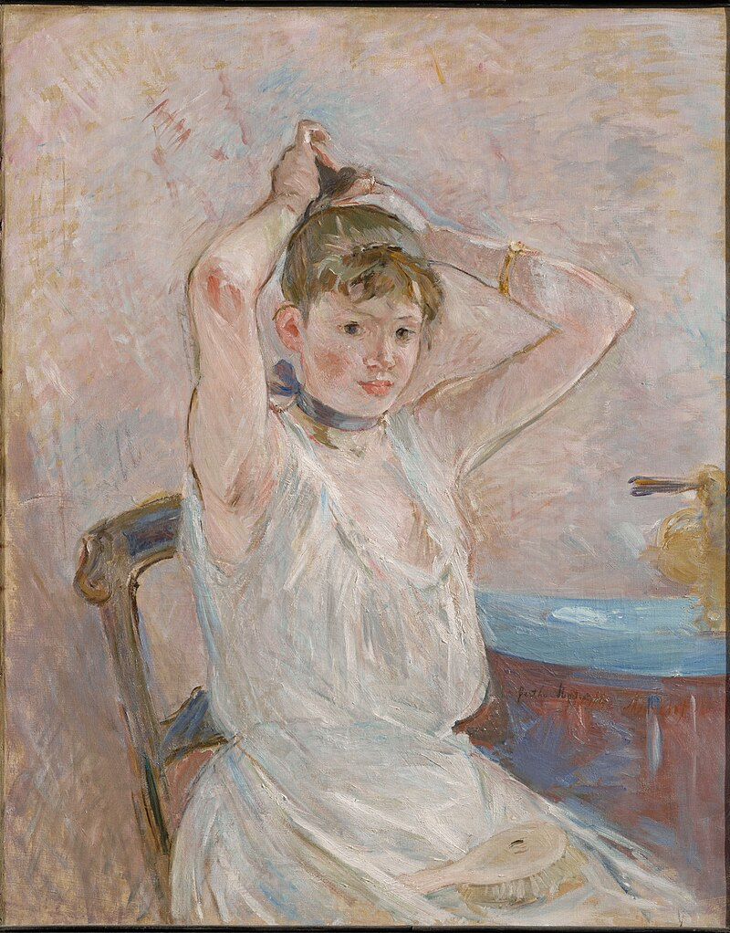
Berthe Morisot
沐浴(整理头发的女孩) The Bath (Girl Arranging Her Hair), 1885-1886
Oil on canvas, 66x81.5cm

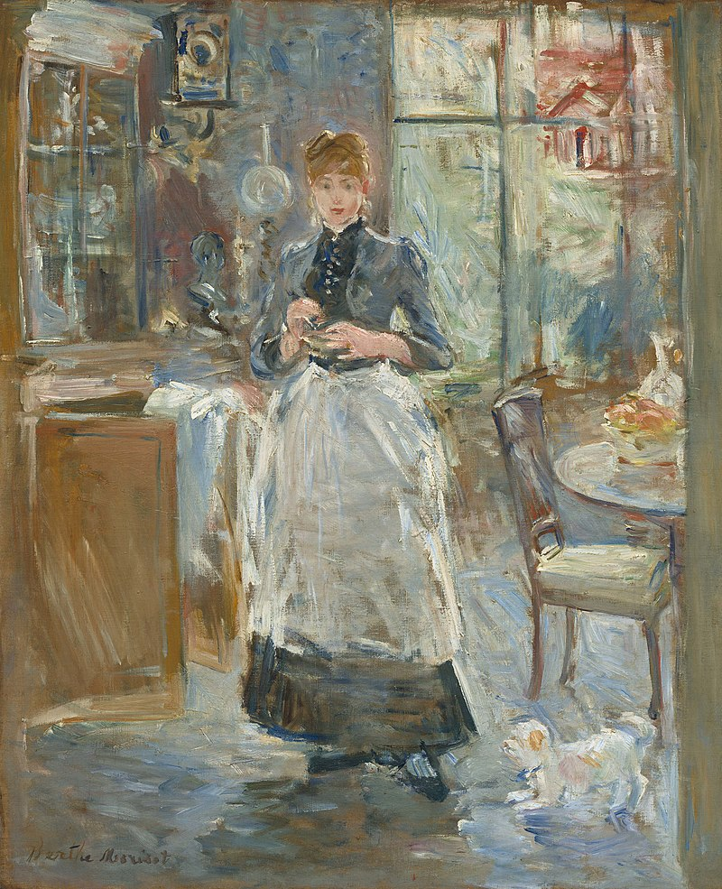
Berthe Morisot
在餐厅里 In The Dining Room, 1886
Oil on canvas, 61.3x50cm

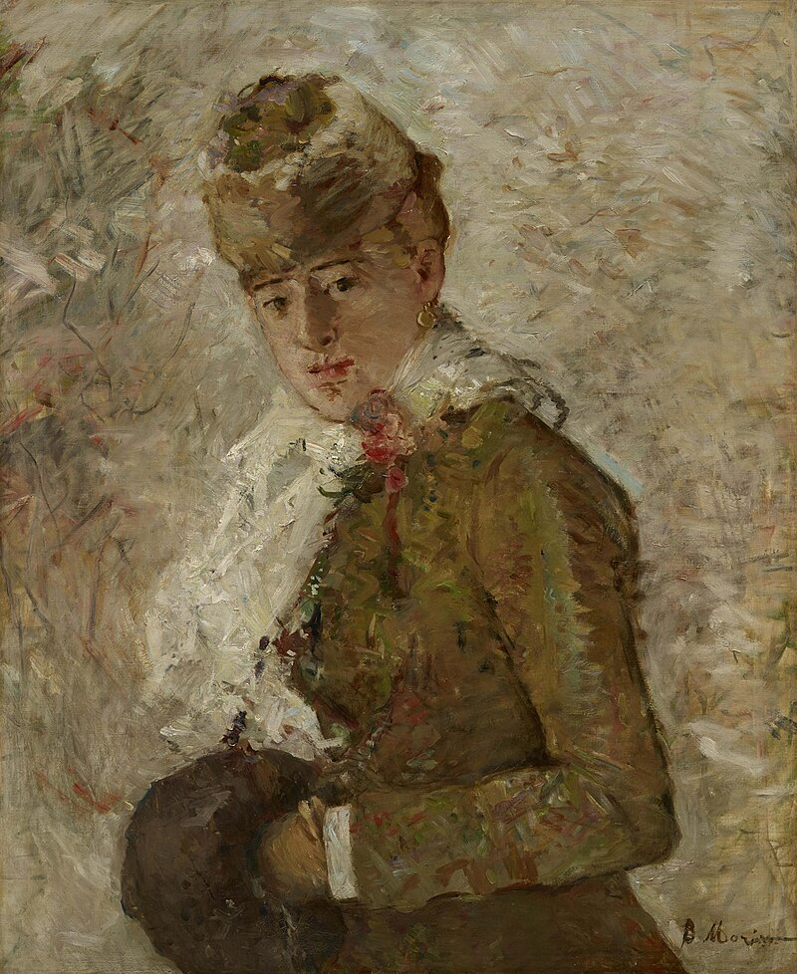
Berthe Morisot
冬天戴手套的女人 Winter aka Woman with a Muff, 1880
Oil on canvas, 73.5x58.5cm

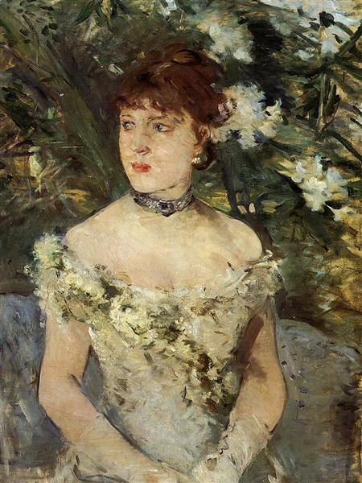
Berthe Morisot
身穿舞会礼服的年轻女孩 Young girl in a ball gown, 1879
Oil on canvas, 54x71cm

