**Carrie Cox**

**12/11/2022**

**Instructor: Pak Chung Wong**

**BAIS 6140 Information Visualization**

**Ditch or Get Hitched?**

**An Analysis on Women’s Age of First Marriage in U.S.**

This report and Tableau storyboard will show an analysis of what factors are prevalent in states with a young or old median age of first marriage. I chose this issue because of my own experience in the last year. As a 22-year-old in Iowa City, many of my friends are engaged and planning to get married within the next year. I have noticed that every state has its own culture that impacts whether individuals marry young or wait until they are older. When attending my cousin’s wedding in Missouri this fall, I was the oldest single person there. Most of my family members that live there either got married right out of high school or had a baby. On the other hand, I went to San Diego to visit my brother for Thanksgiving. California’s state culture is completely different and most of my brothers’ friends are in their late 20’s and have not even thought about settling down and getting married yet. For this reason, I wanted to see what factors are common in a state with a young versus olde age of first marriage to see what could be impacting this cultural trend.

Young marriages have a large economic and societal impact in the United States. Most of the negative effects of marrying young are on women in the relationship. These impacts can be seen through educational disadvantages, poverty, divorce, and poor health. Women who marry before the age of 19 are four times less likely to attend college and 50 percent more likely to drop out of high school (“August 2020 Child Marriage in the United States”, 2020). A young marriage can cause a woman to be financially dependent on their spouse and lead to them neglecting their own educational pursuits. The effects of marrying young not only put women behind but creates generational issues. Women who marry before the age of 20 are two-thirds more likely to get divorced within 15 years than women who wait until they are older (“Child Marriage in the United States”, 2022). A high divorce rate along with low income, increases the number of children living in poverty. This topic is not only interesting in determining states culture, but it can also be a predictor of states that are at high risk for child marriage. Child marriage can be defined as a marriage below the age of 18 and is currently legal in 43 states in the U.S. There are 20 states within the 43 that do not even require a parental waiver of marriage. This creates an issue because it allows minors between the ages of 12 to 17 to get married and engage in sexual activity. Between 2000 and 2018, 300,000 children were married (Dahl, 2020). At the Federal level, child marriage is even viewed as a valid defense to statutory rape. Overall, there are negative affects of young marriages on the individuals involved along with issues that face the country.

I used three sources to defend and demonstrate the importance of this topic. The first source is icrw.org which stands for International Center for Research on Women. ICRW is an organization focused on conducting research on issues that create gender inequity. This source created a pdf document on Child Marriage in the U.S. and the impact it has. The next source used is ncbi.nlm.nih.gov, which is the National Library of Medicine. This is an official website of the U.S. government and provides a description of a research study conducted on “Early Teen Marriage and Future Poverty”. The last research source used is equalitynow.org, which is an organization that fights for a just world for women. Equality Now is against Child Marriage because it can be an exemption to statutory rape and overall harmful to women.

**Description of Data**

This visual analysis is based on four different data sets. The main data set is from prb.org and contains data on the median age of first marriage of women in the U.S. There are two different time periods in this data set: 2006-2010 and 2015-2019. The other three data sources are used as potential factors in predicting/impacting the age of first marriage in each state. A data set on high school graduation rates in 2019-2020 is from US news and will be used to see if states with a young marriage age also have low graduation rates. Another data set is from chronicl.com and contains the poverty rates in each U.S. state from 2019. The last source of data is from cookpolitical.com and popular vote information from the 2020 presidential election in each state. It shows what party a state called, along with the percentage of voters that voted for the Democrat and Republican party. This source will be used to see if there are any trends with political affiliation and age of marriage. Political affiliation can be used as a summary of different demographics, religions, and beliefs within a state. For this analysis, the period of 2015-2019 will be used for the median age of first marriage in order to be relevant to the rest of the data sets from 2019-2020. The earlier time period of marriage age will only be used in comparison to the later time period.

**Below is the main question this visual analysis is aiming to answer, with supporting questions:**

1. What are the main trends/factors that may influence a state to have a young or older median age of first marriage?
   1. Is there a trend within geological position and age of first marriage?
   2. Do states with a higher population typically marry younger or older?
   3. Does the high school graduation rate within a country affect the age of first marriage?
   4. Is there a relationship between a state’s poverty rate and the median age of first marriage?

**Tableau Story Board (by page)**

Median Age of Marriage Overview:

The second page of the storyboard is an overview of the median age of first marriage. **Figure 1** shows a map of the United States colored by the median age of first marriage in 2016-2019 and labeled with the ages as well. We can see that the states in the lightest shade of teal are Utah and Idaho with median ages of 24.60 and 25.40 respectively. It appears that the states on the coast lines have older ages than the states in central U.S. These central states include Montana, Wyoming, North Dakota, South Dakota, Idaho, Utah, Nebraska, Kansas, etc. Comparatively, states such as California, Florida and Northeast states all have older ages. Just from this map, there is geological relations to the age of first marriage within a state.

The median marriage age data set included two averages for each state from the different time periods. While most of this report is focused on the later period, this page of the story board shows information on the differences in age based on the years. **Figure 2** shows the U.S. average age of first marriage based on the median ages from each state, for both time periods. In 2006-2010, the average age was 26.10. In 2015-2019, the overall age increased by 1.52 years to 27.62. Overall, this visual shows us that the U.S. is changing in cultural trends and the age of marriage is getting pushed to older ages.

While the median age of first marriage seems to be a cultural trend of a state, we can visualize what states are trending to marrying older. In Figure 3, the top 5 states based on greatest increase in age of first marriage from (2006-2010) to (2015-2019) is shown. These states are Delaware (+2.60), Florida (+2.30), Arizona (+2.20), Nevada (+2.10), and California (+2.10). All these states have had their median age of first marriage increase by over two years, within a short time. This shows us that the U.S. is changing in cultural trends and the age of marriage is getting pushed to older ages.

The last visual (**Figure 4**) on this page includes a cluster analysis of states by their median age of marriage and change between the time periods. This is a way to view states that are undergoing cultural trends causing their age to increase or to view states that are not changing much. The first cluster contains states that have an older marriage age, with relatively large change between the two periods. These states have a median age between 27.6 and 29.5, with a change between 1.7 and 2.6 years. Some of the states include California, Illinois, and Florda. The second cluster of states have an older age of first marriage, with a small amount of change in time periods. Their median age is between 27.8 and 30.6, with change only between 1 and 1.70. A few of these states are Minnesota, New York, and Ohio. The third cluster consists of states with a relatively young marriage age, yet large change. The median marriage age of this group ranges from 24.6 to 27.3 with a change between 1.3 to 2.10. This cluster was the most interesting as it has the states with a culture of marrying young, yet they age increased greatly. This could indicate that this group of states are undergoing changes that is impacting the culture. A few of the states in this segment are Utah, Idaho, and Texas. The fourth and final cluster has states with a young marriage age, and little change from the first period to the second. Median age ranges from 25.7 to 27 with a change between 0.30 and 1.20. Some of the states in this group are Indiana, Iowa, Kansas, and North Dakota (with the lowest amount of change out of all states at 0.30). Most of this last cluster is from the Midwest. This can be interpreted as many of the Midwest states have a culture of marrying young, and it does not seem to be changing much from 2006-2019.

States with the Youngest Age of First Marriage

|  |  |
| --- | --- |
| **State** | **Median Age of First Marriage** |
| Utah | 24.60 |
| Idaho | 25.40 |
| Arkansas | 25.70 |
| Wyoming | 25.70 |
| Oklahoma | 25.90 |
| Kansas | 26.10 |
| Kentucky | 26.40 |
| Montana | 26.40 |
| Alaska | 26.40 |
| Texas | 27.00 |

**Table 1: States with the Youngest Age of First Marriage**

This page of the story board focuses on the states with the 10 lowest median ages of marriage from the period of 2015-2019. The ten states in this visual can be seen in **Table 1**, in order from lowest median age of first marriage to highest. In this dashboard, there are five visuals, showing geographic location, population, high school graduation rates, and poverty rates within these ten states. **Figure 5** shows where these states are located within the U.S. They are all mostly centralized, except for Alaska. The color scale shows the age of marriage and gets darker as the age increases. All these states have a young median age of first marriage, with Utah the youngest at 24.6 and Texas the latest at 27.

**Figure 6** shows a bar chart visual of the 10 states focused on in this page, ordered by population size. This purpose of this chart is to evaluate if countries with young ages of first marriage, also have smaller populations. While Texas has a large population, partially due to size of the state, the rest of the states have relatively low populations. All besides Texas and Kentucky have a population under 4 million. This shows that it is common for states with a smaller population, to trend towards marrying younger. This may also show that states with smaller populations, that tend to have more rural areas, get married younger.

The next thing this dashboard analyzes is the high school graduation rates within these 10 states. This is found in **Figure 7**, with a color scale going from high rates in dark teal, to lower rates in lighter teal. The range in high school graduation rates in these states is from 81% (Alaska) to 94% (Texas). States with a 90% graduation rate and above are considered high. There are four states out of this group that are at a 90% or higher high school graduation rate. Montana and Arkansas are at 88% and Oklahoma and Idaho are at 87%. The only two states with relatively low rates are Wyoming and Alaska. Overall, there doesn’t seem to be a trend with graduation rates and states with a younger marriage age. Texas has the highest graduation rate in the U.S. and Alaksa has one of the lowest, so the full range is covered in this visual. These rates proved my initial theory, that these states would have lower graduation rates, wrong and shows that there does not seem to be a trend.

The last visual on this dashboard is a tree map of the 10 states with the youngest marriage age compared to poverty rates (**Figure 8**). The size of the sections in the tree map indicates the level of poverty. States with the highest rates of poverty have the biggest size and are towards the left side. Darker teal shows the poverty rate scaling as well, with darker teal showing higher rates. Kentucky has the highest percentage of poverty out of these states, at 16.30% and Utah has the lowest amount at 8.9%. Kentucky and Arkansas are #4 and #5 (respectively) for highest poverty rates in the U.S. Additionally, there is only one state out of this group that is under 10% for poverty. With these factors in mind, the states with the lowest median age of first marriage tend to have high poverty levels compared to the rest of the country.

Overall, this dashboard shows the following trends for states with a young age of first marriage: located centrally in the U.S., low populations, a range of high school graduation rates, and higher poverty rates compared to the rest of the country. All these visuals can be filtered to view only information for one state at a time. These trends can be interpreted in different ways. Most of these states being located centrally seems to say that states have a different culture based on their location. It also could go along with the population size trend and show that these ten states have a higher rural, country population and marrying young is more common. The high poverty rates could be interpreted as young marriages prevent individuals from advancing in their careers and becoming financially stable. Or this could show that individuals in these states get married younger to survive financial hardships.

One last conclusion from this dashboard is that Alaska is an outlier of this group of states. While it has a low median age of first marriage and low population, the rest of the factor are different. Its population is larger than Montana, but the size of Alaska is a lot larger and overall makes it not comparable. It also has the lowest high school graduation rate. While Alaska is a state of the U.S., it appears to have a different culture because of where it is located and the extremely low population for the given size of the state. In **Visual 1** you can see the dashboard filtered by just Alaska.

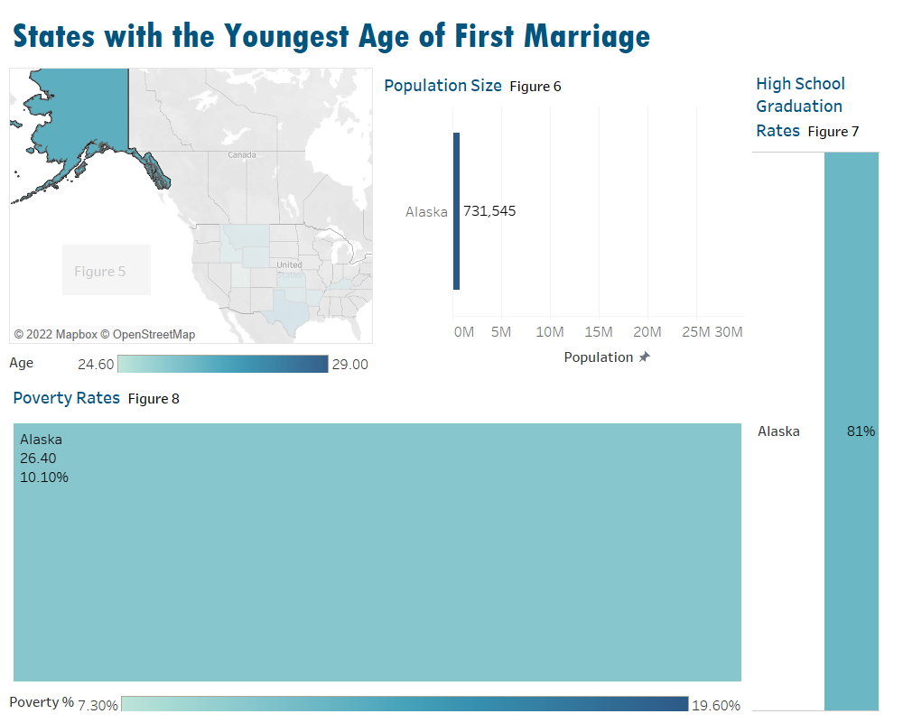

Visual : Alaska as an outlier.

States with the Oldest Age of First Marriage:

|  |  |
| --- | --- |
| **State** | **Median Age of First Marriage** |
| District of Columbia | 30.60 |
| Massachusetts | 29.90 |
| New York | 29.70 |
| Rhode Island | 29.70 |
| New Jersey | 29.30 |
| Maryland | 29.10 |
| Illinois | 28.90 |
| Pennsylvania | 28.70 |
| Connecticut | 29.50 |
| Hawaii | 28.40 |

**Table 2: States with the Oldest Age of First Marriage**

The next dashboard on the story switches over and focuses on the states with the 10 highest median ages of marriage from the period of 2015-2019. The ten states are shown in **Table 2** in descending order of marriage age. There are five visuals, showing geographic location, population, high school graduation rates, and poverty rates within this group of states. **Figure 9** shows the location of the states with the oldest median age of marriage. Most of the group is in the northeastern region of the U.S., except for Illinois, Hawaii and California. There seems to be a cultural trend in this area country of marrying at an older age. Many of these states have large city populations, which could be a factor in the marriage age as well. The color scale shows that the states will be presented in a darker teal for the older the median age is. All these states are in a dark teal as they age range spans from 28.40 to 30.50.

**Figure 10** shows the population for the states with an older age of marriage. New York has the highest population of over 19 million, with District of Columbia at 705,749. This visual shows that these states tend to have a higher population than states with a younger median age. The lowest of these states are Hawaii, Rhode Island, and District of Columbia, which can be seen as exceptions because they are an island, a very small state, and a district respectively. Even with this in mind, they have a higher population than a few of the states on the younger age of first marriage dashboard. This illudes to the conclusion that states with higher populations typically have a later marriage age. As stated before, this could be related to the large cities within these states that bring along a different culture than rural areas. In city areas it is much more common for women to focus on their education or career advancement rather than starting a family.

High school graduation rates for the top states for oldest marriage age are comparable to that of the younger states. The range of graduation rates is in dark teal to light teal based on the percentage of the population in **Figure 11.** While DC is very low for graduation rates, the rest of the states have percentages in the 80s and 90s. When compared to the younger age of marriage states, both rates have a range from around 80% to 93/94%. From this visual, one could conclude that there does not seem to be a significant difference in high school graduation rates from the states with a young marriage age versus states with an older marriage age. Both high school graduation rates (**Figure 7 and Figure 11**) show a similar scale within the group of states. This could also show that the marriage age is old enough in the U.S. that it does not affect the high school level significantly.

The last visual on this dashboard is a tree map based on state’s poverty rates in **Figure 12**. The size and color scale are by the percentage of poverty for population. These states are shown in light teal as they do not have high poverty levels. The range of the scale below is from 7.3% to 19.6%, which is the lowest and highest poverty percentages for all the U.S. The overall range was chosen so that one could compare the colors of this tree map, to the one on the dashboard before. States with an older median age of first marriage have lower levels of poverty when compared. Only one of the states in the younger age group was under 10%, versus this group of states have four states under 10% and two states at the 10% level.

Trends with the states with older marriage ages include being in northeastern U.S., high population, a range of high school graduation rates, and high poverty rates. While Hawaii, Rhode Island, and DC have some differences compared to the rest of the states in this group, there is not enough evidence to say any of them are outliers. They have a small population, but since their overall size is small, it is comparable to the rest. This dashboard can be filtered to look at individual states as shown in **Visual 2**.

Visual : Dashboard filtered to show New York's population, high school graduation rate, and poverty rate

Political Analysis:

A state’s political affiliation can stem from a combination of cultural factors. It can include demographic, education, occupation, religion trends and more. For this reason, the fourth dashboard on the story is focused on state’s political affiliation, to see if there are any trends within median age of first marriage. **Figure 13** shows a map of all states (besides Hawaii and Alaska) colored based on the political party that they called in the 2020 presidential election. Red is for Republican, and blue is for Democrat. The visuals at the bottom of the dashboard show the same map, but when it is filtered by the top 15 or bottom 15 based on age of first marriage. **Figure 14** is the map filtered by the 15 states with the highest age of marriage. All states on this visual are in blue for Democrat besides Florida (Hawaii is not shown due to size but is blue). Then in **Figure 15**, all 15 states are red when filtered by the states with the lowest age of first marriage, including Alaska. This dashboard shows that there is obviously trend with political affiliation and the median age of first marriage within a state. This is likely the strongest trend because of all the factors that politics encompass. This relationship between marriage age and political affiliation is the most evident out of all the factors. As stated before, this variable takes in account many cultural factors of a state and therefore makes sense that it would show the most obvious trend.

Political Correlation:

This dashboard takes a closer look within the politics of a state to see if a correlation with age of marriage is. After determining that the lowest and highest 15 states based on marriage age related to the two political parties, it seemed crucial to look at political percentages. The 2020 presidential election data set had the percentage of the population that voted for each party. There are two scatter plots on this page with trend lines that show the correlation between a state’s median age of first marriage and percentage of the population that voted for the given party. While it is a typical rule of thumb in visualizations to always have axis’s start at 0, these visuals break it. Because the median age of marriage spans only between 24 and 31 for this data set, the graphs are harder to interpret when the axis starts at 0. For this reason, the axis starts at 20 and goes until 33 to see the true trend of plots. **Figure 16** shows the correlation between the percentage of votes for Democrat candidates and the age of first marriage. There is a strong, positive relationship between these variables. The p-value is less than 0.05, which can be viewed as to say the percentage of Democrat votes is significant. The R squared is 0.7309, which shows strong correlation. In this visual, the R Squared is saying that 73% of the variation in a state’s median age of first marriage can be explained by the percentage of Democrat votes. Lastly, the equation *Median age = 9.24*Democrat % + 23.13* can be used to make future predictions. Similarly, to the Democrat correlation, **Figure 17** shows the relationship between median age of first marriage and percentage of population that voted Republican. There is a strong negative correlation between these variables, and it is found to be significant based on having a p-value less than 0.05. The R Square value is strong and says that 69% of the variation in median age can be explained by the percentage of a state’s population that votes Republican. An equation that can predict the median age of first marriage for a state is: *Median Age = -9.0119*Republican % + 32.05.* Overall, this dashboard shows that there is a strong correlation between a state’s political affiliation and its median age of first marriage.

**Conclusion/Main Takeaways**

Overall, the factors that seem to be prevalent and influence a state’s culture of marrying young include population, geological location, poverty rate, and political affiliation. These factors were determined from this visual analysis focused on the 10 states with the youngest median age of first marriage and the 10 states with the oldest age of first marriage. Conclusions from the analysis are summarized below:

States with a young median age of first marriage for women tend to have:

* Low state population size
* A central location in the U.S.
* High rates of poverty
* A political affiliation closest to Republican

States with an older median age of first marriage for women tend to have:

* High state population size
* Located in Northeastern U.S. or on the coast
* Low rates of poverty
* A political affiliation closest to Democrat

While high school graduation rates seemed like a factor that would influence the of marriage, there were no conclusions that could be made based on this analysis. Both the youngest and oldest states in terms of marriage had a range of high school graduation rates. There were states with the highest and close to the lowest in both groups of states. For future analysis, I think college graduation rates may be a better indicated to include. As the U.S. marriage age has gotten older over the years in this analysis, it could be possible that high school graduation is not as impacted. However, college graduation rates may be more impacted since it would be at a later age in life.

While there were trends within population, location, and poverty for the groups of states, there were not strong correlations between these variables. The only variables that had a strong correlation was political affiliation. This could be explained by understanding that a state’s political affiliation encompasses many factors and opinions that could influence the culture. Instead of just using information from the presidential election, this analysis could be done focused just on political affiliation, with a more detailed data set. This could look at different views in states to see if there are any correlations with age of first marriage.

There are a few other variables that could be factored in for a future analysis of marriage age. While population was looked in in this analysis, going further in depth and examining states and their percent of city and rural population could be interesting. It appears that state’s known for being more rural had a young marriage age, so looking at this further could benefit the analysis. Additionally, a variable on the percentage of different religions within a state may draw new conclusions. Religion is known to prioritize marriage and there may be younger median ages of marriage in states that have a higher percent of their population religious. For example, Utah had the youngest age of marriage in all the U.S. and is known for a high Mormon population. Similarly, factoring in the state’s culture and demographics of the population would be interesting to look at. This visual analysis story could also change and look at states with young and old ages of first marriage, along with divorce rates. I could not find a divorce rate data set for this analysis, but I was curious what that data would say. One could predict that younger ages of marriage would lead to higher divorce rates, however, it could relate more to the culture within an area rather than the age of marriage. Especially with variables such as religion and demographics, divorce may be more common in areas that are not religious rather than relating to initial age of marriage. This would be a more in-depth analysis on states and seeing what factors affect marriage and divorce.

I was originally interested in this topic because I would like to live in a state with a culture of marrying older. As a graduate student, I am prioritizing my education, career and finances over marrying young and starting a family. From this analysis, I have been able to see trends within different states and it has given me an idea of where I would like to potentially move. After conducting further research on the effects of young marriages, I have also realized that there are negative effects on the economy and individuals involved in young marriages. These effects tend to be most common on the women in the relationship. Getting married at a young age can prohibit a woman from academic and profession success, as well as contribute to health issues and poverty. Along with young marriages, child marriages are a serious issue in the U.S. While this report did not focus solely on marriages under the age of 18, it can be assumed that states with a young median age of marriage may have a higher population of child marriages. This is very concerning due to the harm on the individuals involved along with generational issues from these marriages. In conclusion, this visual analysis can be used to look at trends when deciding what type of culture a state has, as well as an indication of what states may have an issue with child marriages.

Report Sources:

“August 2020 Child Marriage in the United States.” *International Center for Research on Women,* https://www.icrw.org/wp-content/uploads/2020/08/child-marriage-in-the-US-prevalence-impact_8-2020_ICRW.pdf.

“Child Marriage in the United States.” *Equality Now*, 9 Nov. 2022, https://www.equalitynow.org/learn_more_child_marriage_us/#:~:text=Child%20marriage%20is%20currently%20legal,a%20parental%20or%20judicial%20waiver.

Dahl, Gordon B. “Early Teen Marriage and Future Poverty.” *Demography*, U.S. National Library of Medicine, Aug. 2020, https://www.ncbi.nlm.nih.gov/pmc/articles/PMC3000061/#:~:text=Women%20who%20marry%20while%20in,to%20have%20those%20children%20earlier.

Data Sources:

<https://www.prb.org/usdata/indicator/marriage-age-women/table>

<https://www.usnews.com/education/best-high-schools/articles/see-high-school-graduation-rates-by-state>

<https://www.cookpolitical.com/2020-national-popular-vote-tracker>

<https://www.chronicle.com/article/almanac-states>