Student Name: Colin Sexton
Class and Section Java II
Total Points (20 pts) __________________
Due: Nov 15, 2017 before the end of the class

Project: Displaying Words in Ascending Alphabetical Order

Problem Description:

Write a program that reads words from a text file and displays all the words (duplicates allowed) in ascending alphabetical order. The words must start with a letter. The text file is passed as a command-line argument. Here is a sample run:

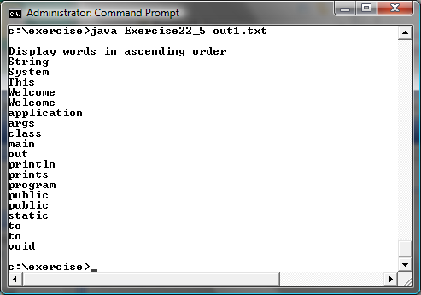

Paste your source code here:

File file = new File("dictionary.txt"); // Declares file to read from
Scanner file_in = new Scanner(file); // Scanner to read in file data
LinkedList<String> list = new LinkedList<>(); // LinkedList to store file data into for sorting

// Read until there are no more lines to read
while(file_in.hasNextLine())
{
String word = file_in.next(); // Set word to the next value
Collections.addAll(list, word); // Adds word to LinkedList list
}

System.out.print(list); // Prints out words in text document order

Collections.sort(list); // Puts documented words in alphabetical order

System.out.print(list); // Prints out words in alphabetical order

Screen shots:

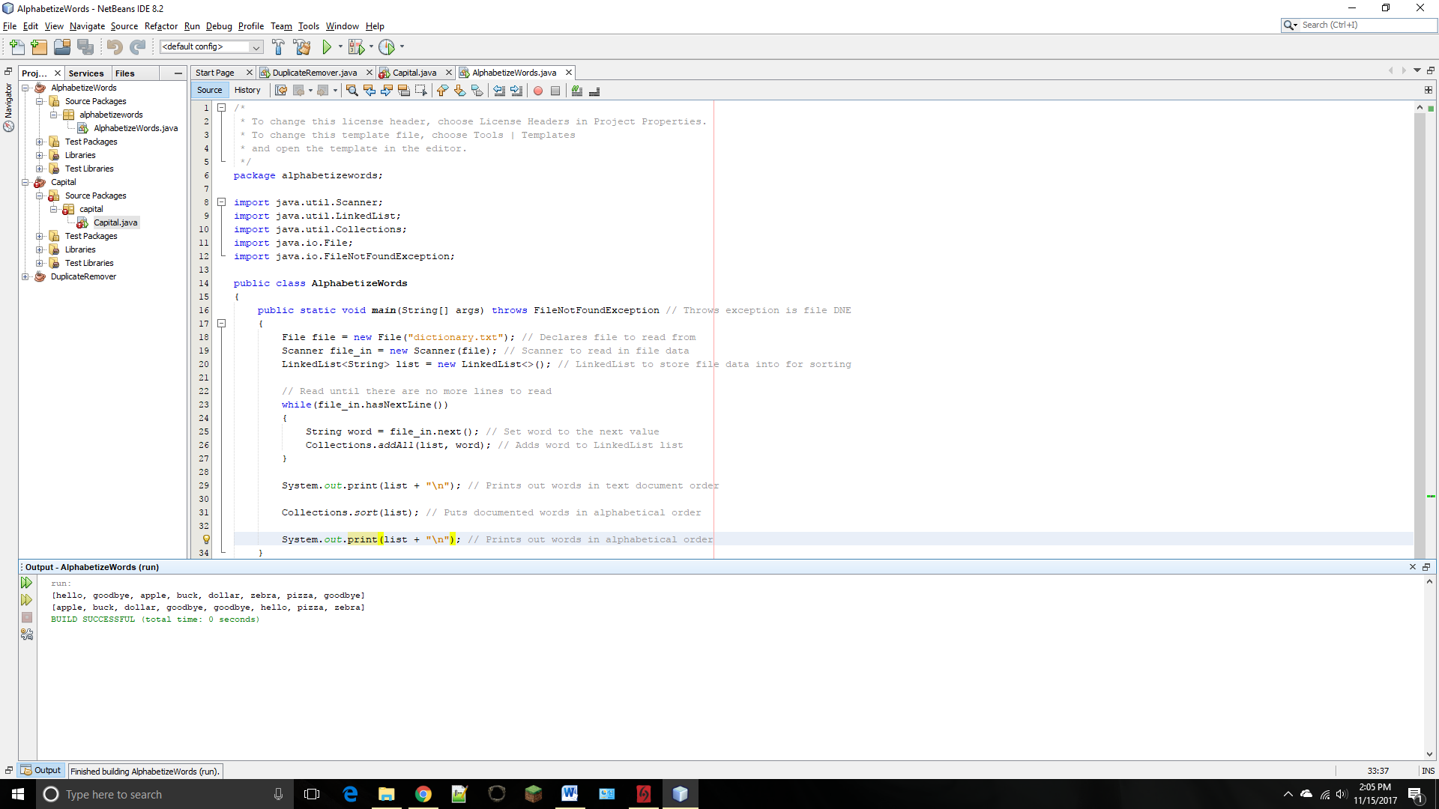

What to submit?

1. This document

2. Sava/Compile and Submit to BB (you must submit the program regardless whether it complete or incomplete, correct or incorrect)

Fill in self-evaluation:

- Can your program display words only? Yes
- Can your program display words in increasing order? Yes
- Can your program display duplicate words? Yes
- Can your program pass argument from the command-line? Yes

