**Discrete data TCO2/pCO2 Quality Control**

**Introduction:** What follows are the steps and rationale for quality control (QC) of Hakai discrete total dissolved inorganic carbon (TCO2) and carbon dioxide partial pressure (pCO2) data collected by our oceanography long-term monitoring program, from platforms-of-opportunity, or by citizen science groups. The QC process begins at the stage of compiling a metadata mastersheet (i.e. concatenating required information from field notes and analysis SRVC CO2 files).

**Flags:** 1 = good, 2 = replicate, 3 = questionable, 4 = not a number (NaN);

**Protocols:**

1. The QC process begins at the stage of concatenating analysis SRVC CO2 files. Combine analysis SRVC CO2 files with a metadata mastersheet that was generated during sample analysis with inputs (date, time, position, depth, project, etc.) from the sample field sheets. Match sample ID with sample ID in the metadata mastersheet and add a column “QC flags”. For each sample: add a “1” if no comment is given on the SRVC file and if not a replicate, add a “2” if the sample is one of a replicate set (usually triplicates), add a “3” if there is a comment specifying an issue encountered during sample collection or during sample analysis. At this time, add a column for storage time (days) and calculate the duration of time between sample collection and analysis date. If any of the CO2 samples have been stored for >183 days (~6 months), they receive a QC Flag = 3.

**NOTE:** *TCO2 data will have already been assessed during the analysis and generation of the SRVC file by examination of correction factors and variance (STD) of triplicate Certified Reference Material (CRM) runs or from Internal Reference Material (IRM).*

1. The second step takes place at the point of merging CTD data with a Matlab-ready version (text encoded so the file is all numbers) of the master file. Once data are merged (i.e. matched by time, position, depth), comparisons between NIST probe T (measured on deck following sample draw from the Niskin bottle) and CTD T (measured in the water column and extracted for the depth of the Niskin bottle – adjusted to RBR solo pressure measured on each bottle). YSI salinity (measured in the laboratory using a YSI conductivity cell that is calibrated using CRM salinity) with CTD salinity is also compared (all salinity units should be PSS-78). The NIST T and CTD T comparison does not provide a QC metric, but is useful to see the degree of on-deck warming of the sample prior to NIST T measurement. The YSI S and CTD S comparison, however, should be much closer, and large differences here should be indicative of sampling issue (i.e. either drawn from the wrong Niskin bottle or the Niskin bottle was fired at a shallower depth then the target depth. Note large departures between YSI S and CTD S tend to fall well below the 1:1 line indicating a lower YSI determined S relative to CTD S.) The root mean square error (RMSE) is used to flag data that exhibit a large departure between YSI S and CTD S. Typical RMSE values between YSI S and CTD S are < 0.2. To capture only large salinity departures, data that exhibit differences between YSI S and CTD S greater than 4*RMSE are given a flag of “3”.

**NOTE:** *If the project/platform CO2 data do not have accompanying CTD data, this step is skipped.*

* 1. If nutrient data were collected at the same time as the CO2 samples, they are merged at this point.CO2 system parameters are then recomputed with CTD temperature, salinity and pressure, we ignore the nutrient inputs for PO4, SiO2, NH4 (µmol kg-1 SW). Likely some pCO2 and TCO2 measurements do not have accompanying CTD data (due to issues with RBR CTD data processing). These data are given a QC flag of “4” due to the missing data.

1. The third QC step is to identify wild outliers in TA-S (from YSI) and/or TA:TCO2 space. Wild outliers for each case will deviate far from a linear relationship between TA-S (see Cross et al for example of non-conservative TA behavior in the Bering Sea) and be well outside of an expected TA:TCO2 range (0.98-1.14, for example), respectively. Mostly these cases are due to failing to fix the seawater sample during collection leading to wildly high pCO2 with elevated TCO2.
2. The fourth QC step is to attempt to identify samples that may have been impacted by sample collection (capping issues, not enough HgCl2 fixative) or analytical errors. Analytical errors in TCO2 should have already been accounted for during the SRVC finalization step where correction factors and variance in CRM/IRM triplicate runs are assessed. Therefore any remaining analytical errors should only be present in the pCO2 measurements (i.e. atmospheric contamination). In addition, issues resulting from poor sample collection should have magnified pCO2 signals due to carbon buffering (i.e. Revelle factor). Likely most erroneous pCO2 signals are due to poor sample collection. If using a CRM during the analysis, pCO2 is run on the last CRM triplicate in order to calculate CRM TA and compare it against the certified TA value. Close agreement between calculated and certified CRM TA provides some confidence in the pCO2 analysis. If using IRMs during the analysis, treat an IRM as a sample in the middle of the processing day with a TCO2 analysis followed by pCO2. In any case, within analysis batch analytical error and/or error due to poor sample collection may exist. Assessing this error requires either: (1) a third CO2 system measurement or (2) a reliable regional TA-salinity relationship. In most cases, we are without a third CO2 system measurement and therefore reliant on regional TA-S relationships.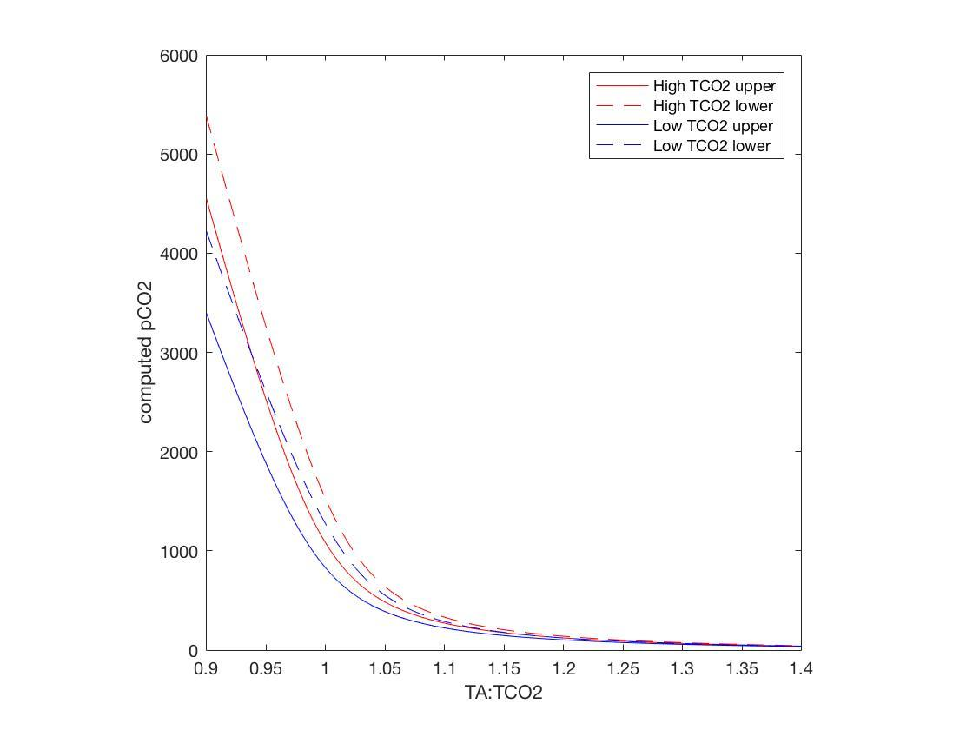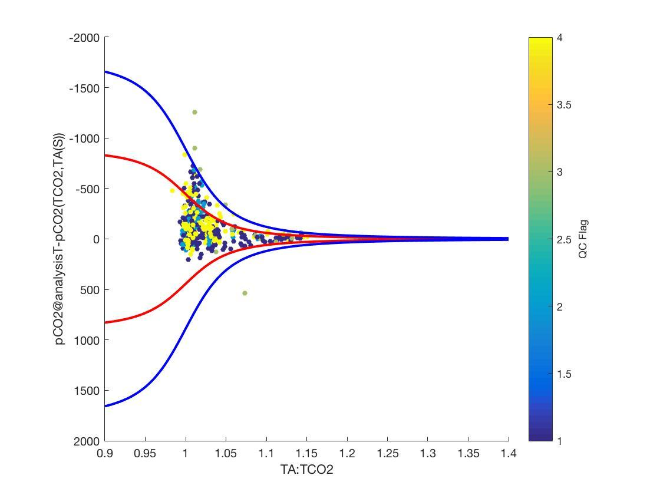

**NOTE:** *Do not proceed with this step if you are not confident in the available regional TA-S relationship.*

* 1. If analyzed pCO2 is erroneous, this should be identified by large differences with pCO2 computed from TCO2 and TA(S). The offset between these terms is highly dependent on TCO2:TA and the RMSE of the TA-S relationship (see figure). At high TCO2:TA (i.e. 1.4), the effect of the TA-S relationship RMSE on calculated pCO2, as defined by the difference between pCO2 (TCO2,TA(S)+RMSE) and pCO2 (TCO2,TA(S)-RMSE), is minimal as the sample is highly carbon buffered (low Revelle factor). At low TCO2:TA (i.e. 0.9), the effect of the TA-S relationship RMSE on calculated pCO2 is maximal due to the weaker buffering. The TA-S relationship RMSE is not impacted by TCO2 concentration, as indicated by the nearly identical spread between high and low TCO2 cases in the figure above. Therefore the difference between pCO2@analysisT and pCO2 (TCO2,TA(S), analysis T, YSI S) is TCO2:TA dependent, and values outside of the expected variance in pCO2 (TCO2,TA(S)) can be identified as questionable and given a QC flag of “3”. The figure on the left shows the maximum variance in pCO2 (TCO2,TA(S)) due to the RMSE of the regional TA-S relationship is ~800 µatm for TA:TCO2 ~0.9. The difference between pCO2 (TCO2,TA(S)+RMSE) and pCO2 (TCO2,TA(S)-RMSE) scaled up by 100% to account for possible divergence from the local TA-S relationship, is used as a threshold to identify questionable pCO2 data. This scaling is based on observed differences between continuous BoL TA(pCO2,TCO2) and TA(S), and is somewhat subjective as well as can be used to tune how aggressively data are flagged. The figure below shows an example of this approach using data from QU39. The red lines are the theoretical differences between pCO2 (TCO2,TA(S)+RMSE) and pCO2 (TCO2,TA(S)-RMSE) and the blue lines are those differences scaled up by 100%. Data that exhibit differences between pCO2@analysisT and pCO2(TCO2,TA(S)) outside of the range of the blue lines are identified as questionable and given a QC flag of “3”.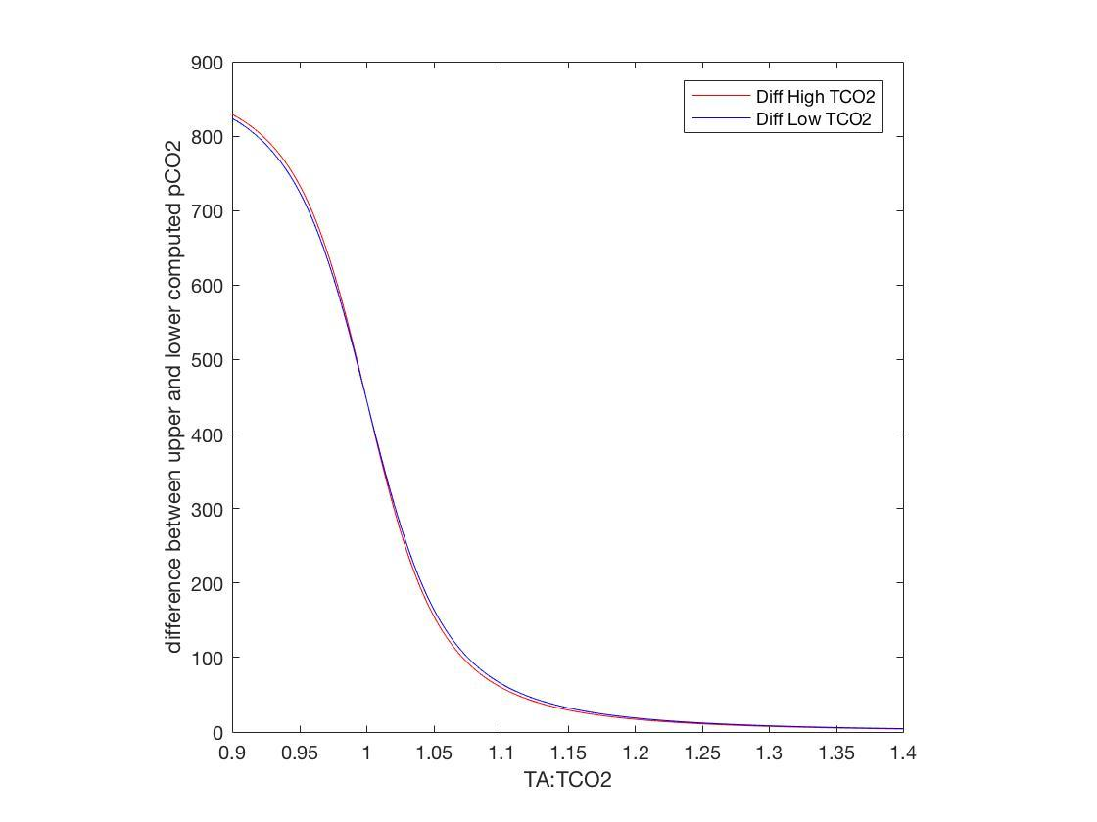

1. The final QC step is to look for inconsistencies in the data (i.e. mis-matched T, S, CO2 system parameters in a vertical profile suggesting the sample depth was not recorded correctly). This step is not programmable and occurs during the analysis of results.
   1. Looking into profile plots with other existing data primarily from the CTD sensors, i.e. does the pCO2 trend follow the oxygen signal within the water column? Visual checks are important and necessary for determining if the data were properly computed.