**4003 Assgn – submit this annotated document in Bb.**

1. Page 81/pick any of the problems

#11 Distance Per Tank of Gas

**screen shot of output goes here**

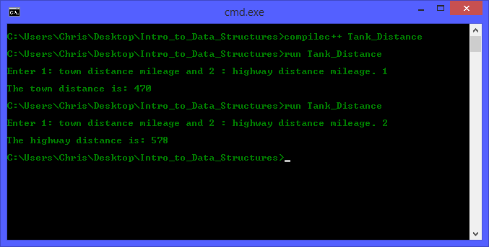

**Source code goes here (not a screen shot)**

#include "headers.h"

#include <iostream>

#include <iomanip>

using namespace std;

int main(int argc, char * argv[])

{

// Initialize and Declare Variable

int travel = 0;

int Number_of_Gallons = 20;

double Average_Miles_Per_Gallon = 0;

double Distance = 0;

double town_average = 23.5;

double highway_average = 28.9;

// Input

cout << "\nEnter 1: town distance mileage and 2 : highway distance mileage. ";

cin >> travel;

cout << endl;

// Town Calculation

if(travel == 1)

{

Average_Miles_Per_Gallon = town_average;

// Distance Calculation

Distance = Number_of_Gallons * Average_Miles_Per_Gallon;

// Output

cout << "The town distance is: " << Distance << endl;

} // Highway Calculation

else if(travel == 2)

{

Average_Miles_Per_Gallon = highway_average;

// Distance Calculation

Distance = Number_of_Gallons * Average_Miles_Per_Gallon;

// Output

cout << "The highway distance is: " << Distance << endl;

}

else

{

cout << "A Invalid Entry has been entered! Please try again!" << endl;

}

return 0;

}

2) Page 81/pick a different one of the problems

#10 Miles per Gallon

**Screen shot of output goes here**

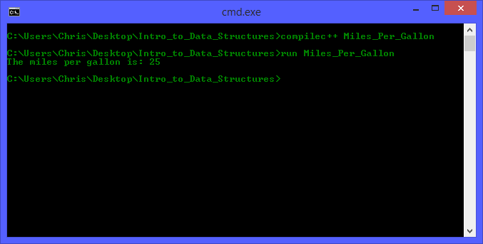

**Source code goes here (not a screen shot)**

#include "headers.h"

#include <iostream>

#include <iomanip>

using namespace std;

int main(int argc, char * argv[])

{

// Initialize and Declare Variable

int Miles_Driven = 375;

int Gallons_of_Gas_Used = 15;

double MPG = 0;

// Distance Calculation

MPG = Miles_Driven / Gallons_of_Gas_Used;

// Output

cout << "The miles per gallon is: " << MPG << endl;

return 0;

}

1. Page 81/pick a different one of the problems

#14 Personal Information

Not sure which way you wanted it so I did both. Hard code and Variable Substitution

**Screen shot of output goes here**

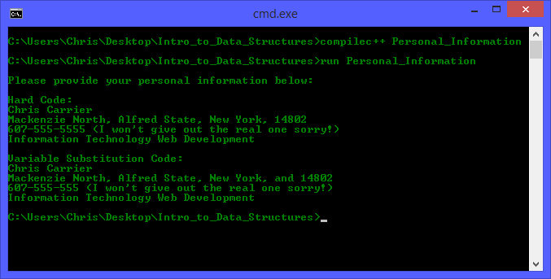

**Source code goes here (not a screen shot)**

#include "headers.h"

#include <iostream>

#include <iomanip>

using namespace std;

int main(int argc, char * argv[])

{

// Initialize and Declare Variable

string your_name = "Chris Carrier";;

string address = "Mackenzie North";;

string city = "Alfred State";

string state = "New York";

int zip_code = 14802;

string telepone_number = "607-555-555"; // I won't give out legit number sorry. If you need it though let me know.

string college_major = "Information Technology Web Development";

// Input

cout << "\n" << "Please provide your personal information below: " << "\n\n"

// Hard code

<< "Hard Code:" << "\n"

<< "Chris Carrier" << "\n"

<< "Mackenzie North, Alfred State, New York, 14802" << "\n"

<< "607-555-5555" << " (I won't give out the real one sorry!) \n" // I won't give out legit number sorry. If you need it though let me know.

<< "Information Technology Web Development" << "\n\n"

<< "Variable Substitution Code:" << "\n"

<< your_name << "\n"

<< address << ", " << city << ", " << state << ", and " << zip_code << "\n"

<< telepone_number << " (I won't give out the real one sorry!) \n"

<< college_major << endl;

return 0;

}