1测试java类

|  |  |  |  |  |
| --- | --- | --- | --- | --- |
| 测试类 | 测试方法 | 传参 | 结果 | 覆盖类 |
| EmpeController | getEmployeeByPage() | 李四 | v | 87% |
| deleteByPrimaryKey() | 3 | v | 87% |
| searchEmployeesByCriteria() | 图一 | v | 87% |
| addInterview() | 图二 | v | 87% |
| addEmployeeExercise() | 图三 | v | 87% |
| updateEmployeeExercise() | 图四 | v | 87% |
| exportData() | 李四 | v | 87% |
| importData() |  |  |  |

图一

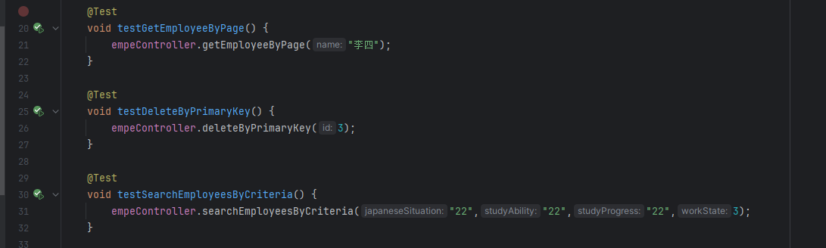

图二

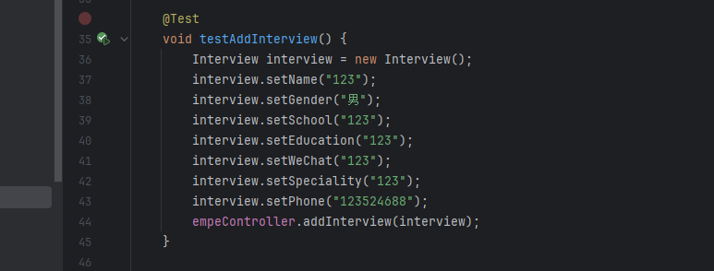

图三

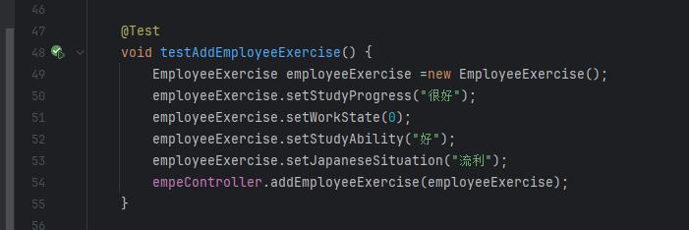

图四

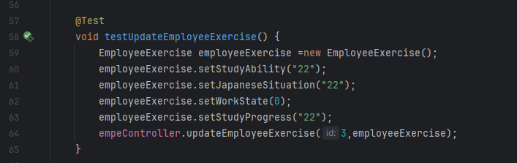

覆盖率结果图

