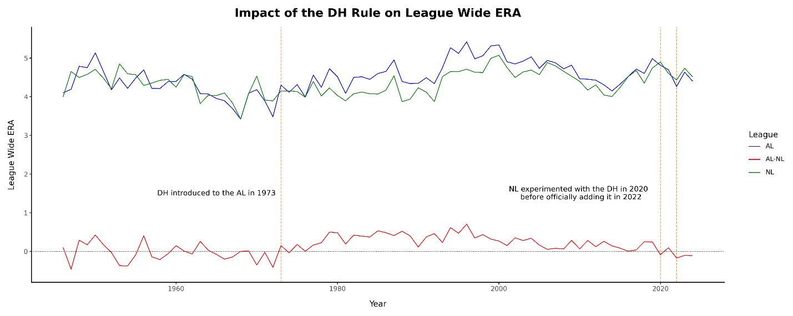

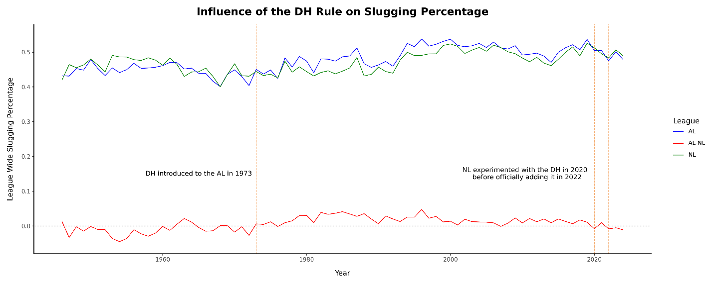

Since the DH rule was introduced in the American League in 1973, both ERA and slugging percentage generally rose in the AL and NL. From 1973 to 2020, when the DH was limited to the AL, the AL consistently posted higher values in both metrics. In 2020, when the DH was adopted league-wide, the gap closed and the leagues showed nearly identical performance. When the NL briefly removed the DH in 2021, the AL once again posted an advantage. However, beginning in 2022 when the DH became permanent across both leagues, the NL surpassed the AL in both ERA and slugging percentage.