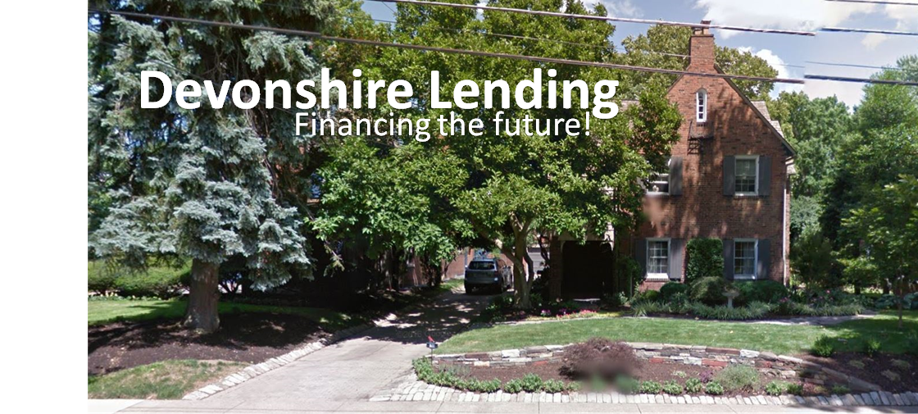

Team,

Devonshire Lending LLC has decided to build an Online Banking System (OBS) described in the companion document OBS Market Intent. They do not have sufficiently skilled internal resources to develop such a system, so they have engaged your services. This task is an addendum to the previously defined requirements task. As part of this contract they have asked that we elicit the requirements to support their future business objectives, design a solution to meet the organizational needs, and prototype the solution.

The customer would like the team to adopt an agile approach towards understanding, designing, and developing the system. While the required artifacts has been defined (and listed below), Devonshire Lending would like to see incremental versions of the system as the team progresses. While not required, this suggests an agile processes such as SCRUM (<https://www.scrumalliance.org/>) be used.

While some understanding of the system can be obtained from the provided Market Intent, this does not provide sufficient detail to understand and build the system. Furthermore, the ideas presented in this document are subject to change. Thus the stakeholders for this system should be engaged throughout the development lifecycle.

From a requirements perspective, the required deliverables are:

* A working version of the software that supports the requirements, including unit, integration, and other systems tests.
* A requirements document package including
  + Functional and Performance Requirements (F/P)
  + Operational and -ility Requirements, and (O/I)
  + Physical Characteristics and Design and Construction Standard Requirements (PCD/CSR)
  + Fully dressed use case documentation (UC)
* User stories (US)

We understand that completeness might not be possible in this phase of the project. Work with the stakeholders to ensure that the most important features are fully implemented and tested and consistent with documentation. All implementation should be implemented alongside and delivered with associated tests. Work with the stakeholders to deliver PCD/CSR requirements as makes sense given time available. What is delivered should be high-quality. Limit scope, not quality.

Thank you for your continued efforts at our company.

Sincerely,

Ajit Singh, Ph.D.

Director, eBusiness Consulting