**Instruction Jiajun Chen**

1.

* If you are using Mac/Linux system, please double click on the IMS.jar file to open the program.
* If you are using Windows system, please double click on the IMS.exe file to open the program.

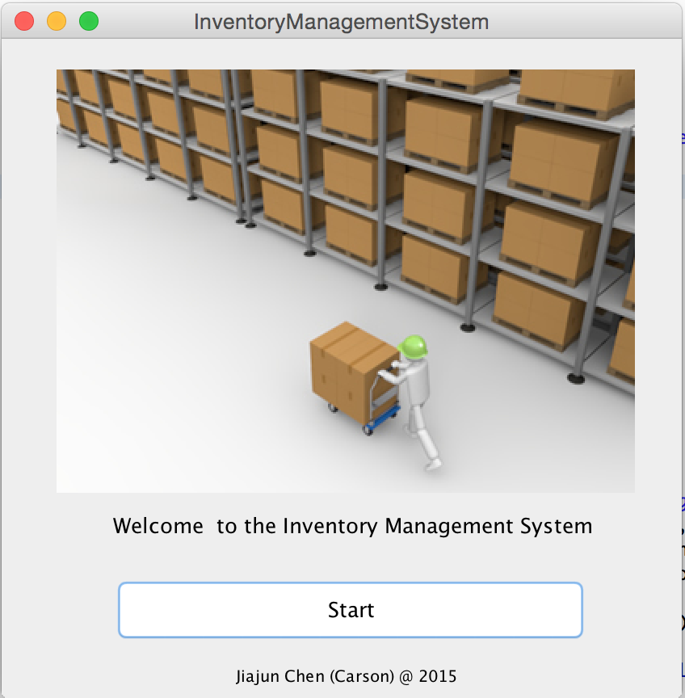

2. Click the “Start” button and direct to the operation page:

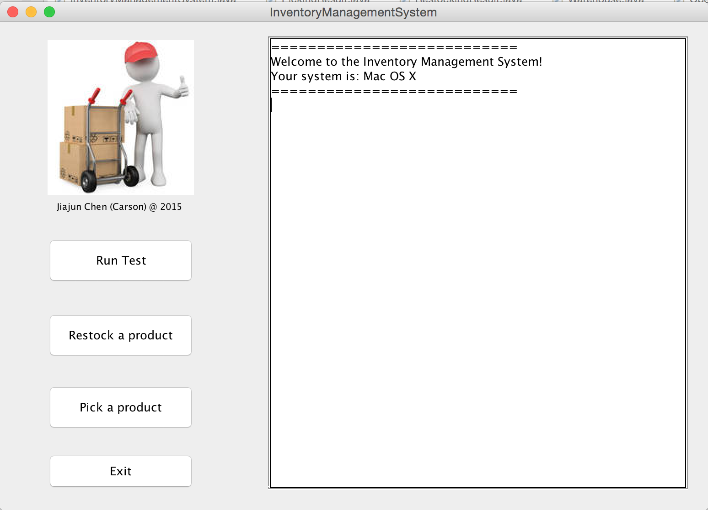

3. Click on the “Run test” button will run a test that do the restock request 100 times and the pick request 100 times:

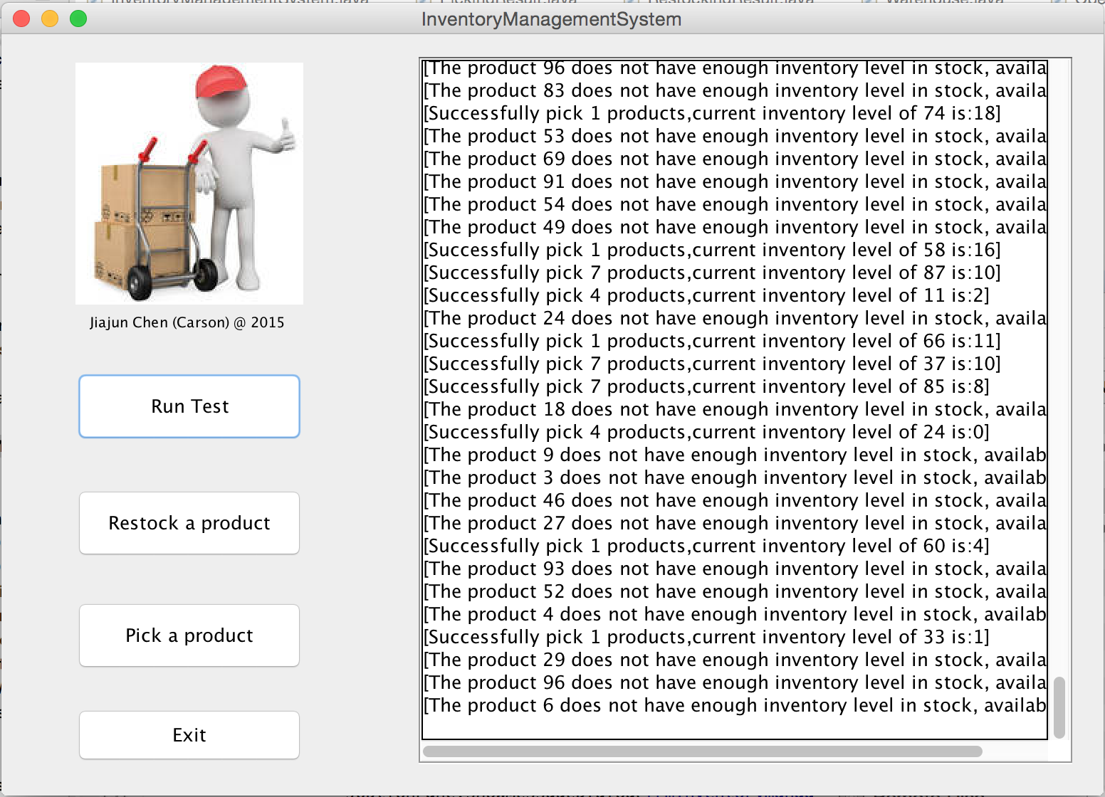

4. Click on the “Restock a product” button to restock a product manually:

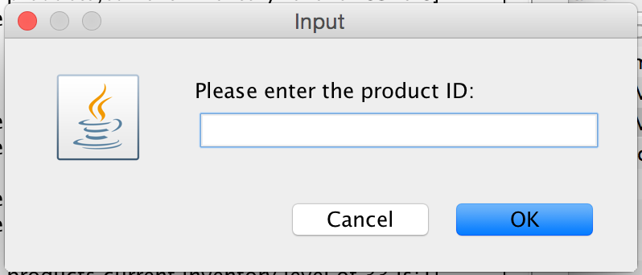

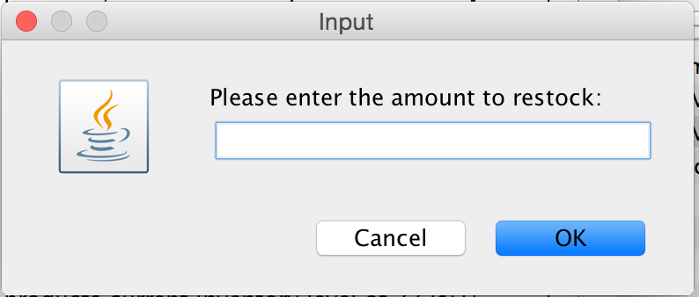

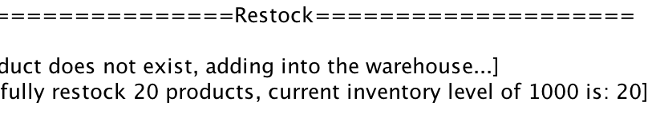

5. Click on the “Pick a product” button to pick a product manually:

