Final: Question 1 Report

By: Carson Ellsworth

**Q1-A:**

For this question I was tasked to write code that displays 5 random images within the training set and then 5 random images within the testing set. The code written displays one image at a time in which you will need to exit out of each image to bring up the next, first five from the testing, then followed by five from the training set.

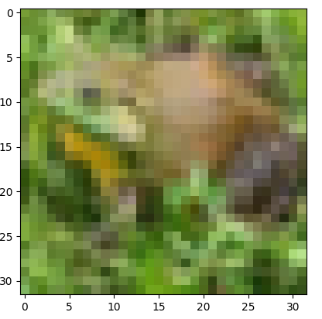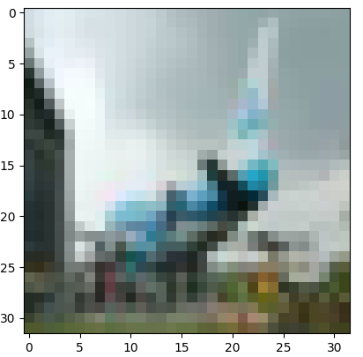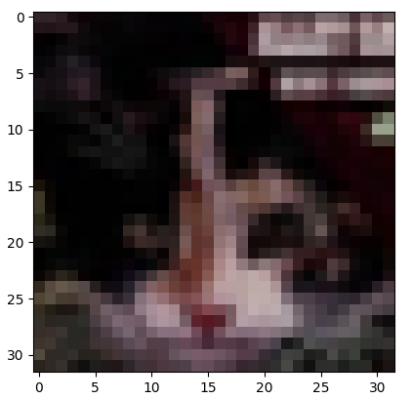

Random sample of five images from the training set

Random sample of five images from the testing set

**Q1-B:**

For this problem I was to construct a 1000 x 3072-dimensional matrix from the training set of images. Then run a PCA analysis on the matrix to obtain the top 120 components. Below are the components and how much data variation is represented by those components.

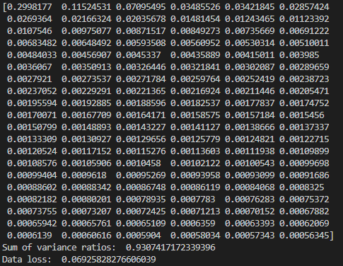

**Q1-C:**

The final part of question 1 wants me to create a convolutional neural network and test it against the image set. To evaluate the performance of different aspects of the network I created multiple models with a different number of “layers”, where each “layer” is comprised of a convolution layer, ReLU activation layer, and either an average or max pooling layer. I then created two-, three- and four-layer models that used either average pooling or max pooling giving a total of six models to evaluate. The metric used to determine the model’s performance was accuracy over epoch number, which boils down to a model that could achieve higher accuracy in the minimum number of epochs would be considered the best model for the given data. Below are the results of testing each model over the span of twenty epochs.

**Results:**

The results of the test seem to indicate that the two-layer model performed the best over the dataset, this could be because a simpler model is often better at generalization cases which is especially useful in classification problems. It is also worth noting that average pooling seems to be slightly better in all cases with the biggest difference in the four-layer models.