 

# ELEC S212

**Network Programming and Design**

## 2018 Autumn Presentation

**Assignment One**

Please e-submit this TMA via the OLE

### by 23 Nov 2018, 23:59

**Preamble**

Dear ELEC S212 Students,

You must submit your answers to this assignment by the cut-off date: **23 Nov 2018**.

If you need to seek permission to submit your assignment after this date, then make your request through the ELEC S212 OLE **before the cut-off date**. Failure to obtain permission for late submission will result in OLE rejecting the mark awarded by the tutor.

All solutions to questions must be presented to your tutor in electronic form. Solutions requiring written answers must be presented within a single solution file and submitted to your tutor through your OLE account. To ensure that your tutor can read your solution file, it must be prepared in a format that Word can display. If you are unsure about the format to be used, then you are strongly advised to discuss this with your tutor well in advance of submitting your solution file. Your tutor is not responsible for finding ways in which your solution file can be converted into a suitable format.

When you have prepared your solution file, then you must load it into your ELEC S212 OLE account. You must name your solution file using the convention. For example, if your student number is 88545673, then your file for TMA01 must be called ‘s8854567a1.doc’ or equivalent.

Copying of any part of another student's solutions or quoting the work of someone else without acknowledgement is a serious disciplinary offense for which the minimum penalty is the rejection of the mark for the whole TMA.

After marking your tutor will enter the marks and upload the marked script into your OLE account.

Steven Choy

ELEC S212 Course Coordinator

### Question 1 (24 marks)

1. Discuss why **layers** are used to model and analyze computer networks. **(4 marks)**

|  |  |
| --- | --- |
| **Advantage** | **Explanation** |
| 1. **Standardized** | Different vendors of network equipment can communicate with each other without getting confused. |
| 1. **Easy to analyses the network status** | For example, network monitor software -Wireshark can easy to capture network traffic through different layers. |
| 1. **Simplify the network** | Each layer is Independent Layer, clearly identify the protocol. |
| 1. **Easy to troubleshoot the network problem** | Share upper-layer & lower-layer information, provide information to troubleshoot the network problem. |

1. Briefly describe **CSMA/CA** and **CSMA/CD**. What is the major difference between them? **(8 marks)**

|  |  |  |
| --- | --- | --- |
|  | **CSMA/CA** | **CSMA/CD** |
| Full Name | Collision Sense Multiple Access / Collision Avoidance | Collision Sense Multiple  Access / Collision Detection |
| Transmission method | Wireless (EG. 802.1g, n) | Ethernet (EG. CAT6) |
| Difference | Sending packets at the same time but cannot detect any collisions on the channel, only try to 'avoid'; | * Before sending out the data, listen to the media status. * After waiting for a period (no one use), then send out the data. * If 2 or more pc transmit at the same time, collision will be detected. |

1. What are the benefits of using **switched Ethernet** over the original **shared Ethernet**? Why are such benefits possible? **(6 marks)**

|  |  |  |
| --- | --- | --- |
| **Name** | **Switch Ethernet (Switch)** | **Share Ethernet (Hub)** |
| Physical protocol | Star Ethernet   * Better scalability * Failure of one link will not affect another pc | Bus Ethernet   * Single point of failure |
| Speed | Full-Duplex | Half-Duplex |
| Collision Size | Less Collision | More Collision |

1. **Despite the complexity of TCP, its basic operation can be reasonably simplified by describing its primary functions. Use your own words to describe the working of the following three main tasks that TCP performs. (6 marks)**
   1. Data multiplexing

Multiplexing means that different application processes on the sender can use the same transport layer protocol to transmit data.

* 1. Data reliability

TCP is using Three-way Handshake to confirm data reliability. SYN – SYNACK – ACK.

Following is the process,   
Device A sends a SYN to start the connection process. (SYNchronize)

Device B acknowledges with a SYN-ACK (SYNchronize-ACKknowledge)

Device A sends a ACK to confirm data received.

The connection is completed!

* 1. Flow control

Flow Control is used to balance the traffic between the transmitter and the receiver, avoid high-speed transmissions and low-speed receivers.

### Question 2 (18 marks)

The following questions are about general concepts in computer networking. You should answer them **in your own words**.

1. Compare LANs against WANs in terms of the following properties: covered area, data transfer rates, connection technology, and prevalent standards/protocols involved. **(8 marks)**

|  |  |  |
| --- | --- | --- |
|  | **Lan (Local Area Network)** | **Wan (Wide Area Network)** |
| **Covered Area** | Small Area (Home Network, computer in office or home) | Large Area (Connects geographically separated LANs, Regional) |
| **Data transfer rates** | High Speed 10/100/1000(Mbps) or more | 56Kbps – 200 Mbps,  Less speed than Lan |
| **Connection Technology** | Ethernet, Tokin Ring | Frame Relay, Leased Line |
| **Prevalent Standards/Protocols** | IEEE 802.3 | Multiprotocol Label Switching (MPLS) |

1. These are some of common devices to build networks: hubs, bridges, switches, routers, and repeaters. Use your own words to describe what they do and the main differences between them. **(10 marks)**

|  |  |
| --- | --- |
| Repeater | * OSI Layer 1 device * Connect network device * Transmit the electronic signal * One Collision & Broadcast domain |
| Hub | * OSI Layer 1 device * connect network device * Half-Duplex * Transmit the electronic signal * One collision & Broadcast domain * multiport than repeater |
| Bridges | * OSI Layer 2 device (How does it work?) * Less port switch |
| Switches | * OSI Layer 2 device * Less collection problem * Make forwarding decision based on mac-address-table * Full duplex speed * More port than bridge |
| Routers | * OSI Layer 3 devices * select the shortest path to route packet * Make forwarding decision based on destination ip address |

### Question 3 (20 marks)

1. Explain **3 differences** between MAC addresses and IP addresses. **(12 marks)**

|  |  |  |
| --- | --- | --- |
|  | IP Address | Mac Address |
| Size of address | 32bits | 48bits |
| Layer operating at | TCP Layer 3 – IP Layer | TCP Layer 2 – Data link Layer |
| Addressing Scheme | Hierarchical | Flat |
| Logical Significance | Logical address | Physical Address |

1. The following illustrates a TCP connection establishment between a web browser and a web server. Determine the values for (A), (B), (C), (D), (E) and (F) respectively. **(8 marks)**

Client Web Server

SEQ=800, DATA-SIZE=200 bytes

src_port=1967, dst_port= 443

SEQ=1567, DATA-SIZE=100bytes, ACK=(A),

src_port=(B), dst_port=(C)

SEQ=(D), DATA-SIZE=200 bytes, ACK=(E)

src_port=1967, dst_port=(F)

|  |  |
| --- | --- |
| A | 801 |
| B | 443 |
| C | 1967 |
| D | 801 |
| E | 1568 |
| F | 443 |

### Question 4 (18 marks)

Complete the Lab 1.2 – Networking I: Fundamentals (as attached).

1. Submit the filled Table 1.2.1 for Step 2, and the screen dumps for Step 4 (traceroute) and Step 5 (host). **(6 marks)**

|  |  |  |  |
| --- | --- | --- | --- |
| **Hosts** | Minimum round-trip  times (ms) | Average round-trip  times (ms) | Maximum round-trip  times (ms) |
| localhost | **0.037** | **0.079** | **0.092** |
| 103.247.158.245 | **3.252** | **6.486** | **9.644** |
| www.ouhk.edu.hk | **4.143** | **6.863** | **11.198** |
| www.berkeley.edu | **182.836** | **186.919** | **189.797** |
| www.einst.ee | **229.876** | **265.243** | **330.641** |

**Step 4 (traceroute)**



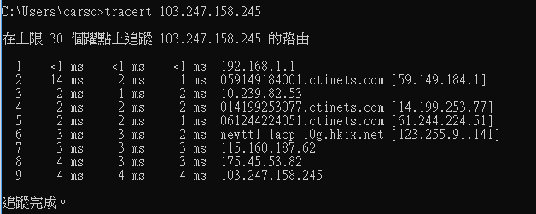

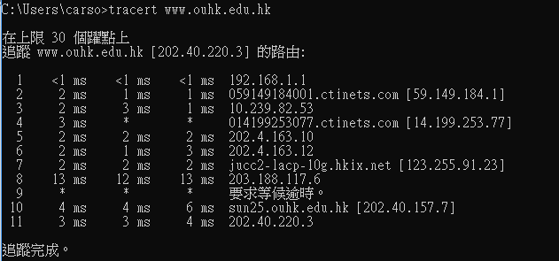

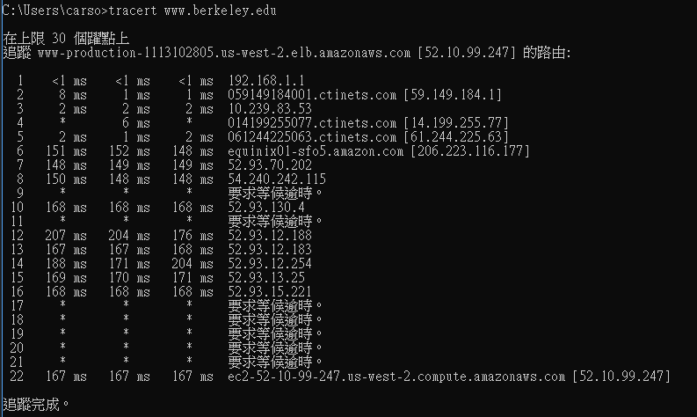

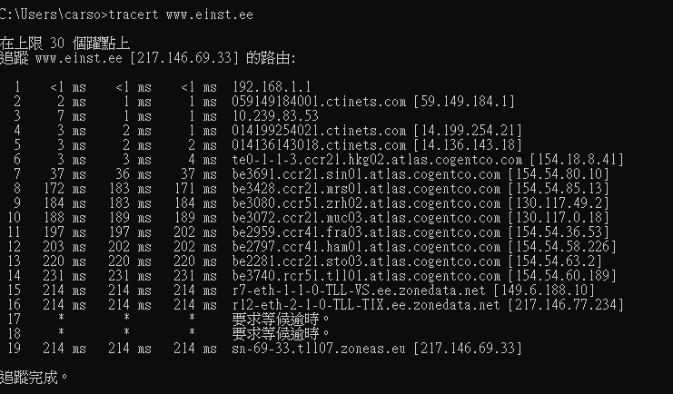

**Step 5 (host)**

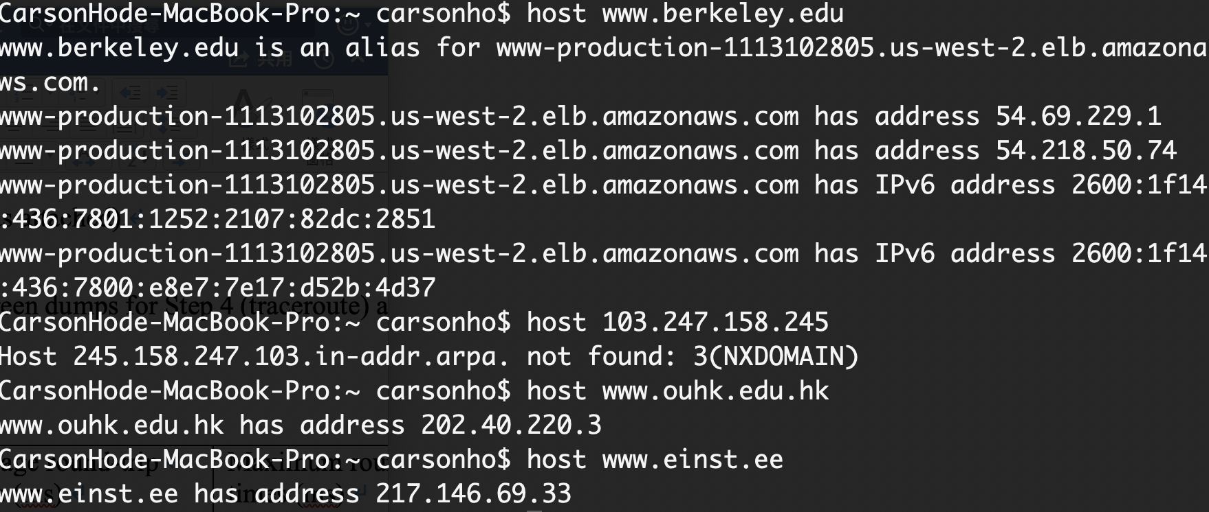

1. Answer the six questions in the section "questions and exercises". **(12 marks)**

Q1. Any 5 application protocols listed in the article. Both full name and acronym must be provided.

|  |  |
| --- | --- |
| Acronym (port no.) | Full Name |
| FTP (21) | File Transfer Protocol |
| SSH (22) | Secure Shell Protocol |
| SMTP (25) | Simple Mail Transfer Protocol |
| DNS (80) | Domain Name System |
| HTTPS (443) | Http protocol over TLS/SSL |

Q2. Just run “man ifconfig” and read the output. What is the command and options for doing so? You cannot try this command in any of OUHK servers as you are NOT administrator. However, you can try in your own Linux system with “root” account, if you have.

Command:

If



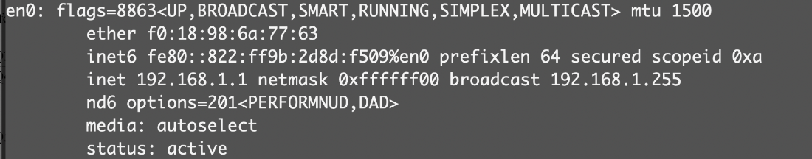

Q3.What ports are used by WHOIS and DNS respectively?

|  |  |
| --- | --- |
| Name | Ports |
| WHOIS | 43 |
| DNS | 53 |

Q4. What are forward DNS lookups and reverse DNS lookups?

|  |  |
| --- | --- |
| Forward DNS lookup | using an Internet domain name to find the IP Address. |
| Reverse DNS lookup | using an Internet IP address to find a domain name |

**Q5. Read the man page of nslookup. What are the commands that you could use to perform Step 5 using nslookup instead of host?**

Host is a simple & quick answer. For example: host & nslookup (website name), which can querying the DNS.

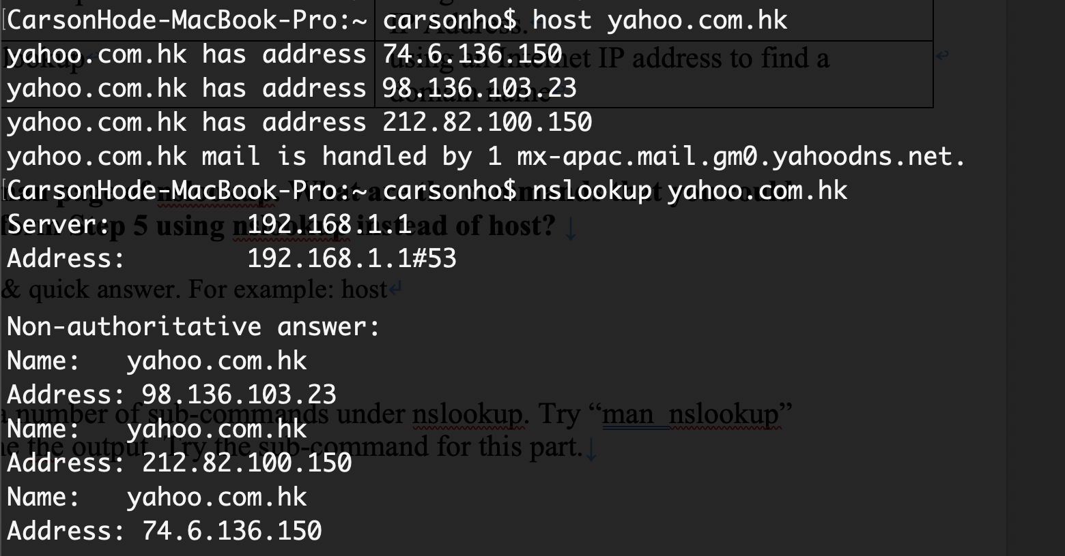

Q6.   
Find the names and IP addresses of the DNS root servers

|  |  |
| --- | --- |
| Root Server | IP |
| A.root-servers.net | *198.41.0.4* |
| B.root-servers.net | 199.9.14.201 |
| C.root-servers.net | 192.33.4.12 |
| D.root-servers.net | 199.7.91.13 |
| E.root-servers.net | 192.203.230.10 |

### Question 5 (20 marks)

Imagine that your boss has asked you to work with Blue Ocean Computing Limited, a small company that grew large overnight and needs recommendations about network set-up and design. Recently, a venture capital company has purchased Blue Ocean Computing Limited and wants them to move into a new three-storey building. The venture capital company plans to expand the original eight engineers to 80. They also plan to add 20 employees for a business department and a human resources department. All employees will use Windows 7 Professional workstations and connect to two servers running Windows Server (one for business information and one for research use). In a few months, they will add another Linux server as a dedicated FTP server (which you are going to develop for them as well). Give your recommendations with explanations for the proposed network on:

1. Physical network topology. **(4 marks)**

I would choose Star Topology.   
- It’s simple. It’s easy add or remove pc.

Its is not single point failure. One pc gg will not cause other pc problem.

The install is easy (plug )

Easy to troubleshooting

For example, all workstation through the network cable connect to the switch.

- Reliability.   
It’s isolated, when one of the workstations down, it will not affect another workstation.   
All other pc can still work functionally.

* Scalability (easy)
* Single point of failure (NO)
* Installation (EASY)
* Ease of troubleshooting & management (EASY)
* ….

1. Network access technology (i.e., Ethernet, Token Ring, Wireless, etc.). **(4 marks)**

**I would choose Ethernet.**

1. Network cable. **(4 marks)**

**Unshielded Twisted pair cable.**

1. Network protocol. **(4 marks)**

**IP**

1. If Linux were used for all servers (instead of two servers running Windows Server and one Linux), would your answers in parts (a), (b), (c) and (d) be changed? Why and why not? **(4 marks)**

**Linux No one need to change**