Hint file for TMA04, 2018 (group 1 & 2)

Note:
1. Read carefully the question and make sure you understand what the question asks. Never answer with a lot of un-related description. Unrelated answer doesn’t get any mark and marks may be deducted

2. Read carefully about submission format stated in tma page of my teaching website.

Q1
This question lets you experience and understand how network analyzer work and its functions. This question also tests your understanding on characteristics of MAC and IP address and different header fields in TCP/IP packet

You need to download and install Wireshark, a free network analyzer, in your PC. Then complete lab. 1.5 by referring to my Tutorial 7 ppt file.

(a) Provide your own screen-capture (similar to Figure 1.5.14), showing part of your work for lab 1.5. Your capture should include your username and password for accessing password protected version of lab2.5 in ucouse.ouhk.edu.hk

(b) A Wireshard capture file *.pcap recording what you have done in lab 1.5. Your capture file should include packet for:
- http packet for accessing www.google.com)
- pop3 packet
- packet for dns query
- https packet

(c ) The key points are “application protocols” and “vulnerable to packet sniffing”. Can you capture and decode any HTTPS packet? Why? Think about any 5 application protocols which do not provide encryption of data.

(d) You need to install Wireshark and find out the “display filter” to capture only “HTTP POST” packets.

(e). Think about difference of hub and switch. Can PC1 at port 1 receive the packet sending from PC2 at port 2 to PC3 at port 3?

(f) This question expects you to fill in the value of (a) to (f) for the packet sent out by PC2 and received by web server in the segment between PC2 and Router.
- Ethernet II, source = source MAC address of ETHERNET frame header
- Ethernet II, destination = destination MAC address of ETHERNET frame header
- Internet Protocol, Source = Source IP address of IP packet header
- Internet Protocol, Destination = Destination IP address of IP packet header
- TCP, Source Port = Source port number of TCP header
- TCP, destination Port = Destination port number of TCP header

For (i), (ii), please refer to ARP part (P.39 to 42) of my Surgery 3 ppt file (s212_2018_surgery_3_TCPIP_part1.ppt)
For (iii), (iv), think about:
- What is used to represent host in INTERNET?
- Which machine is sending the packet?
- Which machine is receiving the packet?
For (v), (vi), think about:
- What is used to represent a software running in a machine?
- Which machine is retrieving the web page?
- Which machine is providing the web page?
- Which port is used by web server?

(g) This question expects you to fill in the value of (i) to (vi) for the packet sent out by web server and received by PC2 in the segment between PC2 and Router. Apply concepts in Q2(f)
Q2 This question tests your understanding on writing command line client socket program.

In ~joe/public/tma4/ of labsupport, you are provided with :
- a server side socket program (server.c)
- some library & header files (md5.c, md5.h, proverbs.c, wisdom.h)
- a makefile (Makefile)
- an incomplete client side socket program (wisdom.c)

Note that you only need to modify widom.c for this question.

What you need to do:
- Create directory ~/tma4/ under your labsupport home directory.
- mkdir ~/tma4
- copy above files to your ~/tma4 directory
  - cd ~/tma4
  - cp ~joe/public/tma4/*.* .
  - cp ~joe/public/tma4/* .
- Modify value of SERVER_PORT in wisdom.h as described in the question. (We suggest you to use the port 8xxx where xxx are the last 3 digits of your student ID)
- Determine whether server.c is a stream server or datagram server from its coding. (refer to my demo files, stream_server.c datagram_server.c)
- Ensure you know what the client program needs to do by reading & understand comments of wisdom.c & first page of question 2 of tma04 question paper.
- Modify wisdom.c
- // Your code (your code for command line syntax checking, creating client socket and connecting to server. Refer to my demo files, stream_client.c, datagram_cleint.c)
- // send(... user_name ...); (your code to send your “user_name” to server and display in monitor)
- // recv(... challenge ...); (your code to receive “random challenge” from server and display in monitor.)
- // input = challenge + user_name + password (your code to concantenate “challenge”, “user_name” and “password” as “input”.)
- //md5(input, response); (function md5() to generate “response” to server. Read md5.c to understand how it works.)
- //send(... response ...); (your code to send your “response” to server and display in monitor.)
- //recv(…authentication result….); (This is missed in wisdom.c. You should add this code to receive “authentication result” from server and display in monitor.)
- //close socket; (This is missed in wisdom.c. You should close the socket after “authentication result” from server is received.)
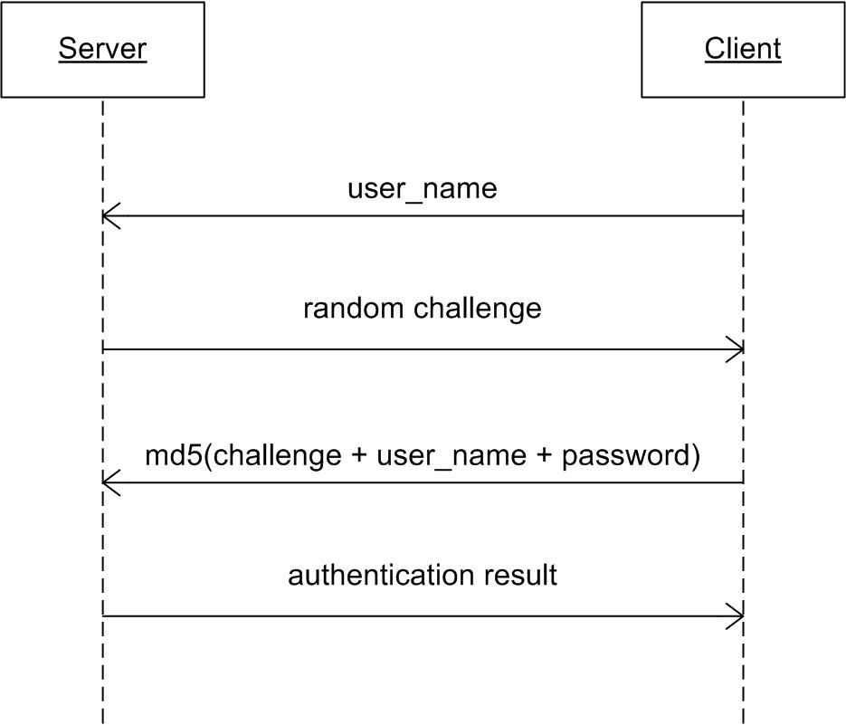

- Compile both server.c and widom.c until no compilation error.
  - make -f Makefile
- Test correctness of your wisdom.c using 2 login sessions to labsupport
  - In one session, starts the server while there other starting the wisdom.
  - Remember to start server before running wisdom.
  - Test following screen-dumps in 1st page of Q2.
    - command line syntax checking
    - incorrect (user_name, password): (jacky, ct212)
    - correct (user_name, password): (jacky, ELECS212-2010). Note that the authentication results from server are different even your user_name and password is correct. This is because the challenge is random.

Q3 This question tests your understanding for some terms used in Public Key Infrastructure, PKI, for e-banking.

For each term, you must explain in your own word and give an example that is specific to your online transaction with an e-banking service. Each term is worth 3 marks only. 3 to 4 sentence for each term is good enough. Don’t provide lengthy description. Or, marks will be deducted.

(a) For explanation of asymmetric key encryption algorithm, please refer to this URL, http://en.wikipedia.org/wiki/Public-key_cryptography
For practical example, name one commonly accepted asymmetric key encryption algorithm

(b) For explanation of public key, please refer to this URL, http://en.wikipedia.org/wiki/Public-key_cryptography
For practical example, screen-dump how to find out public key of an ebanking (eg. HSBC)

(c) For explanation of certificate authoriry, please refer to following URLs:
  - http://en.wikipedia.org/wiki/Certificate_authority
  - http://searchsecurity.techtarget.com/definition/certificate-authority

For practical example, try to find out certificate authority for HSBC’s (or other banks) e-banking.

(d) For explanation of digital certificate, please refer to following URLs
- http://en.wikipedia.org/wiki/Public_key_certificate

For practical example, try to provide screen-dumps for finding out digital certificate of an e-banking. Or, what is the common filename extension for digital certificate?

(e ) For explanation of X.509, please refer to this URL, http://en.wikipedia.org/wiki/X.509
For practical example, what is the common filename extension for digital certificate?

(f) For explanation of digital signature, please refer to this URL, http://en.wikipedia.org/wiki/Digital_signature
For practical example, how digital signature helps in providing one of the 4 network security goals?

(g) For explanation of Transport Layer Security, please refer to this URL, http://en.wikipedia.org/wiki/Transport_Layer_Security
For practical example, which ebanking is using Transport Layer Security?
Q4 This is an open question.
All knowledge you learned from this course, especially unit 1, 2, 3, 4, 8, 9 & 10 will be required. Your proposal should at least provide:
- Assumptions made for your design – eg. Size of café, number of employee, how to order, how to bill, any INTERNET connection, etc…
- Software(s) required and corresponding functions.
- Hardware required and corresponding functions
- Network diagrams showing devices & cables used.
- Your design may include, but not limited to, following items:
    - Physical topology
    - Transport method
    - Transmission speed and cable type chosen
    - NOS
    - Protocol for wired part and protocol for wireless part.
    - IP address range.
    - Assignment of IP address
    - Location of AP(s),
    - Number of AP(s),
    - Security issues, if any
    - Others.
- Cost estimate

You should provide your reasons for making each decision.

---End of hint file ---

