Autonomous Vehicle

Setup Guide
December 2025

Introduction 3
Getting Started 3
Welcome 3
Powering on the Vehicle 3
Network Connection 4
The Router 4
Wi-Fi Network 5
USB Tethering 5
Development Environment Setup 6
Remote Development Setup 6
Running the Projects 8
Running the Vehicle Project 8
Running the Client Project 9
Remote Piloting Setup 11

Introduction
This setup guide is intended to help you get set up to be able to develop on the vehicle. It includes information about how to set up your computer to talk to the vehicle. You’ll only have to do most of these steps once for a new computer. For day-to-day usage, refer to the user guide. This is a living document, so if your team adds or removes things on the vehicle, please add it to this document for future reference!

Getting Started

Welcome
This is the Remote Pilotless Vehicle project under the guidance of Dr. Tamer Omar. It has undergone several revisions, and this document pertains to the vehicle’s progress as of Fall 2025. These are the features included on the vehicle as of Fall 2025:
- Remote control via keyboard
- Cellular connectivity between the vehicle and the pilot.
- Stream live video back to the pilot with reasonable quality and low latency.
- Onboard battery monitoring.
You can find more information in the final report from Fall 2025.

Powering on the Vehicle
The first thing to do is to power on the vehicle. Locate the two pairs of female spade connectors as shown below:

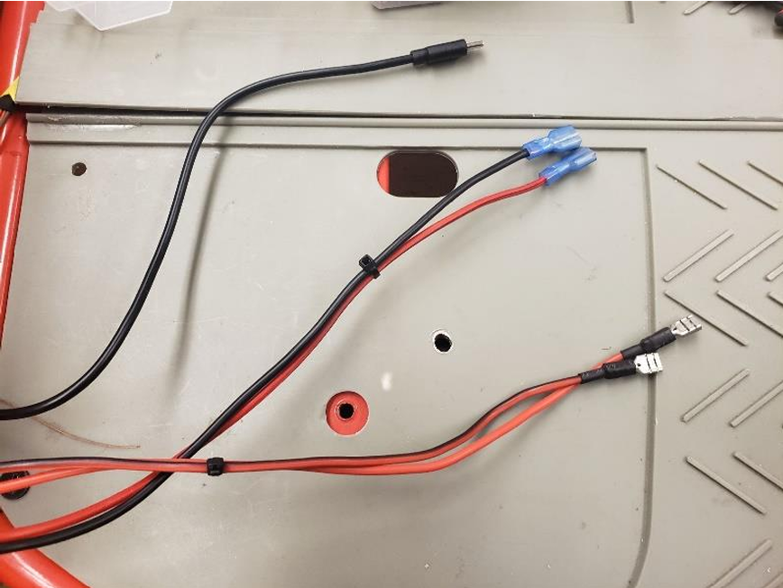

The wires with the connectors that have blue insulation are for everything EXCEPT the high current motors used for propelling and steering the vehicle. These wires power the Orange Pi, the Wi-Fi router, and everything else. These wires expect 12 volts, with red being positive and black negative. There is no reverse voltage protection! Please ensure the correct polarity before connecting. You can use one of the two sealed lead acid batteries onboard the vehicle or you can use any 12-volt power adapter that can provide at least one amp of current (useful for when you don’t need to move the vehicle but need it on). If things don’t turn on, flip the toggle switch shown below:

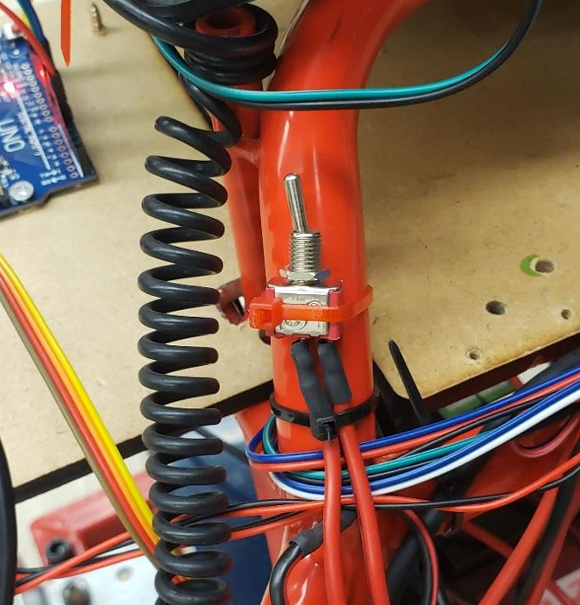

Once you do, everything should light up like a Christmas tree.

The other pair of wires is for the high-current motors mentioned above. The reason for two 12 volt lines is so the Orange Pi doesn’t reset if the voltage dips too low when driving hard on a shared battery. Don’t be alarmed by any sparks when you connect these wires, that’s from the current rushing into the capacitors of the motor drivers.

Network Connection

The Router
The GL.iNet GL-AR300M16 router is the small grey square box on the rear of the vehicle. The purpose of this router is to bridge your smartphone’s internet connection with the computers onboard the vehicle. It also broadcasts a Wi-Fi network for accessing the computers.

Wi-Fi Network
After powering on, wait a few minutes until you see all three lights lit on the Wi-Fi router. You should now see a Wi-Fi network called “rpv-local”. Connect to this network with the password “022223” with the computer you intend to write code and test the vehicle with.

USB Tethering
Once connected, you’ll notice that your computer doesn’t have an internet connection. That’s because the router doesn’t have any way to reach the internet. To give it (and the whole vehicle) an internet connection, you need to connect a smartphone to the USB port and turn on USB tethering on your phone. If an Android device last connected to the router, it will automatically begin piping the internet connection from the phone without any further action. The same goes for iOS devices. However, if the last device connected is different from the one you just connected, you need to initialize the connection from the router side.

To do this, open a web browser and type in “192.168.8.1”. You should be greeted with a login page. Login with the admin password “avcpp25”. You should now see the home page below:
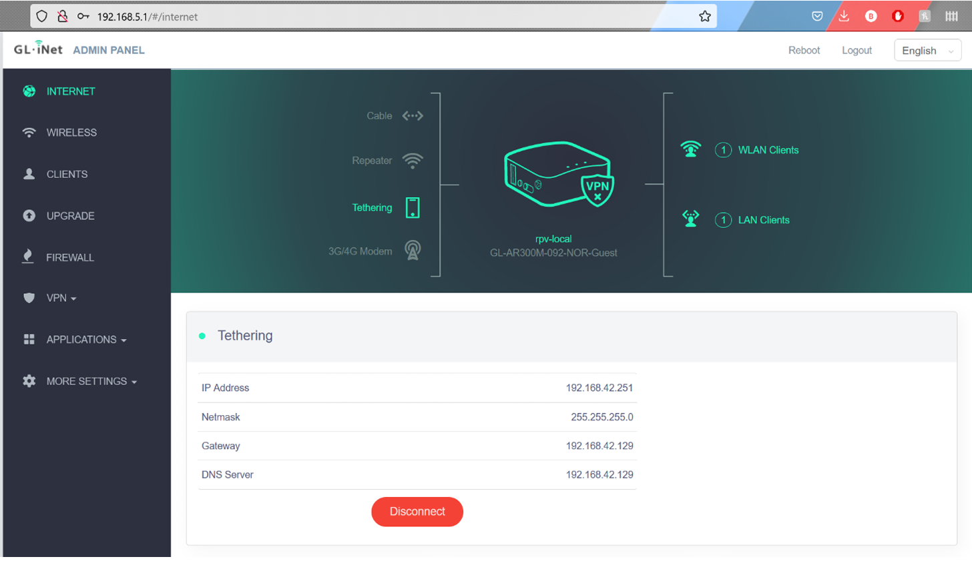

If you see a red “Disconnect” button, then there is no further action needed. If you see a “Connect” button, click on it, and wait for it to show an IP address. The router will remember the last type of device connected so you only need to do this once if you continue using that type of device.

Once connected, you should be getting internet access. One thing to note is that cell reception is very weak in the lab. Your internet connection is going to be very slow. To get around this, turn on Wi-Fi on your phone and let it connect to the school’s network. If your phone supports it, it can share this Wi-Fi connection with the router which will give the Orange Pi a high speed connection to the internet. Just remember to turn Wi-Fi off if you want to run the vehicle over a cellular connection.

Development Environment Setup

Remote Development Setup
Before we start writing code, we first need to set up our development environment on our computer. To make it easier to do such tasks without having to re-upload code to the Orange Pi every time we make a change, we will use Visual Studio Code with the SSH extension. Your VS Code IDE will connect to the Pi and stay in sync with it while you are connected. This means that when you write code in your IDE, your code is simultaneously being written to the Pi. There is no need to bother with remote desktop or manually copying files over with this method. Here are the steps to get set up:

- Download the latest version of VS Code here: https://code.visualstudio.com/download
- Run the installer and open the IDE.
- When you finish the initial setup, look for the Extensions icon shown below:
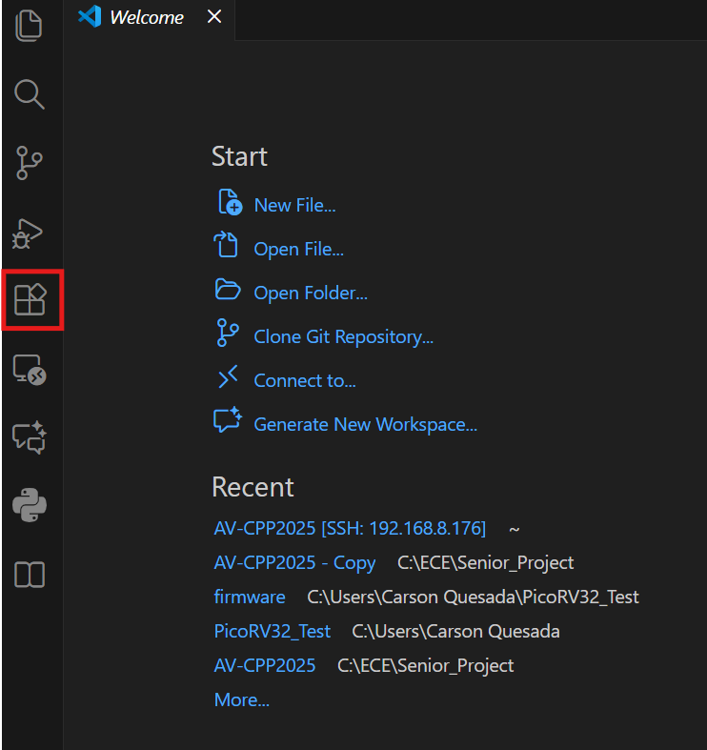
- Find the “Remote - SSH” extension by Microsoft and install it.
- Once installed, you should see a new icon on the left icon bar. Click on the new icon and click on the “+” to add a new remote.
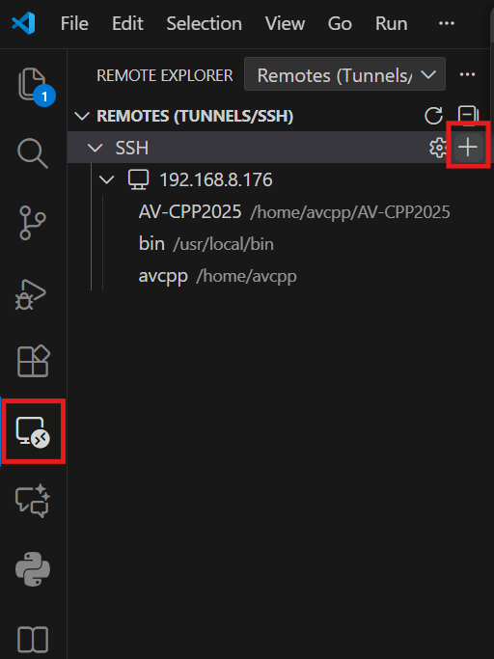
- It should now give you a prompt in the text box at the top of the window. Type the following command “ssh avcpp@192.168.8.176”.
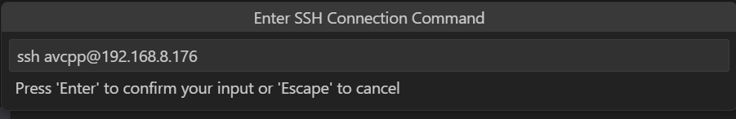
- It will ask you to select a config file. Hit Enter to select the first one or specify a different config file if you like
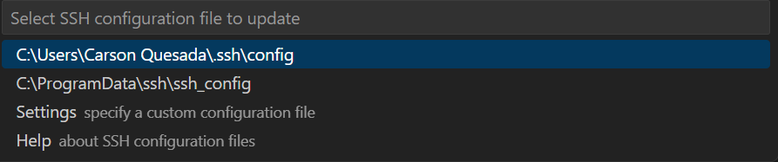
- If the newly added target doesn’t show up on the list, click the Refresh button:
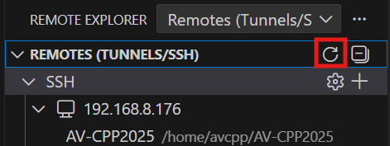
- You should now see the new target. Hover over it and click on the arrow:
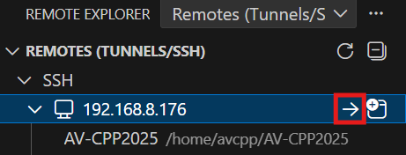
- It will prompt you for a password. The password to the Orange Pi is “022223”.
Note: if it never prompts you for a password, ensure the Pi is powered on and you are connected to the Wi-Fi network.
- Select “Linux” when it asks for the remote operating system.
- Once logged in, you will want to open the project folder. Click on the Folder icon, and click “Open Folder”:
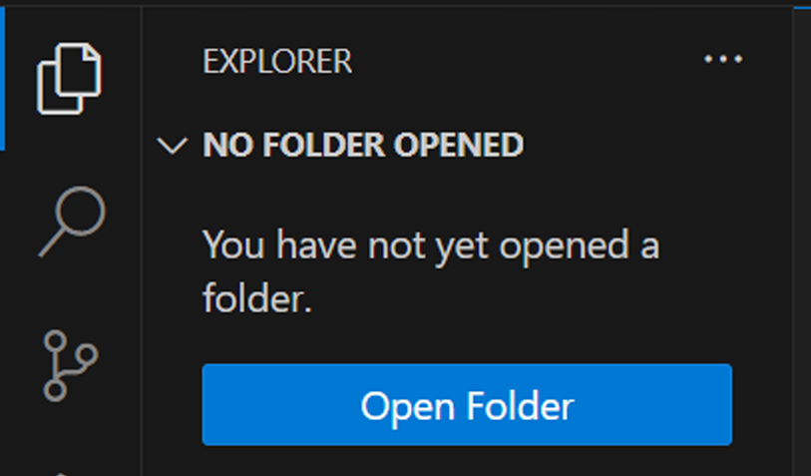
- Navigate to the folder “AV-CPP2025”. It should be in “/home/avcpp/”.
- You should now see all the source code.

Running the Projects
Two main projects exist: the vehicle project and the client project. To drive the vehicle, running both programs is necessary. The following section gives instructions on how to do this. At this point you should be able to access the Orange Pi through VS Code’s ssh remote extension tool.

Running the Vehicle Project
Navigate to the root directory of the entire project, AV-CPP2025. From here you may simply run the following commands:
- Run the following three commands to first navigate to the Vehicle project directory, then source the ROS2 Humble setup, and finally source the project’s local setup. This must be done every time you log into the Orange Pi.
cd ~/AV-CPP2025/Vehicle
source /opt/ros/humble/setup.bash
. install/setup.bash
- Run the following command to launch the ROS2 program.
ros2 launch vehicle_core bringup.launch.py

- If the project has not been built yet, or if you have made changes and want to rebuild it, use the following command (after Step 1):

colcon build

Object Detection Node:
The 2D Lidar driver is located in the avcpp directory, along with the shell script. As for the objection detection program, this will be located under the Vehicle directory

- Open two terminals, in the first terminal enter the shell script to launch the driver for the 2D LiDAR. This should be done in the avcpp directory.
./start_d300_lidar.sh

- In the second terminal, change directory to the following:
cd ~/AV-CPP2025/Vehicle

- If needed, enter the following after changing directory:
source /opt/ros/humble/setup.bash
. install/setup.bash

- Run the following command to now launch object detection
ros2 run object_detector object_detector.py

Optional: Webviewer
For visual purposes, a web viewer was made to see the LiDAR’s functionality in real time. Have the driver running, along with the object detection code.

- Open 3 additional terminals, in the first terminal enter the following command:
ros2 run rosbridge_server rosbridge_websocket --ros-args -p port:=9090

- Now in the second terminal enter the following:
ros2 run rosapi rosapi_node

- In the third terminal, change the directory to web_visualizer which can be found in AV-CPP2025
cd ~/AV-CPP2025/web_visualizer

- Now launch the following command:
python3 -m http.server 8001

- To now view the lidar visuals open browser and enter the following:
http://localhost:8001

Running the Client Project
To run the Client project you must first build the project. Follow the steps below to do this.

Note: The client project build process and output (e.g., TCPClient.exe) assume you are running Windows. If you are using macOS or Linux, the build will produce a different executable name, and additional setup steps may be required.

- Get the project on your machine. You can find the project on the orange pi or get it from the Github repository.

- If using VS Code you can run a task to build the project. In VS Code open the AVCPP-2025 project. This folder contains the .vscode folder with files needed to build it with VS Code.

- Before building the project you must add a file named Keys.h in the Shared folder. This file stores the local and remote network settings used by both the client program and the vehicle software.. At this stage only the local values matter — the remote values will be filled in later during the Remote Piloting Setup section.
Create the file and proceed to the next step.
- Once this file is created update the contents with the following

#pragma once
inline constexpr int LOCAL_TCP_PORT = 5000;
inline constexpr int LOCAL_VIDEO_PORT = 8554;
inline constexpr const char* LOCAL_PI_IP = "192.168.8.176";
inline constexpr int REMOTE_TCP_PORT = 15000;
inline constexpr int REMOTE_VIDEO_PORT = 18554;
inline constexpr const char* VM_PUBLIC_IP = "";

REMOTE_TCP_PORT, REMOTE_VIDEO_PORT and VM_PUBLIC_IP do not need to have meaningful values. This will be updated in the Remote Pilot Setup section.

- OPTIONAL: if you want streaming capabilities with the application then you must download prebuilt libraries and headers for FFmpeg on Windows. You can get these from anywhere but one option is from System233 FFmpeg MSVC Prebuilt on Github. Make sure to get the shared libraries. Once you have the package find the bin folder. Copy this into /TCPClient/Dependencies/ffmpeg. You may delete the executables (ffmpeg.exe, ffprobe.exe, ffplay.exe) in the bin folder or you may keep them somewhere on your machine to test streaming. Only the DLLs are required for streaming.

- Now we can build the project. Press Ctrl + Shift + P. You will see a list of items drop down from the search bar. Search for “run tasks”. Click on it.
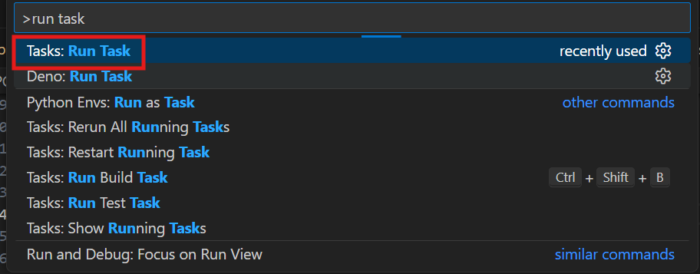

- If configured correctly it should display two build options. “Build (TCPClient Debug - with streaming)” allows you to build with streaming capabilities. Only do this if you choose to follow step 5. If not then choose “Build (TCPClient Debug)”. Both these options build the project with the ability to control the vehicle.
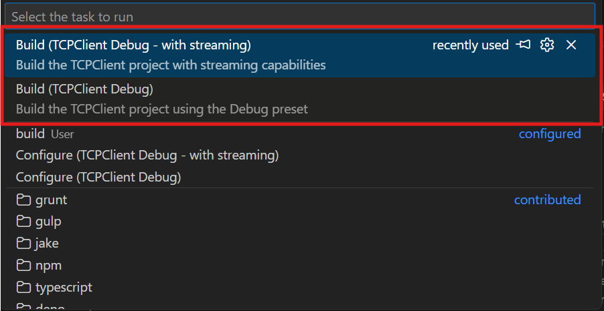

- Once built the executable is written to the build directory under the TCPClient project. At the root directory navigate to /TCPClient/build. In this folder you should have the executable listed as TCPClient.exe. This is the program you should run to bring up the console and GUI.
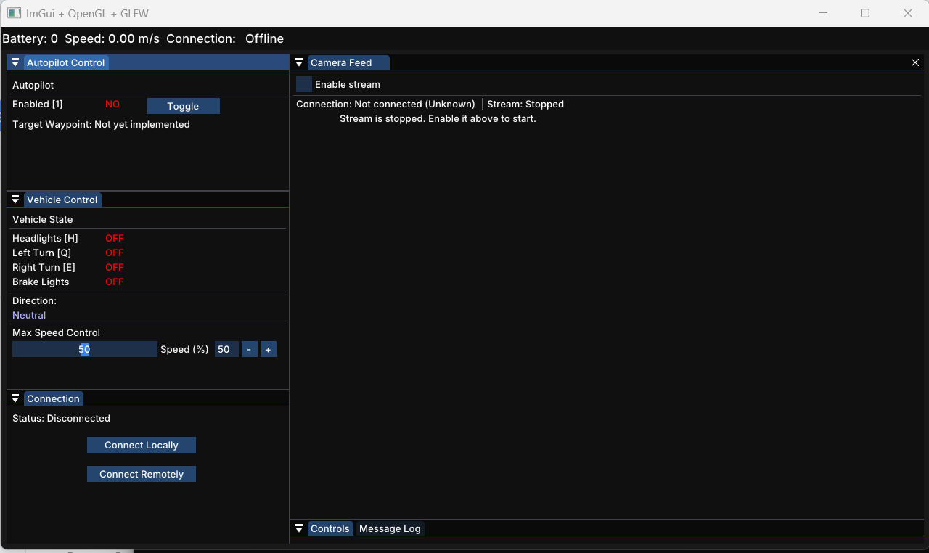

Remote Piloting Setup
Now that you can run both projects you should know how to connect to the vehicle remotely. This guide explains how to let remote users connect to your vehicle’s control (TCP) and video (RTSP) streams securely, even when the vehicle is behind a router or cellular network.
It uses FRP (Fast Reverse Proxy) — a lightweight open-source relay — and a small cloud VM as the “meeting point”.
- Overview
[Laptop] ⇄ Internet ⇄ [Cloud VM running frps] ⇄ [Vehicle (Orange Pi) running frpc]
- frps (server) runs on a cloud VM with a public IP.
- frpc (client) runs on the vehicle. It connects outbound to the VM and keeps the tunnel alive.
- The VM forwards selected TCP ports back to the vehicle.

- Choose a VM Provider
Any VPS or cloud provider with a public IP works. We recommend a provider with a free trial like Google cloud or AWS. Though not permanent, free trials are usually generous and are usually reliable and fast. Paying for a VPS is also an option.
VM recommendations
- 1 vCPU, 512 MB–1 GB RAM (tiny instance is enough)
- Ubuntu 22.04 LTS or Debian 12
- Keep one public IPv4 address

- Firewall / Network Ports
You may choose any ports, but you need three types:

Purpose | Example | Direction
FRP control channel | 7000 | open ingress on VM
Vehicle control TCP | 15005 | open ingress on VM
RTSP video stream | 18554 | open ingress on VM

If you change a port, you must update it in Keys.h, frps.ini, frpc.ini, and your firewall.

- Setup FRP Server (frps) on the VM
  - Download and install
Run the following commands on the VM

sudo apt update -y && sudo apt install -y curl tar
VERSION=0.61.1
curl -L -o /tmp/frp.tar.gz \
https://github.com/fatedier/frp/releases/download/v${VERSION}/frp_${VERSION}_linux_amd64.tar.gz
sudo mkdir -p /opt/frp /etc/frp
sudo tar -xzf /tmp/frp.tar.gz -C /opt/frp --strip-components=1
sudo install -m 0755 /opt/frp/frps /usr/local/bin/frps

  - Configure /etc/frp/frps.ini
In the file /etc/frp/frps.ini write

[common]
bind_port = 7000
token = <a-long-random-string>

Replace <a-long-random-string> with a long random string. You can generate one by running the following command in the terminal

openssl rand -hex 24

You will need this string in a future step so keep it around.

  - Systemd service
Run this in the terminal

cat <<'EOF' | sudo tee /etc/systemd/system/frps.service
[Unit]
Description=FRP Server
After=network.target
[Service]
ExecStart=/usr/local/bin/frps -c /etc/frp/frps.ini
Restart=on-failure
[Install]
WantedBy=multi-user.target
EOF
sudo systemctl daemon-reload
sudo systemctl enable --now frps

  - Open firewall ports
In your cloud provider’s firewall (or ufw) open your frp control port, vehicle control port and RTSP video stream port for TCP communication.

- Install FRP Client (frpc) on the Vehicle(Orange Pi)
  - Download and install
frpc should already be installed on the Orange Pi. However, if not, then run

sudo apt update -y && sudo apt install -y curl tar
VERSION=0.61.1
curl -L -o /tmp/frp.tar.gz \
https://github.com/fatedier/frp/releases/download/v${VERSION}/frp_${VERSION}_linux_arm64.tar.gz
sudo mkdir -p /opt/frp /etc/frp
sudo tar -xzf /tmp/frp.tar.gz -C /opt/frp --strip-components=1
sudo install -m 0755 /opt/frp/frpc /usr/local/bin/frpc

  - Configure /etc/frp/frpc.ini
Replace SERVER_IP with the VM’s external IP, and use the same token as in frps.ini and replace <same-long-random-string> with the long random string you used in step 4.2.

[common]
server_addr = SERVER_IP
server_port = 7000
token = <same-long-random-string>
tls_enable = true
heartbeat_interval = 10
heartbeat_timeout = 40

# Vehicle control (example)
[ros_ctrl]
type = tcp
local_ip = 127.0.0.1
local_port = 5000 # whatever your TCP server uses
remote_port = 15005 # choose any free VM port

# RTSP video
[video_rtsp]
type = tcp
local_ip = 127.0.0.1
local_port = 8554 # RTSP server port
remote_port = 18554 # choose any free VM port

  - Systemd service

cat <<'EOF' | sudo tee /etc/systemd/system/frpc.service
[Unit]
Description=FRP Client
After=network.target
[Service]
ExecStart=/usr/local/bin/frpc -c /etc/frp/frpc.ini
Restart=always
RestartSec=2
[Install]
WantedBy=multi-user.target
EOF
sudo systemctl daemon-reload
sudo systemctl enable --now frpc

  - Check logs
Run

sudo journalctl -u frpc -n 50 --no-pager

You should expect to see a line that says “start proxy success”.

- Verify Connection
On the VM run

sudo ss -ltnp | egrep ':7000|:15005|:18554'

And you should see all ports listening.

From your device run in PowerShell

Test-NetConnection SERVER_IP -Port 15005
Test-NetConnection SERVER_IP -Port 18554

Both should report TcpTestSucceeded : True

- Updating the Application Key File (Keys.h)
If not already created, create a file named Keys.h in the Shared folder. Update the contents of Keys.h to contain the following.
Important: The Keys.h file is shared by both the vehicle code and the client code. Make sure the version on your development machine and the copy on the Orange Pi always match. Any change in port numbers or the VM’s public IP must be updated in both places.

#pragma once
inline constexpr int LOCAL_TCP_PORT = 5000;
inline constexpr int LOCAL_VIDEO_PORT = 8554;
inline constexpr const char* LOCAL_PI_IP = "192.168.8.176";
inline constexpr int REMOTE_TCP_PORT = 15000;
inline constexpr int REMOTE_VIDEO_PORT = 18554;
inline constexpr const char* VM_PUBLIC_IP = "<your vm public ip";

- Test streaming
If you kept the executables from the FFmpeg download in step 5 then you can do this step or optionally download VLC. Ensure the vehicle-side RTSP server is running (this happens automatically when the vehicle program starts). Make sure the FFmpeg executables are in your current path and run:

ffmpeg rtsp://<your vm public ip>:18554/stream

Make sure to replace <your vm public ip> with your server’s public ip. You should be able to see the video.

Notes:
- VM should always be running. If stopped the external ip address may be changed.
- If the VM is changed, remember to adjust the macros in the Keys.h file.
- When troubleshooting to see frp logs run:
  - On the pi: sudo journalctl -u frpc -n 50
  - On the VM: sudo journalctl -u frps -n 50

