Autonomous Vehicle
User Guide
Version 2.0
12/12/2025

Table of Contents
Table of Contents
Introduction 3
Workflows 3
Workflow 1: Directly connected. 3
Workflow 2: Remotely connected. 3
Running Programs 4
Directories and Program Locations 4
Controlling the Vehicle 5

Introduction
This user guide is intended to guide you through the procedures to get the vehicle up and running when you need to work on it. If you haven’t already, ensure that your development workstation and the vehicle have been set up according to the setup guide. This is a living document, so if your team adds or removes things on the vehicle, please add it to this document for future reference!

Workflows
There are a few different ways to connect to the vehicle and start the necessary programs to drive the vehicle. You can follow whichever procedure fits your use case.

Workflow 1: Directly connected.
This workflow assumes that you want to work with the vehicle while directly connected to it over Wi-Fi or Ethernet.
- Power on the vehicle.
- Connect your laptop to the GL-AR300M16 Wi-Fi network.
- Connect a smartphone to the router and turn on USB tethering.
  - Adjust router settings if device type changed from the last (refer to setup guide under “USB Tethering”)
- SSH into the Orange Pi 5 and in a terminal navigate to the /AV-CPP2025/Vehicle directory.
- Run the following commands in the terminal:
source /opt/ros/humble/setup.bash
. install/setup.bash
ros2 launch vehicle_core bringup.launch.py

- Run the client side program (See Running Programs section)
- Click connect Locally in the connection panel on the GUI.

Workflow 2: Remotely connected.
This workflow assumes that you want to work with the vehicle while remotely connected to it through a VPN tunnel. These steps are performed on your laptop and VRX simulator if you’re using it.
- Power on the vehicle.
- Connect your laptop to the GL-AR300M16 Wi-Fi network.
- Connect a smartphone to the router and turn on USB tethering.
  - Adjust router settings if device type changed from the last (refer to setup guide under “USB Tethering”)
- SSH into the Orange Pi 5 and in a terminal navigate to the /AV-CPP2025/Vehicle directory.
- Run the following commands in the terminal:
source /opt/ros/humble/setup.bash
. install/setup.bash
ros2 launch vehicle_core bringup.launch.py

- Disconnect your laptop from the GL-AR300M16 Wi-Fi network while leaving the vehicle program running.
- Connect your laptop to the university’s network via Wi-Fi or Ethernet.
- Run the client side program (See Running Programs section)
- Click connect Remotely in the connection panel on the GUI.

Running Programs

Directories and Program Locations
All programs are located in the rpv-sdp folder at /home/avcpp/AV-CPP2025
Directory | Main Program Location | Description
Vehicle Core | /AV-CPP2025/Vehicle/src/vehicle_core | ROS package for running main functionality of vehicle
Object Detection | /AV-CPP2025/Vehicle/src/object_detection | ROS package for using the 2D LiDAR on the vehicle
Computer Vision | /AV-CPP2025/Vehicle/src/computer_vision | ROS package for using YOLO on the vehicle
subsystems | N/A | Source code for Arduino subsystems.
TCPClient | /AV-CPP2025/TCLClient/build | Client program for controlling the vehicle

Controlling the Vehicle
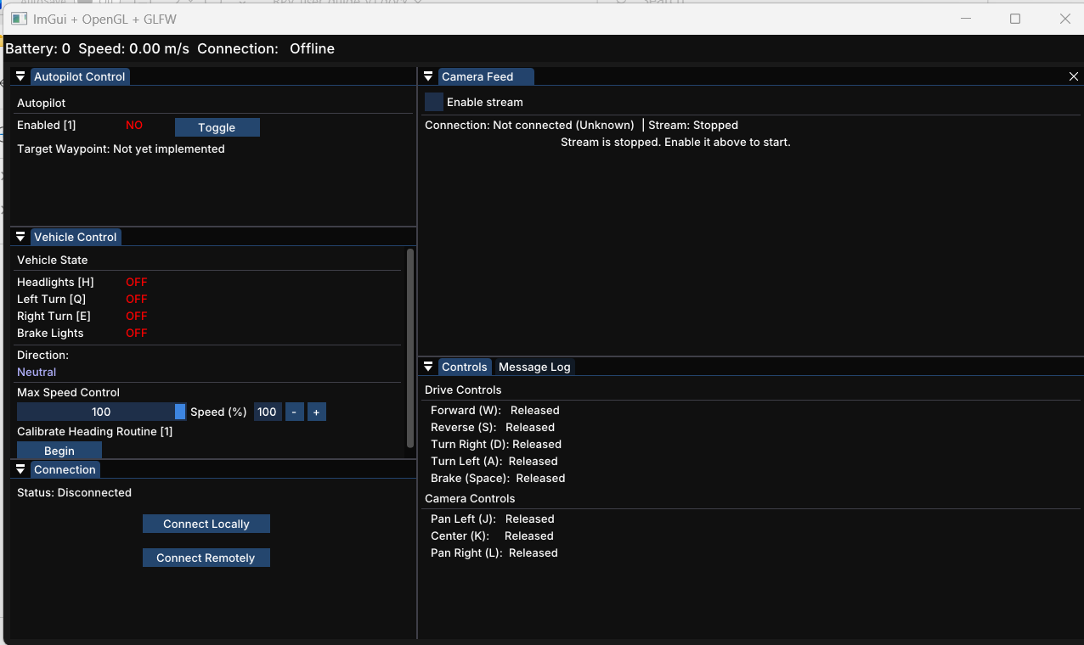

The vehicle can be controlled from a keyboard while the client program is running. The window for the client program must be in focus for it to take keyboard inputs. The key for each control is displayed on the screen next to the action in square brackets. For example, Forward is the ‘W’ key. Some controls are directly toggled from the panel such as enable stream.

