**Module 2 Assignment 2: Exploring JavaScript Topics with EJS, Node.js, and Express**

Carson E. Trevino

The Polytechnic School, Arizona State University

IFT 458: Middleware Programming & Database Security

Professor Dinesh Sthapit

09/04/2023

**Module 2 Assignment 2: Exploring JavaScript Topics with EJS, Node.js, and Express**

For this assignment we covered EJS and how to create a dynamic web page that does server-side rendering with basic calculations. It utilized two EJS templates, one that accepted form submissions and then passed to the other which then performed basic arithmetic before displaying the results. We used JavaScript code within the EJS files to dynamically generate HTML content for the web page through lines we will see in Figure 1. One example of this is using the syntax <$= variableName %> which pulls from the main JavaScript file.

**Figure 1**

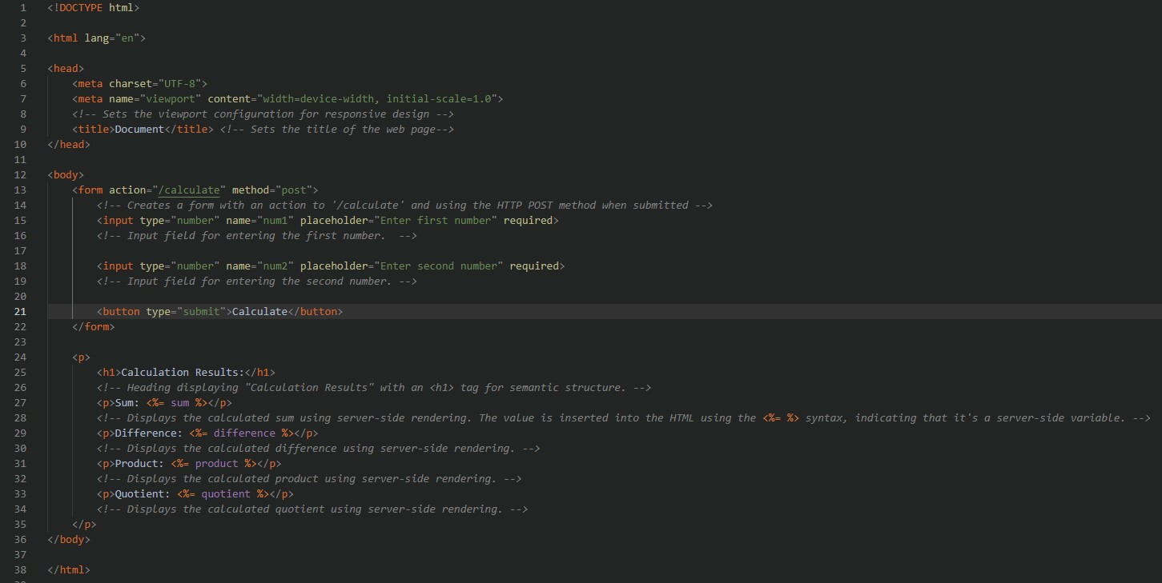*A screenshot of the result EJS file*

The parts of the HTML code viewed from inspecting the page source that is dynamically generated is the size of the page and the calculated resulting numbers. This can be seen in Figure 2.

**Figure 2**

*A screenshot of the HTML source code pulled from the web page*

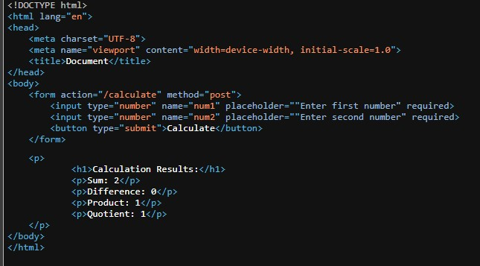

The HTML source code is fairly similar to the EJS file. There are just spots like mentioned above where the EJS can utilize JavaScript in the main file to do rendering server-side. This is more than just what HTML can do. The ability to dynamically adjust the viewport configuration is also more aesthetically pleasing. The EJS template allows for a more robust coding environment with more options for a powerful web application. HTML is very basic in structuring words on a screen. The main example from this assignment is doing the math calculations server-side and producing the answers based on user input to the web page.