Q: Define a database and the three database language types covered in this lesson

A: Definition: It is an organized collection of structured data or information.

A DBMS generally controls a database. The DBMS, the data, and the associated applications

are referred to as a database system, often shortened to database.

Data within today's most common databases are typically modelled in rows and columns in a

series of tables to make processing and data querying efficient.

The data can be easily accessed, managed, modified, updated, controlled, and organized.

Most databases use structured query language (SQL) for writing and querying data.

Three Database language types:

1) Data Definition Language (DDL)

2) Data manipulation language (DML)

3) Query languages (SQL)

Q: Using the INVOICE table given below, draw its dependency diagram and identify all dependencies (including transitive and partial dependencies).

You can assume that the table does not contain any repeating groups and that an invoice number references more than one product.

A:

INV_NUM, PROD_NUM -> SALE_DATE, PROD_LABEL, VEND_CODE, VEND_NAME, QUANT_SOLD, PROD_PRICE

PROD_NUM -> PROD_LABEL, VEND_CODE, VEND_NAME, PROD_PRICE

PROD_LABEL -> VEND_CODE, VEND_NAME

VEND_CODE -> VEND_NAME

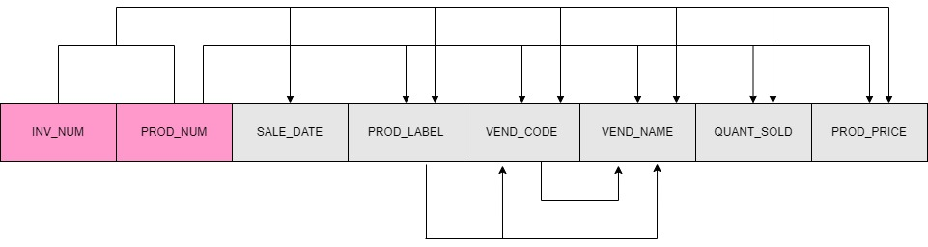

Figure 1.jpg

Q: Draw new dependency diagrams to show the data in 2NF.

Step 1.1

A:

INV_NUM

PROD_NUM

INV_NUM PROD_NUM

Step 1.2

PROD_NUM

PROD_LABEL

VEND_CODE

VEND_NAME

PROD_PRICE

PROD_NUM PROD_LABEL VEND_CODE VEND_NAME PROD_PRICE

Step 1.3

INV_NUM

PROD_NUM

SALE_DATE

PROD_LABEL

VEND_CODE

VEND_NAME

QUANT_SOLD

PROD_PRICE

INV_NUM PROD_NUM SALE_DATE PROD_LABEL VEND_CODE VEND_NAME QUANT_SOLD PROD_PRICE

Step 2.1

ITEM_TRANSACTION (INV_NUM, PROD_NUM)

Step 2.2

PROD_NUM (PROD_NUM, PROD_LABEL, VEND_CODE, VEND_NAME, PROD_PRICE)

Step 2.3

INV_NUM (PROD_NUM, SALE_DATE, PROD_LABEL, VEND_CODE, VEND_NAME, QUANT_SOLD, PROD_PRICE)

Step 3.1 Dependency diagram below shows the result of Steps 1 and 2.

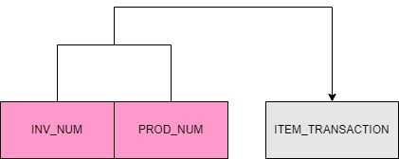

Figure 2.jpg

Step 3.2 Dependency diagram below shows the result of Steps 1 and 2.

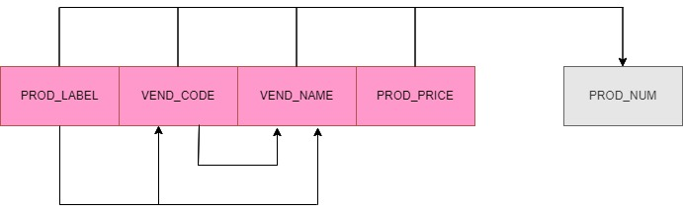

Figure 3.jpg

Step 3.3 Dependency diagram below shows the result of Steps 1 and 2.

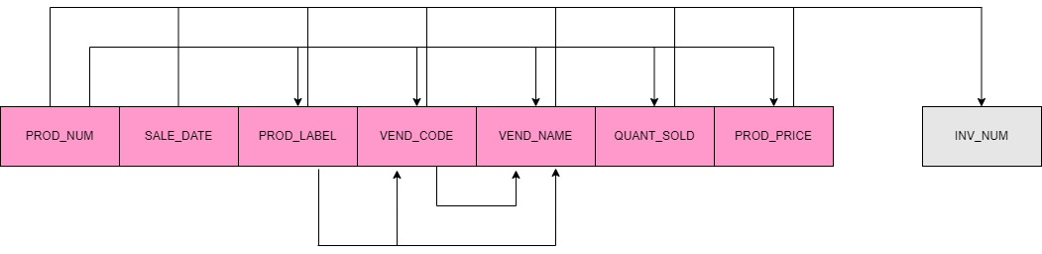

Figure 3.2.jpg

Q: Draw new dependency diagrams to show the data in 3NF.

A:



Figure 4.jpg

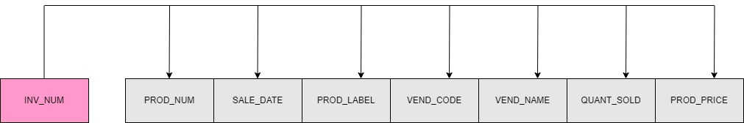

Figure 8.jpg

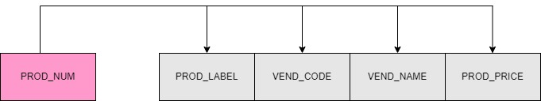

Figure 5.jpg

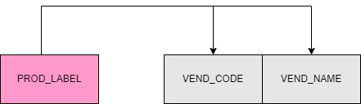

Figure 6.jpg

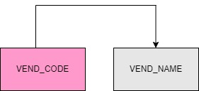

Figure 7.jpg