HANOI UNIVERSITY OF SCIENCE AND TECHNOLOGY

SCHOOL OF ELECTRICAL AND ELECTRONIC ENGINEERING



PROJECT REPORT

APPLYING CHATGPT IN DEVELOPING A MATH-SOLVING PLATFORM

Name of students: Class code: 152564 – Group 7

Pham Bac Dai Duong – 20233846

Pham Danh Tuan Dung – 20233844

Nguyen Minh Huy – 20233852

Vu Duc Minh – 20233868

Name of instructors: Dr. Pham Van Tien

Assoc. Prof. Tran Thi Thanh Hai

Hanoi, 12/2024

Table of Contents

LIST OF TABLES v

ACKNOWLEDGEMENT vi

ABSTRACT vii

1. Introduction 8

1.1. Motivation 8

1.2. Objectives 8

1.2.1. Main objectives 8

1.2.2. Specific objectives 8

2. Methodology 9

2.1. State of the art 9

2.1.1. Methods for math-solving platform 9

2.1.2. Existing products for math-solving platform 9

2.1.3. Dicussions 9

2.2. Application of the 9 steps in engineering design process 9

3. Project implementation 9

3.1. Step 1: User requirement 9

3.2. Step 2: Specifications 10

3.2.1. Functionality 10

3.2.2. Non functinality 10

3.3. Step 3: Planning 10

3.4. Step 4: Block Design 11

3.5. Step 5: Detail block design 11

3.6. Step 6: Best altenatives selection 11

3.7. Step 7: Protyping 12

3.7.1. Simulation 12

3.7.2. Produce the prototype 12

3.8. Step 8: Testing 12

4. Discussions 12

5. Conclusions and future works 12

6. Reference 14

LIST OF FIGURES

Figure 1.1 Objective of the project 8

Table 3.1: Summary of the main functions of our proposed system / prodcut 11

Table 3.2: Summary of task distrubution and completeness 11

Figure 3.1 Main blocks of our proposed system 12

Figure 3.2 The flowchart of generating response 12

Figure 3.3 The flowchart of OCR Text Extraction 13

Figure 3.4 The flowchart of Graph Plotter Functionality 13

Table 3.3: Comparision of the best alternatives 14

Figure 3.5 The welcome page 15

Figure 3.6 The Math tutor page 15

Figure 3.7 The Graph Plotter page 16

LIST OF TABLES

Table 3.1: Summary of the main functions of our proposed system / prodcut 11

Table 3.2: Summary of task distrubution and completeness 12

Table 3.3: Comparision of the best alternatives 13

# ACKNOWLEDGEMENT

In the age of the present information explosion, the applicability and the potential development of the advertising information are very big, the application of the new techniques is very necessary in this field.

We sincerely express our gratitude to our instructors, Dr. Pham Van Tien and, for Assoc. Prof. Tran Thi Thanh Hai their invaluable guidance and support throughout this project.

We would like to say thanks to everybody who helps us on this project!

# ABSTRACT

The growing integration of artificial intelligence in education has opened new opportunities for innovative learning tools. Developing a website to help students solve math problems using ChatGPT stems from the motivation to make learning math more accessible and engaging. Many students struggle with math due to the lack of personalized guidance, often feeling overwhelmed by complex concepts or unsure how to approach problems. This creates a significant barrier to their academic progress and confidence in the subject. The problem lies in the limited availability of affordable, on-demand math tutoring tailored to individual needs. This project focuses on developing a math-solving platform using ChatGPT to assist high school students in problem-solving. The platform leverages ChatGPT's natural language processing capabilities to interpret math problems, provide step-by-step solutions, and offer explanations. The system was tested with real-world math problem sets, demonstrating its ability to enhance learning efficiency and engagement. Future enhancements will focus on integrating more advanced problem-solving algorithms and personalized learning pathways.

# *Introduction*

## *Motivation*

Mathematics is a fundamental subject that forms the basis of many disciplines. However, students often face difficulties in understanding complex mathematical concepts and solving problems effectively. Traditional math tutoring methods may not be accessible to all students due to resource constraints. With the advancement of AI, ChatGPT offers an opportunity to bridge this gap by providing real-time math assistance and interactive problem-solving support.

## *Objectives*

### Main objectives

* Develop an AI-powered math-solving platform using ChatGPT to assist students in understanding and solving mathematical problems effectively.

Main objective

Specific objective 3

Specific objective 2

Specific objective 1

Figure 1.1 Objective of the project

### Specific objectives

- Specific objective 1: Design a user-friendly interface for math problem input and output.

- Specific objective 2: Integrate ChatGPT for problem interpretation and solution generation.

- Specific objective 3: Evaluate the accuracy and efficiency of the platform using real math problem datasets.

# *Methodology*

## *State of the art*

### Method for math-solving platform

- Define Scope and Features Identify target users : middle school and high school students Define key features such as: Display step-by-step solutions. Giving clues and explanation so that users can solve the problem by their own Support solving math problems with pictures Support drawing and displaying mathematical graphs

- Backend Development Model Integration: Use the ChatGPT API to process and respond to user queries. Use Pytesseract: OCR (text recognition from images). Use Matplotlib: Plotting function graphs. Logic and Workflows: Develop algorithms to parse user input, classify problem types, provide structured, step-by-step solutions and give clues, explanations to solve the problem

- Main Interface Technologies: Streamlit: Used for all interface components such as sidebar, navigation, input, and data display. Matplotlib: Plotting function graphs. Pytesseract: OCR (text recognition from images).

### Existing products for math-solving platform

* Existing platforms such as Photomath, Microsoft Math Solver, and Wolfram Alpha provide solutions to math problems. However, many lack detailed explanations or fail to handle complex contextual queries.
* Wolfram Alpha

Strengths: Broad STEM coverage, advanced computations, professional graphs.

Weaknesses: Subscription needed for step-by-step solutions, less interactive.

* Photomath

Strengths: Accurate OCR, clear step-by-step solutions, free basic features.

Weaknesses: Math-only focus, lacks custom explanations, subscription for advanced features.

* Microsoft Math Solver

Strengths: Free, high-quality OCR, wide topic coverage, Microsoft ecosystem integration.

Weaknesses: Static explanations, limited customization.

### Dicussions

* While existing tools are effective, integrating ChatGPT can address current limitations by enhancing flexibility and providing interactive feedback

## *Application of the 9 steps in engineering design process*

* Step 1: Identify the Problem The difficulty students face in understanding and solving complex mathematical problems was identified as the core problem. Objective: Develop an AI-powered platform utilizing ChatGPT to assist in math problem-solving.
* Step 2: Research and Gather Information Reviewed existing math-solving platforms and their features. Analyzed ChatGPT's capabilities in processing mathematical queries. Collected user requirements through surveys and interviews.
* Step 3: Specify Requirements Functional Requirements: Accurate problem-solving, interactive user interface, step-by-step explanations. Non-Functional Requirements: Scalability, responsiveness, and data security.
* Step 4: Brainstorm and Analyze Ideas Multiple architectural designs for the platform were proposed. Key considerations: User experience, integration with ChatGPT, cost, and scalability.
* Step 5: Choose the Best Solution Evaluated proposed designs based on feasibility, efficiency, and alignment with project goals. Selected the architecture that maximized accuracy and user-friendliness.
* Step 6: Develop a Prototype Created an initial prototype with a user-friendly interface. Integrated ChatGPT API for real-time math problem-solving and explanation generation.
* Step 7: Test the Prototype Conducted functional and user testing to validate the system’s performance. Identified key areas requiring improvement.
* Step 8: Refine and Improve the Design Addressed issues found during testing. Enhanced system accuracy, interface responsiveness, and overall performance.
* Step 9: Communicate Results Documented findings, test results, and project achievements. Prepared a presentation and report to demonstrate platform capabilities and future potential.

# *Project implementation*

## *Step 1: User requirement*

- Accurate Solutions

- Detailed Explanations

- Convenience

- Multilingual support

- Integration of Modern Technology

## *Step 2: Specifications*

### Functionality

Function 1: Chatbot for Q&A

Function 2: Function graph

Function 3: Scanning picture

### Non functinality

Non- Function 1: Response time <1 second

Table 3.1: Summary of the main functions of our proposed system / prodcut

|  |  |  |
| --- | --- | --- |
| Function | Description of the function | Priority (Requỉed / Optional) |
| Chatbot for Q&A | Enter question, math problem | Required |
| Function graph | Graphing from given equations | Required |
| Scanning picture | Scan image into text for AI GPT processing | Required |

## *Step 3: Planning*

Table 3.2: Summary of task distrubution and completeness

|  |  |  |
| --- | --- | --- |
| Member | Tasks | Completeness |
| Pham Bac Dai Duong | Tester/DevOps | 80% |
| Pham Danh Tuan Dung | Frontend Developer | 80% |
| Vu Duc Minh | Content Specialist | 80% |
| Nguyen Minh Huy | Backend Developer | 80% |

## *Step 4: Block Design*

Figure 3.1 Main blocks of our proposed system

## *Step 5: Detail block design*

### Generates a response from the OpenAI chat model for a given math question :

* **Purpose :** To interface with the OpenAI API and retrieve step-by-step reasoning and answers/clues for a given math problem

Figure 3.2 The flowchart of generating response

### Extracts text from uploaded images using Tesseract :

* **Purpose :** To process uploaded images and extract text that might contain math problems

Figure 3.3 The flowchart of OCR Text Extraction

### Plots a mathematical function provided by the user :

* **Purpose :** To visualize mathematical functions on a graph

Figure 3.4 The flowchart of Graph Plotter Functionality

## *Step 6: Best altenatives selection*

Table 3.3: Comparision of the best alternatives

|  |  |  |  |
| --- | --- | --- | --- |
| Item | Criteria 1  Price | Criteria 2  Reliability | Criteria 3  Appearance |
| Python | Free | High | Designed to be easy to read, learn, and use flexibly. |
| Mathpilot | Free | High | Optimized for integrating AI and solving complex mathematical problems |
| Tesseract OCR | Free | High | Flexible in customizing and integrating into your own system |

## *Step 7: Protyping*

### Produce the prototype

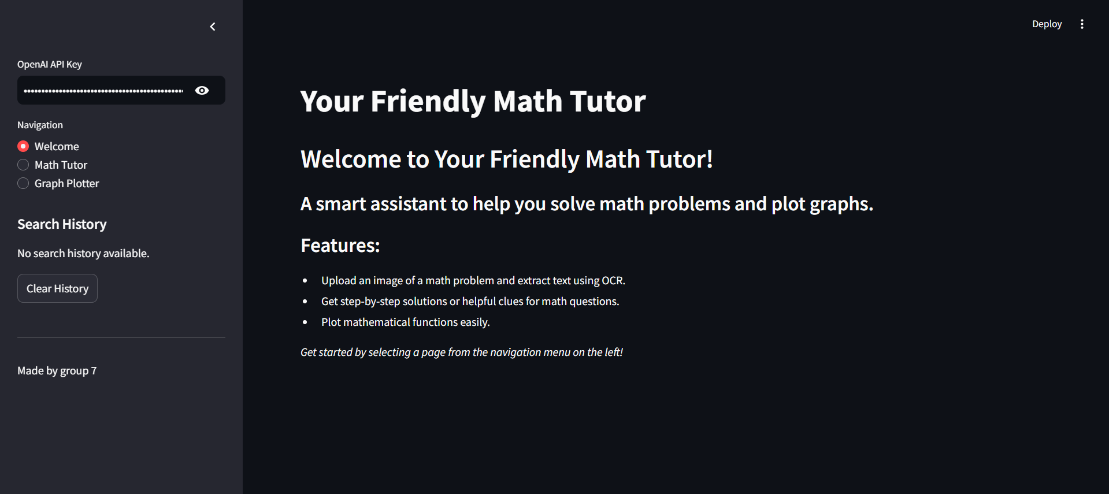

Figure 3.5 The welcome page

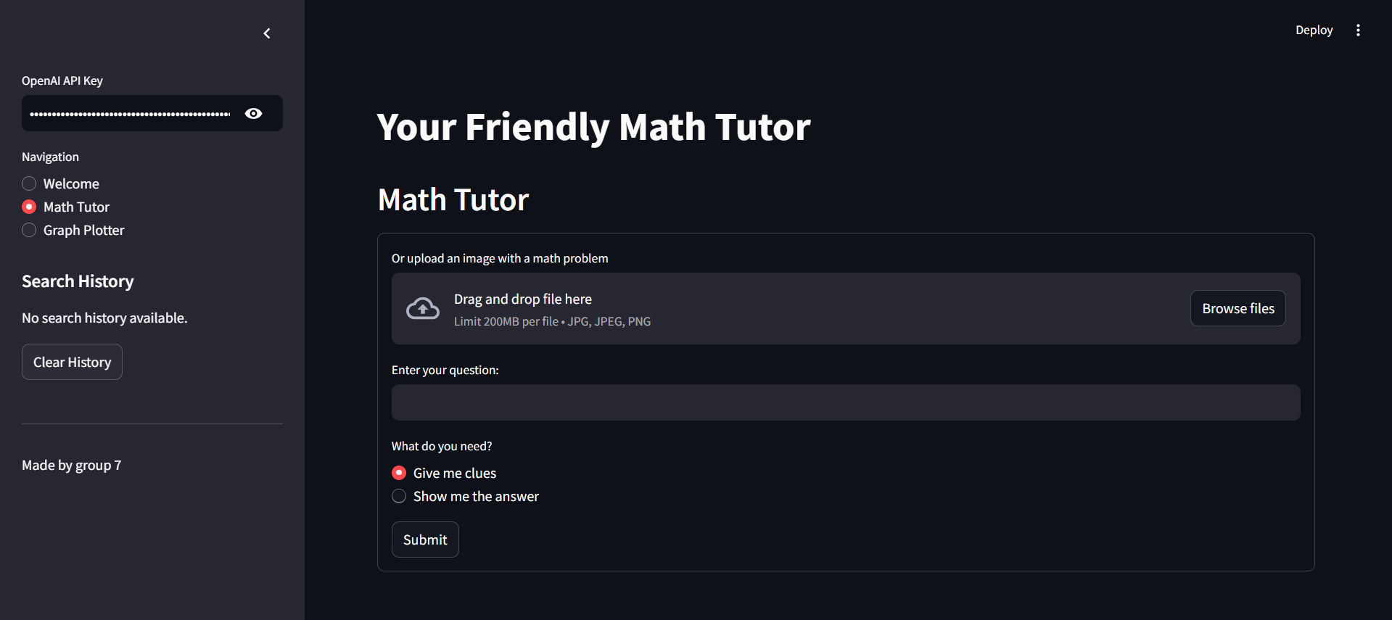

Figure 3.6 The Math tutor page

Figure 3.7 The Graph Plotter page

## *Step 8: Testing*

**Write the problem** :

* The results are up to 80% - 90% accurate
* Can slove math problemns of varying difficulty
* In some certain circumstances, the presentation is a bit difficult to understand
* The math problem is solved well when it is written in English and quite well when it is written in Vietnamese
* Presenting better result when receiving math problem written in English

Test case :

* Math problems written in Vietnamese :
* Ví dụ 1(dễ):Cho đường thẳng Δ biết Δ đi qua A (2 ; 1 ; 5) và có vectơ chỉ phương u =(1;1;2). Tìm Pt đường thẳng chính tắc và tham số của Δ.
* Ví dụ 2(trung bình):Cho tam giác ABC có A(1; -2; 5), B(3; -1; 4),C(4; 1; -3). Tìm phương trình đường thẳng tham số và chính tắc của trung tuyến AM.
* Ví dụ 3 (khó):Một trang sách có dạng hình chữ nhật với diện tích là 384 cm vuông. Sau khi để lề trên và lề dưới đều là 3 cm, để lề trái và lề phải đều là 2 cm. Phần còn lại của trang sách được in chữ. Kích thước tối ưu của trang sách là bao nhiêu để phần in chữ trên trang sách có diện tích lớn nhất?
* Math problems written in English :
* Example 1 (easy):Let the line Δ know that Δ passes through A (2; 1; 5) and has direction vector u =(1;1;2). Find the canonical straight line Pt and the parameter of Δ.
* Example 2 (medium):Let triangle ABC have A(1;-2;5), B(3;-1;4), C(4;1;-3). Find the parametric and canonical straight line equation of median AM.
* Example 3 (difficult): A book page is rectangular with an area of ​​384 square centimeters. After leaving the top and bottom margins both 3 cm, leave the left and right margins both 2 cm. The rest of the book's pages are printed with text. What is the optimal size of a book page so that the printed text on the page has the largest area?

Result :

* Math problems written in Vietnamese :
* Ví dụ 1(dễ):

* Ví dụ 2(trung bình):

* Ví dụ 3 (khó):

* Math problems written in English :
* Example 1 (easy):

* Example 2 (medium):

* Example 3 (difficult):

**Take a photo of the problem :**

* Mathematical symbols : Can rarely scan
* Handwriting documents : Unable to scan
* Printed documents : Can rarely scan
* Screenshot : Can scan verry well

Test case :

* Image of printed documents :

* Image of handwriting documents :

* Screenshot :

* Mathematical symbols :

Result :

* Image of printed documents

* Image of handwriting documents :

* Screenshot :

* Mathematical symbols :

**Graph :**

* Only in 2D function and 100% correct.

# *Discussions*

* The project "Applying ChatGPT in Developing a Math-Solving Platform" has demonstrated the potential of artificial intelligence to address real-world educational challenges. Throughout the development process, several aspects of the platform's performance, design, and functionality were evaluated to highlight its strengths and limitations.
* Firstly, the use of ChatGPT proved highly effective in interpreting math problems and providing detailed step-by-step solutions. This capability bridges the gap between theoretical learning and practical application, making the platform a valuable tool for high school students. The natural language processing capability of ChatGPT also enabled the system to handle diverse problem statements, improving accessibility for users with varying levels of proficiency in framing mathematical queries.
* However, limitations were identified, particularly in solving complex symbolic or abstract problems that required advanced algorithms. While the system succeeded in processing structured problem inputs, it sometimes struggled with ambiguous or poorly framed queries, indicating a need for enhanced pre-processing algorithms.
* The testing phase revealed promising results, with significant improvements in problem-solving accuracy and efficiency. However, there is potential for further optimization in handling large-scale datasets and ensuring robust system performance under high user demand.
* In conclusion, the discussion highlighted the system's core achievements and areas requiring future development. These insights will guide subsequent iterations of the project to ensure its relevance and effectiveness in the evolving educational landscape.

# Conclusions and future works

* The math-solving platform utilizing ChatGPT has successfully achieved its objectives of providing an effective learning tool for high school students. The system demonstrates the ability to interpret problems, provide step-by-step solutions, and enhance student engagement with mathematics. Results from testing with real-world math problems show significant improvements in learning efficiency and speed compared to traditional methods.
* However, there are still some limitations that need to be addressed in the future, including:

Enhancing the accuracy of solving complex problems, especially those involving symbolic computations.

Improving interaction capabilities to support multiple languages and ensure a more user-friendly interface.

Integrating personalized learning recommendations to cater to the specific needs of individual students.

* In the future, we plan to:

Apply advanced deep learning algorithms to optimize the platform’s problem-solving capabilities.

Integrate a classroom management system to create an interactive learning environment between teachers and students.

Expand the platform's applications to other educational levels and support problem-solving in multiple disciplines, such as physics, chemistry, and economics ….

# *Reference*

1. Dr. Pham Van Tien , Lecture Slides.
2. Wei, Jason, et al. (2022). Chain-of-Thought Prompting Elicits Reasoning in Large Language Models. ArXiv. <https://arxiv.org/abs/2201.11903>
3. Assoc. Prof. Tran Thi Thanh Hai