**Evaluation 02**

**Members:**

**Frence Lord Christian A. Albarracin**

**Cart Gladden Bandong**

**Jhonnel Araneta**

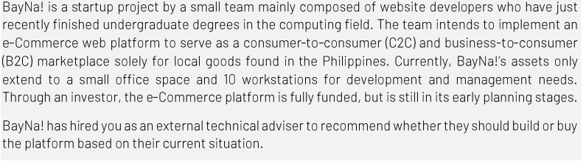**Angelo Sayson.**

In a group composed of 2 – 3 members, you will be accomplishing a SWOT matrix after considering the solutions on (1) building a custom software AND (2) buying a COTS software to address the given case scenario:

**Building a Custom Software:**

|  |  |  |  |
| --- | --- | --- | --- |
| S | W | O | T |
| * You get what you desire/planned * Provides a perfect solution to the problem. * It can be easily maintained, updated and applied changes. * The system especially the features can be easily manipulated * Save money | * The process could be prolonged * It undergoes long-term planning * Organizational support is a must * Consumes a lot of time and attention * Requires multiple testing and maintenance * Working it alone may be a hassle * Requires a lot of skill set and knowledge | * As an I.T, you will become more competitive and skillful * Some organizations might hire you in a position * Your skill would be recognized by some individuals or organizations * Clients from local or international might hire you. | * Your system might be used by someone outside the organization without your permission * There’s a possibility that the system will not meet the request of the client due to lack of skill sets. * The project might be a failure. * Your ROI might not reach the target profit that could end up to a loss of investment. |

**Buying a Software**

|  |  |  |  |
| --- | --- | --- | --- |
| S | W | O | T |
| * The system is will be available in no time * Less expensive because you don't need a software to build * Time efficiency * The system will be available quickly than making it * You can demand what system you want to do * Making your Startup Project faster * Your team will not work hard to make the system. * The system will be surely works | * Can't decide what is the system looks like * Can't change or add things that you want * Usually, it didn't meet your expectations * Can’t manipulate the system easily | * Using system purchase strengths is to consolidate and expand the market position * Using a purchased system can make your Startup project grow faster. * Using the purchased system could help your team to guide your startup Project. * More investor will be interested in your Startup Project | * If buying a system there are some threats in the security matters. * The system that you buy was possible same system that your competitor using * If you don’t know how to analyze the system it could be a scam. |