CS 340 4-1 Milestone: Create and Read in Python

Carter Taylor
Southern New Hampshire University
Professor: Jeffrey Scranton
04/14/2026

About the project
This project’s goal was to build a functional dashboard application for Grazioso Salvare to allow the company to review animal Austin Animal Center data to locate dogs that meet their rescue training requirements. The dashboard provides an interface for filtering and visualizing the dog candidates data stored in the connected database.

The application is built with the following architecture:

- MongoDB database that stores individual animal information.
- Python CRUD module that is used to interface with the database.
- A Leaflet, Dash, Plotly layer used to render the web interface.

Required Functionality

- Interactive filter controls to allow the user to select filters for the data
  - Water Rescue
  - Mountain or Wilderness Rescue
  - Disaster or Tracking Rescue
  - Reset
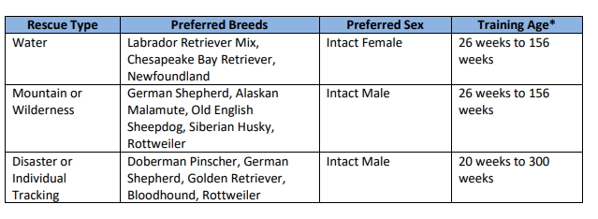
- Data table that updates upon a filter being applied
- A map that displays the geolocation of the selected animal
- A chart that displays relevant table data and is updated with filters

Display Dashboard Functionality
Initial Dashboard display
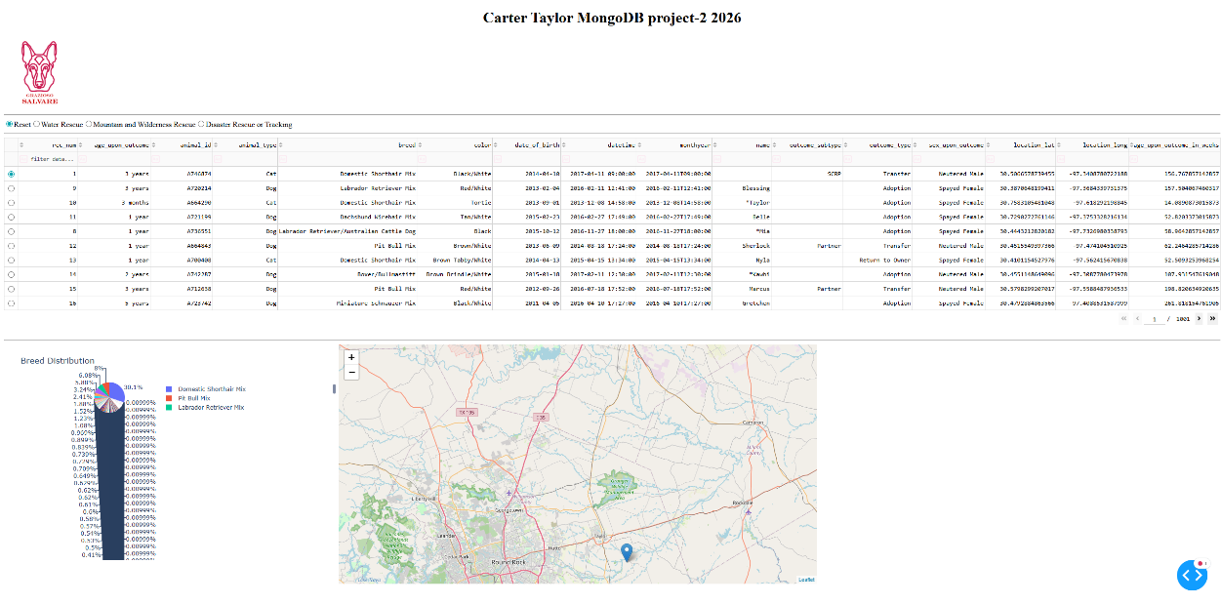

Filter by dogs suited to water rescue
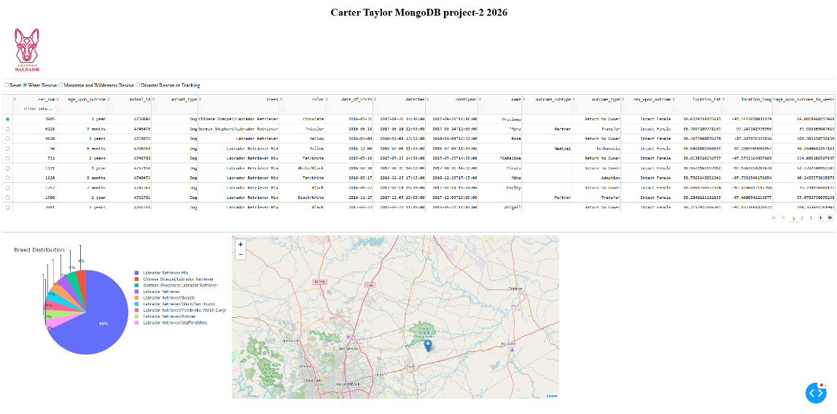
Filter by dogs suited to Mountain/Wilderness rescue
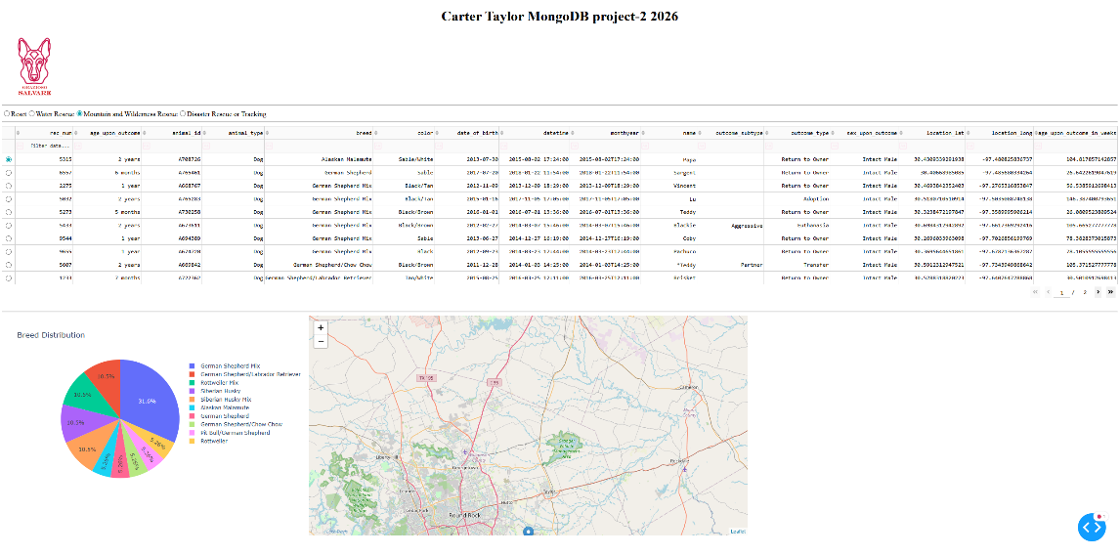
Filter by dogs suited to Disaster/Tracking rescue
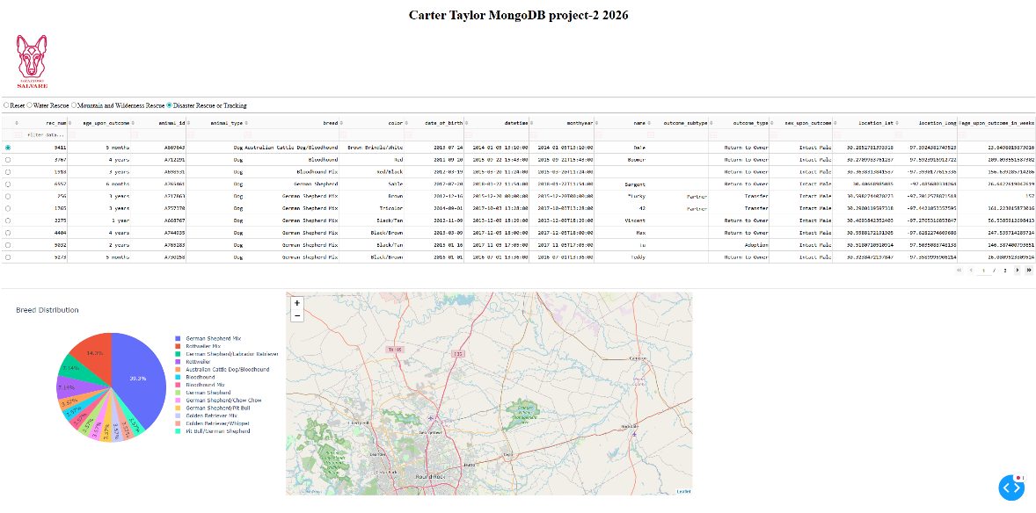
Reset the filter
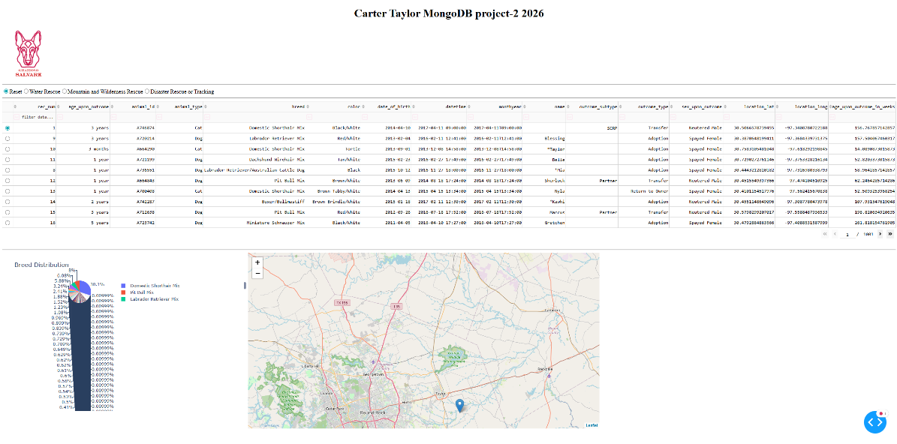

Components
- MongoDB is used in this project as it is a very popular NoSQL solution for storing information. MongoDB is highly flexible, well documented, and highly efficient database system. The data structure of the animal shelter dataset aligns perfectly with MongoDB.
- Python is used for its simplicity and widespread usage. Python allows for fast script and module development and is well-supported with libraries for database interactions.
- PyMongo was chosen because it is the official MongoDB driver for Python. The driver provides a connection between the application and the database enabling the use of CRUD operation using MongoDB commands. PyMongo also handles functionality like database connection and returning results in a way that can be understood by Python.
- Dash was used in this project as the web application framework because it provides an efficient way to build interactive dashboards in Python.
- Plotly was used for chart generation due to its seamless integration with Dash and ability to quickly generate dynamic visualizations from Pandas Data Frames.
- Leaflet was used to implement the geolocation map functionality because it provides interactive map support directly within Dash applications.
- Jupyterlab was used as the development environment as it allows for running code in small sections and can quickly test and view outputs of code modules.

Software Used
- MongoDB Installation:
https://www.mongodb.com/docs/manual/installation/
- Python:
https://www.python.org/downloads/
- PyMongo Documentation:
https://pymongo.readthedocs.io/
- Dash:
https://dash.plotly.com/
- Plotly Express:
https://plotly.com/python/plotly-express/
- Dash Leaflet Documentation:
https://dash-leaflet.herokuapp.com/
- Jupyterlab Documentation:
https://jupyter.org/

Steps taken to create the project

- Install the requisite components listed above as all will be needed to complete the project in its entirety.
- Load the Austin Animal Center information into MongoDB to create the database

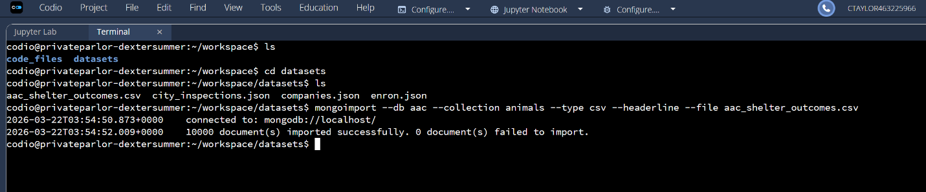

- Create a user in the admin database to access the newly created database.
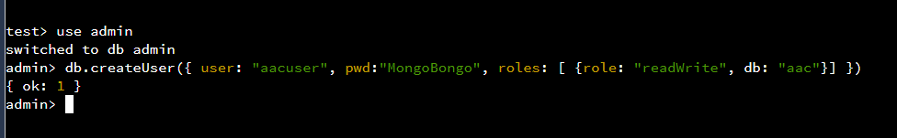
- Create a CRUD middleware class for interactions between the dashboard and the database. Example:
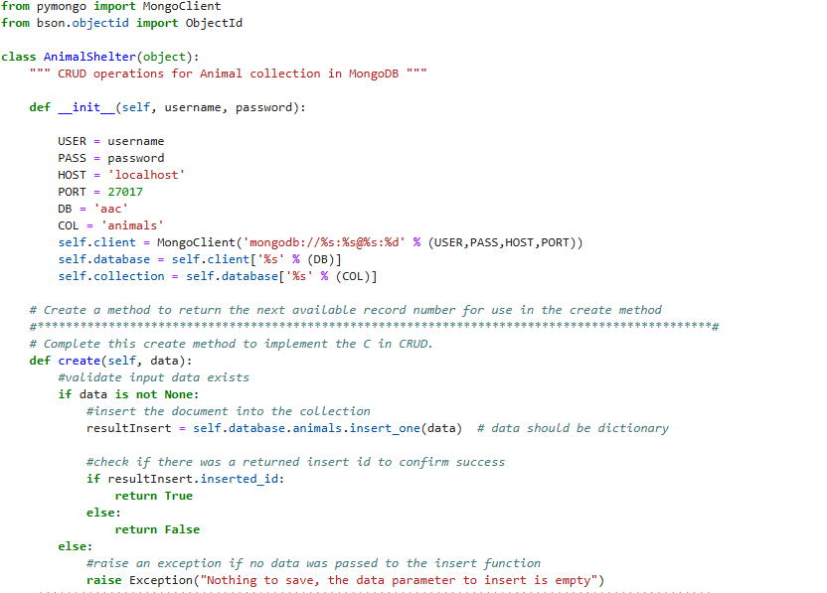
- Create Dash components and callbacks to load and display database information
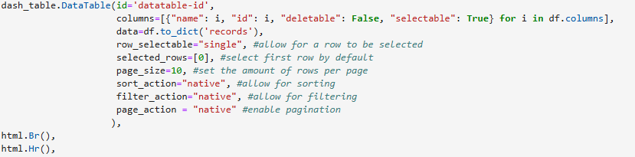
- Implement individual filter controls and individual filter queries using Dash commands
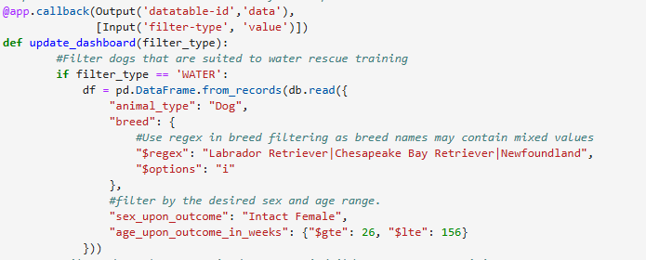
- Run the Python program to run the local dashboard instance.

Challenges

One of the primary challenges encountered was inconsistent breed inputs in the AAC dataset. Many breed values included mixed breeds or some alternate abbreviations that did not match the client-provided breed names exactly. This issue was resolved by implementing regex-based MongoDB queries to allow partial breed matching. This ensured that valid mixed breed dogs were not excluded from rescue candidate results.

