By: Carter Baumgartner For: Project 3

LLM and GitHub Copilot Usage Documentation
Prompts and Suggestions, Rationale for AI Usage, and Incremental Development
Explain why you used particular prompts and how the AI’s suggestions influenced your implementation.
Describe how AI tools helped you optimize or debug your code. Show how you used AI tools step-by-step, from initial function prototypes to refinement. If you modified AI-generated code, explain what and why.

Prompts and Rationale for AI Usage: I only used Chat GPT for AI usage on this project. For each use, I provided the Question(Q) I had, Reason/Rationale(R) for why, Output the response from the AI, and ideas/concepts learned after response(L). I also labeled each use with an overall goal to such as debugging or understanding/learning to help clarify and organize the prompts. In order to gain a clear understanding of what the AI is outputting you must consider your own thought process of your previous code, what the AI offered to change, check the AI code, and then decide what you think you should change based on the critique from the AI.

debugging
Q: Why am I not able to define my constructors and methods? Does it have to do with it being a template DT class?
R: My code would not stop giving me error messages for writing my constructors and functions and I did not
know what to do.

Output:
In your code, you wrote:
template <class DT>
NestedBST::NestedBST() {

}
But it should be:
template <class DT>
NestedBST<DT>::NestedBST() {

}
You missed the <DT> after NestedBST in each definition.

Learned: It was a simple syntax error which involved putting the <DT> in front of the class name. This helps the complier understand that when I define a function that I am referring to the template class.
understanding/learning
Q: How should I go about removing the first element in a vector and shifting all of the other elements forward in C++?
R: I am trying to write a recursive call that allows me to shift down a dimension by removing an element from the values vector, this way whenever I call values(0) it will always be associated with however many times I have called the function:ie how many dimensions deep I am. I am also really unfamiliar with vector commands so this is a good start to learning some of the useful commands it can do.

Output:
You need to pass a new vector that contains all elements except the first one.
Here’s the idiomatic fix:
Option 1 — copy and erase
std::vector<DT> remaining = values; // make a copy
remaining.erase(remaining.begin()); // remove first element
innerTree->insert(key, remaining); // recurse with the rest
✅ This works exactly as you intend.
Yes, it copies the vector, but unless your vectors are huge, it’s perfectly fine.
Option 2 — construct a subvector (cleaner and faster for small data)
std::vector<DT> remaining(values.begin() + 1, values.end());
innerTree->insert(key, remaining);
This builds a new vector from all elements after the first — no need to call erase() at all.
⚡ Pro tip
If your goal is just to “move down one dimension” and the size of values is small (as it usually is for coordinate-like data),
→ Option 2 is the cleanest and most readable way.
✅ Final form example
if (!values.empty()) {
// go to the next dimension with all but the first element
std::vector<DT> remaining(values.begin() + 1, values.end());
innerTree->insert(key, remaining);
}

Learned: I learned that since the values vector is passed as a const parameter, I cannot change it so instead I needed to create a new vector using the elements from the old values vector and pass that into the next recursive call to make sure I was in the correct dimension. I also learned that in order to add an element to a vector it is not .add() but .push_back() instead. To access an element, it is vector[element] not vector(element).
understanding/learning + debugging
Q: Is my thought process for the first insert recursive valid based on the class code? I am concerned about my current implementation to update the dimension and checking if the the BST is currently empty.

R: I was struggling to figure out how to update dimension through recursion when the only parameters that werebeing passed through were the key and shortened values vector.

Output:
Checking for an empty tree
You have this in insert:
if(this->innerTree==NULL && this->dimension==nullptr)
There are two issues here:
this->dimension is an int, not a pointer, so comparing it to nullptr is incorrect.
You probably intended to check if the node is “uninitialized”. Usually, you can use a sentinel like -1 for dimension to represent uninitialized nodes.
Example:
if (this->innerTree == nullptr && this->dimension == -1)
this->innerTree == NULL is fine for checking if there is no nested tree yet.
✅ Fix: Initialize dimension = -1 in your default constructor, then check dimension == -1 instead of nullptr.

Updating the dimension
You wrote:
this->dimension = 3 - values.size();
This seems arbitrary and tied to an example where the total dimensions were 3.
Generally, the dimension of a node should be the level in the nested tree, not 3 - values.size().
Example:
root is dimension 0
root->innerTree is dimension 1
etc.
You can pass dimension recursively or calculate it as dimension + 1 when creating innerTree.

Recursive insertion
if (this->dimension == -1) { // empty node
this->value = values[0];
this->dimension = 0; // root node
this->keys.push_back(key);

vector<DT> updatedValues(values.begin() + 1, values.end());
if (!updatedValues.empty()) {
innerTree = new NestedBST<DT>();
innerTree->dimension = this->dimension + 1;
innerTree->insert(key, updatedValues); // recurse
}
}
✅ Notes:
Only create innerTree if there are remaining values.
dimension increments naturally as you descend.
The recursion works regardless of dimension once the node has been initialized.

Learned: The AI suggested I make the dimension -1 in the default constructor to illustrate that the dimension has not been created yet instead of making it NULL. It also explained that I needed to think of a different approach when dealing with tracking my current dimension. Finally, it helped me understand that I needed to develop a base case to make sure that the function stops being called with the values vector is empty.
debugging
Q: I have added a helper variable called isEmpty that is associated with the default Nested BST constructor. Please check if my first insert implementation for the insert function works accordingly.
R: I feel like I have solved the issue of tracking my dimensions by adding an extra helper variable to track if we are in an empty NestedBST instead of using variables that will change.

Output:
What works well:
Empty BST insertion logic
When isEmpty is true, you correctly:
Set the value of the current node from values[dimension].
Push the key into keys.
Set isEmpty = false.
This handles the base case of the first insertion properly.
Nested Tree Handling
You check dimension < values.size()-1 and recursively create an innerTree for the next dimension, which is correct.
Dimension tracking
Incrementing innerTree->dimension = this->dimension + 1 ensures correct dimension assignment.
⚠️ What is missing or problematic:
Non-empty BST insertion
Currently, the else block for non-empty BST is empty.
You need to handle:
Left/right traversal: Compare values[dimension] with this->value and go left or right accordingly.
Value matching: If values[dimension] == this->value, check innerTree:
If it exists, recursively insert into it.
If not, create innerTree if more dimensions remain.
Key duplication: Add key to keys only if it’s not already present.
Without this, the BST will only ever store the first value in each dimension and cannot handle multiple nodes per dimension.
Memory and isEmpty consistency
isEmpty is never updated for nodes created in recursion if the node is non-empty.
Newly created nodes should initialize isEmpty = true.
Returning from insert
return; at the end of the else block does nothing and does not implement the recursive insertion logic.

Learned: The AI seemed to be content with my structure of code. It reminded me that I needed to return after the values vector had been fully traversed to avoid errors through recursion. It also reminded me I needed to handle the cases of if the values are not new. I confirmed that my thought process for the first insert of the BST Nodes was correct.
debugging
Q: I have written my implementation for my display method and I want to check it for any bugs.
R: When I run the input code there is a segmentation fault meaning that I am probably referencing something that does not exist. I have looked over the code, and I cannot determine what the cause might be.

Output:
Major Bugs & Fixes in display()
1. this == NULL check is never true in C++
if (this == NULL) return;
⚠️ This is undefined behavior in C++ — if this were actually NULL, calling a method on it already crashed before entering.
✅ Fix: You must check child pointers before dereferencing:
if (this == nullptr) return; // this line is useless; remove it entirely
and then:
if (left) left->display(indent);
...
if (right) right->display(indent);
2. Missing nullptr safety before dereferencing children
Current code calls:
this->left->display(indent);
this->right->display(indent);
💥 If left or right is NULL, this crashes.
✅ Fix:
if (left) left->display(indent);
...
if (right) right->display(indent);
3. Indentation logic bug — indent is incremented permanently
You do:
indent += 2;
for (int i = 0; i <= indent; i++) cout << "\t";
cout << "-> dim " << this->dimension + 1 << endl;
this->innerTree->display(indent + 2);
But this modifies indent for subsequent lines, causing runaway indentation.
✅ Fix: Don’t modify indent permanently — use a temporary variable:
if (innerTree) {
int nextIndent = indent + 2;
for (int i = 0; i <= nextIndent; i++) cout << "\t";
cout << "-> dim " << dimension + 1 << endl;
innerTree->display(nextIndent);
}
4. Candidate key count logic: possible empty vector access
You do:
if (this->keys.size() == 1)
cout << "key=" << this->keys[0] << endl;
⚠️ If keys is empty, this will segfault.
✅ Fix:
if (keys.empty()) {
cout << "(no keys)" << endl;
} else if (keys.size() == 1) {
cout << "key=" << keys[0] << endl;
} else {
cout << "(candidates=" << keys.size() << ")" << endl;
}
5. Spacing and formatting improvements
Tabs can look inconsistent across environments.
You can print indentation more clearly:
for (int i = 0; i < indent; i++) cout << " ";

Learned: Needed to create a temporary variable for increasing the indent called NextIndent to make sure that I was not changing the overall indent variable. I needed to change my first if statement that was checking to see if the object was NULL. Most of my edits were data referencing errors or syntax errors.
understanding/learning
Q:I am confused on where to start and record information for my find() method. Could you explain the steps in pseudo code.
R: I am struggling to figure out how to implement the printing key and value information aspect of the find method using recursion
Output:
1. Path Tracking for Output
A static vector<DT> path is maintained to record the current path of values as the recursion descends through dimensions.
Each node updates its slot in the path so that the full tuple (like (10,23,5)) can be printed at the end.
if (path.size() <= dimension)
path.push_back(value);
else
path[dimension] = value;

2. Key Printing at the Final Dimension
Once the recursion reaches the final dimension (dimension == pattern.size() - 1), all the keys stored at that node are printed.
The output format matches the problem specification:
key=101 for (10,23,5)
for (int k : keys) {
cout << "key=" << k << " for (";
for (size_t d = 0; d < path.size(); d++) {
cout << path[d];
if (d < path.size() - 1) cout << ",";
}
cout << ")" << endl;
found = true;
}

Learned: The AI helped me realize something that I overlooked, creating another tracker that would track the path taken, allowing me to
print the data correctly when I reached the final dimension. I learned the value in creating temporary lists inside of functions to adding
in data tracking/storing. I did not use its found key concept because I believed I had a better way to implement it.
understanding/learning + debugging
Q: Could you help me understand why my current implementation to output empty when there are no possible keys for the given pattern does not work appropriately?
R: My current implementation of the find method works except for tracking when there are no possible keys found for a given pattern.

Output:
You need a shared flag (e.g., bool found = false) that:
Is passed down recursively, by reference or pointer.
Tracks if any match was printed.
Then at the topmost call, if found is still false, print "EMPTY".
Example fix:
template <class DT>
void NestedBST<DT>::find(const vector<DT>& pattern) {
bool found = false;
findHelper(pattern, found); // call recursive helper
if (!found)
cout << "EMPTY" << endl;
}
template <class DT>
void NestedBST<DT>::findHelper(const vector<DT>& pattern, bool& found) {
if (this == nullptr) return;

static vector<DT> path;
if (path.size() <= dimension)
path.push_back(value);
else
path[dimension] = value;

if (pattern[dimension] == -999999) {
if (dimension < pattern.size() - 1) {
if (left) left->findHelper(pattern, found);
if (innerTree) innerTree->findHelper(pattern, found);
if (right) right->findHelper(pattern, found);
} else {
// last pattern card: print key and mark found
cout << "key=" << keys[0] << " for (";
for (int j = 0; j < path.size(); j++) {
cout << path[j];
if (j < path.size() - 1) cout << ",";
}
cout << ")" << endl;
found = true;

if (left) left->findHelper(pattern, found);
if (right) right->findHelper(pattern, found);
}
} else {
if (pattern[dimension] < value) {
if (left) left->findHelper(pattern, found);
} else if (pattern[dimension] > value) {
if (right) right->findHelper(pattern, found);
} else if (dimension < pattern.size() - 1) {
if (innerTree) innerTree->findHelper(pattern, found);
} else {
// last dimension: print key
cout << "key=" << keys[0] << " for (";
for (int j = 0; j < path.size(); j++) {
cout << path[j];
if (j < path.size() - 1) cout << ",";
}
cout << ")" << endl;
found = true;
}
}
}
🧠 Key takeaways
Never print "EMPTY" in recursive branches; do it once after recursion finishes.
Use a shared boolean passed by reference to track if any match was found.
static vector<DT> path should be used carefully — you might want to pass path by reference instead to avoid contamination
across multiple top-level calls.

Learned: I tried to implement this on my own without having to change the parameters or create a separate helper function. However,The AI showed me that I needed to find a way to provide whether keys were found after a full recursive call of the find function. Previously I was trying to track whether it there were any possible combinations within the find method. It suggested I make a helper method that passed a boolean value on whether a key was found for the pattern. It also showed me how to fix my current wildcard key match if
else statements.
-----------------------------------------------------------------------------

Debugging and Testing Plan
You must provide a detailed testing and debugging plan to verify correctness. Include the following:
a) Specific Test Cases
• Verify that Insert correctly builds nested trees across dimensions.
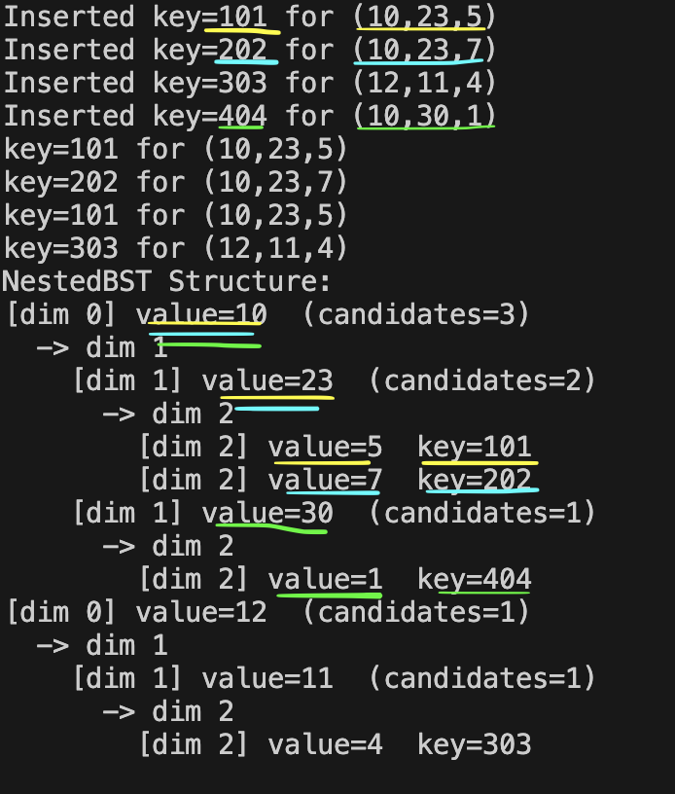
-As shown in the image, we add three groups of values with the same first value, and or same second value. Each of these inserts has a matching key associated with the path/pattern. For instance, we can see through the display of the BST that since the three inserts all have 10 at the start of the pattern, 10 has three candidate keys that are associated with the three different pattern inserts. All inserts match the dimensions and keys appropriately as well.

• Ensure that Find with wildcards (*) returns all matching keys.
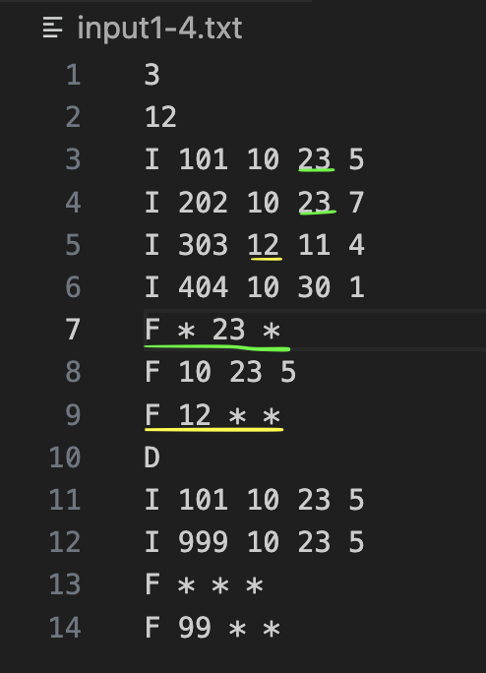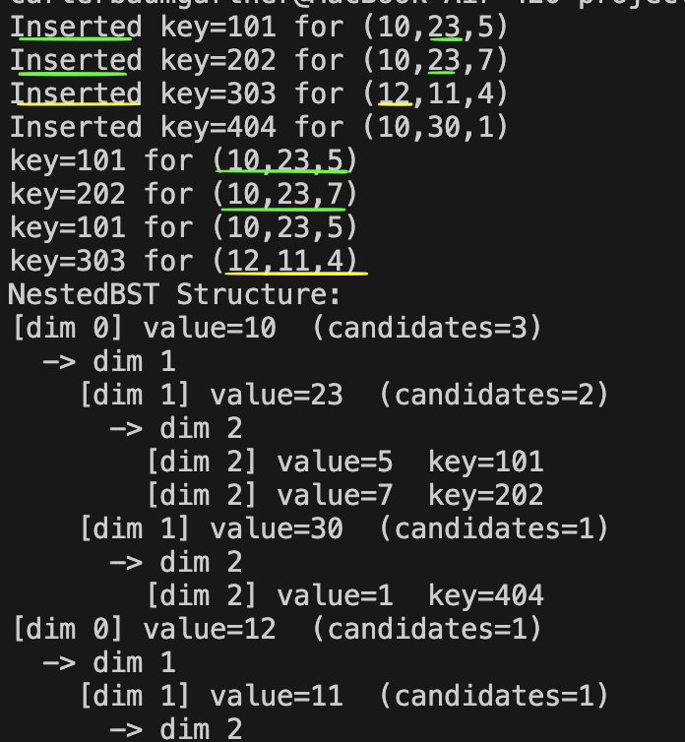
In this example we ca see that we choose to find a (*, 23, *) and (12, *, *) pattern. We can see in both images that we inserted patterns that contain those values at those dimensions, so it should be possible to find a wildcard combination of them. As shown on the output image, we can see we find the only two combinations for (*, 23, *) which are (10,23,5) and (10,23,7) with their corresponding keys. Since, the (12, *, *) only has one combination it will only output that one, (12,11,4) with its key. This verifies the Find method’s ability to use wildcards.

• Confirm that Display accurately shows the tree hierarchy.
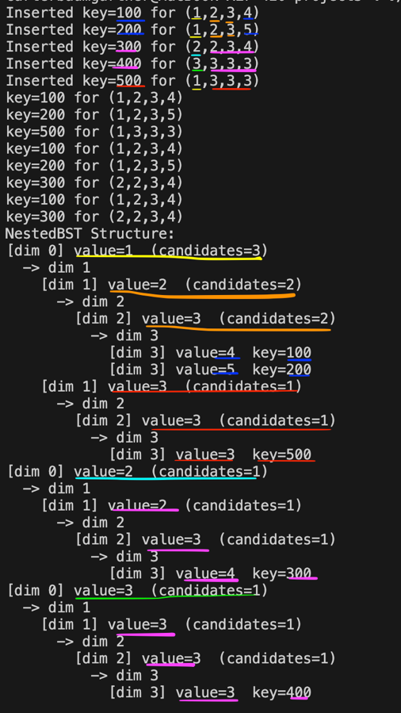
-I have color coded the inserts to show that all the patterns have been inserted which their corresponding keys. If any of them had similar patterns, it would appear accordingly with the number of candidates in the specified dimensions.
• Verify that duplicate inserts are handled correctly (Updated/Unchanged cases).
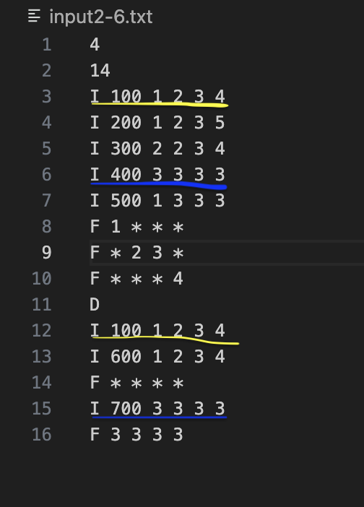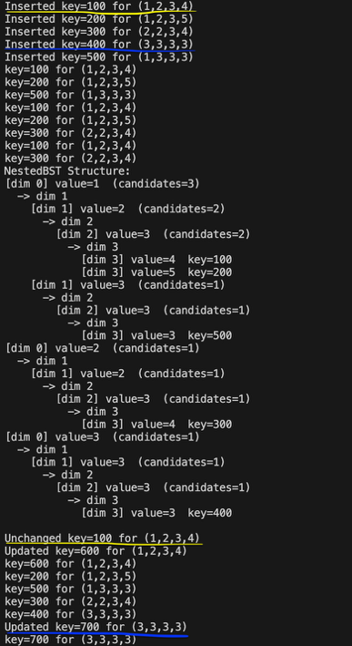
-We can see that the key pattern pairs of 100-(1,2,3,4) and 400-(3,3,3,3) are inserted properly. When we try to insert the 100-(1,2,3,4), it results in an unchanged key case as shown in the output. When we try to insert the 700-(3,3,3,3), it results in an updated key case where the key changed from 400 to 700.

b) Issues and Resolutions
Document major implementation challenges such as:
• Managing recursion across dimensions and trees.

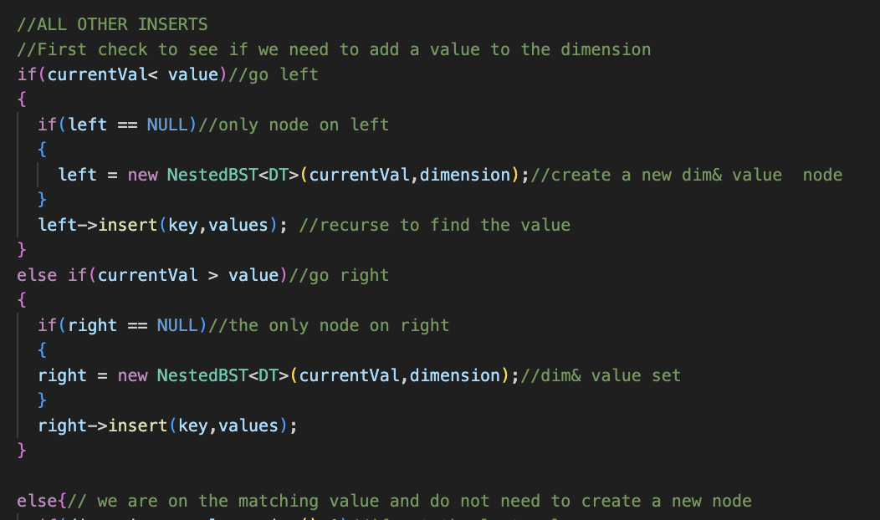
-Here is a snippet of my insert function for all other inserts besides the first insert. I check between three conditions, if the current value we are inserting is less than, greater than, or equal to the value we are on in that dimension. Based on that we will either create a new node to the left, right, or go into the innerTree if it is not the last dimension. Each time we recursively call the insert function with the new node. We carry over the key and dimension (unless we are going down a dimension in which we will add 1). This will occur until we hit the base case which is the last dimension.

• Ensuring consistent indentation and dimension labeling in Display.
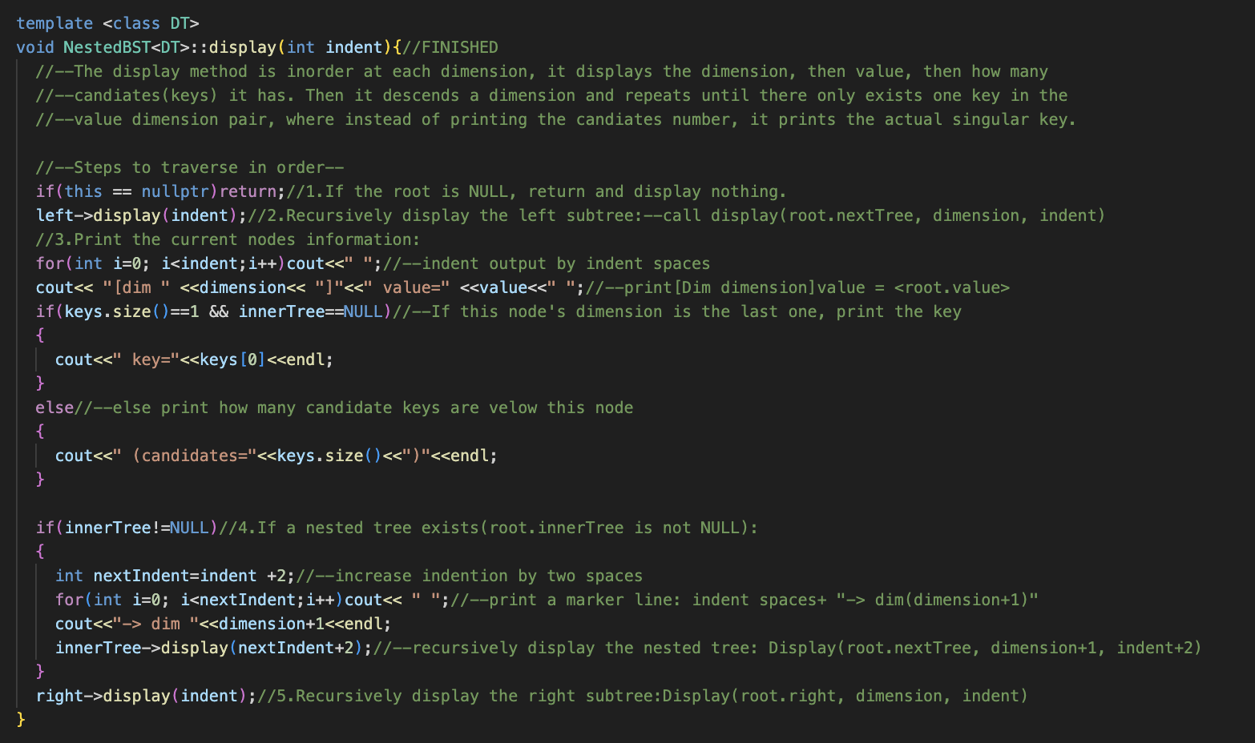
-To start the display function, I followed the instructions given in the project 3 description as closely as possible (This is denoted with my comments. However as expected I could not get everything correct, most notably the spacing/indents. For this, I used a tool of VS code called compare. I would copy my output onto a text file called “test.txt” and then compare it with the corresponding output file given to us and it would highlight what I had differently in red. I then applied these changes to the display function accordingly until it worked perfectly for all three outputs given.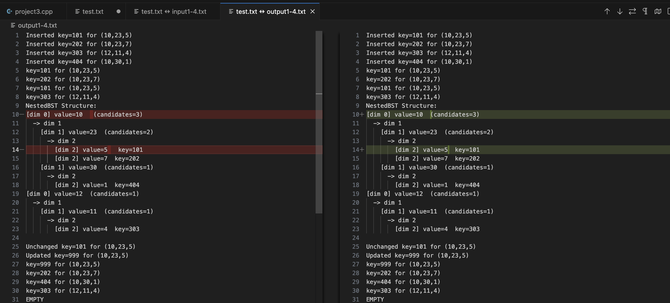
c) Verification
Describe how you verified that your implementation is correct.
Include edge cases, such as:
• Searching with no matches.
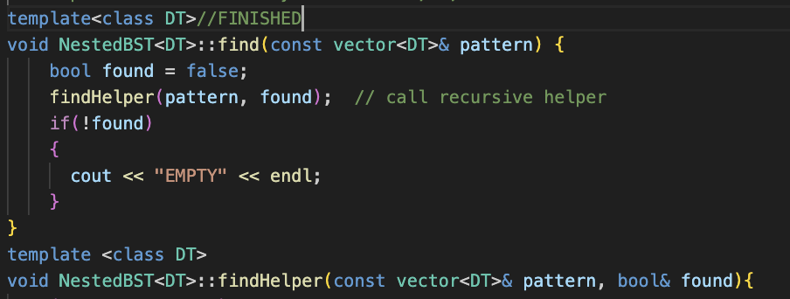
To track if there were no key matches for a given pattern with recursion as one “EMPTY” print statement, I needed to implement a recursive helper function that passed through whether a pattern was found as a Boolean value after all the recursive calls have been ran. Essentially, if a pattern was found in any of the recursive passes, it would change the reference variable found to true.
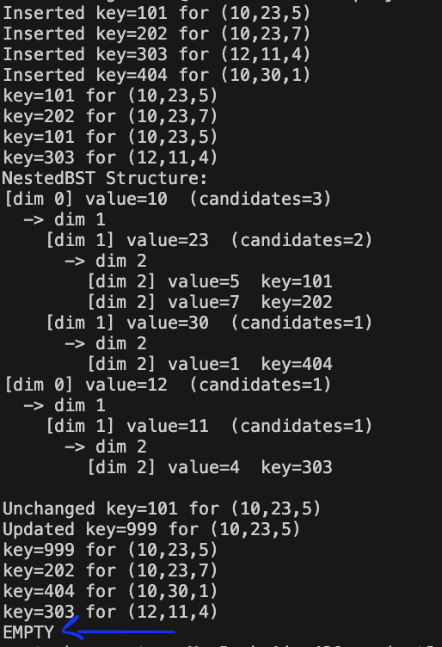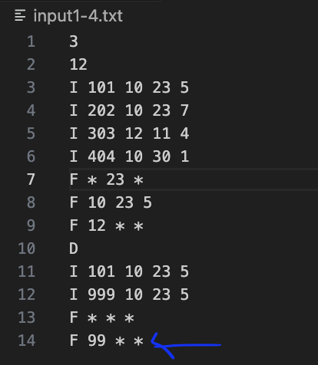
Then I confirmed that it worked appropriately using input and output. In the last line it asks to find any pattern with a 99 at the start and any other two values to follow. We can see that we have inserted no patterns with that such pattern so it should print out one EMPTY statement, which it does.

• Displaying after multiple nested insertions.
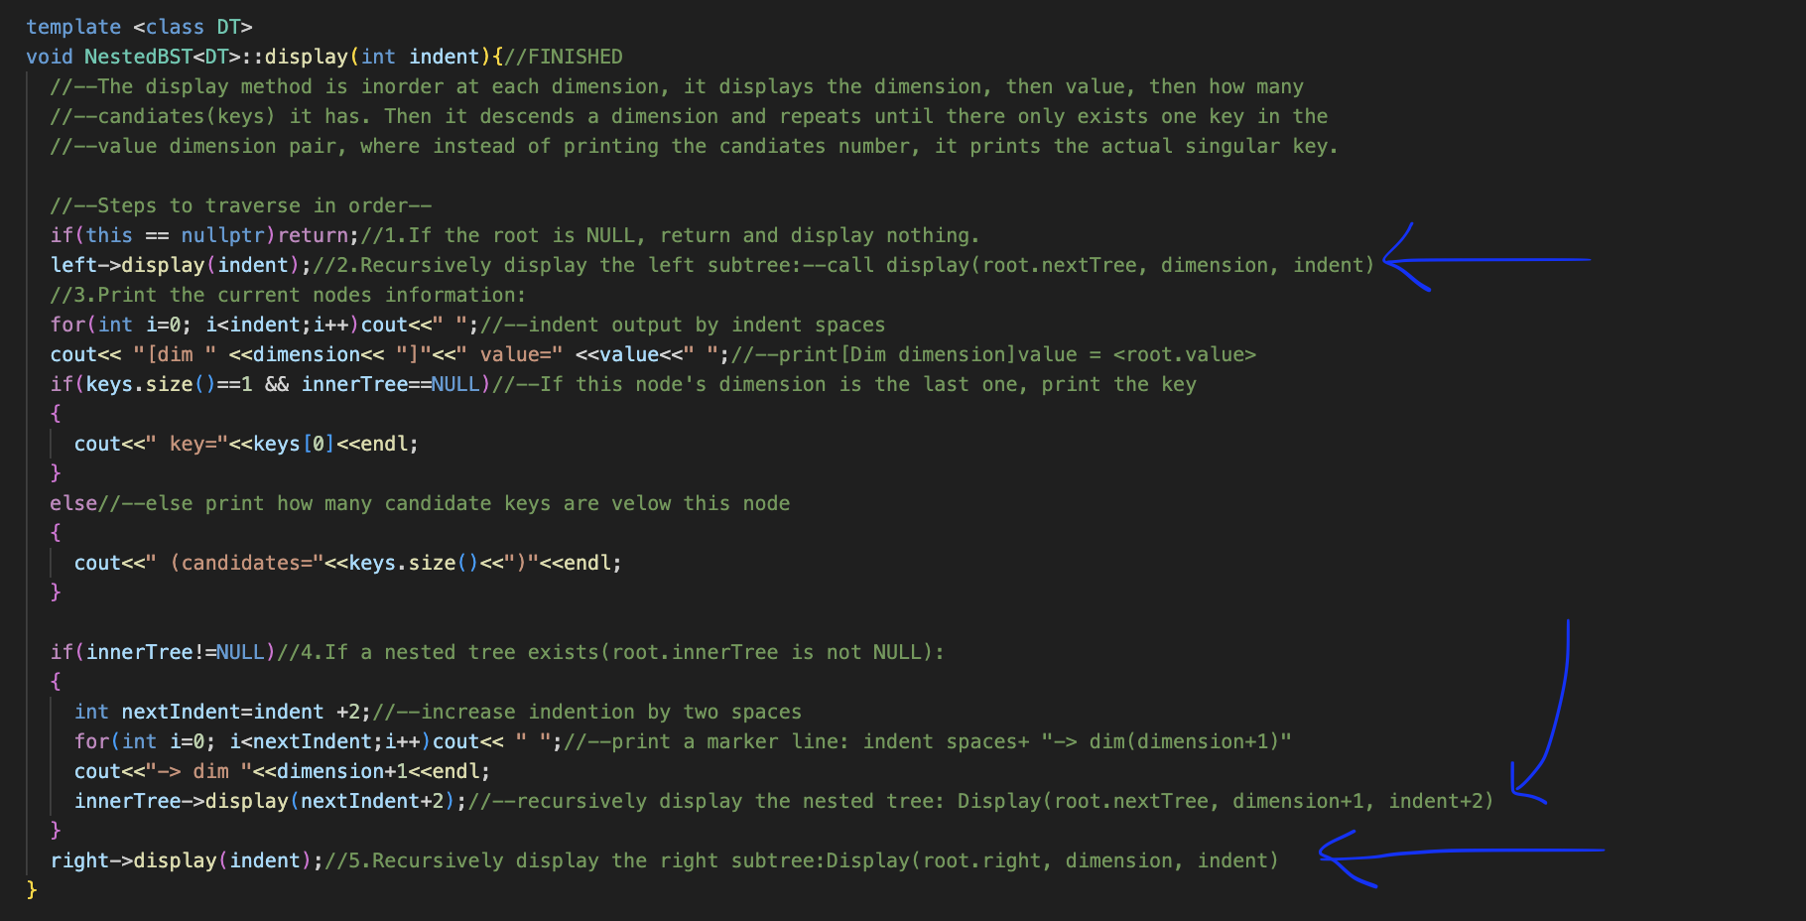
-The display function is meant to print the tree INORDER meaning we go Left root Right. I implemented this by recursively calling the display function to go all the way to left in the current dimension, then it will go into the innerTree and again go left until it has no more left values/dimensions. Finally, it will do all the right values. This corresponds to exactly what INORDER is supposed to do.

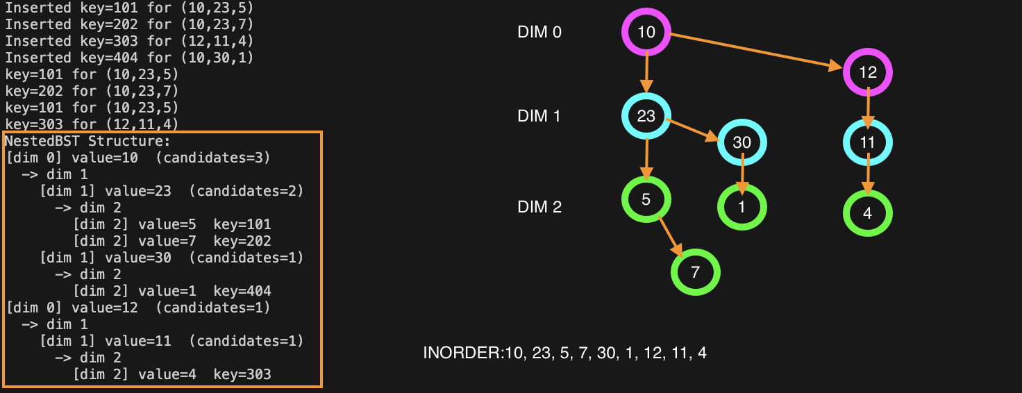
-We can confirm the display function’s INORDER functionality by comparing what the tree looks like along with the order in which the values are being printed out. As shown, they are printed in INORDER traversal.

