By: Carter Baumgartner For: Project 4

LLM and GitHub Copilot Usage Documentation
Prompts and Suggestions, Rationale for AI Usage, and Incremental Development
Explain why you used particular prompts and how the AI’s suggestions influenced your implementation.
Describe how AI tools helped you optimize or debug your code. Show how you used AI tools step-by-step, from initial function prototypes to refinement. If you modified AI-generated code, explain what and why.

Prompts and Rationale for AI Usage: I only used Chat GPT for AI usage on this project. For each use, I provided the Question(Q) I had, Reason/Rationale(R) for why, Output the response from the AI, and ideas/concepts learned after response(L). I also labeled each use with an overall goal to such as debugging or understanding/learning to help clarify and organize the prompts. In order to gain a clear understanding of what the AI is outputting you must consider your own thought process of your previous code, what the AI offered to change, check the AI code, and then decide what you think you should change based on the critique from the AI.

understanding/learning
Q: How should I interpret this parameter "long long &exchanges" if it is defined in a function.
R: I am writing my code/algorithm for the rowSwap function and I don't understand the purpose of the double data type of long and
the fact that it is also a reference.

Output:
In C++, a function parameter written as:
long long &exchanges
should be interpreted as:
✅ A reference to a long long
More specifically:
long long → the data type
& → indicates this parameter is a reference
exchanges → the name of the parameter
What it means
The function receives a reference to an existing long long variable, not a copy.
This allows the function to:
Modify the caller’s variable directly, and
Avoid copying large data types (not a big deal for long long, but standard practice).
Example
void updateCount(long long &exchanges) {
exchanges += 10; // Modifies the original variable
}

int main() {
long long x = 5;
updateCount(x);
// x is now 15
}
Why use a reference?
To return multiple outputs from a function.
To modify an argument directly.
To avoid copying (more important for large structs/classes).
How it differs from pointers
void foo(long long* p); // must pass &variable
void foo(long long& r); // pass variable directly
References cannot be null, must bind to an object on initialization, and use simpler syntax.

Learned: I learned it is basically a type of integer. It can store larger numbers, guaranteed to be 64 bits wide. I also learned it is important to keep the exchanges variable as a reference so we can edit the number directly rather than making multiple copies.
understanding/learning
Q: What does it mean if a function has the prefix "inline" before the return data type?
R: I am still writing my code/algorithim for the rowSwap function and I don't understand the purpose of the "inline" prefix at the beginning
of helper function "inline int* rowPtr(int* data, int r, int C)".

Output:
In C++, putting the keyword inline before a function means:
It suggests to the compiler that the function’s code should be expanded at the call site instead of making a normal function call.
Example:
inline int add(int a, int b) {
return a + b;
}
What “inline” really means today
Historically, inline meant:
“Please replace calls to this function with the function’s code to avoid function call overhead.”
But modern compilers decide inlining automatically, so the keyword rarely affects performance.
What inline actually controls now
In modern C++, the most important meaning of inline is:
✅ A function can have multiple definitions across different translation units, as long as they are identical.
That's why we use inline for:
Functions defined in header files
Templates (implicitly inline)
Small utility functions inside headers
Without inline, defining a function in a header would cause multiple-definition linker errors.
Summary
Effect True today? What it means
“Inline-expand this function for speed.” ❌ Not guaranteed The compiler decides.
Allow multiple identical definitions across the program. ✅ Yes The real modern purpose.
Good for header-defined functions. ✅ Yes Used a lot for this.
Example in a header
// math_utils.h
inline int square(int x) {
return x * x;
}
Simple explanation
inline used to mean “optimize by inlining”.
Today, it mainly prevents linker errors when a function is defined in a header.
If you'd like, I can explain:
Why inlining doesn't always improve performance
How linkers handle inline functions
constexpr vs inline functions

what are linker errors?
In C++, linker errors happen during the linking stage of building your program — after compilation.
To understand linker errors, it helps to know the build steps:
1. Compiler
Each .cpp file is compiled separately into an object file (.o or .obj).
Compiler errors are things like:
“undefined type”
“missing semicolon”
“no matching function call”
2. Linker
The linker takes all object files and combines them into the final executable.
This is where linker errors occur.
🔧 What linker errors mean
Linker errors usually fall into two categories:
1. Undefined reference
The linker can’t find the actual definition (the code body) of a function or global variable that was declared and used.
Example:
// foo.h
void greet(); // declaration only

// main.cpp
#include "foo.h"
int main() {
greet(); // we call it...
}
But if you forget to define greet() anywhere:
void greet(); // declaration only, no definition
The linker will error:
undefined reference to `greet()'
2. Multiple definitions
The linker finds more than one definition of the same function or global variable.
Example:
// utils.h
void hello() { cout << "Hello"; } // BAD: definition in header!
If utils.h is included in 3 different .cpp files, the function is defined three times, causing:
multiple definition of `hello()'
Why?
Each .cpp file gets its own copy of the function.
How to fix?
Mark it as:
inline void hello() { ... }
or move the definition to a .cpp file.
🔧 Why linking matters
Linking ensures:
All declarations you used have real definitions.
You don’t define things more than once.
All modules (object files) get combined into one final program.
Simple analogy
The compiler checks grammar in each chapter separately.
The linker checks that all chapters reference each other correctly:
If Chapter 2 refers to a character that is never introduced → undefined reference.
If two chapters introduce the same character separately → multiple definition.

Learned: Based on what ChatGPT said, it sounds like the "inline" prefix just prevents compilation errors if there are multiple definition of the same function across multiple files. However, I am not sure I understand why this was put in for our case.
understanding/learning
Q: How is this returning the pointer to a specific row and col? // Return a pointer to row r (mutable) inline int* rowPtr(int* data, int r, int C) { return data + r * C; }?
R: I did not understand how data + r*C was accessing data in an array

Output:
We’ll assume this function:
inline int* rowPtr(int* data, int r, int C) {
return data + r * C;
}
And we’ll use a 3×4 matrix stored in row-major order:
Row 0: 10 11 12 13
Row 1: 20 21 22 23
Row 2: 30 31 32 33
Stored as a 1-D array:
Index: 0 1 2 3 4 5 6 7 8 9 10 11
Value:10 11 12 13 20 21 22 23 30 31 32 33
Let:
int data[] = {
10,11,12,13,
20,21,22,23,
30,31,32,33
};
C = 4 because there are 4 columns.
🔷 Example 1 — Get pointer to row 0
Input
rowPtr(data, 0, 4)
Calculation
Offset = 0 * 4 = 0
Output pointer
Points to data[0] (value 10)
Usage:
int* r0 = rowPtr(data, 0, 4);
r0[0] == 10
r0[1] == 11
r0[2] == 12
r0[3] == 13
🔷 Example 2 — Get pointer to row 1
Input
rowPtr(data, 1, 4)
Calculation
Offset = 1 * 4 = 4
Output pointer
Points to data[4] (value 20)
Usage:
int* r1 = rowPtr(data, 1, 4);
r1[0] == 20
r1[1] == 21
r1[2] == 22
r1[3] == 23
🔷 Example 3 — Get pointer to row 2
Input
rowPtr(data, 2, 4)
Calculation
Offset = 2 * 4 = 8
Output pointer
Points to data[8] (value 30)
Usage:
int* r2 = rowPtr(data, 2, 4);
r2[0] == 30
r2[1] == 31
r2[2] == 32
r2[3] == 33
🔷 Example 4 — Access a specific element using rowPtr
Suppose you want element at (r=1, c=2) (row 1, col 2):
Step 1: get row pointer
int* r1 = rowPtr(data, 1, 4);
Step 2: index into that row
int value = r1[2];
Result:
r1[2] == data[4 + 2] == data[6] == 22
🔷 Example 5 — Modify a row
int* r0 = rowPtr(data, 0, 4);
r0[2] = 999;
Now the array becomes:
10 11 999 13 20 21 22 23 30 31 32 33
🔷 Example 6 — Use it without storing the row pointer
Direct access:
int x = *(rowPtr(data, 2, 4) + 1);
Evaluates as:
row 2 → start at data[8]
+1 → data[9]
value = 31

Learned: I learned it is more of a syntax understanding. This function represents getting the first element in a specific row of an array. C represents the number of col in the entire matrix, so by specifying the row, you can get first element of each row. ChatGPT also showed me how to access specific elements after specifying the row.
----------------------------------------------------------------------------------------------------
understanding/learning
Q: How does Quicksort work recursively?
R: I needed a visual interpretation of how QuickSort worked to help me better understand how to implement the code. This also would help me understand the value/role of each of the parameters given.

Resource used: https://www.youtube.com/watch?v=Vtckgz38QHs (QuickSort YouTube Video)

L: The biggest takeaway for me from this video is your code implementation is heavily dependent on how you choose your pivot. I followed the video choice of choosing the last element in the array, or in our case, the last row as the pivot. After deciding this, you need to do a couple of things, define an array set, declare the locations of trackers i and j, increment i and j accordingly, swap elements i and j accordingly, and do a final swap of i and the pivot when j reaches the pivot. I say accordingly because you would do things differently depending on your choice of pivot point. Then you recursively call this until the array is sorted.
--------------------------------------------------------------------------------------------------------------------------------------------------------------------------------
understanding/learning
Q: How does Heap Sort work recursively?
R: I needed a visual interpretation of how HeapSort worked to help me better understand how to implement the code. This also would help me understand the value/role of each of the parameters given.

Resource used: https://www.youtube.com/watch?v=2DmK_H7IdTo (HeapSort YouTube Video)

L: To start with understanding Heap Sort you must define the type of heap, in our case we use a max heap. All rules of max heap apply to heap sort and help with understanding in developing the algorithm. First you must, build the max heap into an array max heap tree with the given array. Then you apply a function called heapify, which takes the root of the tree and swaps it with the last element of the tree. Then you would recursively call the heapsort function excluding the last element because it is now consider sorted. You do this until the list is sorted.

Debugging and Testing Plan
a) Specific Test Cases

• Duplicates: many identical rows; rows equal on column 0 but differing later (tests lexicographic tie-
breaks).
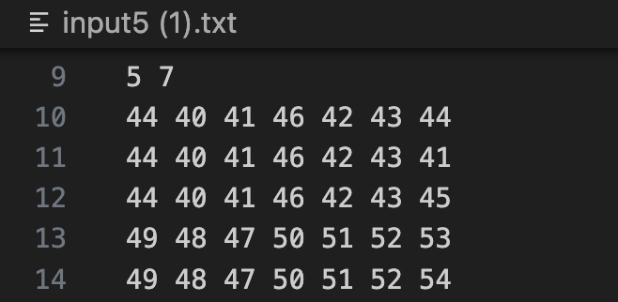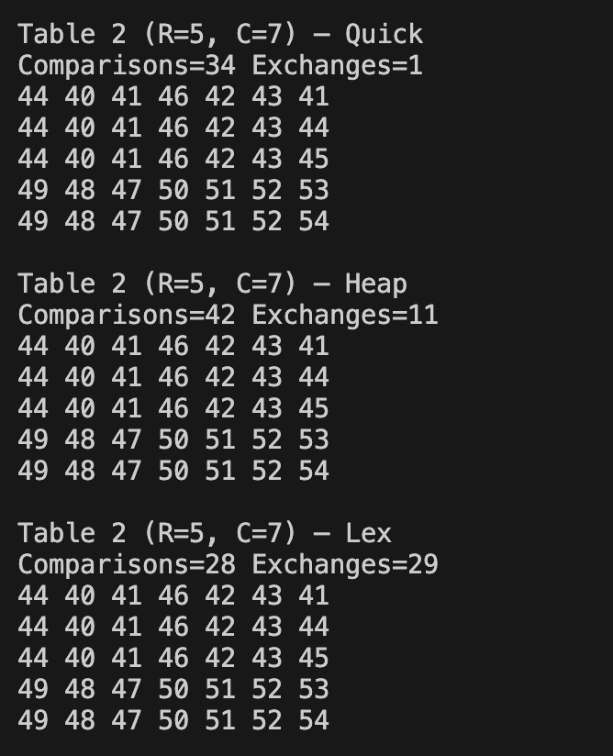
Here we can see based on the input that the first three rows of this table are nearly identical except for the last elements. We can also see that Lex Sort not only had the least number of comparisons among the three sorting algorithms, but also it performed the best given the number of comparisons to exchanges ratio before being sorted.

• Already sorted / reverse sorted tables
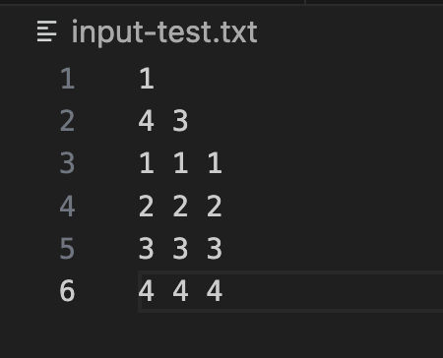
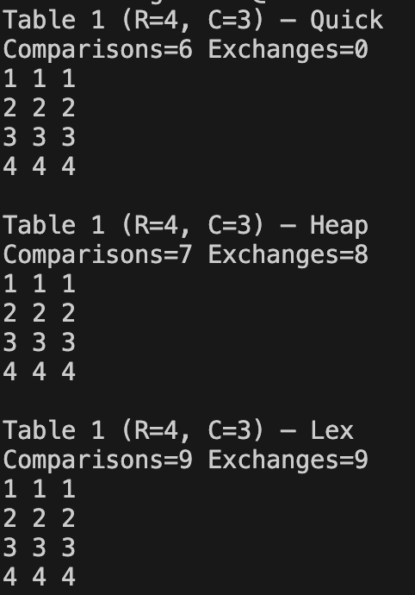
Here is an example of an already sorted table and the total number of comparisons and exchanges for each algorithm.

• Wide rows: larger C to stress row movement.
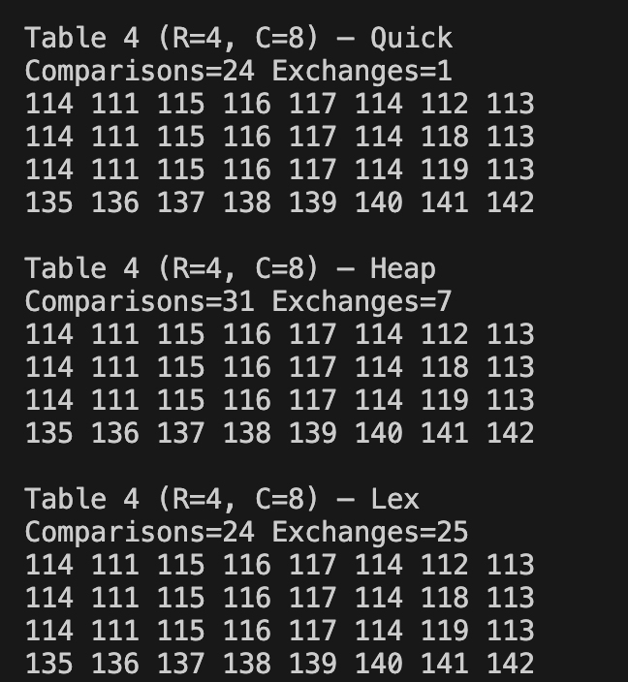
Here is an example of a larger number of columns to stress row movement. In this case, wider rows just become more difficult for the algorithm to traverse (more expensive computationally).

b) Issues and Resolutions
• Comparison counting mistakes (e.g., forgetting to count the last equal-column check).
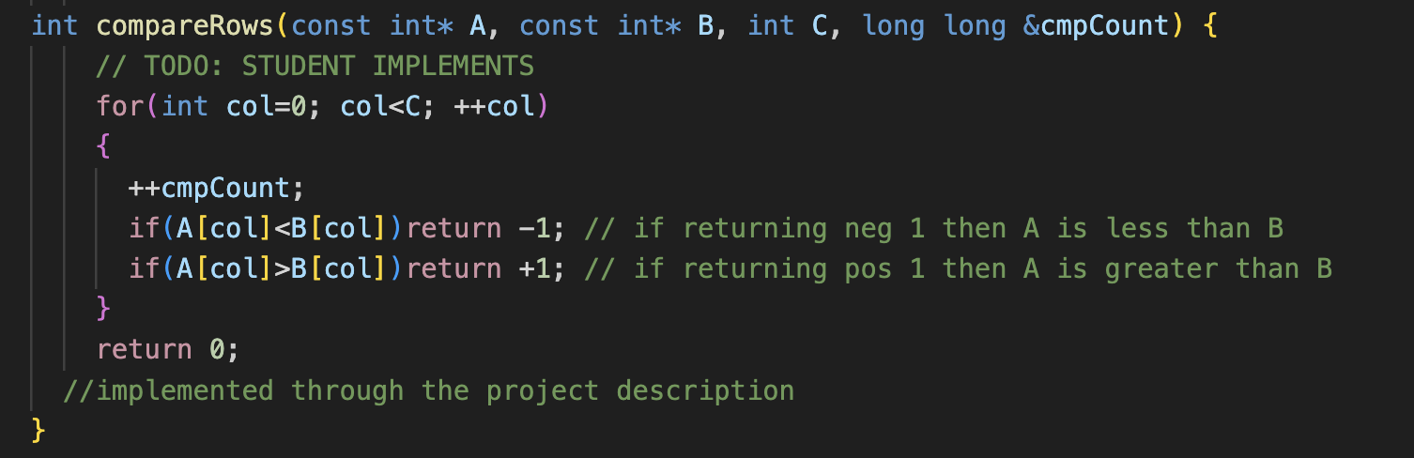
For the most part my comparison counting was correct for Quick Sort, Heap Sort, and Lex because it counted a comparison correctly for every column it checked including the last column. However, whenever I ran into issues where the output did not match the expected output, it usually was an easy fix with my traversal bounds(col/row bounds).

• Exchange counting consistency (index-swap vs row-swap; insertion shifts; merge writes).
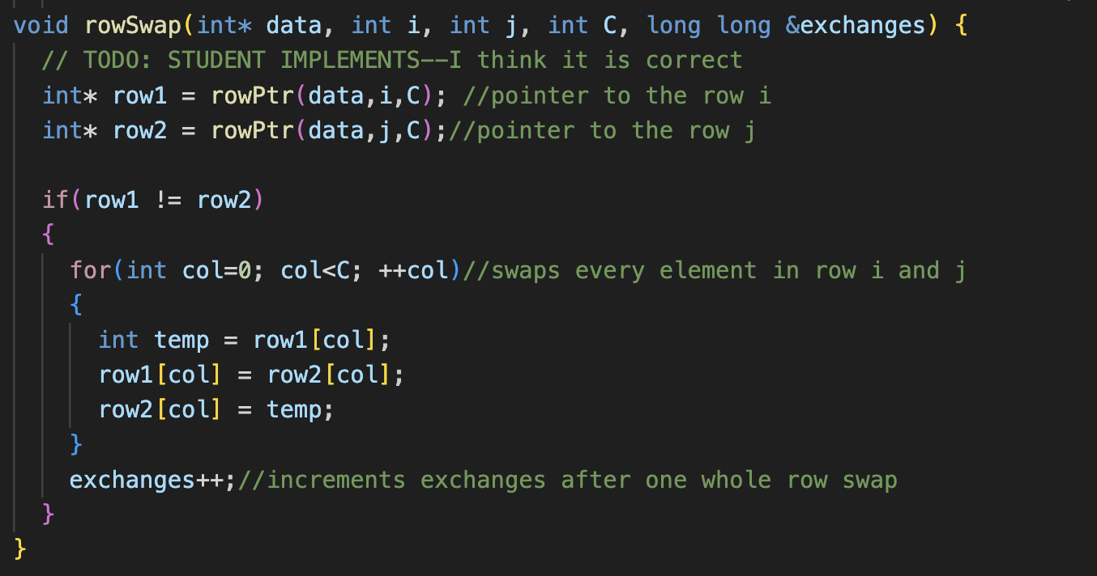
For the most part my exchanges counting was correct for both Quick Sort and Heap Sort, because it counted a exchange correctly for every complete row swap. However, for Lex Sort I ran into issues when implementing the pseudocode given. My output for exchanges was always off by the number of columns in the given table. I fixed this by subtracting the number of columns by the total number comparisons at the end of the lex sort before returning the comparisons.
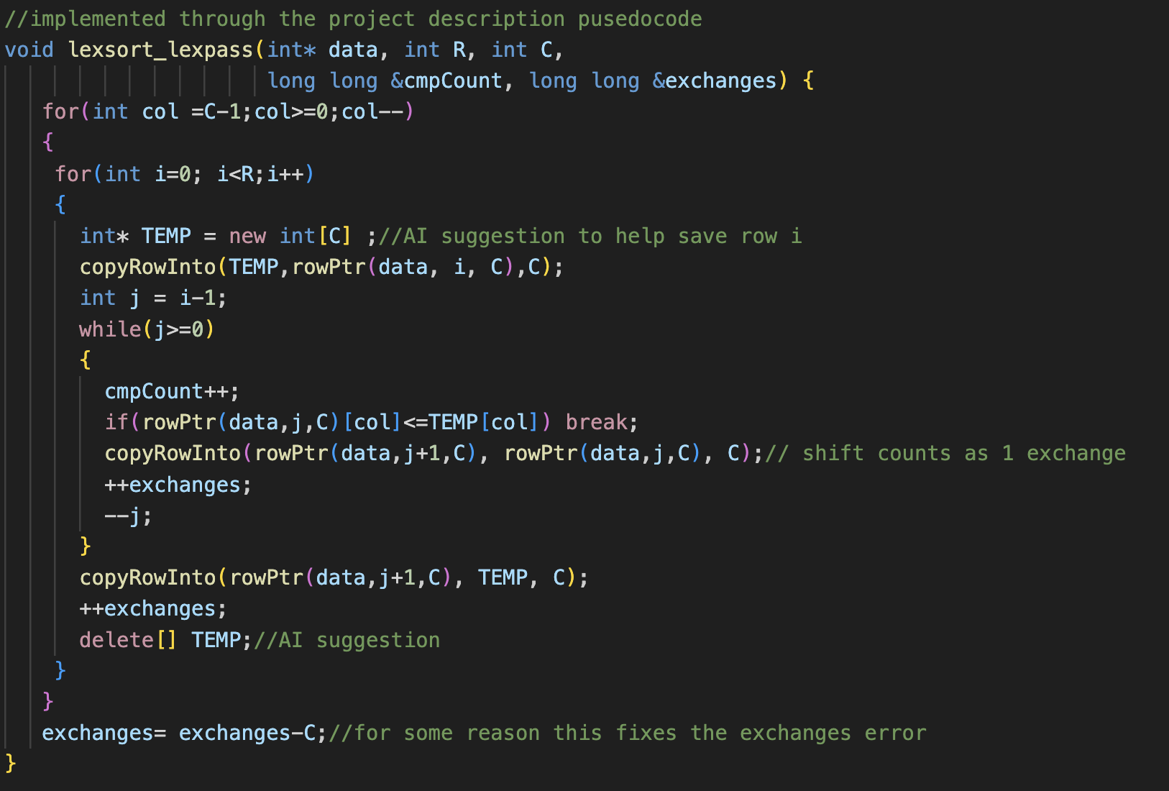
• Temporary buffer handling in merge; avoiding memory leaks.
I was struggling to figure out to save row i temporarily for lexsort because all of my attempts caused memory errors when I ran input. I figured I might not be understanding how memory allocation/pointer variable declaration works so I went to AI for help. It explained that I needed to create an empty row with the same number of columns before copying into it and I needed to delete the temporary variable afterwards to avoid memory leaks.

c) Verification
.• Cross-check that all three algorithms yield the same final order (for a strict total order).
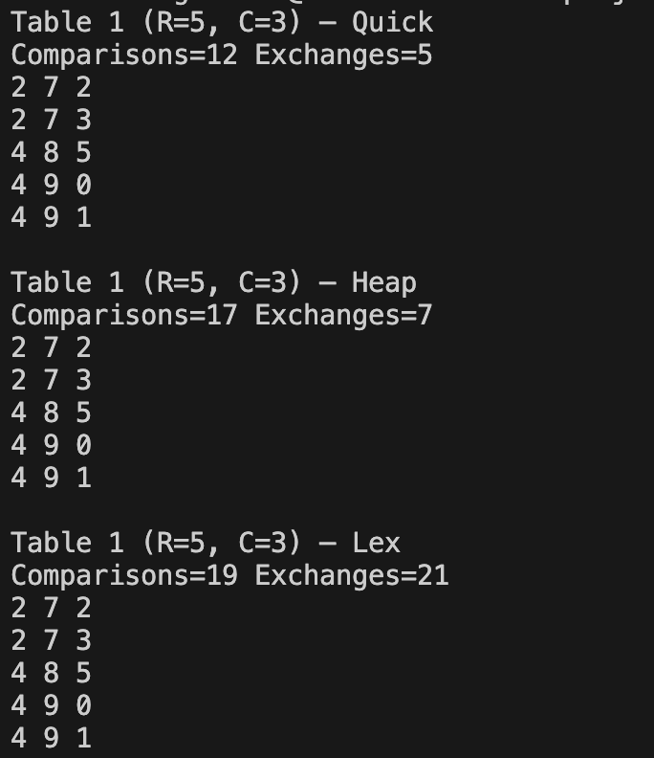
We can clearly see that all three algorithms yield the same final order

• Validate that comparison counts increase with harder distributions (e.g., reverse order).
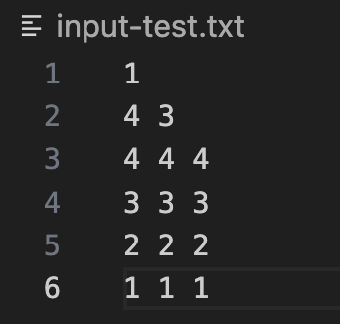
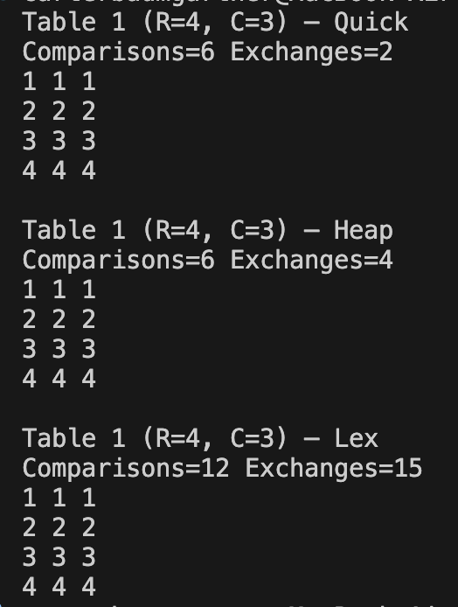
On the left we can see that the table is given already sorted and it results in a number of exchanges and comparisons for each algorithm. On the right side we can see that the table is given in reverse order and it results in a number of exchanges and comparisons for each algorithm. The number of comparisons increases for Lex Sort only whereas Quick Sort remains the same and it decreases for Heap Sort. This makes sense given the table and algorithm. Quick Sort works in the same comparisons because the table “balanced” in generally the same way. Heap Sort works faster because it is already given as a max heap (in reverse order), saving unnecessary comparisons with the building the max heap/heapify.

• Manually compute expected counts for very small examples (e.g., R=3) to confirm your counters.
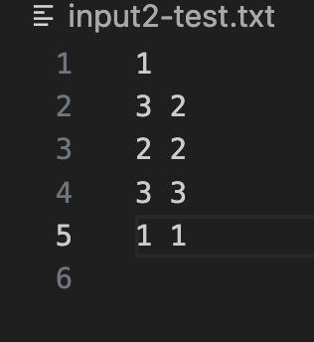
For Quick Sort: First call it would perform a swap between row 0 (2 2) and the pivot (1 1) since neither 2 2 or 3 3 are less than the pivot so the j tracker never gets incremented (1 EXCHANGE and 2 COMPARISONS). Now we have 1 1, 3 3, 2 2 as our table and pivot index is 0. It would then divide the table in half and recursively call quicksort on the left and right. Nothing would happen to the left side and the right side would operate similar to the first call and swap 3 3 with 2 2 (1 EXCHANGE and 1 COMPARISON). Finally, the table would and be seen as sorted. In total: 2 EXCHANGES and 3 COMPARISONS, This reflects accurately in the expected counts for both the comparisons and exchanges for quicksort.
