Relationship Between Common Stream Health Indicators
Carter Coleman
2021-12-10

1 Abstract
Stream health and water quality are typically measured by a stream’s physical characteristics (chemistry, surrounding land use area, channelization, etc.); microbial impacts(fecal indicator), and ecology (diversity of indicator macroinvertebrates). However, these categories are usually analyzed separately to assess stream health. If the impact of urbanization on freshwater bodies is not monolithic, we could be spending a lot of time and effort on monitoring programs that are not effective. Studies have shown conflicting results on what variables like conductivity, turbidity, e. coli cfu (fecal coliform indicator), nutrient (nitrogen and phosphorus) concentration, and biodiversity indicator score actually say about water quality. Therefore, a study was conducted assess how well all these parameters correlated with each other in the context of the Adopt-a-Stream method. Specifically, can you use one of the indicators mentioned (physical, microbial, and ecological) to describe the others to make a statement about overall stream health?
Data was acquired from a publicly available spreadsheet of water quality measurements collected by the Upper Oconee Watershed Network (UOWN) between 2003 and 2020. Data originated from three distinct watersheds in the Athens- Clarke County area: Middle Oconee (MIDO), North Oconee (NORO), and Oconee (BIOC). The data were analyzed first by using bivariate linear modeling of the variables conductivity, turbidity, nitrate (no3) concentration, E. coli cfu, and biodiversity indicator score (biological score). E. coli cfu and biological score were used as outcomes to specifically see if easy to measure physical/chemical properties could predict biological variables to assess water quality. Second, the MIDO data were analyzed using LASSO linear modeling to construct the best combinations of variables to predict E. coli cfu and biological score.
Results indicated that the only significant bivariate relationships that existed were between E. coli cfu and conductivity for the MIDO site only. LASSO modeling produced models that did not fit the data any better than the null model that was calculated for cross validation. This indicates that physical/chemical water quality measurements cannot predict biological measurements. This suggests that the citizen science approach to water quality monitoring should be re-evaluated for sampling robustness or that the effect of urbanization is spatially and temporally different and may not captured well without more in-depth sampling. Future studies should investigate how specific aspects of urbanization actually impact our indicator variables of water quality and stream health.

2 Introduction
The Earth’s surface contains a relative proportion of approximately 3% freshwater to 97% salt water. As such, that three percent is supposedly meant to sustain a growing global population of 9 billion people. In a world where water scarcity is more and more common due to increasingly warmer climate ([1]), our freshwater reserves are also threatened by pollution by urbanization. Urbanization surrounding a freshwater body creates a watershed dominated by impervious surface in the form of concrete and asphalt ([2]). Studies have shown that there is a significant negative relationship between impervious surface coverage and water quality ([3]). This is most likely due to accumulation and concentration of run-off pollutants from an entire watershed into a single drainage basin (i.e. freshwater body)([4]; [5]). Because the urban world continues to grow with population, it is likely that we will see a proportional decrease in water quality in our freshwater bodies as a result ([5]). Therefore, a rapid and consistent monitoring system needs to be in place to effectively allocate resources to remediating body of water in the midst of being polluted.
Currently, stream health and water quality are typically measured by their physical characteristics (chemistry, surrounding land use area, channelization, etc.); Microbial (fecal indicator), and ecology (diversity of indicator macroinvertebrates) ([6]; [7]; [8]). Typically, these measurements include conductivity (measure of dissolved ions), dissolved oxygen, temperature, pH, nitrate and phosphorus concentration, turbidity (measure of suspended particulate matter in the water column), fecal indicator bacteria (measure of waste pollution), and benthic macroinvertebrate diversity indices (measure of impervious surface run-off on sensitive aquatic taxa) ([6]; [7]; [8]). While Biological Indicatior Score is used to measure the combination of stream chemical and physical properties ([7]), it is hard to evaluate whether urbanization affects watersheds and water quality uniformly ([9]). Evaluating how uniform the impact of urbanization is on different watersheds would allow for a cookie-cutter monitoring and remediation method, which would allow implementation to be fairly easy for environmental managers. On the other hand, if the impact of urbanization on freshwater bodies is not monolithic, we could be spending a lot of time and effort on monitoring programs that are not effective. Currently, citizen science groups, like Adopt-a-Stream in Georgia, are collecting data on many watersheds throughout the world in an effort to consistently monitor water quality in a community. However, studies have shown conflicting results on what variables like conductivity, turbidity, e. coli cfu (fecal coliform indicator), nutrient (nitrogen and phosphorus) concentration, and biodiversity indicator score actually say about water quality ([10]). Therefore, I aim to answer how well are these parameters correlated with each other in the context of the Adopt-a-Stream method.

2.1 Question and Hypothesis
Based on the UOWN data used, this study asks if it is possible to use physical/chemical measures of stream health to predict microbial (E. coli cfu) and ecological (index score based on measurement of stream macroinvertebrate diversity)?
I would expect that because the all three are correlated with urbanization/anthropocentric impact, a negative impact to stream physical/chemical measurements will indicate a correlated negative impact to stream health in microbial and ecological measurements. The only caveat is that because level of noise in stream health data, significant correlations may be difficult to find.

3 Methods
UOWN has provided a great deal of data dating back to 2003. First, I wrangled missing data values that are a result of inconsistent sampling efforts. This made the data easier to work with and narrowed down a time frame for the data that is consistent and free of sampling bias. Next, I analyzed and compared trends in the change of chemical (conductivity, turbidity, no3.mgL); ecological (index score based on measurement of stream macroinvertebrate diversity); and microbial indicator data (e.coli CFU). In the context of this study, I measured ecological diversity based on the Adopt-A-Stream’s method of describing stream health based on diversity of susceptible and tolerant taxa ([11]). The idea is that the more urban impact to a stream, the lower the richness of macroinvertebrate taxa sensitive to urban pollution. Generally speaking, increases in chemical properties like conductivity (measure of total dissolved ions), turbidity (measure of suspended solids), nitrate concentration (no3.mgL) and abundance of microbial indicator taxa of human waste impact (i.e. E. coli cfu) indicate decreased stream health. In contrast a decrease in biological score indicates decrease in stream health. Next, since biological scores are used as a measure of broader ecological health, I will run t-tests on if the other factors significantly effect biological score. Finally, I will model the interaction of all physical/chemical measurments of stream health on biological score and E. coli cfu via LASSO modeling.

3.1 Data aquisition
The data I am using is the publically avaialable data provided by the Upper Oconee Watershed Network (UOWN). This data is part of a citizen science training effort for routine watershed-scale monitoring of the upper oconee river watershed. Trained freshwater scientists assist in training members of the community to collect both chemical and biological stream characteristics that are useful in describing stream health. All data is compliled and posted in raw form on the UOWN website. Of interest to me are the following variables: WSID (ID number), biological_score, conductivity, turbidity, no3.mgL, e.coli.cfu, month, year, day. The raw data shows 3,075 observations before cleaning. However, while cleaning I had to eliminate “po4.mgl” and “temperature” due to significant amounts of missing data.

3.2 Data import and cleaning
Below is the cleaned data produced from our data processing. Data was processed using the processingscript.R file and includes the following steps:
- Load rawdata from excel file. Note the use of the here() package and not absolute paths.
- Designate NA’s as actually missing values instead of factor data.
- Select variables of interest. These are variables I think are good indicators of stream health or are important identifying labels. Such variables are listed here: WSID, biological_score, conductivity.uscm, turbidity.ntu, po4.mgL, no3.mgL, pH, temperature.c, e.coli.cfu, month, year, and day. This was done using the Select() function.
There is 3,075 rows and 12 columns. This is because data has been collected for ~20 years. Unfortunately, I am seeing a lot of NA’s in the data. Because this is citizen science monitoring data, NA most likely means the data wasn’t collected during that event and is a form of human error bias.
- Use NA assessment to see determine which variables to remove from assessment. This was done using the is_na function. Several of the columns have more than half of the data missing. This is pretty common for citizen science data, seeing as collection is opportunistic. As such, I decided to remove P04 and temperature, because they are missing a lot of data. Finally, I decided to remove all missing values and see the condition of the data knowing that there are now no missing values. I removed NA data using the na.omit() function.
- Change all numeric columns to be read as numeric instead of character. This sometimes happens when R tries to read in data from an external source, but is an easy fix with the as.numeric function. This is important because my analysis uses linear regression functions and they are coded to only deal with numeric values.
- Separate the data into three separate data frames based on location ID: “MIDO,” “NORO,” and “BICO.” This is to separate out any bias based on location of the streams within ACC.
- Because the number of rows between each site data frame and between years is not consistent, measuring between sites and through time may be biased. That being said, my original question refers to the correlation between different indicators of stream health, not how they change spatial or temporally. Therefore, these space and time inconsistencies won’t affect the analyses.

3.3 Exploratory analysis
The following is an exploration of Stream Health Indicator correlation and comparison. The exploration will be structured as follows:
Each dataframe (MIDO, NORO, and BICO) will be analyzed separately. Within each dataframe, there are data explaining biological indicator values, stream chemistry, and fecal indicators over time. The only group with multiple components is stream chemistry. I plan to do a series of correlative analysis showing if there is some sort of relationship between the three indicator types to help inform further analysis via principle component, multivariate analysis, etc. Therefore, the goal of this exploration is basically to summarize how these indicators correlate.

3.4 Full analysis
Following correlation analysis during exploration, focus was shifted to just the MIDO dataset. For ease of interpretation, the MIDO data set will serve as the data frame where I test how robust the linear fit models actually are for the data. MIDO is the only data set large enough that when we split the data set into a “test” and “train” data set, I actually have confidence in the resulting model fit analysis. For comparison, MIDO has an n = 88; NORO has an n = 35; and BICO has an n = 23. The only thing we are missing by dropping the other sites is assessing site-by-site comparison, which I am choosing not to focus on anyway.
Finally, LASSO analyses were performed with either biological score or E. coli cfu as the outcome of choice. The LASSO model analyzed which combination of stream health descriptive variables are the best for predicting either biological score or E. coli cfu values for the MIDO site through time. To test how well the LASSO models performed and how well they fit our data, Root Mean Squared Error (RMSE) was calculated for each model produced and for predicted values of MIDO stream health variables, using the LASSO models. Residuals between actual and predicted values were calculated to show how well the models could predict values. Finally, all RMSE values (actual and predicted data models) were compared to a null model for both biological score and E. coli cfu to evaluate model performance.

4 Results
Results from exploratory data analysis indicates that most interactions between stream health indicators were non-significant, with the exception of E. coli (cfu) and turbidity. Additionally, the data set is most likely not skewed by influential outliers.
In addition to non-significant interactions, the relationships (slopes) between either biological score or E. coli cfu and stream physical and chemical properties varied inconsistently between sites.
Focusing on just biological score as the outcome variable biological score (figures 1-3 below), the interaction with conductivity was determined to be negative for the MIDO and NORO site. However, the BICO site had a positive interaction. Next, the regression plotting found a negative interaction with E. coli cfu for the MIDO and BICO sites. But, there was a positive interaction for the NORO site. For nitrate concentration, the interaction was negative for all sites. Finally, the interaction with turbidity was negative for the BICO site, while a positive interaction was found for the MIDO and NORO sites.
Figure 1: Plots of biological score versus conductivity, E. coli cfu, nitrate concentration, and turbidity for the MIDO site. 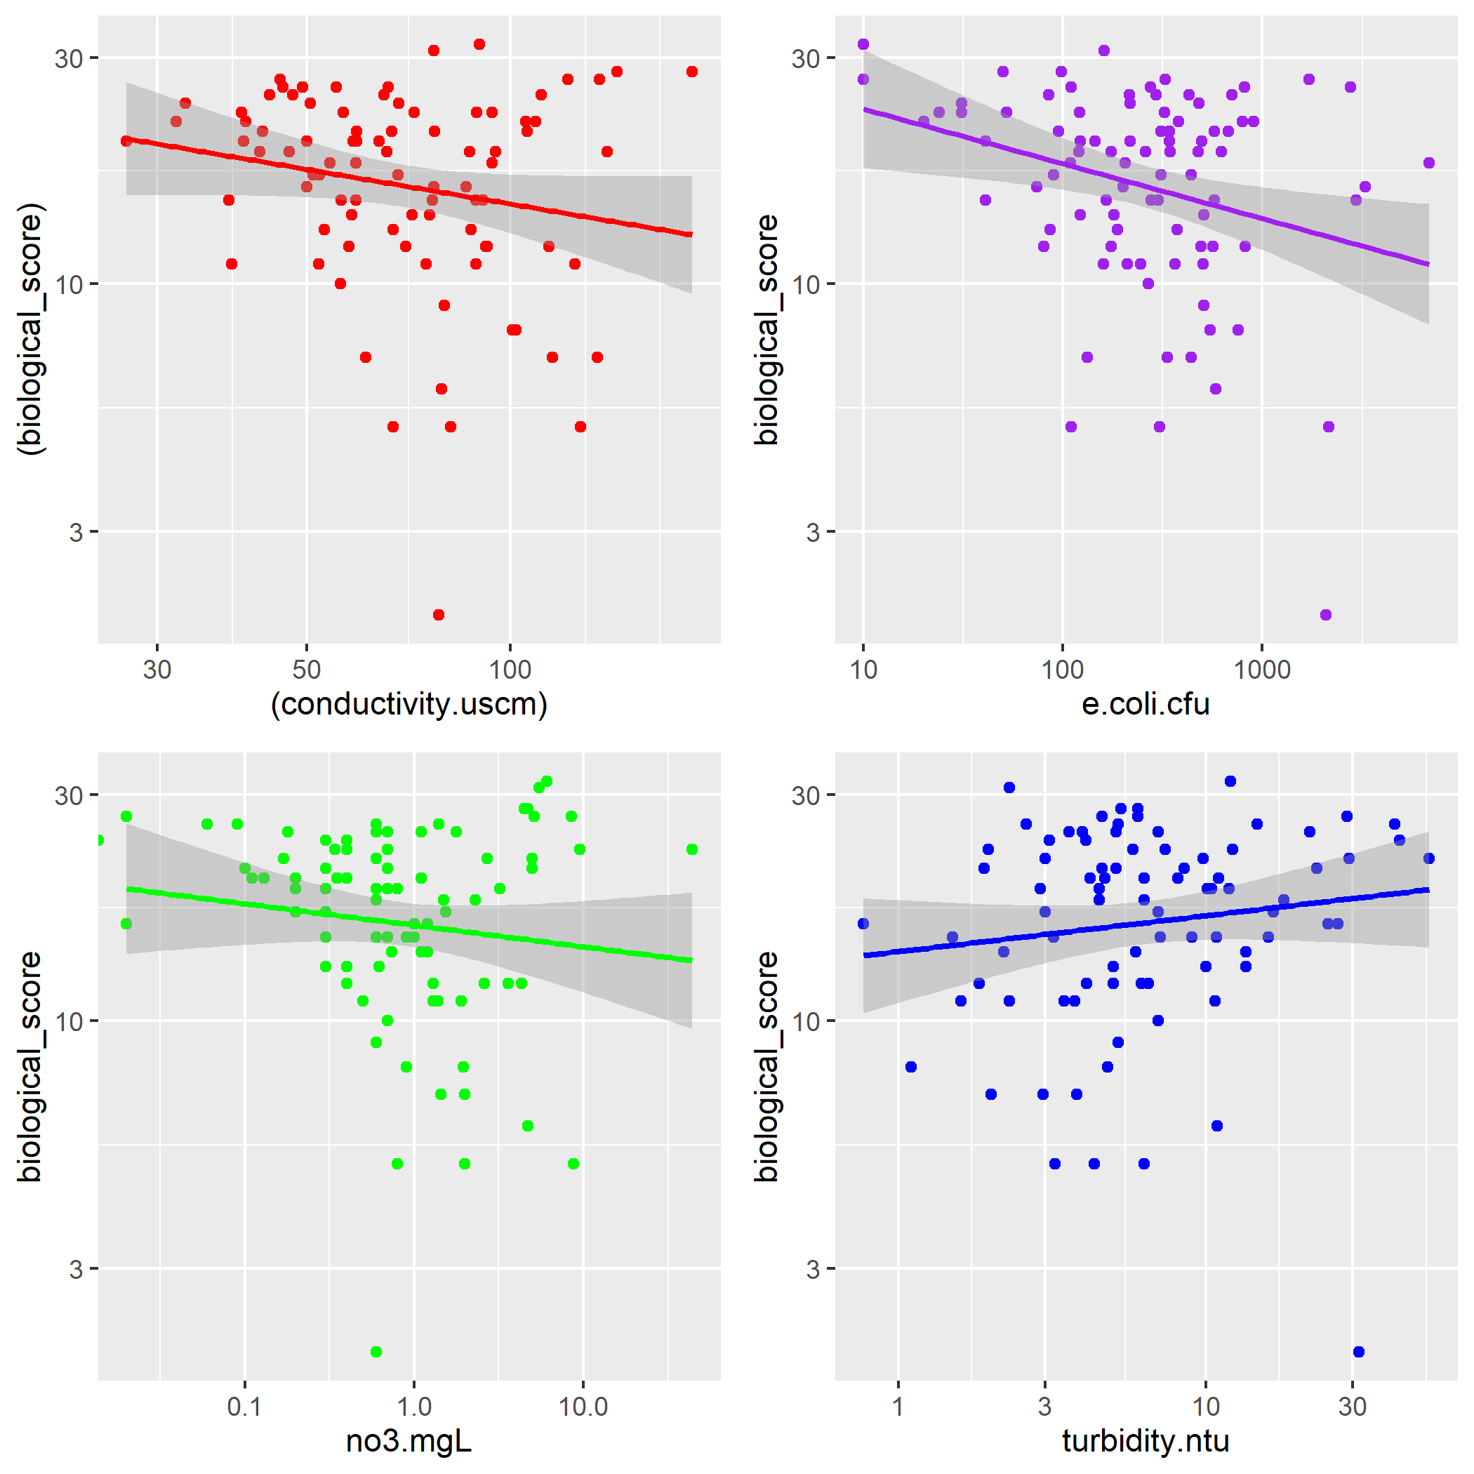
Figure 2: Plots of biological score versus conductivity, E. coli cfu, nitrate concentration, and turbidity for the NORO site. 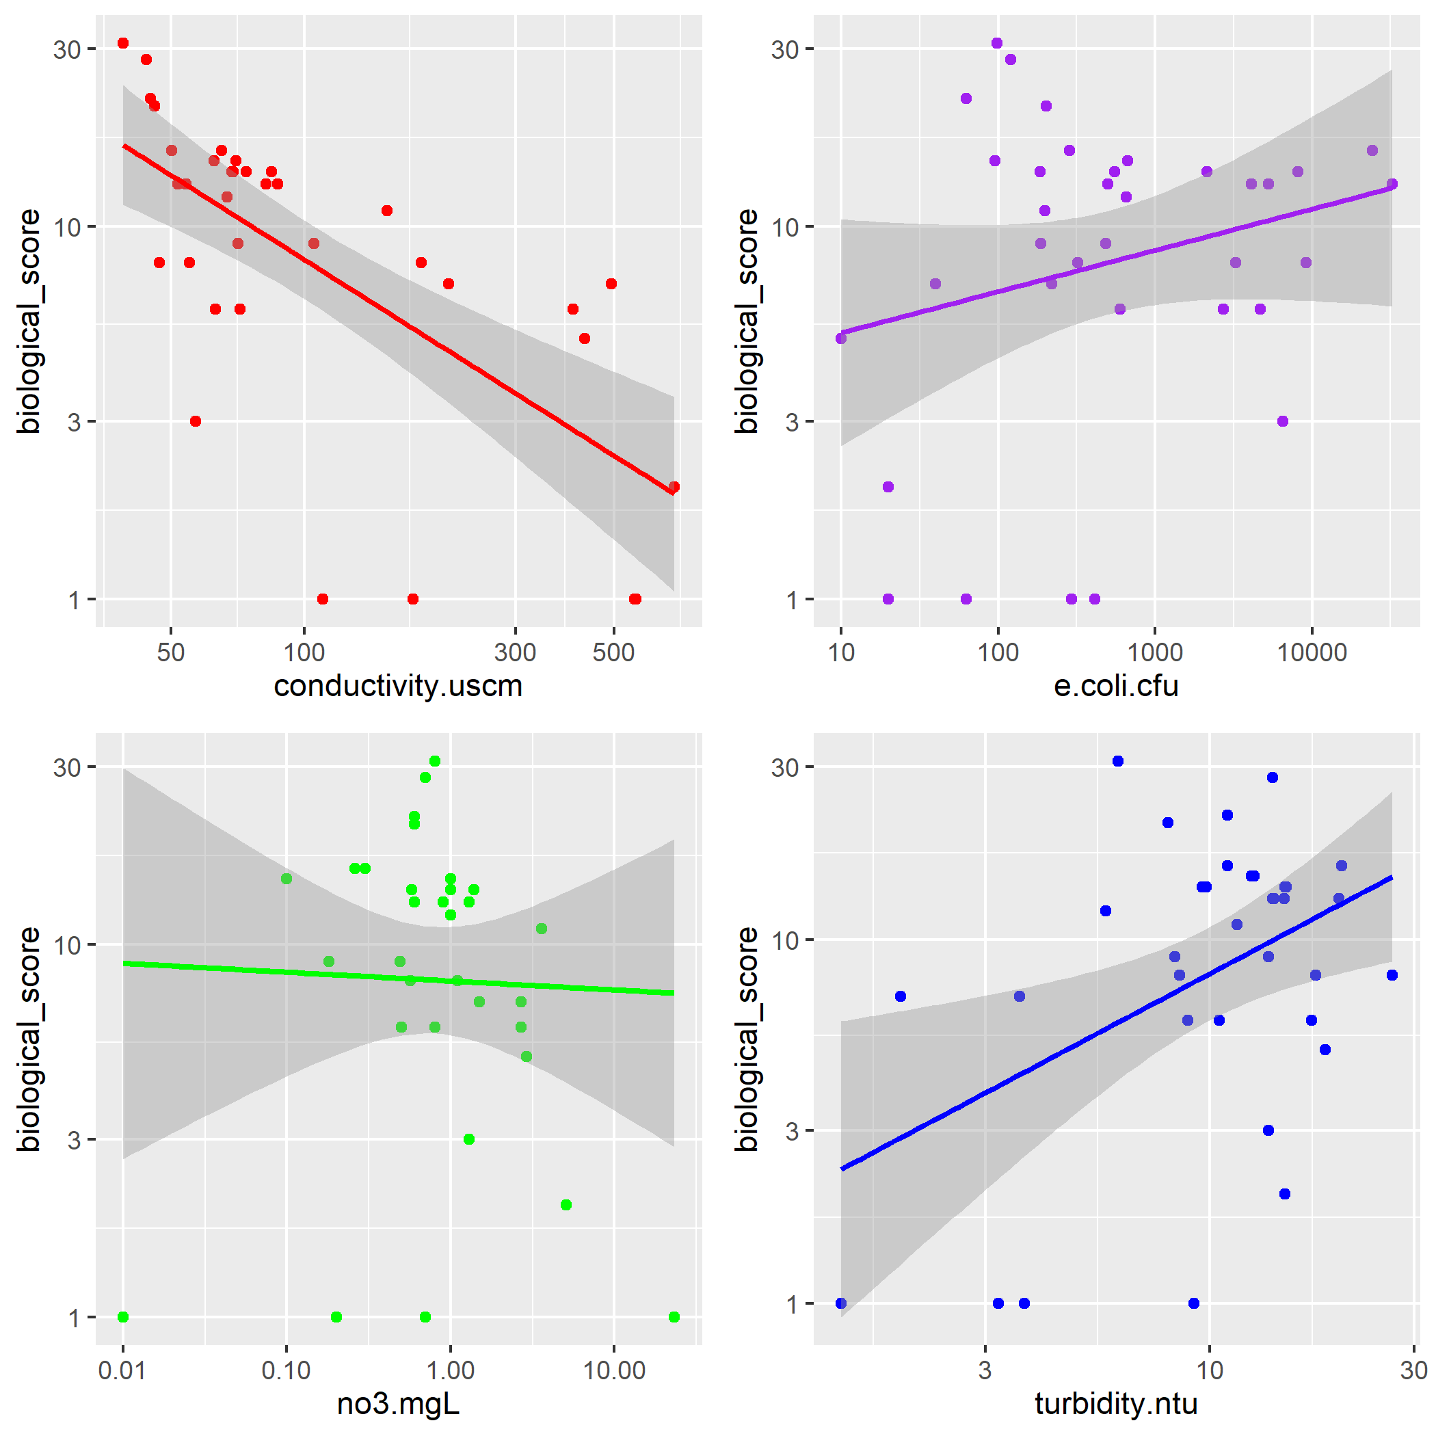
Figure 3: Plots of biological score versus conductivity, E. coli cfu, nitrate concentration, and turbidity for the BICO site. 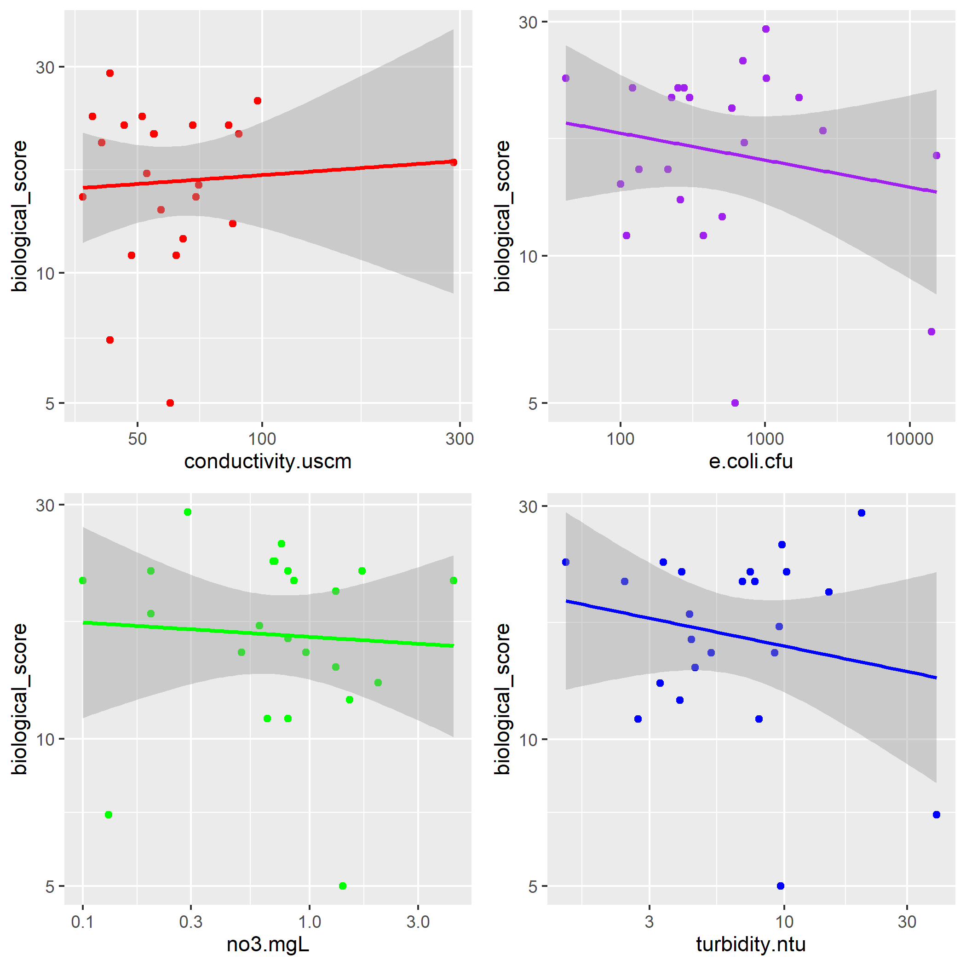
Focusing on E. coli cfu as the outcome of interest (figures 4-6 below), the interaction with conductivity was negative for MIDO and NORO. However, the BICO site had a positive interaction. The interaction with nitrate concentration was negative for all three sites. Finally the interaction with turbidity was positive at all three sites.
Figure 4: Plots of E. coli cfu versus conductivity, nitrate concentration, and turbidity for the MIDO site. 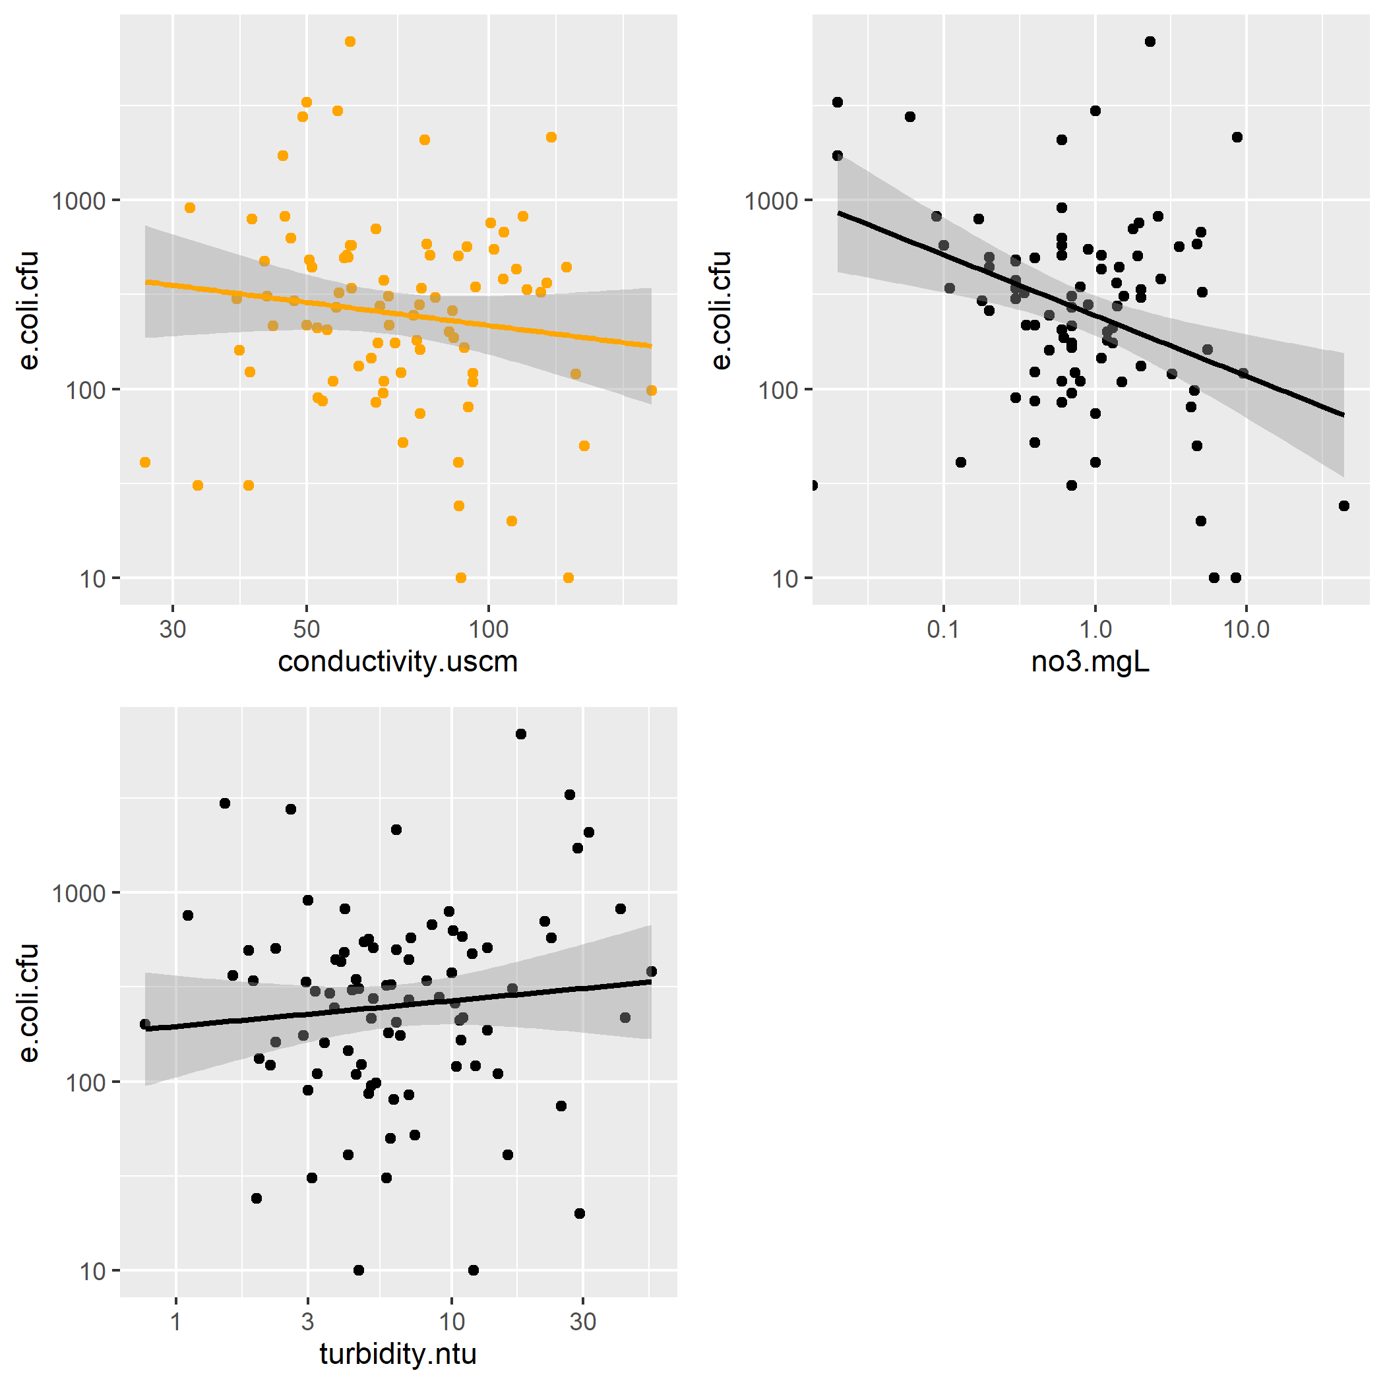
Figure 5: Plots of E. coli cfu versus conductivity, nitrate concentration, and turbidity for the NORO site. 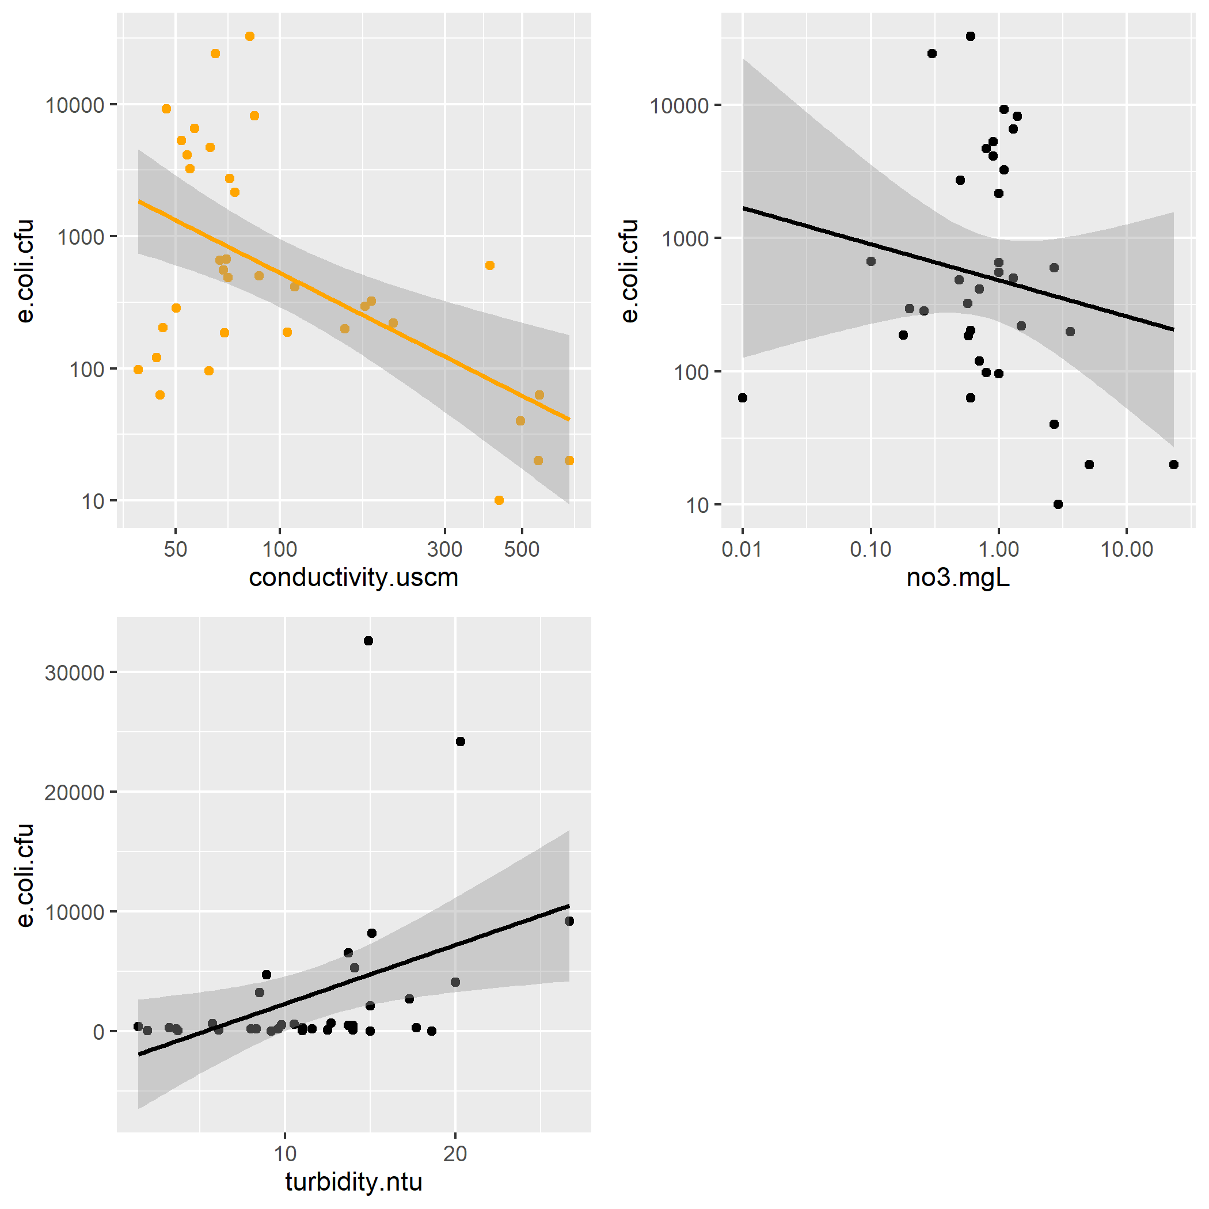
Figure 6: Plots of E. coli cfu versus conductivity, nitrate concentration, and turbidity for the BICO site. 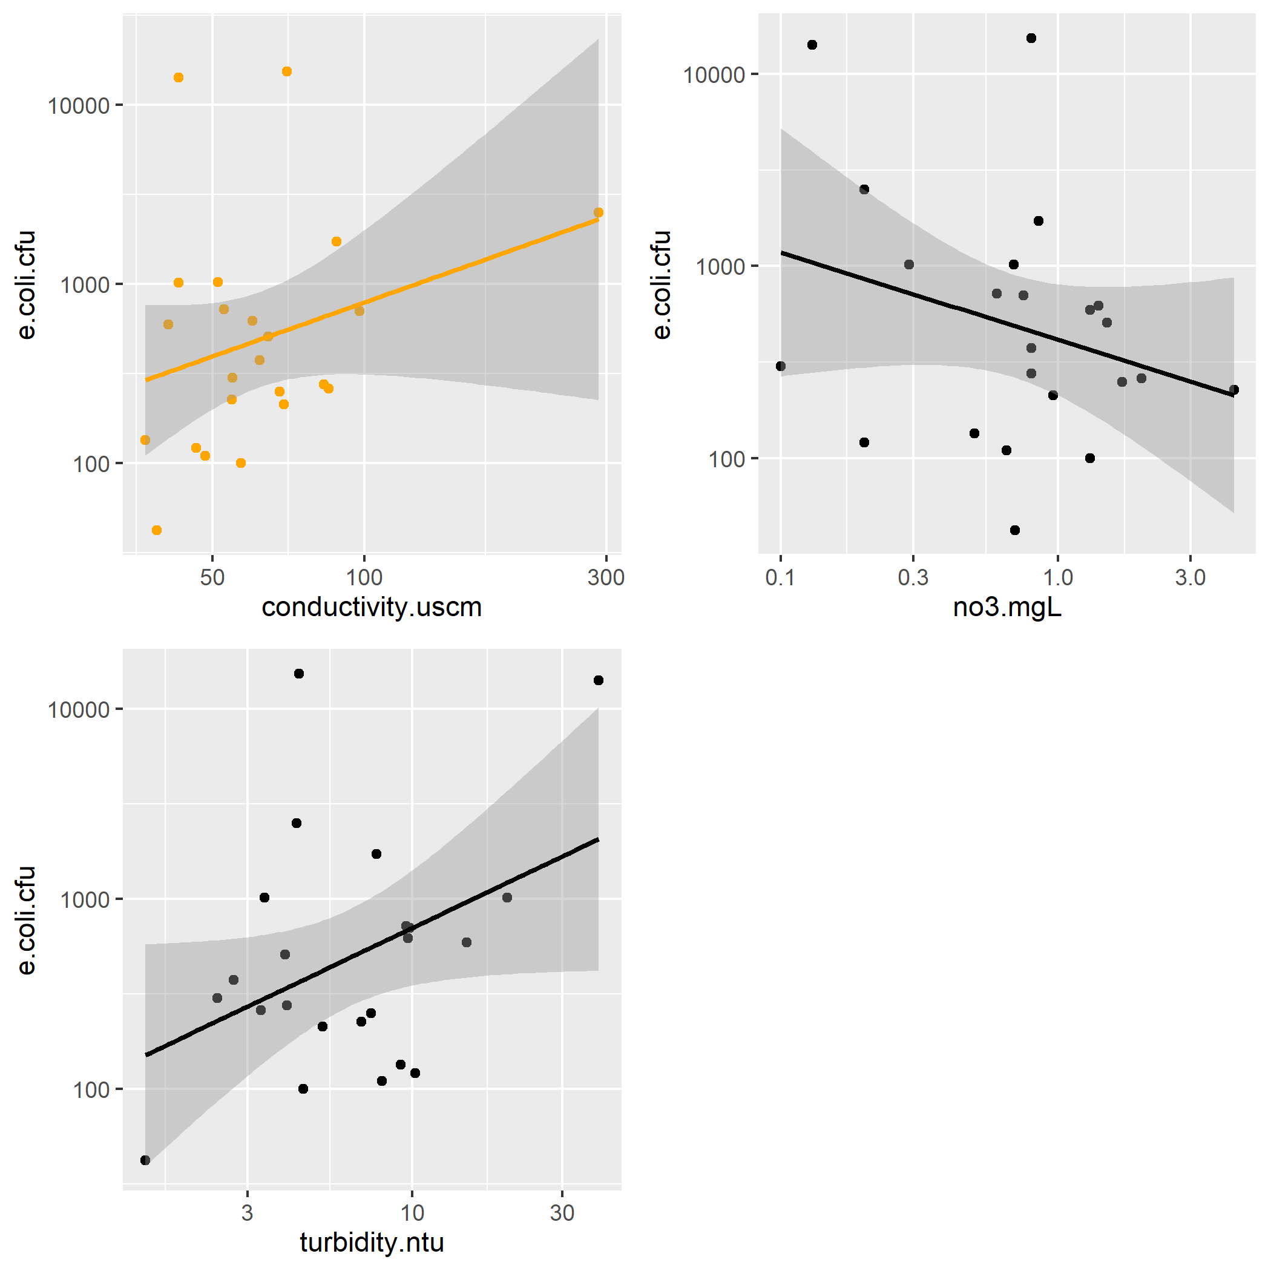
The results indicated that only the relationship between E. Coli (cfu) (Table 1 and 2) and Conductivity were significant for the train data set (p = 1.374747e-05). Large RMSE values indicate that the model did not fit the data well and could not be used to predict E. coli (cfu) from conductivity, despite a significant relationship.

Table 1: Linear Fit Model: E. Coli CFU predicted by Conductivity in the Trained MIDO Data Set
term | estimate | std.error | statistic | p.value
(Intercept) | 543.5227 | 123.8805 | 4.387475 | 4.3e-05

Table 2: Root Mean Square Error: E. Coli CFU predicted by Conductivity in the Trained MIDO Data Set
.metric | .estimator | .estimate
rmse | standard | 998.7567
The null linear models for biological score (Table 3) and E. coli cfu (Table 5) produced a RMSE = 6.63, with a standard deviation of 0.13 and RMSE = 0.52, with a standard deviation of 0.014, respectively. Results from the biological score LASSO machine learning model (Table 4; Figure 7) indicated that model 47 is the best performing model (RMSE = 6.50; STE = 0.16). However, based on comparative RMSE scores, model 47 does not really perform any better than the null model. This indicates that it is a bad fit to the MIDO data. Results from the E. coli cfu (Table 6; Figure 8) LASSO machine learning model indicated that model 41 is the best performing models (RMSE = 0.50; STE = 0.012). However, based on comparative RMSE scores, model 41 does not really perform any better than the null model. This indicates that it is a bad fit to the MIDO data.
Table 3: Root Mean Squared Error and Standard Deviation for Biological Score Null Linear Model
.metric | .estimator | mean | n | std_err | .config
rmse | standard | 6.628388 | 25 | 0.1313342 | Preprocessor1_Model1
rsq | standard | NaN | 0 | NA | Preprocessor1_Model1

Table 4: Top 5 best performing LASSO Models for Biological Score as the Outcome
penalty | .metric | .estimator | mean | n | std_err | .config
0.2442053 | rmse | standard | 6.490085 | 25 | 0.1632713 | Preprocessor1_Model47
0.3906940 | rmse | standard | 6.491326 | 25 | 0.1502093 | Preprocessor1_Model48
0.1526418 | rmse | standard | 6.537139 | 25 | 0.1744540 | Preprocessor1_Model46
0.6250552 | rmse | standard | 6.541565 | 25 | 0.1382506 | Preprocessor1_Model49
0.0954095 | rmse | standard | 6.592059 | 25 | 0.1863224 | Preprocessor1_Model45

Table 5: Root Mean Squared Error and Standard Deviation for E. coli cfu Null Linear Model
.metric | .estimator | mean | n | std_err | .config
rmse | standard | 0.5244775 | 25 | 0.0138556 | Preprocessor1_Model1
rsq | standard | NaN | 0 | NA | Preprocessor1_Model1

Table 6: Top 5 best performing LASSO Models for E. coli cfu as the Outcome
penalty | .metric | .estimator | mean | n | std_err | .config
0.0145635 | rmse | standard | 0.5046378 | 25 | 0.0122163 | Preprocessor1_Model41
0.0091030 | rmse | standard | 0.5046412 | 25 | 0.0120305 | Preprocessor1_Model40
0.0056899 | rmse | standard | 0.5048005 | 25 | 0.0119313 | Preprocessor1_Model39
0.0035565 | rmse | standard | 0.5049614 | 25 | 0.0118755 | Preprocessor1_Model38
0.0022230 | rmse | standard | 0.5050356 | 25 | 0.0118479 | Preprocessor1_Model37
Figure 7: Scatter plot of LASSO model predicted Biological Score data as a function of actual Biological Score from the MIDO data set. 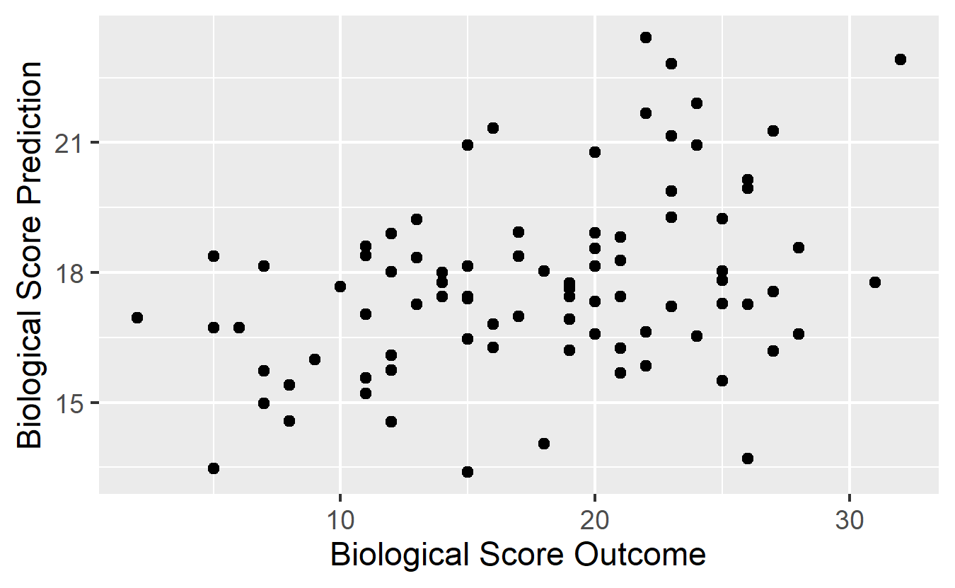

Figure 8: Scatter plot of LASSO model predicted E. coli cfu data as a function of actual E. coli cfu from the MIDO data set.
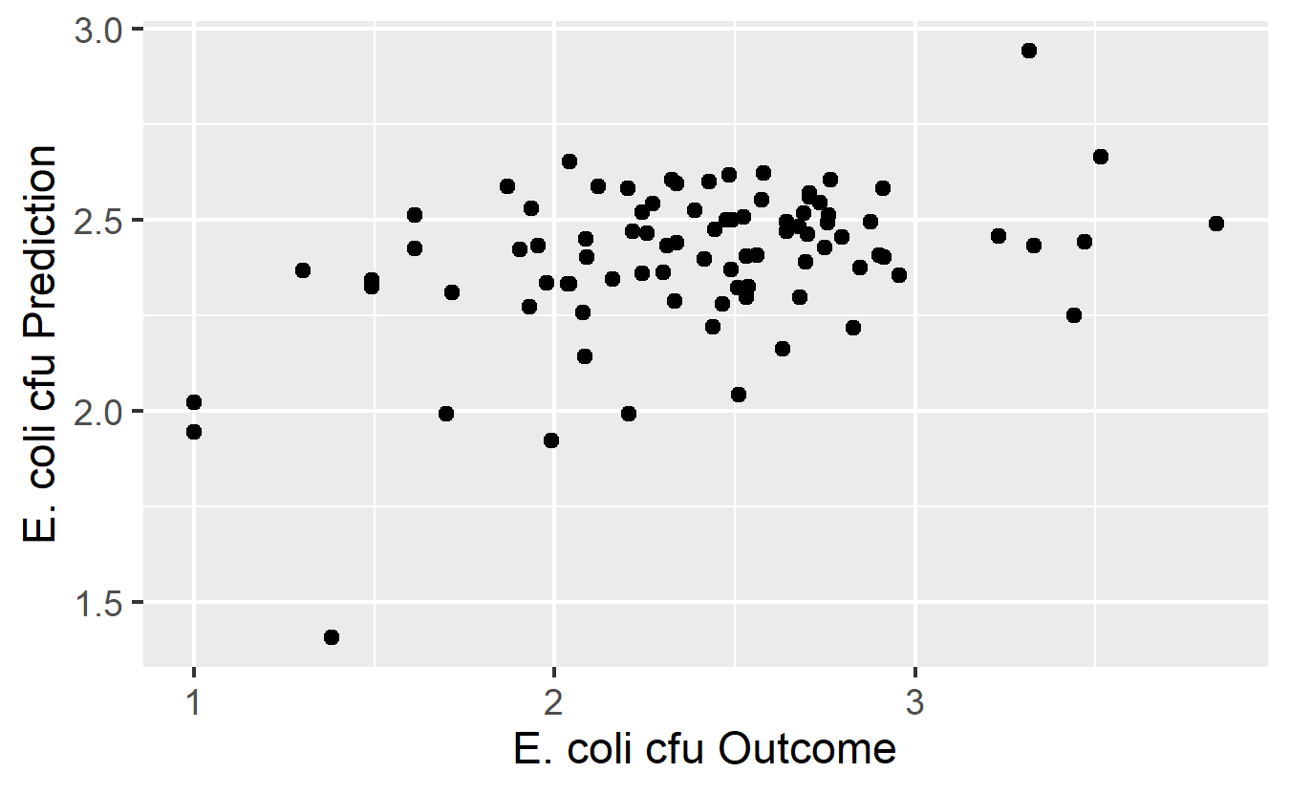

5 Discussion
Based on the inconsistent linear modeling exploratory analysis and LASSO modeling for best combination of predictors, the results indicate that combinations of the variables biological score, E. coli cfu, nitrate concentration, conductivity, and turbidity are not able to predict values for biological score or E. coli cfu. This indicates that one cannot predict either Biological Score or E. coli cfu from any combination of stream physical and chemical properties. This is seen by a lack of consistent significant correlations between each stream health predictor and either biological score or E. coli cfu as well as LASSO modeling to find the ideal combination of stream health variables to predict biological score or E. coli cfu. Given these results, it is likely that the data was biased due to the inconsistent and opportunistic sampling efforts done by citizen science ([12]). When examining the data set, many values were observed to be missing, with a disproportionate amount of extent observations in what I suspect to be the more easily collected stream health variables. For example, significantly more NA observations were included in the biological score column relative to variables like turbidity and conductivity. This is because both turbidity and conductivity can be measured in situ with a meter in a matter of minutes, while biological score is calculated following collection and identification of macroinvertebrate families from samples ([11]). Therefore, biological score is much harder to measure. Additionally, E. coli cfu is processed by culturing E. coli from samples and generally requires a trained scientist to perform such methods. While confidence in values may be greater in this case, there is now a shortage of labor due to need for a specialized skill set to process and quantify E. coli cfu values.

5.1 Conclusions
Based the results of this study, I would recommend that existing methodology for UOWN stream health characterization and monitoring be re-evaluated. The issue being that there seems to be a disparity in sampling effort, both in quality of samples and time spent sampling, for each different stream health metric. The result being that the term “healthy stream” does not have a unified definition in terms of the metrics used to quantify stream health. I would suggest future scientific studies be conducted to assess to relationship between stream health metrics in order to be able to predict metrics like biological score and E. coli cfu so citizen based monitoring does not have to collect these data while still having easier to measure variables that can be used to describe stream health in terms of biological score and E. coli cfu.

References
[1] J.M. Winter, J.R. Lopez, A.C. Ruane, C.A. Young, B.R. Scanlon, C. Rosenzweig, Representing water scarcity in future agricultural assessments, Anthropocene. 18 (2017) 15–26. doi:10.1016/j.ancene.2017.05.002.
[2] I. Bouizrou, N. Chahinian, J.L. Perrin, R. Müller, N. Rais, Network representation in hydrological modelling on urban catchments in data-scarce contexts: A case study on the Oued Fez catchment (Morocco), J. Hydrol. Reg. Stud. 34 (2021). doi:10.1016/j.ejrh.2021.100800.
[3] K.K. Birawat, T. Hymavathi, M. C.Nachiyar, N.A. Mayaja, C.V. Srinivasa, Impact of urbanisation on lakes—a study of Bengaluru lakes through water quality index (WQI) and overall index of pollution (OIP), Environ. Monit. Assess. 193 (2021) 1–20. doi:10.1007/s10661-021-09131-w.
[4] R.D. Klein, Urbanization and Stream Quality Impairment, JAWRA J. Am. Water Resour. Assoc. 15 (1979) 948–963. doi:10.1111/j.1752-1688.1979.tb01074.x.
[5] J. Wolfram, S. Stehle, S. Bub, L.L. Petschick, R. Schulz, Water quality and ecological risks in European surface waters – Monitoring improves while water quality decreases, Environ. Int. 152 (2021) 106479. doi:10.1016/j.envint.2021.106479.
[6] J.E. Clapcott, K.J. Collier, R.G. Death, E.O. Goodwin, J.S. Harding, D. Kelly, et al., Quantifying relationships between land-use gradients and structural and functional indicators of stream ecological integrity, Freshw. Biol. 57 (2012) 74–90. doi:10.1111/j.1365-2427.2011.02696.x.
[7] C.A. Flinders, R.J. Horwitz, T. Belton, Relationship of fish and macroinvertebrate communities in the mid-Atlantic uplands: Implications for integrated assessments, Ecol. Indic. 8 (2008) 588–598. doi:10.1016/j.ecolind.2007.08.004.
[8] E. Alvareda, C. Lucas, M. Paradiso, A. Piperno, P. Gamazo, V. Erasun, et al., Correction to: Water quality evaluation of two urban streams in Northwest Uruguay: are national regulations for urban stream quality sufficient? (Environmental Monitoring and Assessment, (2020), 192, 10, (661), 10.1007/s10661-020-08614-6), Environ. Monit. Assess. 192 (2020). doi:10.1007/s10661-020-08657-9.
[9] J. Wu, R. Mao, M. Li, J. Xia, J. Song, D. Cheng, et al., Assessment of aquatic ecological health based on determination of biological community variability of fish and macroinvertebrates in the Weihe River Basin, China, J. Environ. Manage. 267 (2020) 110651. doi:10.1016/j.jenvman.2020.110651.
[10] A.J. Boulton, An overview of river health assessment: Philosophies, practice, problems and prognosis, Freshw. Biol. 41 (1999) 469–479. doi:10.1046/j.1365-2427.1999.00443.x.
[11] GAEPD, Macroinvertebrate & Chemical Stream Manual, 319 (2015) 1–48.
[12] M. Kosmala, A. Wiggins, A. Swanson, B. Simmons, Assessing data quality in citizen science, Front. Ecol. Environ. 14 (2016) 551–560. doi:10.1002/fee.1436.

