Carter Figgins

Networking

File_Transporter Documentation (Tested on Ubuntu 20.4)

Sending one File

Raspberry Pi (setting up server)

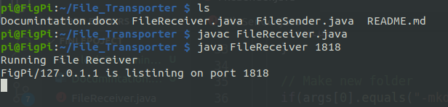

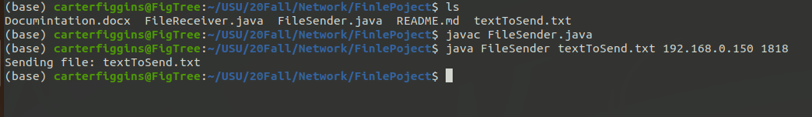Computer Sending over text file.

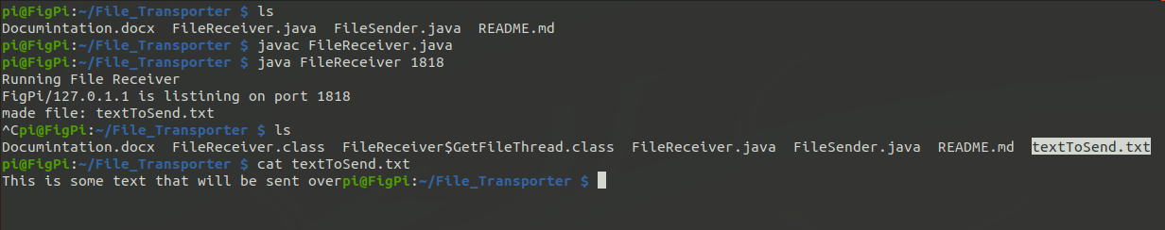Raspberry Pi received file and create it.

Sending Directory

Computer Sending a Folder

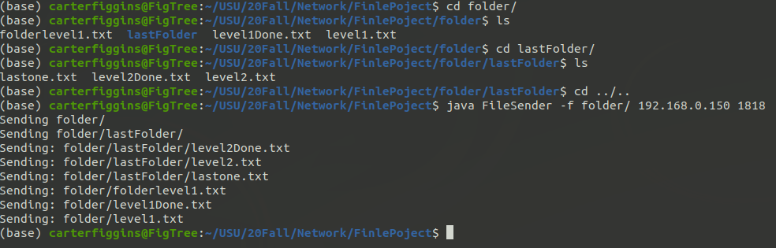

Pi Receiving Folder

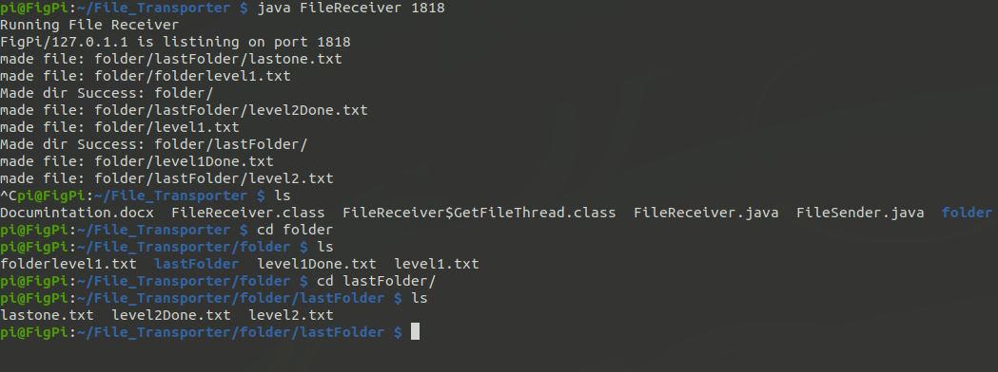

Why

Sending Files To my raspberry pi can be a process. If I just wanted to send one file my methods where to make a new git repository and push it to git hub and then pull it from my pi. Now I just have the FileReceiver running on my pi and I only need to use one command to send files. It was a much needed application.

How It Works

There are two files. One receives files and one sends them. Here are the steps my program takes

If the FileReceiver is running and ready to go then the FileSender can send files to it.

Step 1: User gives 3 things to the File sender a file/folder, host, and port. If the folder tag is sent it will recursively go through the folder to make folders and files and sends them over the socket.

Step 2: The program creates a body and header to send over the socket.

The header has the name of the file and if it is a Folder or not.

The body has the file bytes but null if it is a folder

Step 3: The body and header are sent to the host. (If it is a folder the body is ignored)

Step 4: The host will decode the header and body. It will find out the name of the file and if it is a folder or not.

Step 5: If it is a folder I will make a directory with that name and not look at the body (because it was not sent) If it is a file than it will get the name from the header and make a new file from the bytes in the body.

Step 6: The folders/files will be at the FileReceiver location.