**CSI 2132**



# Hotel Database Project Report

Wallace, Carter

6444010

Yi, Man

8016265

This project is built for the purpose of data logging for hotel chains, including hotel chains, hotels of each chain, rooms of each hotel, employee information and customer information along with booking log.

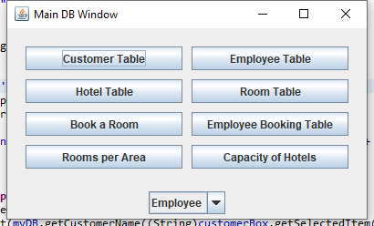

The main view is shown above with every button lead to a different table pulled from uOttawa database where every information is stored.

At the bottom of the window, user can select if they are employee or customer. With status employee, one can edit the booking and delete it. If the user is customer, then he or she can book a room.

Customer Table button allow one to check list of customers.

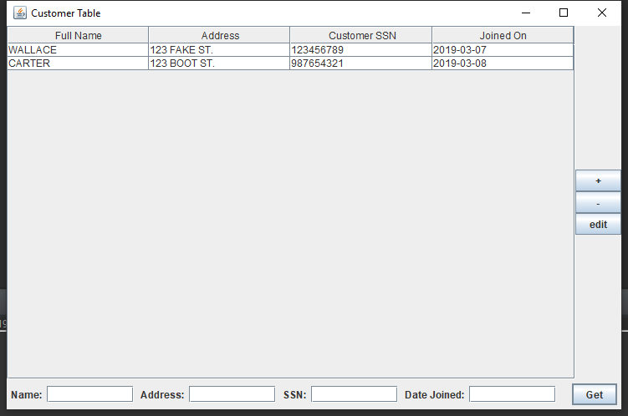

The bottom four fields are used to search through the current table in database.

The ‘+’ button on the right let one add another customer and enters the information.

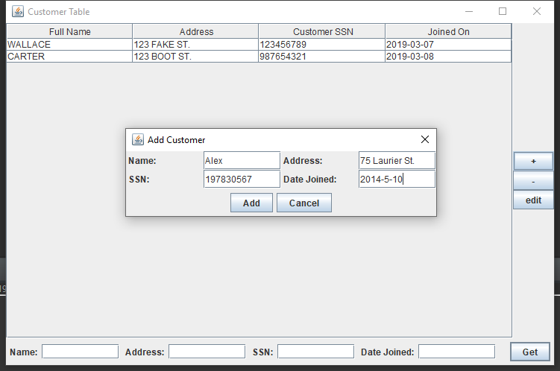

After clicking ‘Add’, the query will be sent to database as follows,

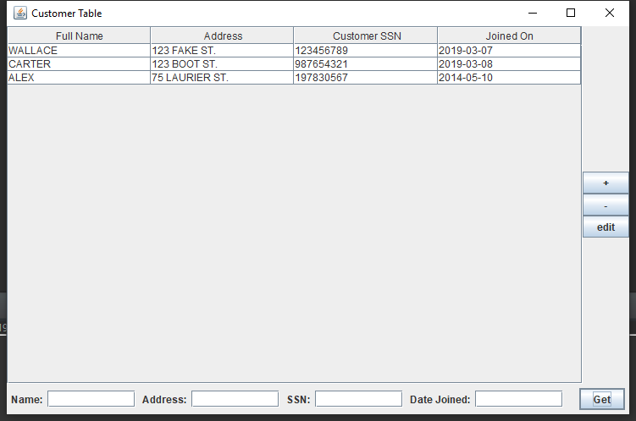

Hotel table button shows all the hotels with their respective information

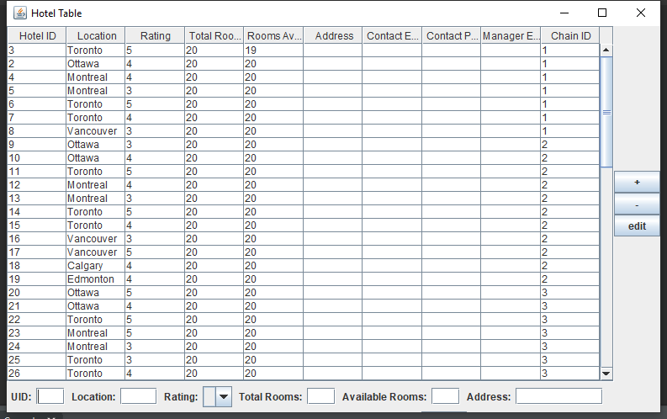

One can still search through database to find the hotel. And there is a drop-down menu to filter through 1-5 stars hotel. This table is linked with a trigger in the database. This trigger will minus after an available room when a booking is made in the said hotel.

The function code is as follows:

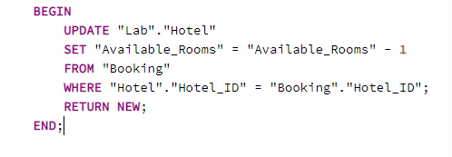

The ‘+’, ‘-’, and ‘edit’ button on the right work the same way as Employee and for all other tables.

Book a room will show all the hotels with available rooms to book.

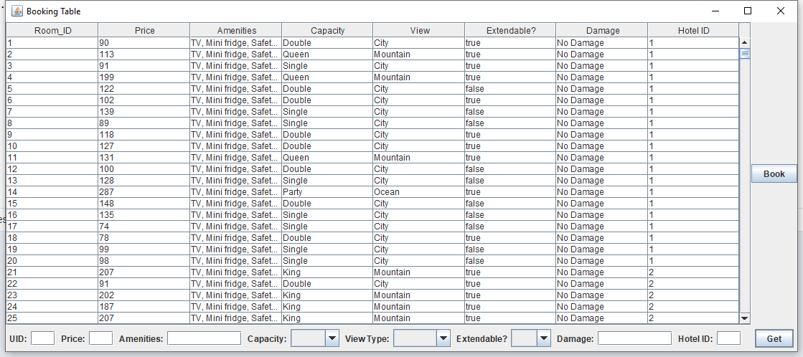

The same search function allows user to use intuitively with search fields and drop-down list for capacity, view type, if it is extendable. The Book button takes user to booking interface. 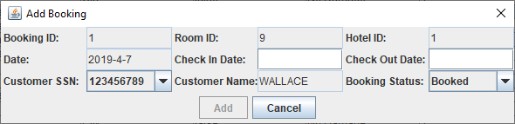

In there, one can booking the room by filling the date and click Add to book.

Another trigger was added to this table to archive all the booking information. Even if the record is deleted by the employee, there will be a copy of that booking archived in the database. With every entry to the booking table, a copy is made to the archive table.

The copy function works as follows:

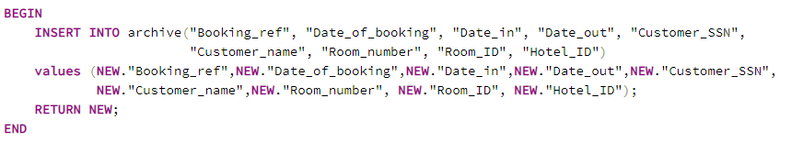

Capacity of Hotel Table allow use to view all the information with Hotel ID, its total capacity, where it is located and the hotel chain name of the hotel.

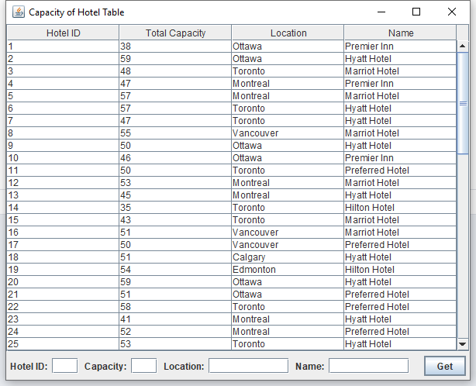

Search function works as intended.

Employee table has functions same as customer table, with add, delete, modify and search functions.

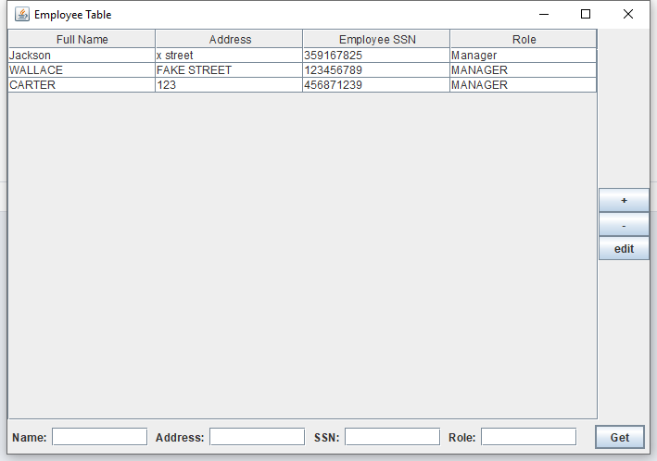

Room Table shows all the room with its price, amenities, capacity, view, if it is extendable and damage. Note that all prices are random generated with intended range for different type of room. Single and Double room are cheapest; King and Queen size room are relatively more expensive than Single and Double, while Party room which include kitchen, swim pool and dance floor are the most expensive type. The number of rooms for a hotel is random generated with proper probabilities. Single and Double size room are the most common type, and Party size is the rarest. Adding, deleting, modifying and search functions work properly.

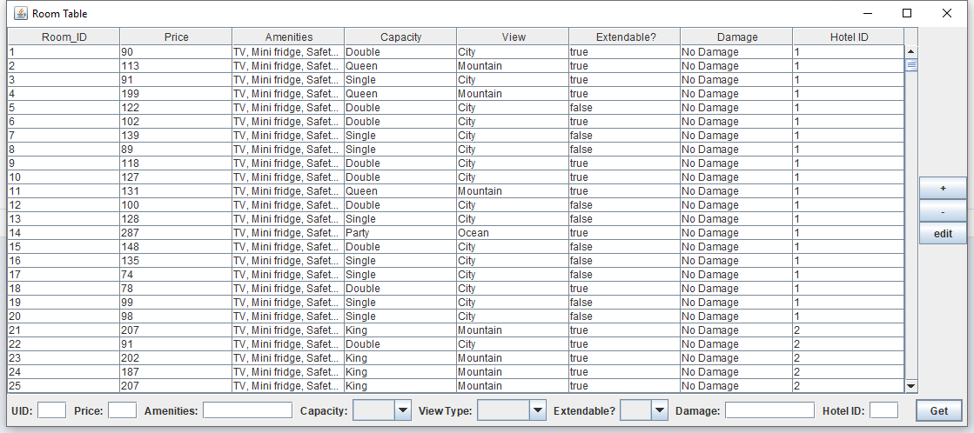

Last but not the least, Rooms per Area Table show all the locations that have hotels and the total room in that area.

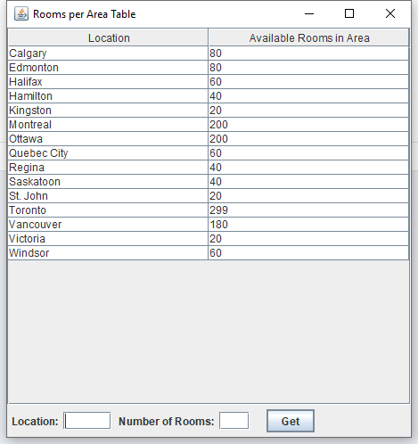

At any point in time, user can choose to close the current window, and this will return user to the main view where they can select tables they want to view.

This project used Eclipse to develop the GUI and used PGAdmin to populate the database. The Java program communicates with uOttawa database instead of hard coding everything in the view. All views pull data from the database instead of hardcoding. Therefore, if there are any changes to the database, the GUI will respond respectively.