PA Problem 1

userInput = input from command line

string str = userInput

int count = 0

char start = userInput[0]

string final = ""

while(reading from userInput){

char x = userInput.next

if(x == start)

{

count++

}

else

{

final += "count + start"

start = userInput.next

count = 0

}

}

WriteLine "final"

PA Problem 2

|  |  |  |
| --- | --- | --- |
| Input | Processing | Output |
| string titlePlayed  int timeSpent | while(games present in userInput){  Display "enter name of game"  titlePlayed = userInput  Display "enter playtime in minutes"  timeSpent = userInput parsed for integers  print("You played " + titlePlayed + " for " + timeSpent + " minutes.")  totalPlaytime += timeSpent  }  print("Total playtime: " + totalPlaytime + " minutes.") | totalPlaytime |

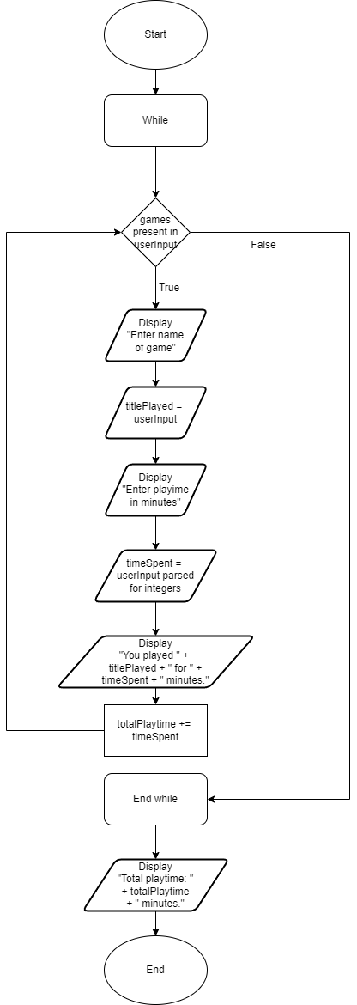

PA Problem 3

|  |  |  |
| --- | --- | --- |
|  |  |  |
| int motionIntensity  string simQuality  string genre  double duration  bool underMaintenance | while(reading from userInput){  Display "enter genre"  genre = userInput  Display "enter duration in minutes"  duration = userInput parsed for doubles  Display "enter intensity of motion"  motionIntensity = userInput parsed for integers  Display "enter quality of simulation"  simQuality = userInput  Display "enter if ride is underMaintenance"  underMaintenance = userInput parsed for bools  if(genre == "space exploration" || genre == "deep-sea adventure" || (duration >= 5 && motionIntensity <= 4)){  if(simQuality == "high-definition"){  if(underMaintenance == false){  fitForGuest = true  }  else{  fitForGuest = false  }  }  else{  fitForGuest = false  }  }  else{  fitForGuest = false  }  //print starts below  if(fitForGuest == true){  print "experience is fit for guest use"  }  else{  print "experience is unfit for guest use"  }  } | fitForGuest |

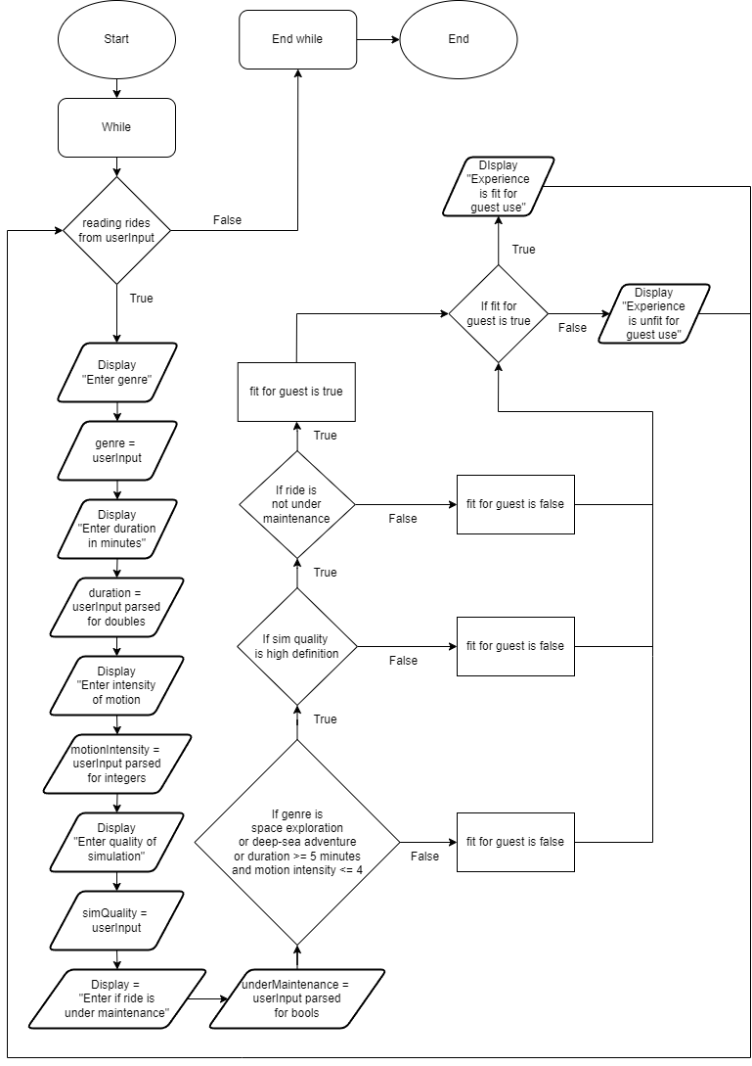

PA Problem 4

|  |  |  |
| --- | --- | --- |
| Input | Processing | Output |
| rosterFile  int flightHours  int missionSuccesses  string assignment  string name | //Elite = 100+  //Veteran = 75-99  //Specialist = 50-74  //Novice = <50  while(reading from rosterFile){  flightHours=rosterFile.flightHours  missionSuccesses = roster.missionSuccesses  name = roster.name  if(missionSuccesses < 50){  assignment = "Novice"  }  else if(missionSuccesses < 75{  assignment = "Specialist"  }  else if(missionSuccesses < 100){  assignment = "Veteran"  }  else{  assignment = "Elite"  }  //print statements  if(assignment == "Novice"){  print name + “ is not assigned to any missions"  }  else if(assignment == "Specialist"){  print name + ” is assigned to support missions"  }  else if(assignment == "Veteran"){  print name + ” is assigned to high-profile missions"  }  else{  print name + ” is assigned to flagship missions"  }  } | assignment |

