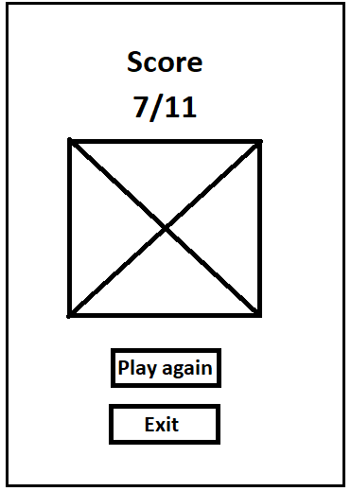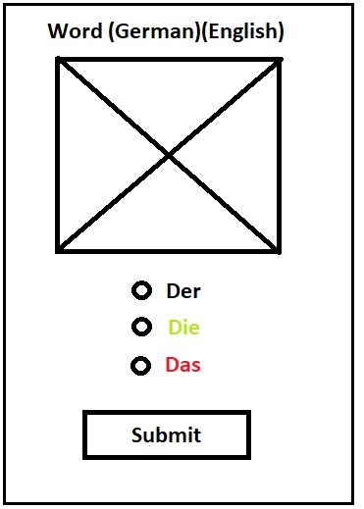A close up of a logo

Description generated with very high confidence

**Interface**

1. What ***controls*** will you provide to the user, both to submit their input (i.e. their choice of article for each noun) and for navigation (i.e. starting the quiz, moving from one item to the next, etc.) and how will they be placed on the screen?

The whole title screen can be tapped to move to the question screen. Question screen will contain three radio buttons for the user to select their answer. A submit button will allow the user to submit their answer. Score screen will contain two buttons which will allow the user to exit the app or replay the quiz.

1. What ***feedback*** will you present to the user, both to display their performance and to display the state of the system (e.g. when the quiz is over).

If the answer was correct, then the selected text will turn to green indicating that the answer is correct. If the answer the user has selected is wrong, then the text that was selected will turn red and the correct answer will turn green.

1. What ***constraints*** will your app provide to prevent errors? For example, can you reduce the chance that a user will inadvertently submit an answer other than the one s/he intends?

User will have to submit an answer before the move on to next question will appear. This means that the user will not be able to move on to the next question until an answer have been given.

1. What is the ***time course*** of your application? That is, the timing sequence of events – show the new picture, accept the answer, present the feedback. Have you made it entirely ***visible*** to the user what is happening at all times?

Timing is all controlled by the user as the user will have to interact with the app using buttons to move on to the next section of the app

1. What ***non-functional*** ***graphical elements*** do you need (colours, borders, logos, etc.)? Remember that screen space on mobile devices is extremely limited, so graphical elements must serve a clear purpose, either functional or aesthetic.

Title and score screen will contain visuals that is only for aesthetic purposes however the question screen will show the picture of the word being presented to the user.

**Implementation**

1. How many Activities do you need?

3 activities for title, question and score

1. What data structure(s) do you need to manage the application data? This includes the nouns, their images, their genders, the user’s responses, etc.

Question object which will contain the question, image and answer. Also, the score will be aggregated with every correct answer and passed to the score activity.

1. What other non-Activity classes do you need?

Question object class and question setup class

1. What algorithm will you use for randomisation of the items? Remember that you must present each noun exactly once during each quiz, and the set of nouns must be presented in random order.

Put random unique number between 0 – 10 and store it into an array. The array will then be used to select the question out of the question array by looping through all the numbers in the random number array.

1. What algorithm will you use to mark each response as correct or incorrect?

Compare the answer that the user has given with the correct answer stored in the question class by getting the variable from the class.

1. How will you store the accumulated results to allow you to present the summary score at the end?

A variable called score which will be aggregated with every correct answer to the questions. This variable will then be passed as an extra to the score activity screen.